1.  
A: O(N^2)  
B: O(N^2)  
C: O(N^2)  
D: O(N^2)

2.  
Iteration 1: anArray = {0, 1, 2, 3, 4, 5, 6, 6}

Iteration 2: anArray = {0, 1, 2, 3, 4, 5, 5, 6}

Iteration 3: anArray = {0, 1, 2, 3, 4, 4, 5, 6}

Iteration 4: anArray = {0, 1, 2, 3, 3, 4, 5, 6}

Iteration 5: Loop terminates because i becomes 3.

3.  
A: O(n) T(1)  
B: O(n3) T(n)= n + 4  
C: O(n) T(1)  
D: O(log(n)) T(1)

4.  
O(1) - Constant Time Complexity

O(log n) - Logarithmic Time Complexity

O(n) - Linear Time Complexity

O(n log n) - Linearithmic Time Complexity

O(n^2) - Quadratic Time Complexity

O(n^3) - Cubic Time Complexity

5.   
ADT is a mathematical model for data types. For example, it includes stacks, lists, and sets   
 1.Stack: Implemented using the Stack class in Java.

2.List: Implemented using the List interface, or its implementations like ArrayList or LinkedList.

3.Set: Implemented using the Set interface, or its implementations like HashSet or TreeSet.

6.

|  |  |  |
| --- | --- | --- |
| Content | List | Arraylist |
| implementation | interface | class |
| Resize behavior | Dynamic resizing | Dynamic resizing |
| performance | More memory efficient than ArrayList | Less memory efficient than List, as it's more flexible |
| memory | Slower for random access, faster for insertion/deletion | Faster for random access, slower for insertion/deletion |

7.  
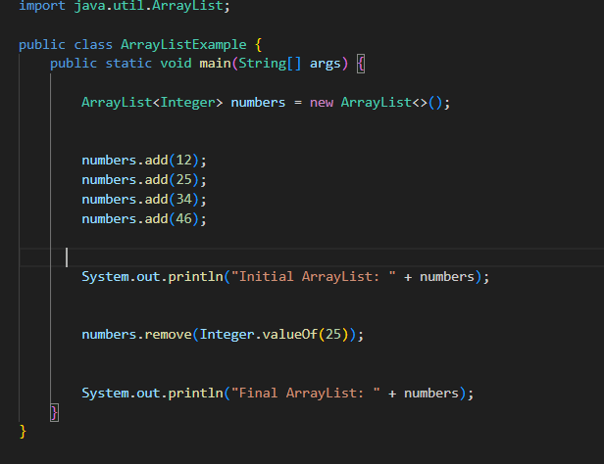

Project Task   
1-3

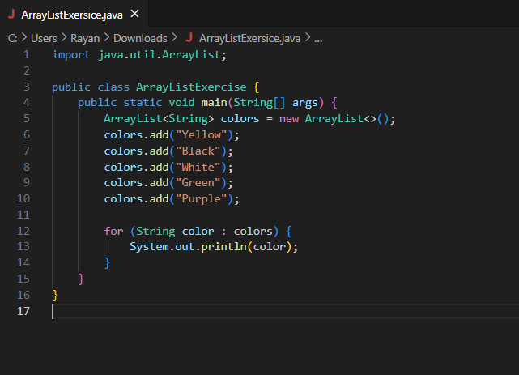

4-6  
