***CGPA CALCULATOR***

*A Project*

*Submitted to the department of computer science and engineering.*

*In partial fulfillment of the requirements*

*For the course of software development (III) 2019*

**Submitted by:**

**Rayhan Al Shorif**

**Id: 16172103133**

**Program: B.Sc. Engg. in CSE**

**Intake: 35,Section: 03**

**Supervised By:**

***Milon Biswas***

**Assistant Professor,**

***Department of CSE***

**Bangladesh University of Business & Technology (BUBT)**

**ABSTRACT**

The User Documentation serves the purpose to guide the user’s of GPA and CGPA calculator. GPA refers to the Grade Point Average where the CGPA is Cumulative Grade Point Average. Through the guide, the user shall be able to learn how to use the program or in some scenario the desktop software concurrently.

**Declaration**

We declare that this project and work presented in it our own and has been generated by us as the result of our own original research.

We confirm that:

This work is done only for mainly oil in and candidature for a research course at this university.

This project work has not been previously submitted for any degree at this university or any other educational institutes. We have quoted from the work of others the source is always given. With the exception of such quotations this thesis is entire our own work.

………………………..

**Rayhan Al Shorif**

**CERTIFICATE**

This is to certify that Rayhan Al Shorif, Fatema Tuz Zohora, Samia Hasan and Ridoy RoyStudents of B.Sc. in CSE have completed their project work titled CGPA calculator satisfactorily in partial fulfillment for the requirement of the course software development 300, Bangladesh University of business and technology in the year 2019.

………………….

**Rayhan Al Shorif**

**…………………………..**

**Project Supervisor:**

***Milon Biswas***

Assistant Professor,

*Department of CSE*

Bangladesh University of Business & Technology (BUBT)

DEDICATION

Dedicated to our parents for all their love inspiration.

**Acknowledgement**

First of all we are thankful and expressing our gratefulness to almighty Allah who offers us His divine blessing, patient mental and physical strength to complete this project work.

We are deeply indebted to our project supervisor Milon Biswas,   
Assistant professor, department of computer science and engineering Bangladesh university of business and technology BU BD he is scholarly guidance,  
important suggestions for going through our drafts and correcting them and generating courage from the beginning to the end of the research work has made the completion of this thesis possible.

A very special Guidant goes out to all our friends for their support and help to important our works. The discussions with them on various topics of our works have been very helpful for us to enrich our knowledge and conception regarding the work.  
 Last but not the least; we are highly grateful to our parents and family members for supporting us spiritually throughout writing this thesis and our life in general.

**APPROVAL**

This project “**CGPA Calculator**” is submitted by **Rayhan Al Shorif** ID No.**16172103133** Department of Computer Science and Engineering Bangladesh University of business and technology under the supervisor of

***Milon Biswas*** assistant professor and Department of Computer Science and Engineering has been accepted as satisfactory for the partial fulfillment of the requirement for the course of SD-300 in Computer Science and Engineering, approved as to its style and contacts.

………………………….

**Project Supervisor:**

**Milon Biswas**

Assistant Professor,

*Department of CSE*

Bangladesh University of Business & Technology (BUBT)

…………………………….

**Chairman:**

**Prof. M.Ameer Ali**

Professor and Chairman

*Department of CSE*

Bangladesh University of Business & Technology (BUBT)

**©** Copyright by **Rayhan Al Shorif (ID: 16172103133)**

All Right Reserved

|  |  |
| --- | --- |
| Contents | Page No. |
| **1.Introduction** | 9 |
| 1.1 Project Aims and Objectives | 9 |
| 1.2 Background of Project | 10 |
| 1.3 Operation Environment | 11 |
| **2. System Analysis** | 12 |
| 2.1 Software Requirements Specification | 12 |
| 2.2 Software Tools Used | 14 |
| **3. System Design** | 16 |
| 3.1 Table Design | 16 |
| 3.2 Data Flow Diagrams | 17 |
| 3.3 E-R Diagram | 18 |
| **4. System Implementation** | 19 |
| 4.1 Module Description | 19 |
| 4.2 Screenshot | 22 |
| **5. System Testing and Analysis** | 24 |
| 5.1 Cyclomatic Complexity (CC): | 24 |
| 5.2 Feasibility Analysis: | 25 |
| **6. Limitation, Conclusion and Future Scope** | 27 |
| **7. Reference** | 28 |

Table of Contents

**CHAPTER-1: INTRODUCTION**

**1.0 Introduction**

CGPA like a grading system and this system is in education is the process of applying standardized measurements of varying levels of achievement in a course.

Grades can be assigned as letters, as a range, as a percentage of a total number of questions answered correctly, or as a number out of a possible total. Most colleges and universities in the United States award letter grades A, B, C, D, or F for each class taken. These marks are then used to determine an overall Grade Point Average from 1.0 to 4.0, which is calculated using a formula. The average GPA is 3.3 at private institutions, and 3.0 at public ones.

In some countries, all grades from all current classes are averaged to create a grade point average for the marking period. The GPA is calculated by taking the number of grade points a student earned in a given period of time of middle school through high school. GPAs are also calculated for undergraduate and graduate students in most universities. That is known as CGPA. The CGPA can be used by potential employers or educational institutions to assess and compare applicants. A cumulative grade point average is a calculation of a student's total earned points divided by the possible number of points. This grading system calculates the average for all of his or her complete education career. Grade point averages can be unweighted or weighted. On the other hand our application also known as AnnexBUBT because beside the CGPA calculation it has also academic information, routine and fees and wavers part that is called annex bubt.

BUBT Annex (**A** **N**ew **N**exus of **Ex**cellence) shortly known as BUBT-NX is an online portal for the students and teachers of BUBT. It is a one stop web portal service where ongoing / running students can get their academic information from anywhere. At present it is in beta version and the stable version will be released very soon.

* 1. **Project Aims And Objectives**

The User Documentation serves the purpose to guide the users of GPA and CGPA calculator. GPA refers to the Grade Point Average where the CGPA is Cumulative Grade Point Average. Through the guide, the user shall be able to learn how to use the program or in some scenario the desktop software concurrently. But our application is android base so an android user can use our apps with internet connection as well as CGPA calculation is performed in offline.

* + 1. **Primary Objective**

The primary objectives of the project are mentions below:

* To calculate CGPA in a short time.
* Collecting information of a student.
* To find our semester-wise course grades.
* To know class routine.
* Calculating CGPA in offline.
  + 1. **Secondary Objective**

The secondary objectives of the project are mentions below:

* To fulfill the requirement the software engineering project.
* To design, development and maintenance of a software in discipline way.
  1. **Background of Project**

Background tasks consume a device's limited resources, like RAM and battery. This may result in a poor experience for the user if not handled correctly.

In order to maximize battery and enforce good app behavior, Android restricts background work when the app (or a foreground service notification) is not visible to the user.

* Android 6.0 (API level 23) introduced [Doze mode and app standby](https://developer.android.com/training/monitoring-device-state/doze-standby). Doze mode restricts app behavior when the screen is off and the device is stationary. App standby puts unused applications into a special state that restricts their network access, jobs, and syncs.
* Android 7.0 (API level 24) limited implicit broadcasts and introduced [Doze-on-the-Go](https://developer.android.com/about/versions/nougat/android-7.0#doze_on_the_go).
* Android 8.0 (API level 26) further [limited background behavior](https://developer.android.com/about/versions/oreo/background), such as getting location in the background and releasing cached wake locks.
* Android 9 (API level 28) introduced [App Standby Buckets](https://developer.android.com/topic/performance/appstandby), in which app requests for resources are dynamically prioritized based on app usage patterns.

It is important to understand your task needs and choose the right solution adhering to system best practices in scheduling your background job.

* 1. **Operation Environment**

Android is a comprehensive open source platform designed for mobile devices. It is championed by Google and owned by Open Handset Alliance. The goal of the alliance is to accelerate innovation in mobile computing and offer consumers a richer, less expensive, and better mobile experience. Android is the vehicle to do so. Android is a Linux-based operating system mainly used for running mobile devices such as smart phones and tablet computers. Its usability is not limited to mobile devices. Because of its open and customizable features, it is used in a wide range of electronics devices, like laptops, smart TV, cameras, headphones, wristwatches, game consoles, car CD and DVD players, home automations and many more [Marko Gargenta]. Android OS is hardware independent and runs on devices from different vendors, unlike other proprietary operating systems such as iOS (Apple Inc. products), Blackberry OS (Blackberry), S40 OS (Nokia), Windows OS (Windows Phone) etc., which are licensed and controlled by certain companies. As of May 2013, Android dominates the smartphone market accounting 74.4% of worldwide smartphone sales [Gartner]. Android is a full-fledged operating system and a complete software stack for mobile devices. Android APIs are a rich set of system services wrapped in an intuitive class files which provides easy access to several features like location, web, telephony, WiFi, media, camera , and so on. All the tools, frameworks and software necessary to develop a mobile application are available for free.

**CHAPTER-2: SYSTEM ANALYSIS**

**2. System Analysis**

In which chapter we will discuss and analyse about the developing process of CGPA calculator including software requirement specification SRS and comparison between existing and proposed system the functional and nonfunctional requirements are included in SRS path to provide complete description and overview of system requirement before the developing process in carried out besides that existing versus proposed provides a view of how the proposed system will be more efficient than the existing one.

**2.1 Software Requirement Specification**

Development of the system requires tools like:

* Front-end: Xml.
* Back-end: Java script.
* Database: Firebase database.
* Browser : Google chrome
* **XML** [code](https://whatis.techtarget.com/definition/code), a formal recommendation from the [World Wide Web Consortium](https://whatis.techtarget.com/definition/W3C-World-Wide-Web-Consortium) (W3C), is similar to [Hypertext Markup Language](https://www.theserverside.com/definition/HTML-Hypertext-Markup-Language) (HTML). Both XML and HTML contain [markup symbols](https://whatis.techtarget.com/definition/markup) to describe page or file contents. HTML code describes Web page content (mainly text and graphic images) only in terms of how it is to be displayed and interacted with. XML data is known as self-describing or self-defining, meaning that the structure of the data is embedded with the data, thus when the data arrives there is no need to pre-build the structure to store the data; it is dynamically understood within the XML. The XML format can be used by any individual or group of individuals or companies that want to share information in a consistent way. XML is actually a simpler and easier-to-use subset of the [Standard Generalized Markup Language](https://searchmicroservices.techtarget.com/definition/SGML-Standard-Generalized-Markup-Language) (SGML), which is the standard to create a document structure.The basic building block of an XML document is an element, defined by[tags](https://searchmicroservices.techtarget.com/definition/tag). An element has a beginning and an ending tag. All elements in an XML document are contained in an outermost element known as the root element. XML can also support [nested](https://whatis.techtarget.com/definition/nested) elements, or elements within elements. This ability allows XML to support hierarchical structures. Element names describe the content of the element, and the structure describes the relationship between the elements. An XML document is considered to be "well formed" (that is, able to be read and understood by an XML [parser](https://searchmicroservices.techtarget.com/definition/parser)) if its format complies with the XML specification, if it is properly marked up, and if elements are properly nested. XML also supports the ability to define attributes for elements and describe characteristics of the elements in the beginning tag of an element.
* **JavaScript** often abbreviated as JS, is a [high-level](https://en.wikipedia.org/wiki/High-level_programming_language), [interpreted](https://en.wikipedia.org/wiki/Interpreted_language) [scripting language](https://en.wikipedia.org/wiki/Scripting_language) that conforms to the [ECMAScript](https://en.wikipedia.org/wiki/ECMAScript) specification. JavaScript has [curly-bracket syntax](https://en.wikipedia.org/wiki/List_of_programming_languages_by_type#Curly-bracket_languages), [dynamic typing](https://en.wikipedia.org/wiki/Dynamic_typing), [prototype-based](https://en.wikipedia.org/wiki/Prototype-based_programming) [object-orientation](https://en.wikipedia.org/wiki/Object-oriented_programming), and [first-class functions](https://en.wikipedia.org/wiki/First-class_function).
* Alongside [HTML](https://en.wikipedia.org/wiki/HTML) and [CSS](https://en.wikipedia.org/wiki/CSS), JavaScript is one of the core technologies of the [World Wide Web](https://en.wikipedia.org/wiki/World_Wide_Web). JavaScript enables interactive [web pages](https://en.wikipedia.org/wiki/Web_page) and is an essential part of [web applications](https://en.wikipedia.org/wiki/Web_application). The vast majority of [websites](https://en.wikipedia.org/wiki/Website) use it and major [web browsers](https://en.wikipedia.org/wiki/Web_browser) have a dedicated [JavaScript engine](https://en.wikipedia.org/wiki/JavaScript_engine) to execute it.
* As a multi-paradigm language, JavaScript supports [event-driven](https://en.wikipedia.org/wiki/Event-driven_programming), [functional](https://en.wikipedia.org/wiki/Functional_programming), and [imperative](https://en.wikipedia.org/wiki/Imperative_programming) (including [object-oriented](https://en.wikipedia.org/wiki/Object-oriented_programming) and [prototype-based](https://en.wikipedia.org/wiki/Prototype-based_programming)) [programming styles](https://en.wikipedia.org/wiki/Programming_paradigm). It has [APIs](https://en.wikipedia.org/wiki/Application_programming_interface) for working with text, [arrays](https://en.wikipedia.org/wiki/Array_data_type), dates, [regular expressions](https://en.wikipedia.org/wiki/Regular_expression), and the [DOM](https://en.wikipedia.org/wiki/Document_Object_Model), but the language itself does not include any [I/O](https://en.wikipedia.org/wiki/Input/output), such as [networking](https://en.wikipedia.org/wiki/Computer_network), [storage](https://en.wikipedia.org/wiki/Data_storage), or [graphics](https://en.wikipedia.org/wiki/Computer_graphics) facilities. It relies upon the host environment in which it is embedded to provide these features.
* Initially only implemented [client-side](https://en.wikipedia.org/wiki/Client-side) in web browsers, JavaScript engines are now embedded in many other types of host software, including [server-side](https://en.wikipedia.org/wiki/Server-side) in web servers and databases, and in non-web programs such as word processors and [PDF](https://en.wikipedia.org/wiki/Portable_Document_Format) software, and in runtime environments that make JavaScript available for writing mobile and desktop applications, including desktop widgets.
* The terms [*Vanilla*](https://en.wikipedia.org/wiki/Vanilla_software)*JavaScript* and *Vanilla JS* refer to JavaScript not extended by any frameworks or additional libraries. Scripts written in Vanilla JS are plain JavaScript code.
* Although there are similarities between JavaScript and [Java](https://en.wikipedia.org/wiki/Java_(programming_language)), including language name, [syntax](https://en.wikipedia.org/wiki/Syntax_(programming_languages)), and respective [standard libraries](https://en.wikipedia.org/wiki/Standard_library), the two languages are distinct and differ greatly in design. JavaScript was influenced by programming languages such as [self](https://en.wikipedia.org/wiki/Self_(programming_language)) and [scheme](https://en.wikipedia.org/wiki/Scheme_(programming_language)). The [JSON](https://en.wikipedia.org/wiki/JSON) [serialization](https://en.wikipedia.org/wiki/Serialization) format, used to store [data structures](https://en.wikipedia.org/wiki/Data_structure) in [files](https://en.wikipedia.org/wiki/Computer_file) or transmit them across [networks](https://en.wikipedia.org/wiki/Computer_network), is based on JavaScript.
* **Firebase database**
* Store and sync data with our NoSQL cloud database. Data is synced across all clients in real-time, and remains available when your app goes offline.
* The Firebase Real-time Database is a cloud-hosted database. Data is stored as JSON and synchronized in real-time to every connected client. When you build cross-platform apps with our iOS, Android, and JavaScript SDKs, all of your clients share one Real-time Database instance and automatically receive updates with the newest data.

**2.2 Software Tools Used**

***Android Studio*** is the official integrated development environment ([IDE](https://searchsoftwarequality.techtarget.com/definition/integrated-development-environment)) for Android application development. It is based on the [IntelliJ IDEA](https://www.theserverside.com/definition/IntellJ-IDEA), a [Java](https://www.theserverside.com/definition/Java) integrated development environment for software, and incorporates its code editing and developer tools.

To support application development within the Android operating system, Android Studio uses a Gradle-based build system, [emulator](https://whatis.techtarget.com/definition/emulator), code templates, and [Github](https://searchitoperations.techtarget.com/definition/GitHub) integration. Every project in Android Studio has one or more modalities with source code and resource files. These modalities include Android app modules, Library modules, and Google App Engine modules.



Android Studio uses an Instant Push feature to push code and resource changes to a running application. A code editor assists the developer with writing code and offering code completion, refraction, and analysis. Applications built in Android Studio are then compiled into the [APK format](https://whatis.techtarget.com/definition/APK-file-Android-Package-Kit-file-format) for submission to the Google Play Store. The software was first announced at Google I/O in May 2013, and the first stable build was released in December 2014. Android Studio is available for Mac, Windows, and Linux desktop platforms. It replaced Eclipse Android Development Tools (ADT) as the primary IDE for Android application development. Android Studio and the Software Development Kit can be downloaded [directly from Google](https://developer.android.com/studio/).

**3. System Design**

**3.1 Table Design**

Various tables to maintain information:

**3.1.1 Firebase Authentication:**

|  |  |  |  |  |
| --- | --- | --- | --- | --- |
| Field | Data Type | Default | Key | Extra |
| Identifier /Gmail | **String** | **null** |  |  |
| Created | **Date** | **null** |  | **Auto** |
| Signed In | **Date** | **null** |  | **Auto** |
| User UID | **String** | **null** |  | **Auto** |

**3.1.2 Firebase Database (Real-Time Database):**

|  |  |  |  |
| --- | --- | --- | --- |
| Field Name | | Data Type | Key |
| Academic Info | Future Courses | Url | Primary Key |
| Present Courses | Url | - |
| Previous Courses | Url | - |
| [Email](https://console.firebase.google.com/u/0/project/annexbubt/database/annexbubt/data/6YM72JDrXTaJnCB3F3JENR1ZEby1/Email) | | string | - |
| [FeesAndWaiver](https://console.firebase.google.com/u/0/project/annexbubt/database/annexbubt/data/6YM72JDrXTaJnCB3F3JENR1ZEby1/FeesAndWaiver) | | Url | - |
| ID | | int | - |
| Intake | | int | - |
| Name | | string | - |
| Routine | | Url | - |
| Section | | int | - |

**3.2 Data Flow Diagrams**

New User? SignUp

Register

No

Already Register

Yes

Log Out

Login

Home Page

CGPA

Calculation

Fees

And

Waiver

Routine

Academic Info

Previous Course

Future Course

Present Course

**3.3 E-R Diagram**

Academic Info

Home Page

**Chapater 4. System Implementation**

Android devices become increasingly more common, demand for new apps will only increase. Android Studio is an easy to use (and free) development environment to learn on. It's best if one has a working knowledge of the Java programming language for this tutorial because it is the language used by Android. There won't be much code used in this tutorial, so I will assume that you know enough Java to understand or are willing to look up what you don't know. This will take roughly 30-60 minutes, depending on how quickly you are able to download and install Android Studio. After using this tutorial to create your first Android app, you'll be well on your way to a fun new hobby or possibly even a promising career in mobile development.

**4.1 System Implementation**

Android Studio was announced on May 16, 2013 at the [Google I/O](https://en.wikipedia.org/wiki/Google_I/O) conference. It was in early access preview stage starting from version 0.1 in May 2013, then entered beta stage starting from version 0.8 which was released in June 2014. The first stable build was released in December 2014, starting from version 1.0.

Since 7 May 2019, [Kotlin](https://en.wikipedia.org/wiki/Kotlin_(programming_language)) is Google’s preferred language for Android app development. Still, other programming languages are supported by Android Studio, such as Java and C++.

**4.1.2 Module Description**

The incremental build model is a method of software development where the model is designed, implemented and tested incrementally (a little more is added each time) until the product is finished. It involves both development and maintenance. The product is defined as finished when it satisfies all of its requirements. This model combines the elements of the waterfall model with the iterative philosophy of prototyping.

The product is decomposed into a number of components, each of which are designed and built separately (termed as builds). Each component is delivered to the client when it is complete. This allows partial utilization of product and avoids a long development time. It also creates a large initial capital outlay with the subsequent long wait avoided. This model of development also helps ease the traumatic effect of introducing completely new system all at once. We followed “Incremental model” to develop our application called “CGPA Calculator”.

**4.1.3 Incremental Model**

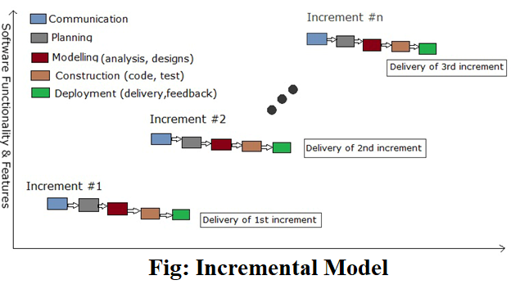

**4.1.4 Incremental Model Phases**

The various phases of incremental model are as follows:

**4.1.4.1 Requirement analysis:** In the first phase of the incremental model, the product analysis expertise identifies the requirements. And the system functional requirements are understood by the requirement analysis team. To develop the software under the incremental model, this phase performs a crucial role.

**4.1.4.2 Design & Development:** In this phase of the Incremental model of SDLC, the design of the system functionality and the development method are finished with success. When software develops new practicality, the incremental model uses style and development phase.

**4.1.4.3 Testing:** In the incremental model, the testing phase checks the performance of each existing function as well as additional functionality. In the testing phase, the various methods are used to test the behavior of each task.

**4.1.4.4 Implementation:** Implementation phase enables the coding phase of the development system. It involves the final coding that design in the designing and development phase and tests the functionality in the testing phase. After completion of this phase, the number of the product working is enhanced and upgraded up to the final system product

**4.1.5 When to use Incremental Model?**

* Such models are used where requirements are clear and can implement by phase wise. From the figure it’s clear that the requirements ® is divided into R1, R2……….Rn and delivered accordingly.
* Mostly such model is used in web applications and product based companies.

**4.1.6 Incremental Model Advantages**

* Generates working software quickly and early during the software life cycle.
* More flexible – less costly to change scope and requirements.
* Easier to test and debug during a smaller iteration.
* Easier to manage risk because risky pieces are identified and handled during its iteration.
* Each iteration is an easily managed milestone.

**4.1.7 Incremental Model Disadvantages**

* Each phase of an iteration is rigid and do not overlap each other.
* Problems may arise pertaining to system architecture because not all requirements are gathered up front for the entire software life cycle.

**4.2 Screenshot**

**4.2.1 Front End Design**



 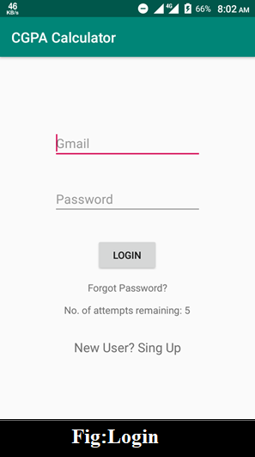 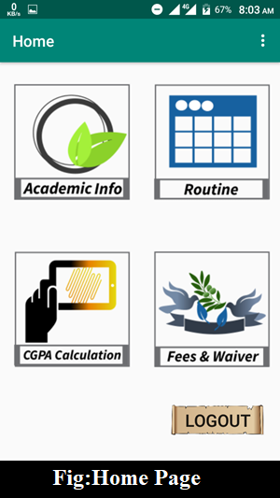

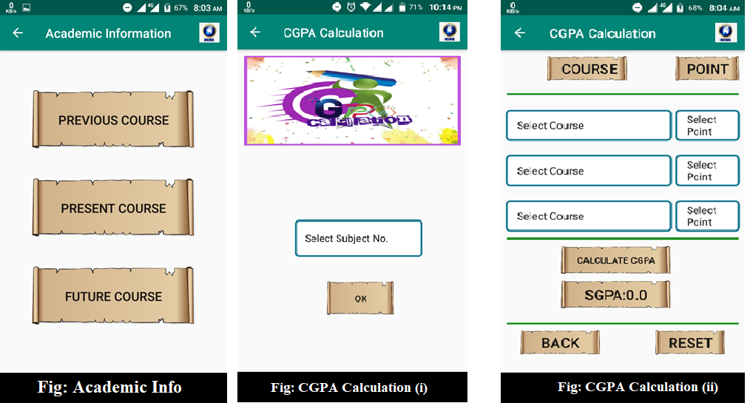

**4.2.2 Database Front End Design**

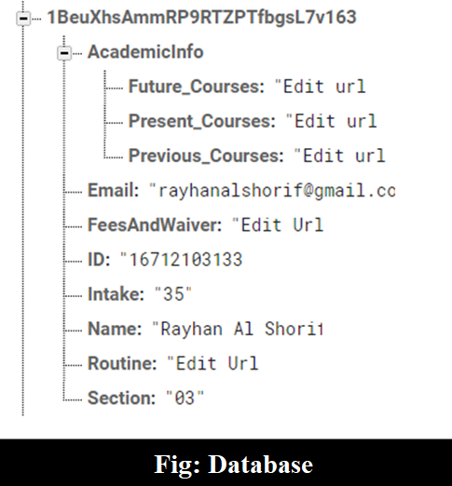

**5. System Testing and Analysis**

**5.1 Cyclomatic Complexity (CC):**

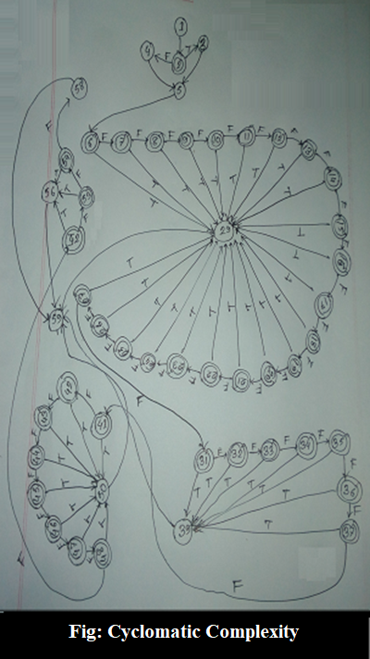

**CC = 41+1=42**

**5.2 Feasibility Analysis:**

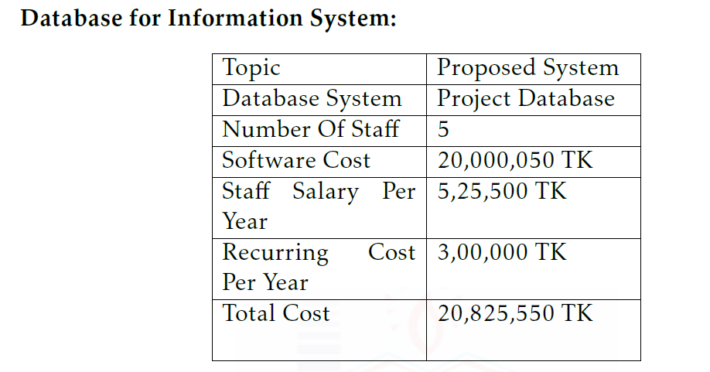

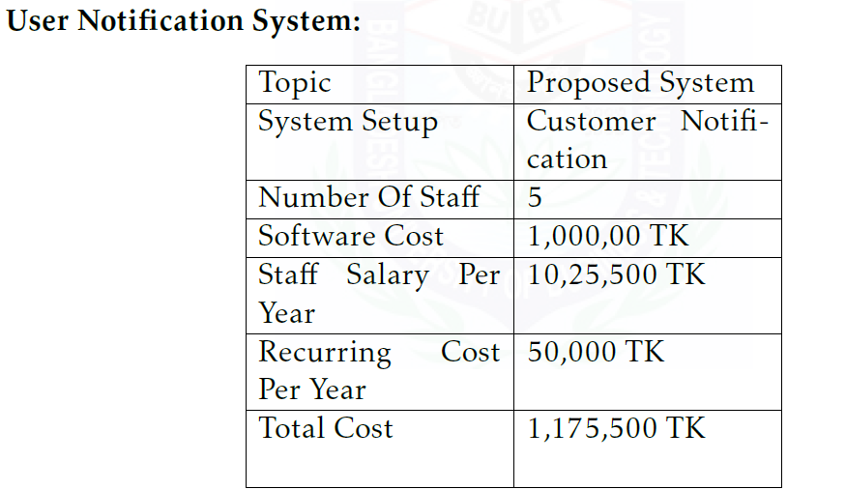

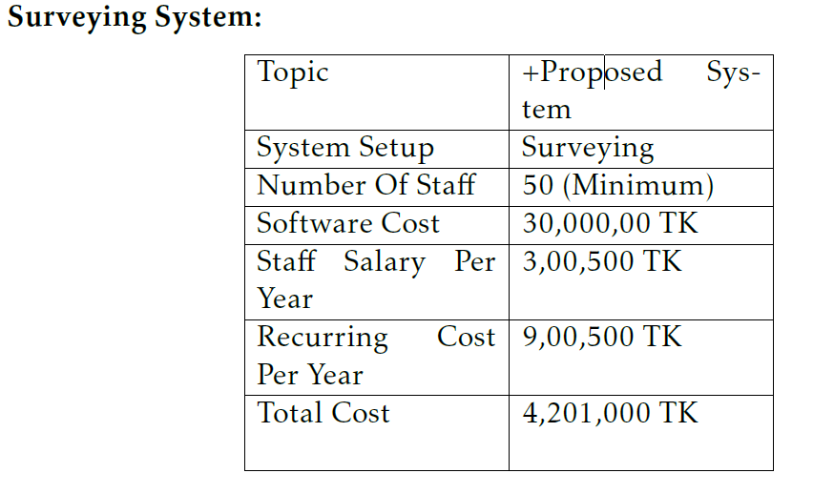

Initial cost of Project Database =20,825,550 Tk.

Cost of notification system = 1,175,500 Tk

Cost of Surveying system = 4,201,000 Tk

Total Cost = 26,202,050 Tk.

Total Income =3,00,00,000 Tk.

Total Benefit = (3,00,00,000-26,202,050) = 3,797,950 Tk./Year

Payback Period = 26,202,050 / 3,797,950 year =6 years & 9 months

**CHAPTER-6: LIMITATION, CONCLUSION and Future Scope**

**6.1 Limitation:**

* No option to search courses.
* Firebase database has not support query language.

**6.2 Conclusion:**

As we developed our application in android studio so we say that, android studio is a popular computing platform based on the Linux® operating system. The initial commercial version of Android hit the market in 2008 in the form of a mobile phone platform, back when the most popular cell phone for a business user was the BlackBerry, when the iPhone was beginning to make meaningful waves across all sectors, and when the majority of phone users were still tapping out texts from a flip phone.

**6.3 Future Scope:**

BUBT Annex (**A** **N**ew **N**exus of **Ex**cellence) shortly known as BUBT-NX is an online portal for the students and teachers of BUBT. It is a one stop web portal service where ongoing / running students can get their academic information from anywhere. At present it is in beta version and the stable version will be released very soon.

Reference

* <https://developer.android.com/guide/background#challenges_in_background_processing>
* <https://www.annex.bubt.edu.bd/?daikonPage=62b38fac0c40012de8b0e>