**FINAL REPORT**

**SERVER SIDE INTERNET PROGRAMMING**



**BY:**

**RAYHAN RIFQI ALDINOVANDI (001202100010)**

**MIKHAEL GLANN BATUBARA (001202100173)**

**ADNAN FATHURIZKY (001202100143)**

**PRESIDENT UNIVERSITY**

**2022**

**TABLE OF CONTENT**

**Chapter 1 Introduction**

* 1. Description
  2. Purpose

**Chapter 2 Process**

2.1System Analysis and Design   
2.2 Project Overview

**Chapter 3 Result**

3.1 User Registration

3.2 User Log in

3.3 PDF to PNG file conversion

3.4 PNG to PDF file conversion

3.5 PNG to SVG file conversion

**Chapter 4 Lesson Learned During The Progress  
Chapter 5 References**

**CHAPTER 1**

* 1. Introduction

‘File.Conv’ is a simple web application that converts a file from one format to another. This web application was created as a requirement to pass our Server Side Internet Programming subject.

* 1. Description

File conversion is the process of taking a file of one format and changing it into another. This is especially handy since you may one day work with files that are not compatible with the different programs you need to use.

File.Conv is a web application that we have created which makes file conversion easier. This web application boast several options for file conversion such as PNG to SVG, PNG to PDF, PDF to PNG, and DOCX to PDF. Let’s say, you run into a situation where you need to turn your PNG file into an SVG file for use in softwares such as Blender. You can use this web app to convert your PNG file into SVG format and then download the result for later use.

**CHAPTER 2**

2.1 Tool Used

* Composer

Composer is a dependecy manager for php that provides a standard format for managing dependencies of PHP software and required libraries.

* convertAPI

convertApi is a file conversion API that features mutiple filetype conversion.

2.2 Project Overview

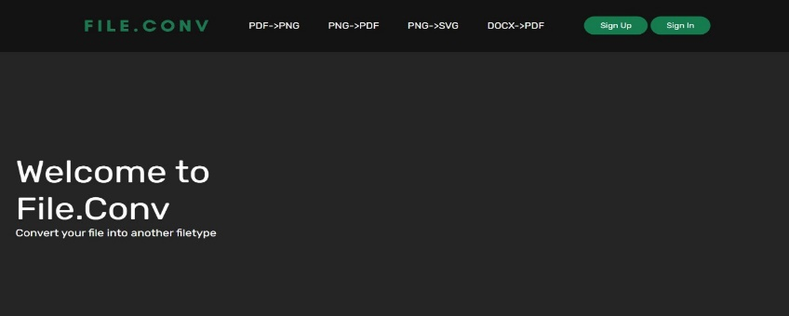

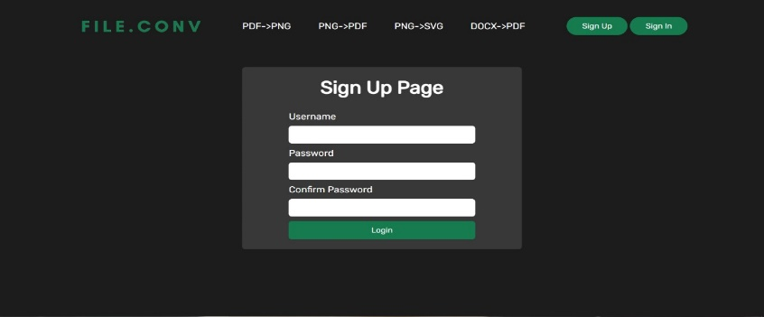

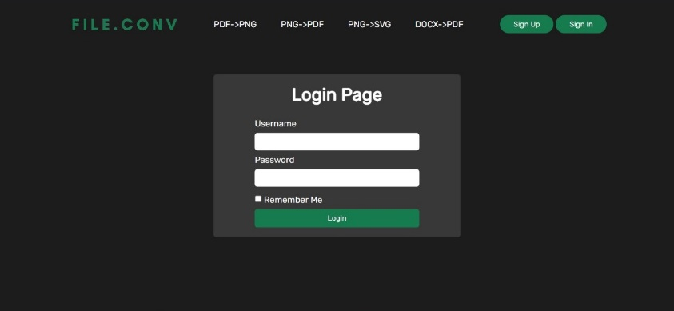

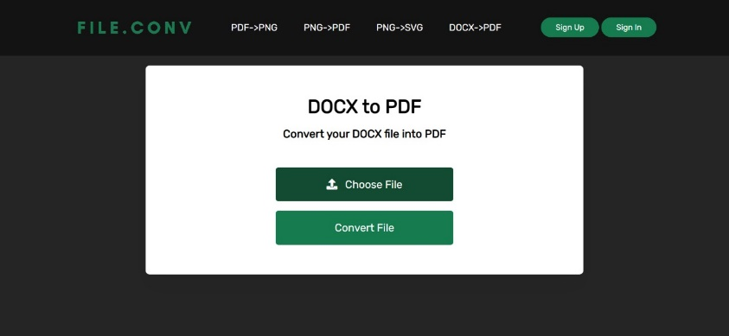

**CHAPTER 3**

3.1 Tutorial For The Web

In this section we will explain the steps, so that users can run our project in their own browser.

First the user must visit to our website, after that they will see the homepage like this.

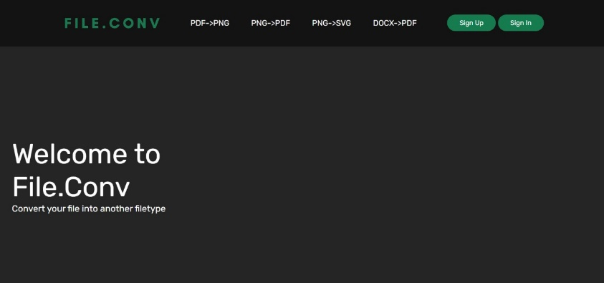

Then the user will be directed to the Sign up page if not registered.

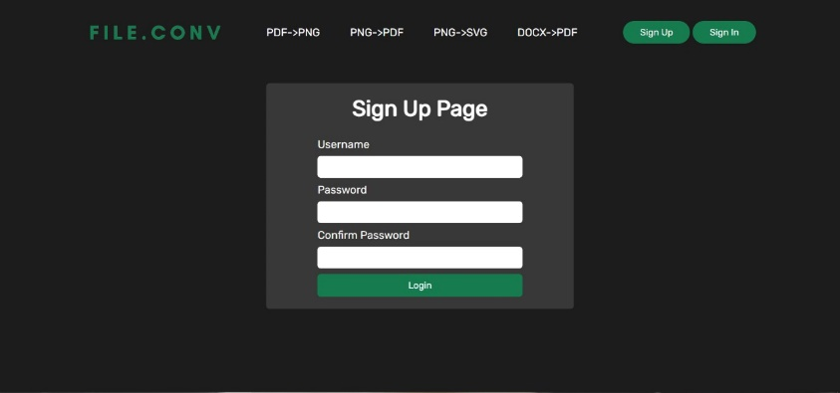

If the user has previously signed up, they can go directly to the Log in page.



After users sign up or log in, they will be able to choose which files will go to the website homepage and they can choose which files they will convert. *Let say Docx to PDF*



**CHAPTER 4**

4.1 Lesson Learn During The Progress

The lesson that we took in this course and final assignment is, we are given the opportunity to be able to freely interpret ideas, judgments, and be creative as we want but still have to comply with the conditions that have been set. then Train us in making hypotheses when we are faced with a problem solving such as a bug or error.

4.2 References

File Input Button With Image Preview & File Name  
(<https://www.youtube.com/watch?v=KgqV0i_ZgLs&t=1s>)

Navbar CSS Tutorial: 3 Ways to Create a Navigation Bar with Flexbox  
(<https://www.youtube.com/watch?v=PwWHL3RyQgk>)

PDF to Image Converter using PHP • Convert PDF to PNG file  
(<https://www.youtube.com/watch?v=I1wgWxyKmp8&t=1117s>)

convertAPI  
(<https://www.convertapi.com/>)

github  
(<https://github.com/ConvertAPI/convertapi-php>)