* The first argument is a 1D row array of resistance values and the second argument is a string defining whether the circuit is 'series' or 'parallel'. Your task is to estimate the equivalent resistance for the series/parallel circuit. The equation for equivalent resistance is:

1) For Series circuit:

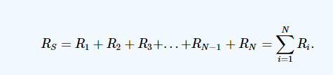

2) For Parallel circuit:

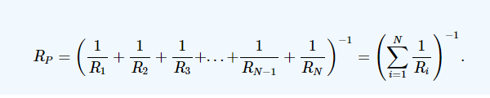

Sample Input-Output:

X = [1 2 4 5]

Y= ‘series’

r_eq = 12