IOT Enabled Tank Monitoring System
By-Rayid Mohammed Afzal, Date-20-03-2026
Saintgits College of Engineering

About the project-
This project is a full-stack IoT-based Water Tank Monitoring System designed to collect, process, and display sensor data through a modern web dashboard. It uses a React-based frontend and a FastAPI backend to provide real-time monitoring of important parameters such as water level and temperature. The system also supports tank and node management, presents model and prediction-related information, and offers an interactive user interface with responsive charts, multiple routed pages, and dark/light theme support. For accessibility and public availability, the backend is deployed on Render and the frontend is hosted on Vercel.

Features Implemented-
- Interactive dashboard for monitoring water level and temperature
- Tank/node selection with live data display
- Water level and temperature charts using Recharts
- Node/Tank creation and management interface
- Prediction page with model information and prediction-related visual components
- Additional analytics widgets such as prediction distribution, activity timeline, real-time prediction, and confidence gauge
- Dark mode / light mode toggle
- Responsive UI with sidebar navigation and improved styling
- College branding integration with logo and theme customization
- Backend API integration using FastAPI
- Deployed backend on Render and frontend on Vercel

API Endpoints Added-
Three additional API endpoints were integrated into the backend to support prediction and monitoring features.

- The POST /api/v1/predict endpoint takes sensor inputs such as distance and temperature, processes them through the machine learning model, and returns a predicted water activity along with a confidence value. If a trained model is not available, the system automatically switches to a mock prediction mechanism to ensure continuity.

- The GET /api/v1/model-info endpoint provides detailed information about the currently deployed model. This includes the model architecture (KNN), version details, achieved accuracy, the most recent training date, and the set of activity classes the model is capable of predicting.

- The GET /api/v1/predictions-history endpoint is used to access previously generated predictions stored in the database. Each record contains the timestamp, input sensor readings, predicted activity, and the associated confidence score. To support this functionality, a dedicated predictions table was introduced in the PostgreSQL database to maintain a complete log of prediction history.

Frontend Enhancements-
Several new features were introduced on the frontend to improve usability and visual consistency.

- College Branding – The Saintgits College of Engineering logo was integrated into the navigation bar to reflect institutional identity. The overall color scheme was also refined to align with college branding, featuring a gradient transition from red (#C8102E) to blue (#003DA5). CSS variables were implemented to maintain a consistent theme across the entire application.
- Prediction Interface – A dedicated page was developed at /prediction, enabling users to enter sensor inputs such as distance and temperature. This page interacts with the prediction API and displays the resulting water activity along with its confidence score in real time, providing immediate feedback.
- Data Visualization – To enhance interpretability, two custom chart components were added to the Prediction page. A pie chart illustrates the distribution of predicted activities over a period of time, while a bar chart highlights recent prediction confidence levels for quick comparison.
- Sidebar Navigation Update – The sidebar was updated with a new Prediction section, complete with an icon, allowing users to quickly access the prediction page without disrupting their workflow.
- Theme Switch - Easily toggle between light mode and darkmode.

Screenshots-
Database Connection Succesful –

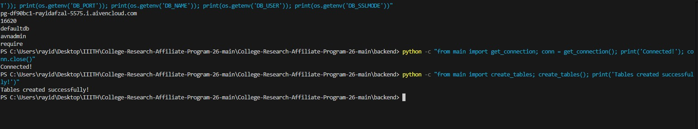

Working API’s –

Model Info API-
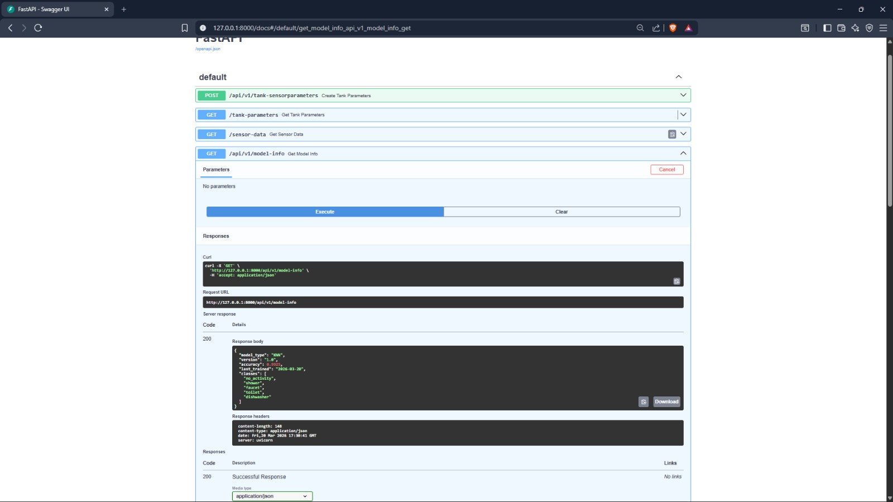

Prediction API-
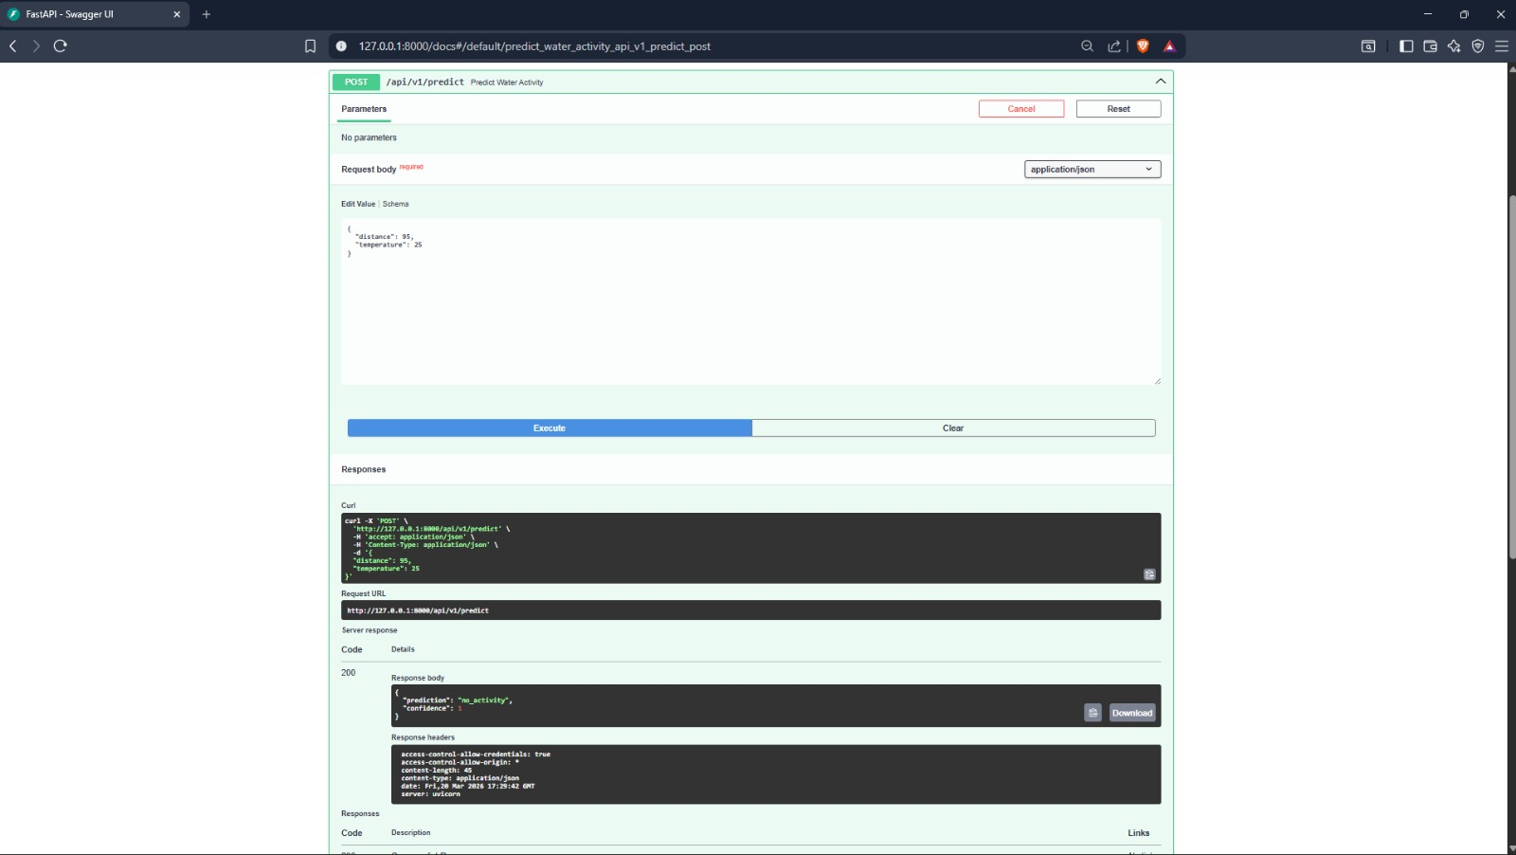

ML Model Code Snippets –

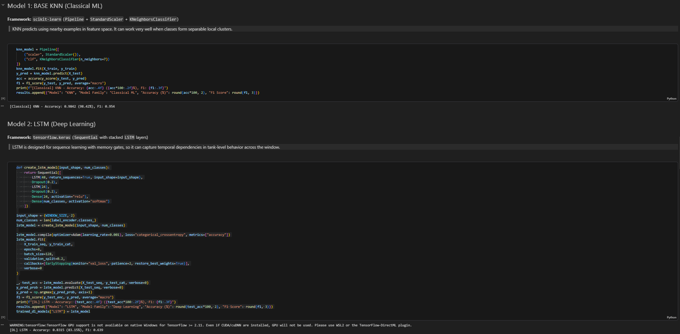

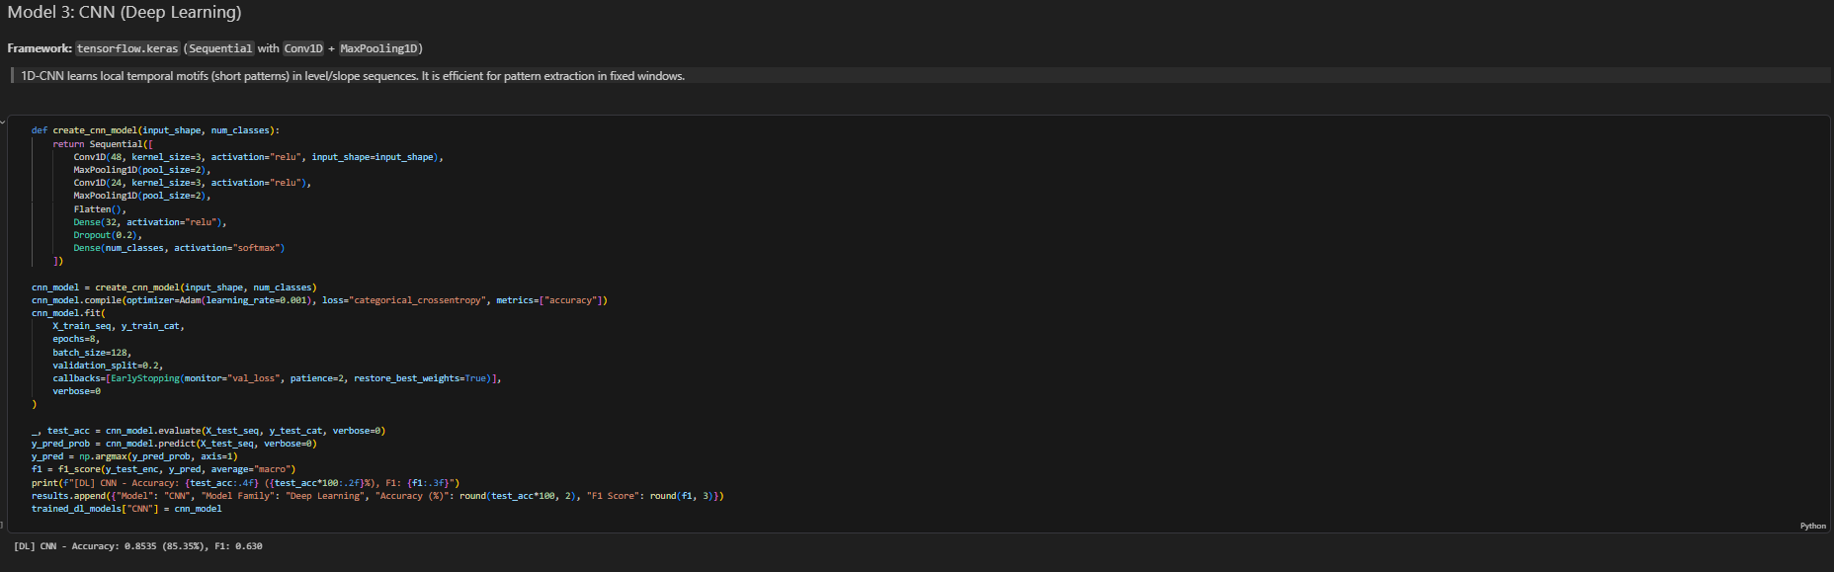

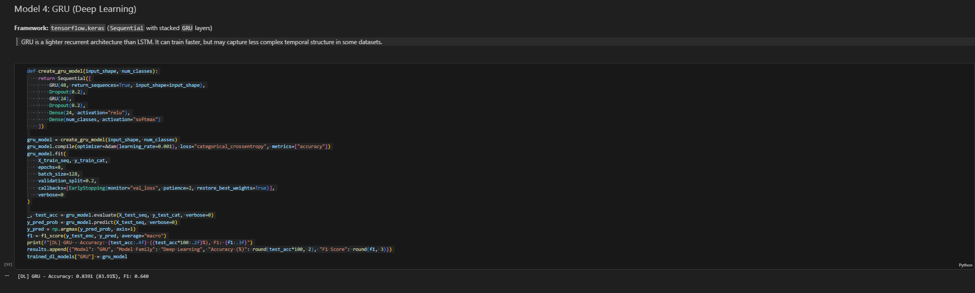

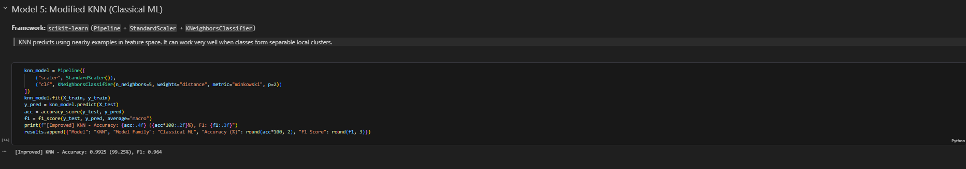

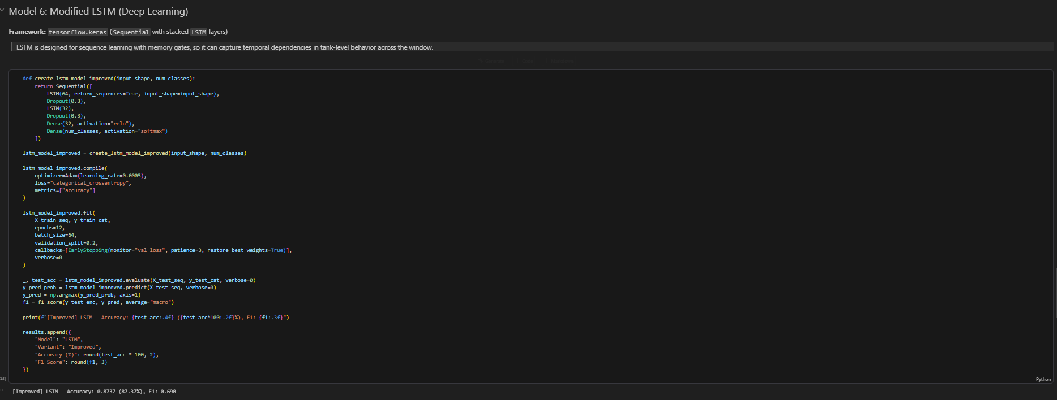

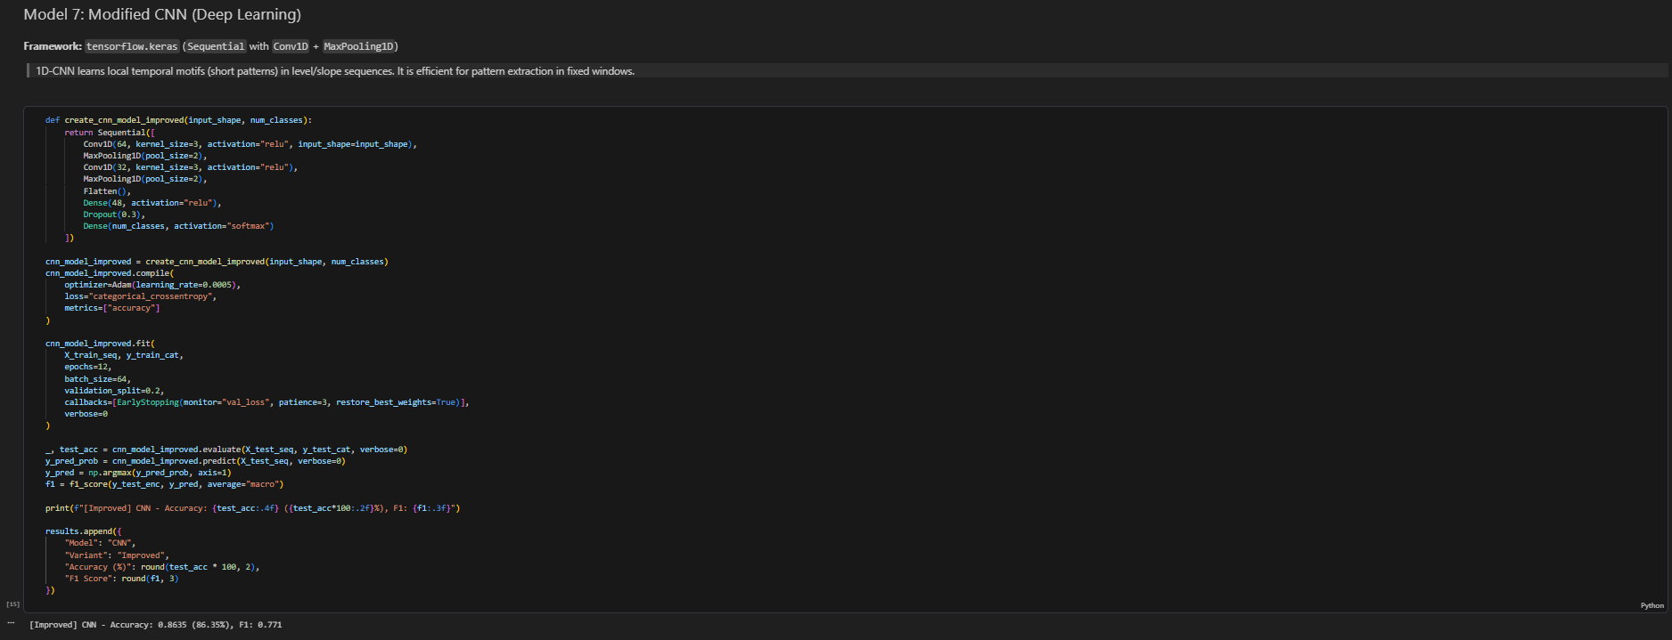

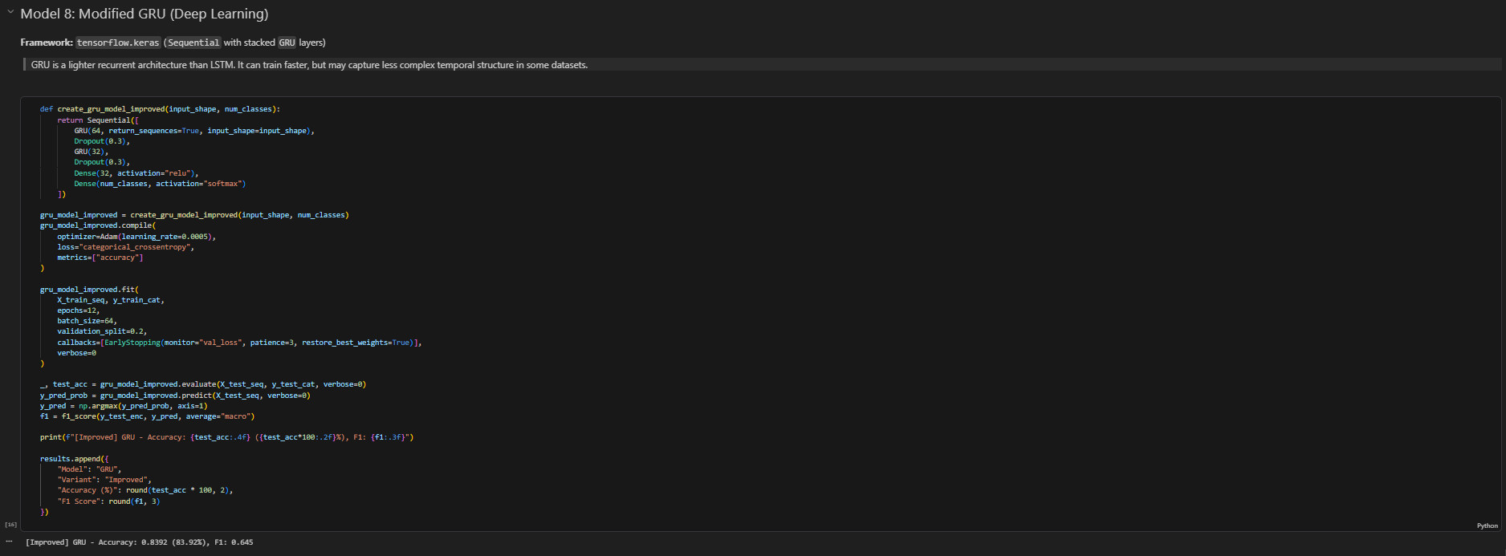

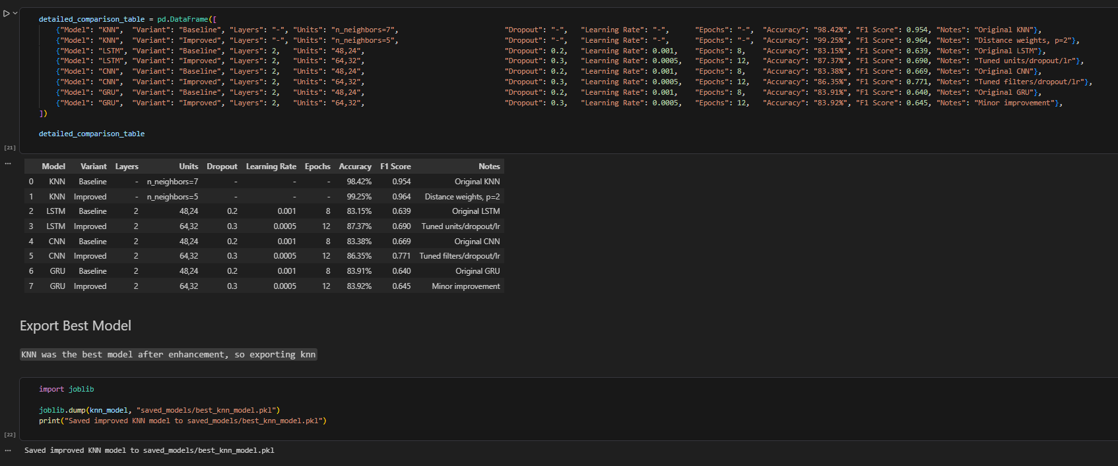

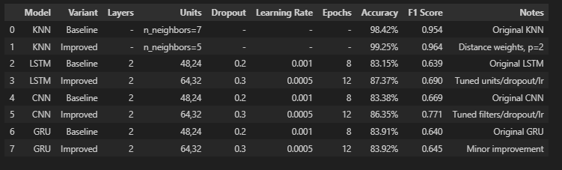

Dashboard Enhancements –
Dashboard with college logo
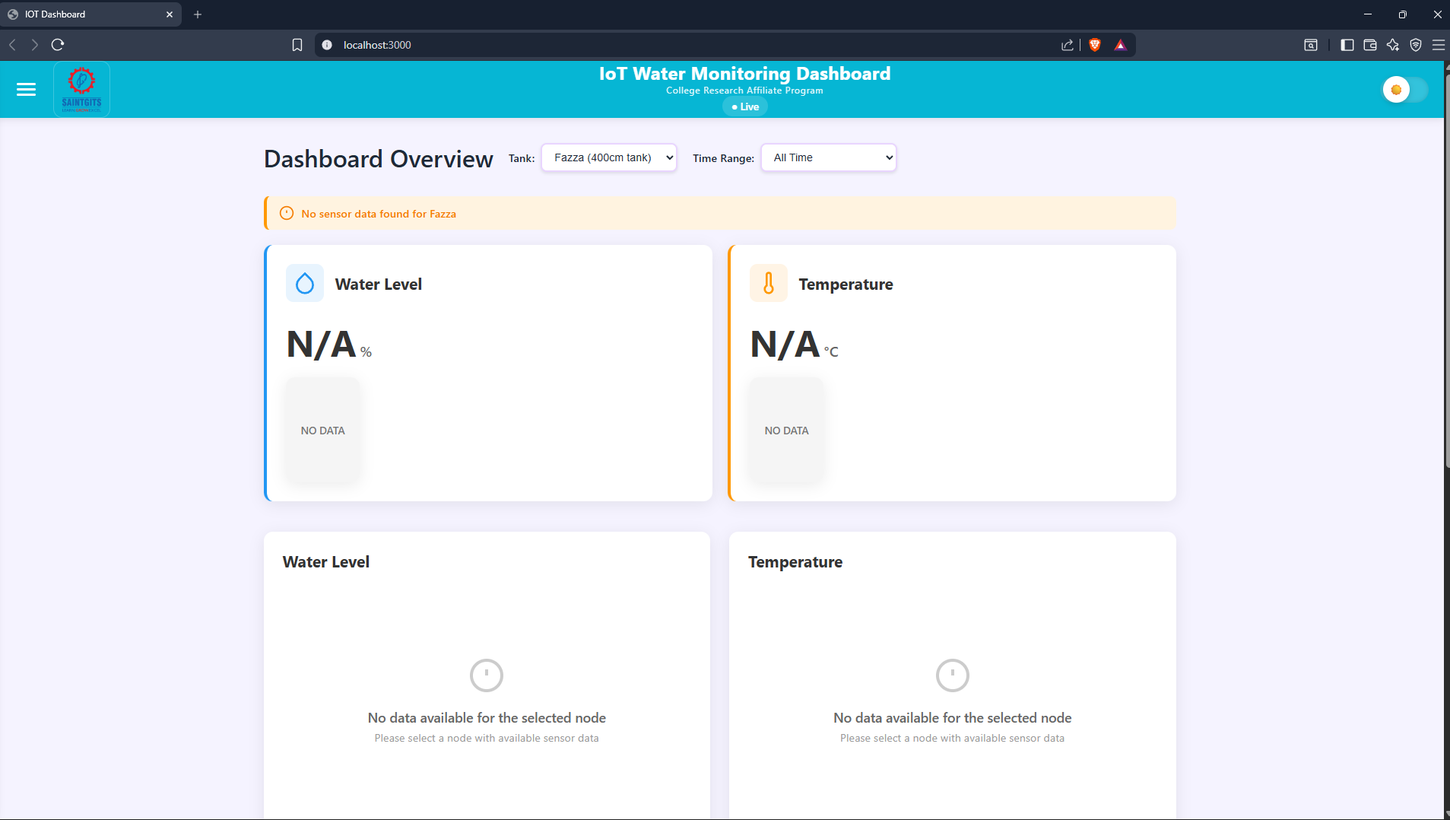
New Custom Charts
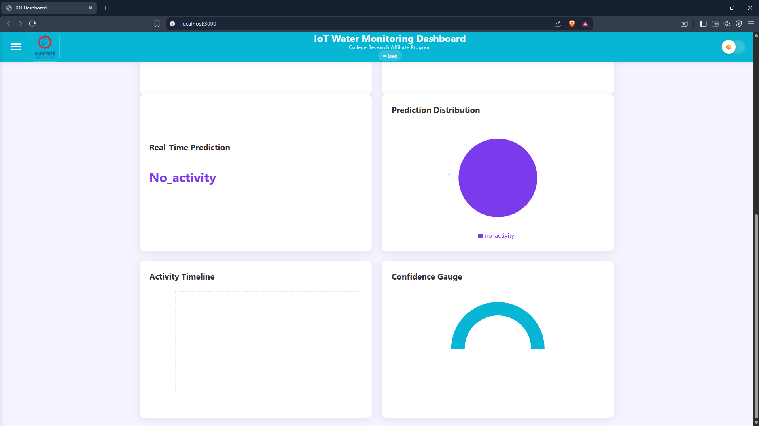

Predictions Page
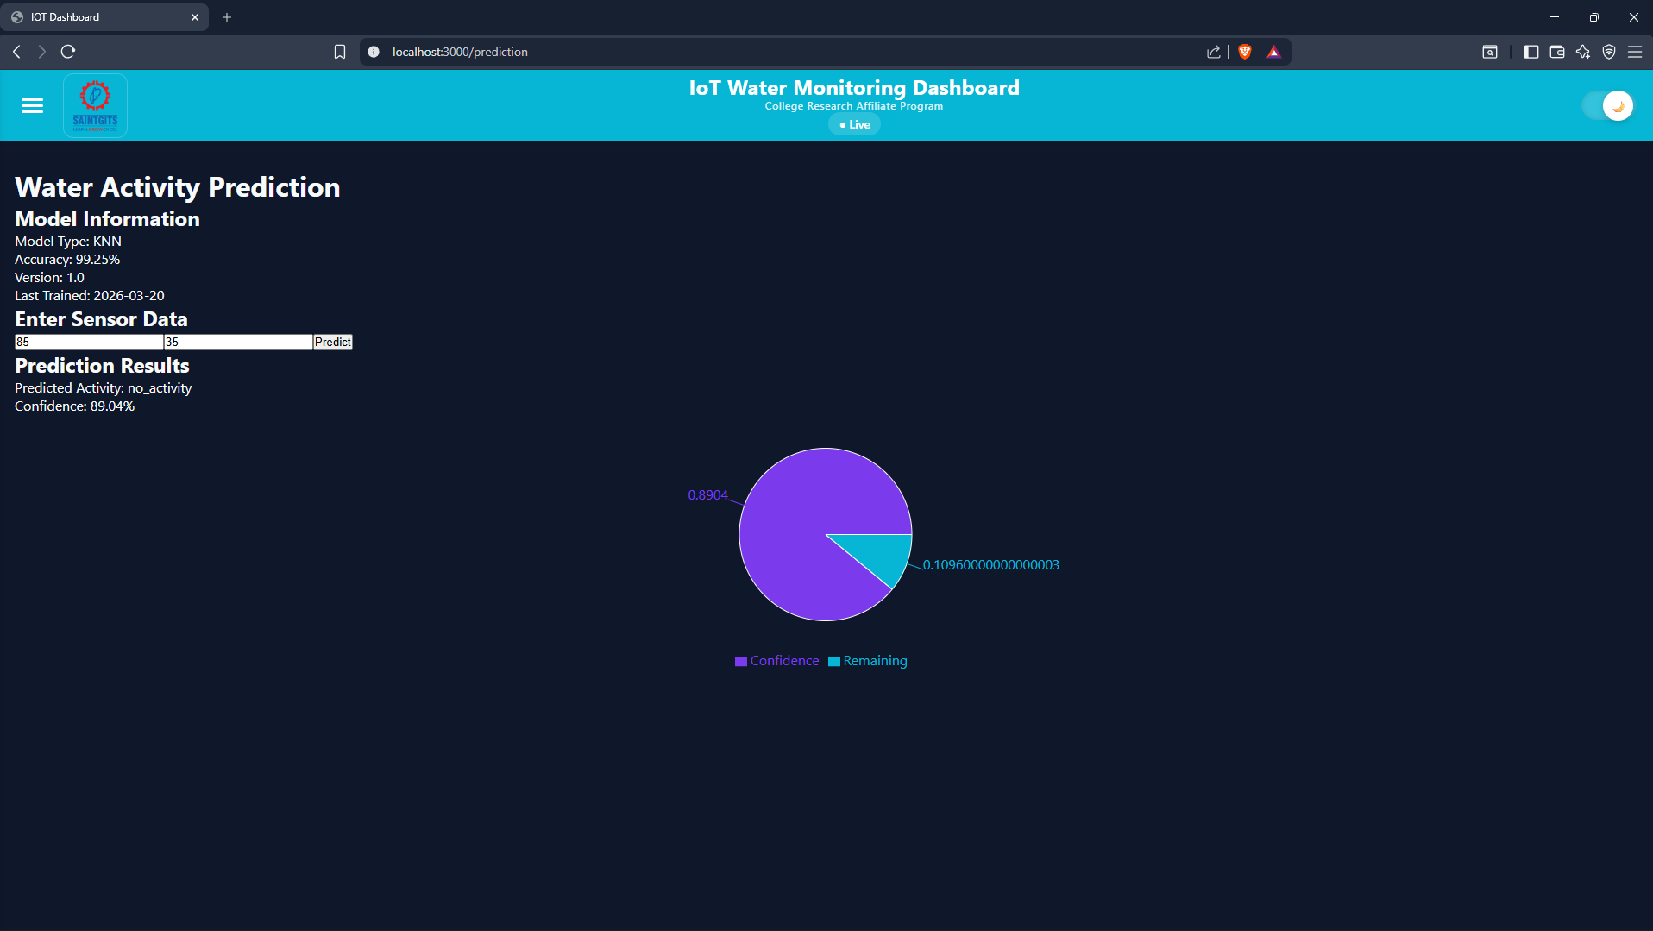

Cloud Deployment-

Deployed Frontend URL –
https://iot-water-tank-monitoring-system-five.vercel.app
Deployed Backend URL-
https://water-monitor-backend.onrender.com/docs

