**DETECTIVE SQL**

There was crime at SQL City. The crime happened on the 15th of January 2018 at The Funky Grooves Tour event.

Someone was murdered and it was my job as the data analyst detective to find who committed the crime.

**This is how I uncovered the murder mystery.**

Case study:

“*A crime has taken place and the detective needs your help. The detective gave you the crime scene report, but you somehow lost it. You vaguely remember that the crime was a murder that occurred sometime on Jan.15, 2018 and that it took place in SQL City. Start by retrieving the corresponding crime scene report from the police department’s database*.”

The Entity Relationship Diagram below is provided to solve the mystery.

Some key points to note from the case study

* The Crime - Murder
* Date - Jan 15, 2018
* Location - SQL City

I started my analysis by checking the crime scene report using the key points above and I used the code below.

This helped me obtain some insights from the description column.

The description says:

“*Security footage shows that there were 2 witnesses. The first witness lives at the last house on "Northwestern Dr". The second witness, named Annabel, lives somewhere on "Franklin Ave".”*

I now had a direction to follow for my investigation. I went to the person, driver's license, income, and get fit now membership table to get further information about the two witnesses.

I used the codes below to get the details

I checked for more details about them

After learning more details about the witnesses. On the day of the crime, January 15, 2018, I made the decision to see whether any of the witnesses had attended a Facebook event. I also wanted to know what the event's name was.

I made the decision to also see if my witnesses had been interviewed, and if so, to read the transcript.

To obtain the data I required, I used the SQL query below.

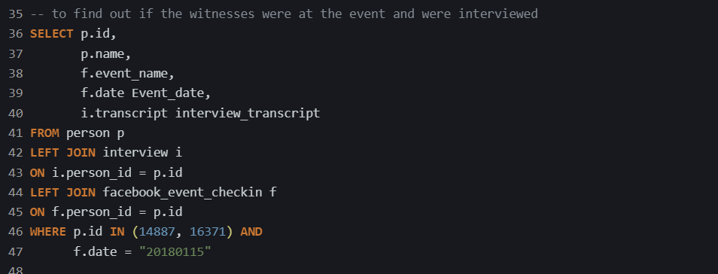

I discovered that the event name is “The Funky Grooves Tour” and this event also happened on the 15th of January 2018.

I took note of their statement of transcript for their interview.

**Witness 1 statement**:

“*I heard a gunshot and then saw a man run out. He had a "Get Fit Now Gym" bag. The membership number on the bag started with "48Z". Only gold members have those bags. The man got into a car with a plate that included "H42W".”*

**Witness 2 statement:**

*“I saw the murder happen, and I recognized the killer from my gym when I was working out last week on January the 9th.”*

I began looking for the people who matched the description given by the first witness. I included everything in my SQL query.

Below is the query that was used.

The result from this query gave me just one person, His information is found below



Perhaps it is safe to presume that he is the murderer. I need to confirm if this account corresponds with that of the second witness.

The second witness stated that she encountered him on January 9, 2018, while she was at the gym. Let's find out if he was there with her at that moment.

I used the code below:

The results of this query confirms that he was there at that time with her.

I checked if he was at “The Funky Grooves Tour” on the 15th of January 2018.

I used the query below to check for that.

I needed to get more details on the murderer, and I used the script below

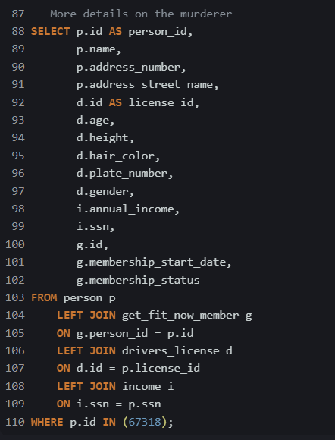

That completes the case study solution I came up with.

On checking if the murderer was interviewed, I discovered he made a statement.

SQL script:



Murderer’s statement:

“*I was hired by a woman with a lot of money. I don't know her name but I know she's around 5'5" (65") or 5'7" (67"). She has red hair and she drives a Tesla Model S. I know that she attended the SQL Symphony Concert 3 times in December 2017.*”

Let’s find who the woman is with the description above

I used the code below

In light of the investigation, the following responses were discovered;

The Murderer - **Jeremy Bowers**

Hired by - **Miranda Priestly**