By clicking the radio button below you attest that you have completed watching the video or document.

 I have reviewed the document

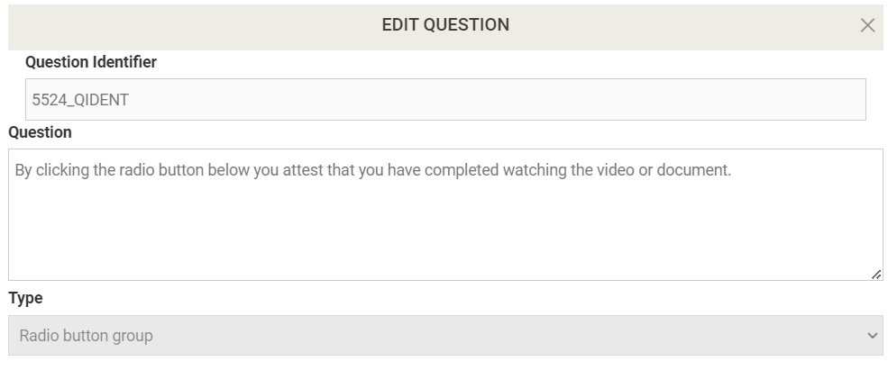

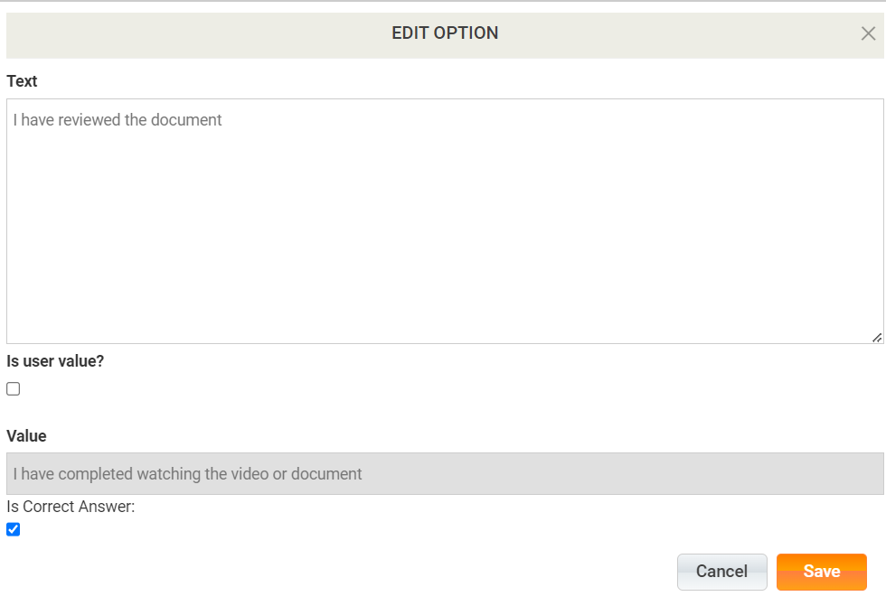

According to Davam's Patient's Rights portion of the policy, which of the following is NOT included?

 The right to complain about care they have received

 The right to outside legal council of their choice, at the expense of Davam Urgent Care

 The right to an interpreter

 The right to contact the Joint Commission

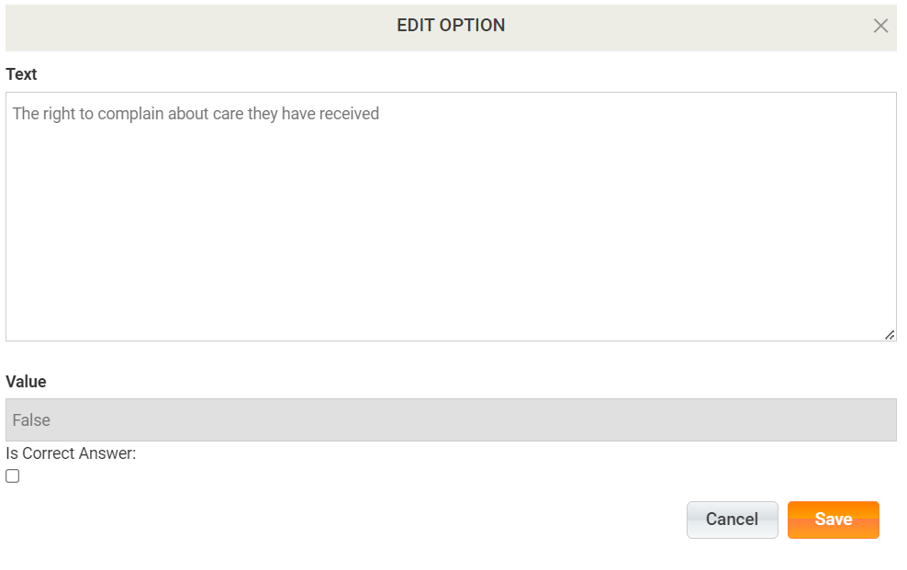

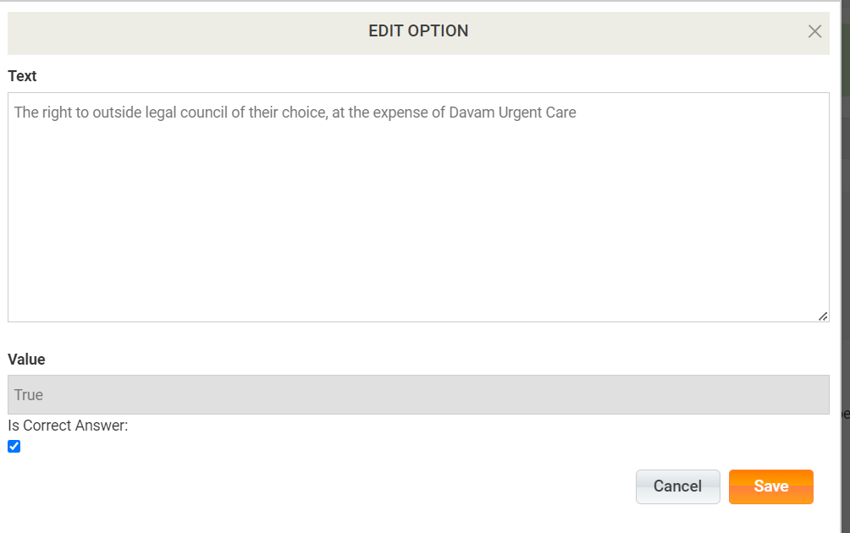

Do all patients need to be told who to call in case of an emergency after hours?

 Yes

 No

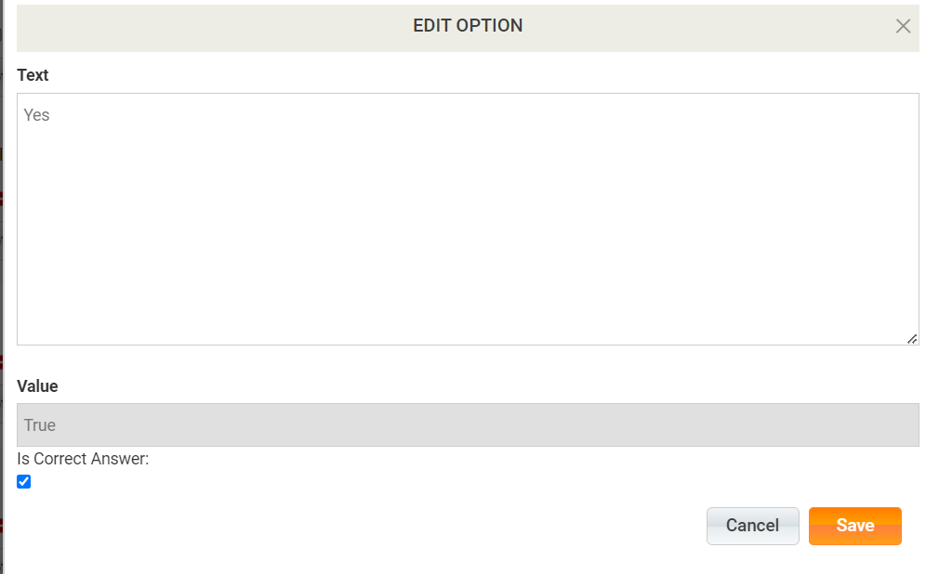-  
Who is responsible for making sure the patient understands the information he/she has been given during their visit?

 The Provider

 The Patient

 The Clinical staff during discharge

 The front desk staff during check out

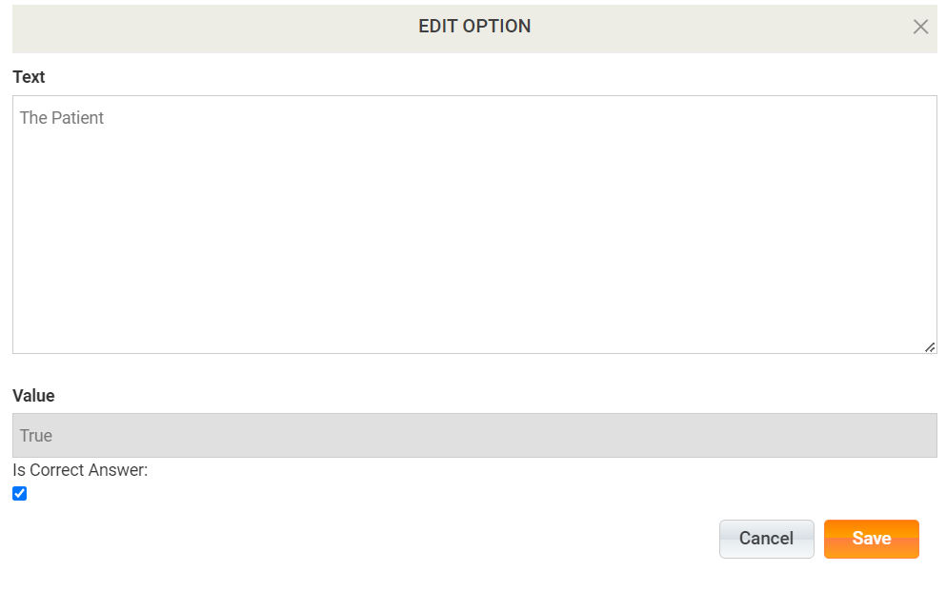

Who reviews and assesses the situation when there is a complaint about a licensed medical provider?

 The Joint Commission

 The Medical Director

 The HR department

 The Texas Medical Board

