1.
TEMP: WORD 0
a: WORD 5; “5”是測試的數字
b: WORD 7; “7”是測試的數字
START: b, TEMP, NEXT;
NEXT: TEMP, a, END;
END

2.
TEMP: WORD 0
TIME: WORD 0
a: WORD 3
b: WORD 8
c: WORD 0
one: WORD 1
START: a, TEMP, STEP1
STEP1: TEMP, TIME STEP2
STEP2: one, TIME, LOOP1
LOOP1: TEMP, TEMP, LOOP2
LOOP2: b, TEMP, LOOP3
LOOP3: TEMP, c, LOOP4
LOOP4: one, TIME, END
STEP3: TEMP, TEMP, STEP4
STEP4: one, TEMP, LOOP1
END

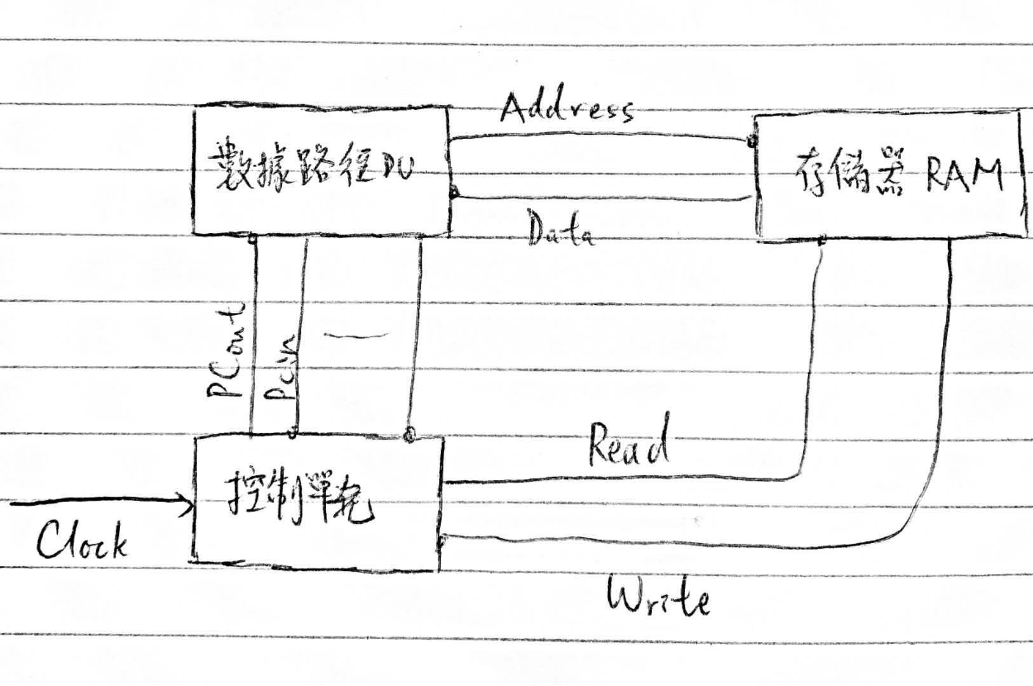
3.

