1.
C++ code:

#include<iostream>
using namespace std;

unsigned int choosing(unsigned n, unsigned int k) {
if (k > n || k < 0) return 0;
else if (k == n || k == 0) return 1;
else if (n > 1) return choosing(n - 1, k - 1) + choosing(n - 1, k);
}
int main() {
unsigned int n = 10;
int** pas_tri = new int* [n];
for (unsigned int i = 0; i < n; i++) pas_tri[i] = new int[2 * n - 1];
for (unsigned int i = 0; i < n; i++) {
for (unsigned int j = 0; j < 2 * n - 1; j++) {
if ((i + j) % 2 == 1) pas_tri[i][j] = 0;
else pas_tri[i][j] = choosing(n - 1 - i, (j - i) / 2); }
}
for (unsigned int i = 0; i < n; i++) {
for (unsigned int j = 0; j < 2 * n - 1; j++) {
if (pas_tri[n - 1 - i][j] > 0) cout << pas_tri[n - 1 - i][j];
else if (pas_tri[n - 1 - i][j] == 0) cout << " ";
cout << "\t";
}
cout << endl;
}
delete[]pas_tri;
return 0;
}

思路分析﹕

unsigned int choosing(unsigned n, unsigned int k) {
if (k > n || k < 0) return 0;
else if (k == n || k == 0) return 1;
else if (n > 1) return choosing(n - 1, k - 1) + choosing(n - 1, k);
}
子函数choosing是数学上的$C_{n}^{k}$函数。利用恒等式$C_{n}^{k}=C_{n-1}^{k}+C_{n-1}^{k-1}$来构造递归子函数。

for (unsigned int i = 0; i < n; i++) {
for (unsigned int j = 0; j < 2 * n - 1; j++) {
if ((i + j) % 2 == 1) pas_tri[i][j] = 0;
else pas_tri[i][j] = choosing(n - 1 - i, (j - i) / 2);
}
}
为了避开输出时的空格问题，我决定在为二维数组赋初值时，是赋杨晖倒三角形，并且在同一行的两个数之间，用数字0作为标记。

for (unsigned int i = 0; i < n; i++) {
for (unsigned int j = 0; j < 2 * n - 1; j++) {
if (pas_tri[n - 1 - i][j] > 0) cout << pas_tri[n - 1 - i][j];
else if (pas_tri[n - 1 - i][j] == 0) cout << " ";
cout << "\t";
}
cout << endl;
}
输出时，我们由二维数列的最后一行依次输出，遇到标记0时便输出空格。

运行结果﹕
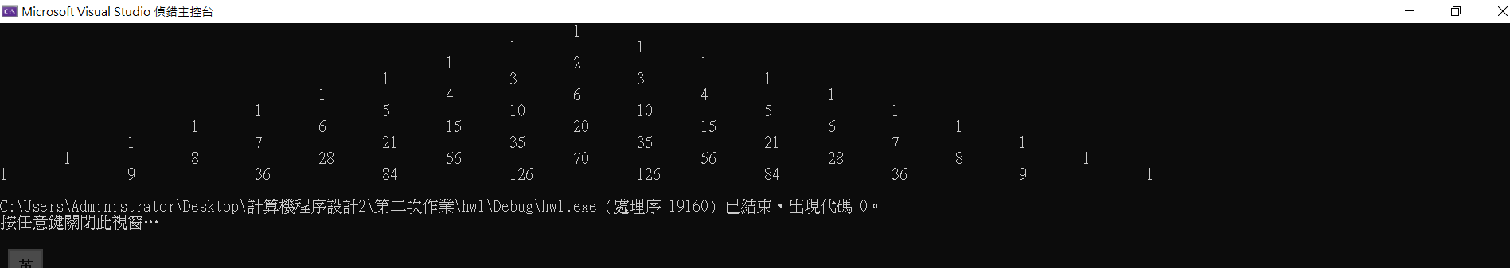
2.
C++ code:
#include<iostream>
using namespace std;

#define m_c 8
#define n_c 5
int main() {
int* a = new int[100], (*b)[25] = new int[20][25], *** c = new int **[9] , **d, s(0);
int m, n;
cin >> m >> n;
for (int i = 0; i < 9; i++) {
c[i] = new int* [m_c];
for (int j = 0; j < m_c; j++)
c[i][j] = new int[n_c];
}
d = new int* [m];
for (int i = 0; i < m; i++)
d[i] = new int [n];

for (int i = 0; i < 100; i++) { a[i] = i; s += a[i]; }
cout << "a数组的元素是" << s << endl;
s = 0;
for (int i = 0; i < 20; i++) {
for (int j = 0; j < 25; j++) {
b[i][j] = i * 25 + j;
s += b[i][j];
}
}
cout << "b数组的元素是" << s << endl;
s = 0;
for (int i = 0; i < 9; i++) {
for (int j = 0; j < m_c; j++) {
for (int k = 0; k < n_c; k++) {
c[i][j][k] = i * 100 + j * 10 + k;
s += c[i][j][k];
}
}
}
cout << "c数组的元素是" << s << endl;
s = 0;
for (int i = 0; i < m; i++) {
for (int j = 0; j < n; j++) {
d[i][j] = i * n + j;
s += d[i][j];
}
}
cout << "d数组的元素是" << s << endl;
s = 0;
delete[]d;
delete[]c;
delete[]b;
delete []a;
return 0;
}
思路分析﹕略。因为这道题太简单
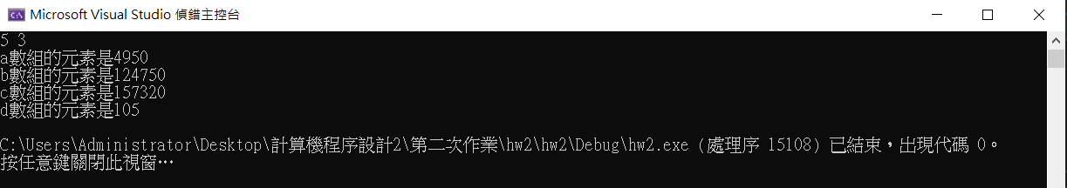
运行结果﹕
3.
C++ code:
#include<iostream>
using namespace std;

#define n 5
#define lim 3

void choose(int num, int &time, int pos, bool* SET) {
const static char color[5][10] = {"red", "yellow", "blue", "white", "black"};
if (num > lim) {
for (int i = 0; i < n; i++) if (SET[i] == true) cout << color[i] << " ";
cout << endl;
time++;
}
else
{
for (int i = pos; i < n; i++)
if (SET[i] == false) {SET[i] = true; choose(num + 1, time, i, SET); SET[i] = false; }
}
}
int main() {
bool set[n] = { 0,0,0,0,0 };
int T = 0;
choose(1, T, 0, set);
cout << "总共" << T << "种选法" << endl;
return 0;
}

思路分析﹕

void choose(int num, int &time, int pos, bool* SET) {
const static char color[5][10] = {"red", "yellow", "blue", "white", "black"};
if (num > lim) {
for (int i = 0; i < n; i++) if (SET[i] == true) cout << color[i] << " ";
cout << endl;
time++;
}
else
{
for (int i = pos; i < n; i++)
if (SET[i] == false) {SET[i] = true; choose(num + 1, time, i, SET); SET[i] = false; }
}
}
这题典型的回溯法。当现在有n个球被选出来后，如果还没有达到规定的数目，则观察在这个球之后是否还存在未被选出的球。

运行结果﹕
