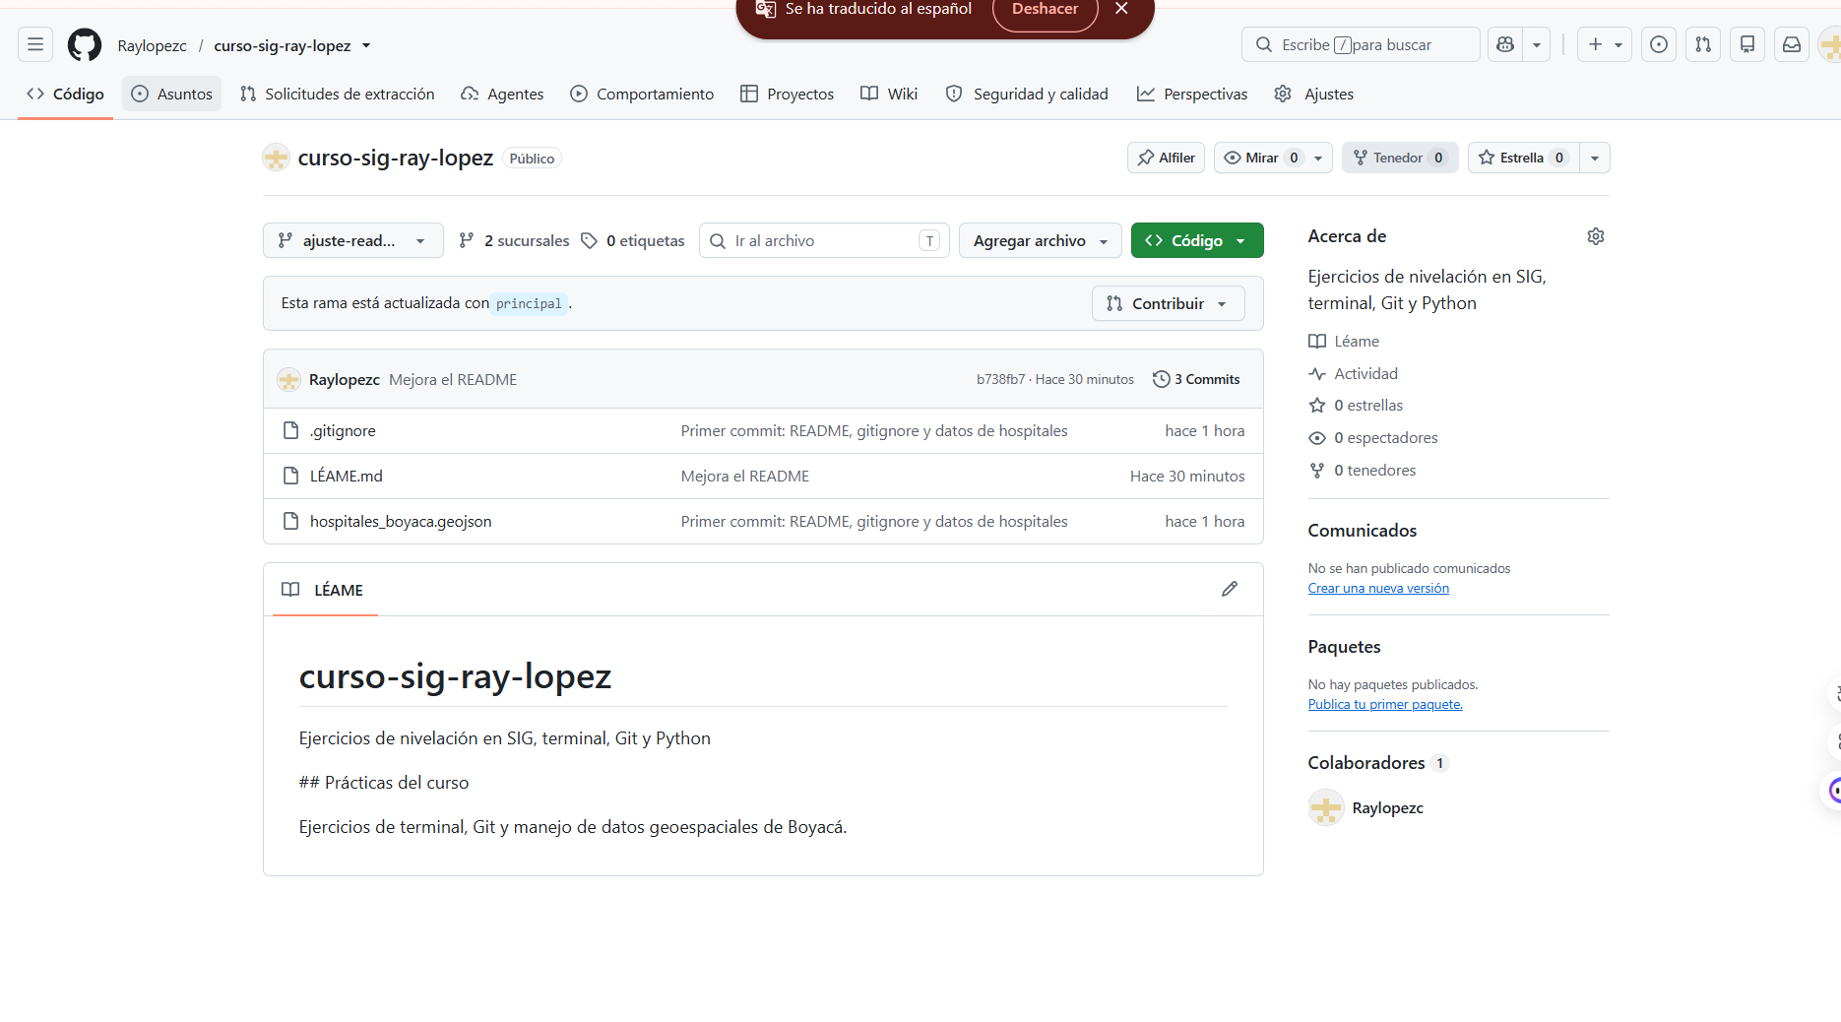
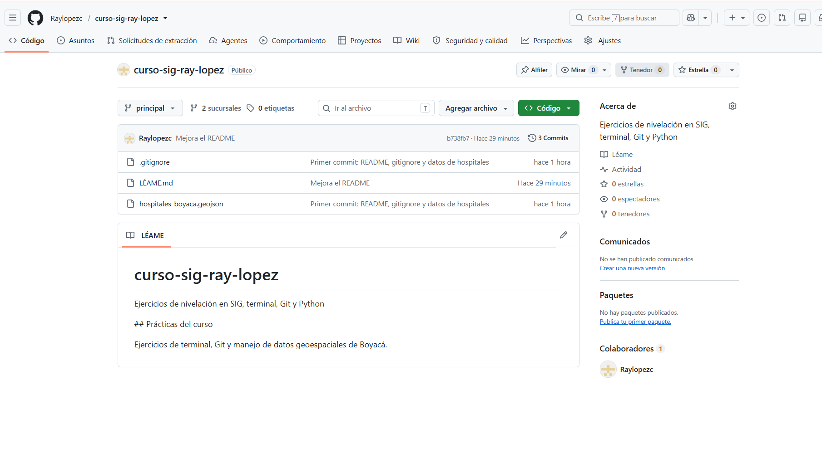
LINK: https://github.com/Raylopezc/curso-sig-ray-lopez/commits/ajuste-readme/
LINK: https://github.com/Raylopezc/curso-sig-ray-lopez?utm_source=chatgpt.com

