F1 2026

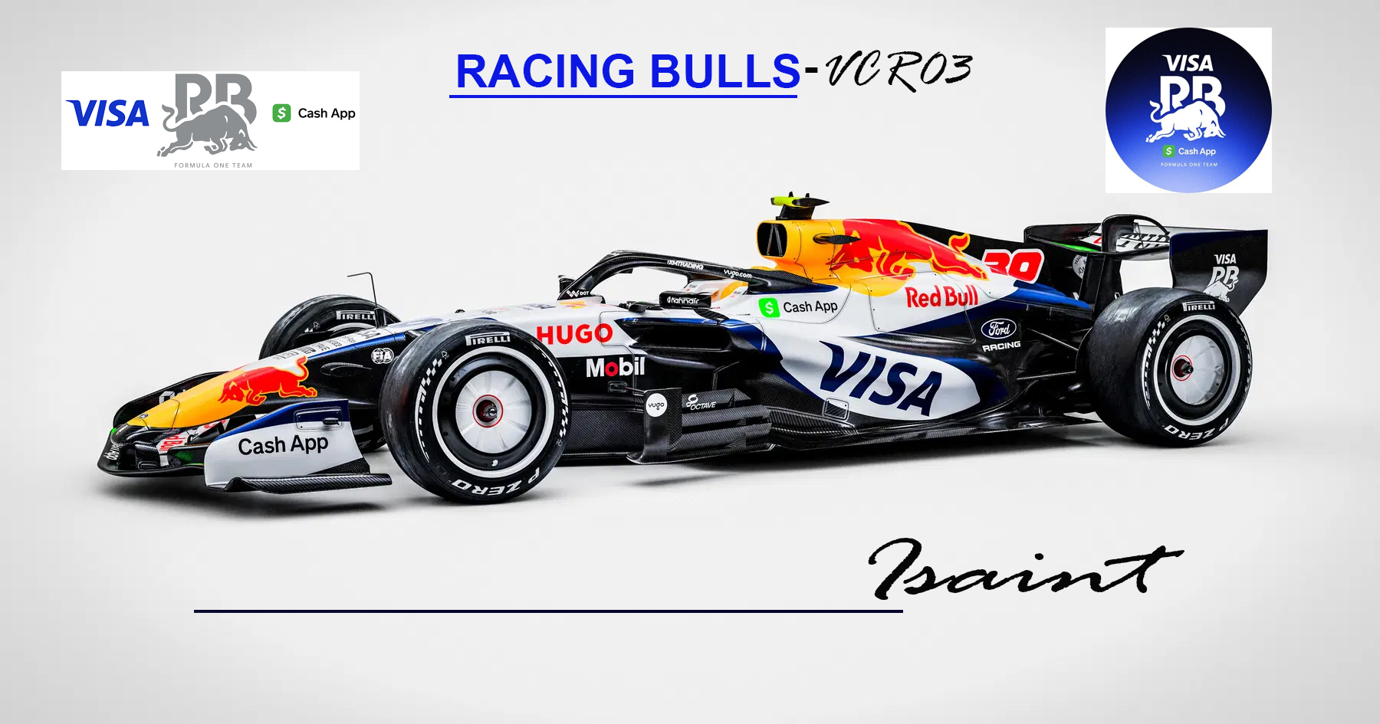

Date: April 2nd, 2026
__________________________________________________________________________
Author: Isaint
__________________________________________________________________________
Description:
RacingBulls VCR03- Launch Shape version:
This archive includes:
- 2 cars (lod_0 only)
- Livery: Current Season

__________________________________________________________________________
Build:
Softwares and tools used: Zmodeler 1.07b, Zmodeler 3,
Photoshop CS3, Photoshop CC2024, GP4Builder, Slimtex,.

________________________________________________________________________
Installation:
Copy the .tex files and the *.gp4 files into your cars.wad/cars/cars folder.
You can use wadupdater, wad installer, GP4master or any other editor you choose.
__________________________________________________________________________
Copyright / Permissions:
New Permission policy rules from the GP4 Community:
* FILE(S) that has been released in public by the author of the file gives automatic permission to use
his file in a mod, league, .... as long the file keep like it is and don't get
modified !!!! Credits for the file in a mod & league is a MUST !!!
* FILE(S) that has been released in public by the author but getting used as BASE or MODIFIED then
PERMISSION to use/release is still a MUST to ask cause you used the file to change/modify if not,
you are LEECHING !!!!
* FILE(S) that has been released in public by the author and getting SOLD on ebay or somewhere
else = STEALING !!!!!!!!
[HELMET_POSITIONS]
Positions by Maison Teles

driver0=-0.0000, 0.1780, -0.2440
[ARMS_POSITIONS]
driver0=-0.0000, -0.0440, -0.4740
[TYRE_POSITIONS_CAR0]
VALUE01 = @FrontRight
VALUE02 = @FrontLeft
VALUE03 = @RearRight
VALUE04 = @RearLeft
FrontRight=0.7300, -0.1800, 1.2900
FrontLeft=-0.7300, -0.1800, 1.2900
RearRight=0.7600, -0.1800, -2.1010
RearLeft=-0.7600, -0.1800, -2.1010
[EXTERNAL_STEER_POSITIONS]
driver0=0.0000, 0.0280, -0.0170
[ONBOARD_CAMERA_CAR0]
VIEW01 = @Cockpit
VIEW02 = @Driver
VIEW03 = @FrontRight
VIEW04 = @RearRight
VIEW05 = @RearRightBack
VIEW06 = @RearCenter
VIEW07 = @RearLeftBack
VIEW08 = @RearLeft
VIEW09 = @FrontLeft
VIEW10 = @Nose
VIEW11 = @FrontWing
VIEW12 = @TVCockpit
Cockpit = 0.0000, 0.1381, -0.3100, 0.0000, -0.900, 0.0000
Driver=4.5520, 0.2000, 6.9100, -145.8000, 0.0000, -0.8200
FrontRight=-6.8290, 2.0330, -6.3330, 51.2200, -15.0400, 28.8400
RearRight=-2.9620, 2.9950, -0.4048, 90.0000, -45.0000, 0.0000
RearRightBack=-0.0000, 0.1857, -0.0524, 0.2747, -14.9900, 0.0000
RearCenter=0.0000, 0.1714, 1.5240, 0.0000, 0.0000, 0.0000
RearLeftBack=-0.2714, -0.1143, 1.5140, 0.0000, 0.0000, 0.0000
RearLeft=0.0000, 0.1429, 0.3762, -180.0000, 0.0, 0.0000
FrontLeft=0.0667, 0.5762, -0.9857, -177.5, -15.0, 0.0
Nose=-0.3810, -0.1905, -2.0950, 175.8000, 0.0000, 0.0000
FrontWing=-6.3140, -0.0619, 1.1430, 103.4000, 0.0000, -0.8200
TVCockpit=-0.0381, 0.5619, -0.5762, 0.2747, -14.9900, 0.0000
[CAMERA_VIEW_ANGLE_CAR0]
VIEW01 = @Cockpit
VIEW02 = @Driver
VIEW03 = @FrontRight
VIEW04 = @RearRight
VIEW05 = @RearRightBack
VIEW06 = @RearCenter
VIEW07 = @RearLeftBack
VIEW08 = @RearLeft
VIEW09 = @FrontLeft
VIEW10 = @Nose
VIEW11 = @FrontWing
VIEW12 = @TVCockpit
Cockpit = 0.0000, 0.0000, -0.3100, 0.0000
Driver=-0.3245, -0.3245, 3.5500, 180.0000
FrontRight=-0.3000, 0.0000, 0.1900, 0.0000
RearRight=0.3232, 0.3232, 1.0600, -160.0000
RearRightBack=0.6900, 0.6900, -0.2400, 160.0000
RearCenter=0.0000, 0.0000, 0.0000, 0.0000
RearLeftBack=0.6300, 0.6300, -0.2850, 0.0000
RearLeft=0.3300, 0.3300, -0.2900, -170.0000
FrontLeft=0.65, 0.65, -0.285, -60.0
Nose=0.0000, 0.0000, 0.0000, 0.0000
FrontWing=0.0000, 0.0000, 0.0000, 0.0000
TVCockpit=0.0300, 0.0300, -0.1500, -400.0000

