Assignment #3:

Q1:

1. sunny AND warm True.
2. sunny AND cold False.
3. sunny OR cold True.
4. (sunny OR cold) AND warm True.
5. happy XOR sunny False.
6. warm XOR ( not happy) True.
7. early NAND happy False.
8. (late NOR (not early) ) AND (windy OR (not warm)) True.
9. (cloudy AND windy) AND ( warm AND early) False.
10. (cloudy AND windy) XOR (warm OR early) True.

Q2:

2,3-

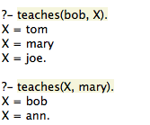

screenshots/2.png4-

Explain:

Prolog looks for a rule that satisfies the goal of the above query, it cannot find this so then resorts to backtracking and sees is there a way to derive the goal from previously defined facts and rules in the DB. It can’t satisfy neither as there is no reference to “joe”so it then returns false by negation as failure.

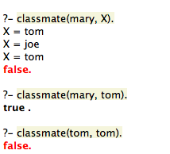5-

screenshots/8.png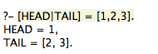Q3:

1-

2-

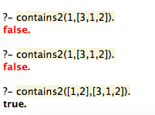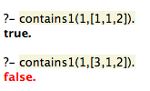3-

screenshots/11.png4-

5-