Real-World Application

A regularly-updated IMDB database file listing the known filming locations for every movie can be found at
ftp://ftp.fu-berlin.de/pub/misc/movies/database/locations.list.gz
This file, when truncated to include only movies starting with the word 'A' looks like:
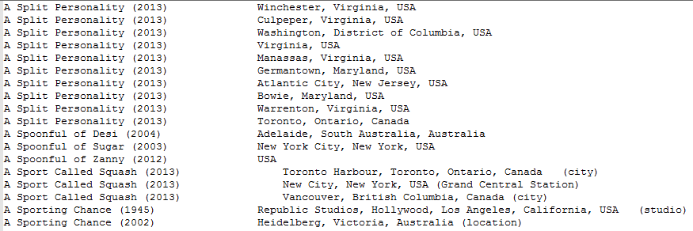
Because most movies are filmed in multiple locations, 2 random movies can often be linked together by a path of movies linked by common filming locations. We wanted to find the shortest such path between 2 movies.
This data set works well because these movies have an average of 6 listed filming locations, striking a good balance between graph size and ability to find a path.

The dataset was converted into a digraph by a separate Java program (included in the submission). The program reads the raw file line-by-line and uses tabs to differentiate movies and locations. It creates a hashmap from a location to a list of movies filmed in that location. It lastly iterates the hashmap and writes to movies-vertex.txt and movies-edge.txt (seen below).
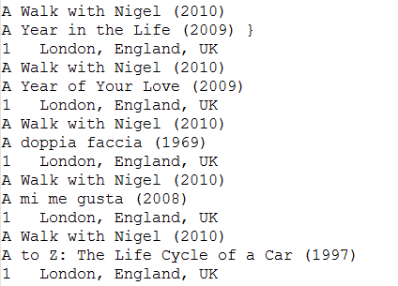
Another goal was to display exactly which location linked each movie when a path is found. To accomplish this, the main program was modified to optionally read a tab-separated “edge description” (in this case, location name) after the edge weight in the edge file. This description is then stored as a field in Edge.java, and is displayed upon finding a shortest path, if present:
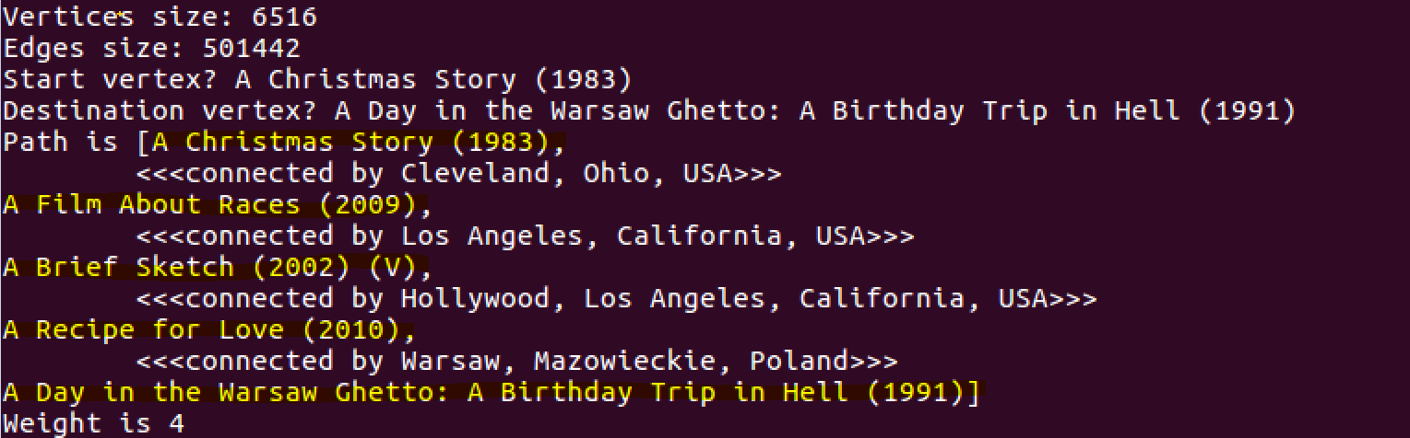
While this dataset works well with our program, it has some inherit flaws. One, the problem is actually an unweighted shortest path problem. Treating it as a weighted problem surely adds some computing overhead. Also, this dataset could be more efficiently represented as an undirected graph, as (movie1, movie2) implies the inverse. To accommodate this however, the program would have to be mostly rewritten.

