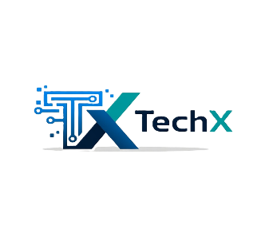 TechX
From Curiosity to Legacy: Pioneering AI Excellence
TechX was born from a single spark - an idea fueled by curiosity and a young dream. Founded by Diamond Ebenyo, a passionate 16-year-old Python enthusiast deeply immersed in AI and robotics, TechX represents the drive to push boundaries and build meaningful technology. What started as personal exploration has grown into a collaborative hub where innovation meets determination, with the bold vision of becoming a leading force in artificial intelligence and technology services worldwide.
At the heart of TechX is a small but exceptionally talented team of four young minds working together seamlessly:
- Diamond Ebenyo (Founder & AI Specialist / Backend Developer): Leading AI development, including our custom LLM Nova and core intelligent systems.
- Raymond Ebenyo (Brother & Full-Stack Developer / IoT & Robotics Expert): Bringing brilliance to frontend experiences, physical robotic design, Arduino projects, and IoT integration.
- Elsie (Web Developer): Crafting intuitive, high-performance web interfaces that bring our ideas to life.
- Emmanuel Kipchirchir (Pentester): Ensuring security and robustness in every solution we deliver.
Our flagship project, Lumina, is an AI-powered adaptive learning platform designed to revolutionize education. Traditional classrooms often leave students disengaged, overwhelmed by unclear instructions, and demotivated. Lumina changes that by delivering personalized, gamified learning experiences. Using advanced AI, it adapts in real-time to each student's pace and style—providing clear explanations, interactive challenges, instant feedback, rewards, and progress tracking. Features include an intelligent AI tutor, lesson personalization, gamification elements to spark motivation, and a powerful teacher dashboard for performance insights, predictions, and data-driven decisions.
Early experiments with 20 students demonstrated Lumina's impact: significant improvements in academic performance, deeper engagement, and greater student ownership of learning. Backed by in-depth research into AI in education, gamification, adaptive systems, ethical AI, bias mitigation, and decision-making, Lumina stands out with its ability to make learning smarter, faster, and genuinely enjoyable.
We also offer Nova, our in-house LLM serving as an intelligent AI assistant, and Edulytics, an analytics tool that converges education data with powerful insights for better outcomes.
Beyond education, TechX provides a wide range of AI and technology services: custom AI development, server deployment, game development, animations, logo design, automation, and more. We focus on economical, fast, and reliable delivery—leveraging AI's seamless power to create value efficiently.
Guided by core values of innovation, sustainability, and teamwork, TechX is a collaborative space where young talent turns bold ideas into real-world impact. We currently serve startups and emerging markets with accessible, high-quality solutions while building toward global enterprises and leadership in AI advancement—including our long-term pursuit of AGI development.
TechX isn't just building tools; we're creating an AI legacy—one innovation, one transformed learner, one empowered business at a time. From a teenager's curiosity to pioneering excellence, we're on a mission to shape intelligent technology that drives progress for everyone.
Ready to collaborate or explore how TechX can support your vision? Let's build the future together.

