**Preparation for the script**

* Create an available EC2 and take a snapshot
* Save key pair
* Install AWS cli tool for your manager server, please refer the below link:

http://docs.amazonaws.cn/en_us/cli/latest/userguide/installing.html

**Script workflow:**

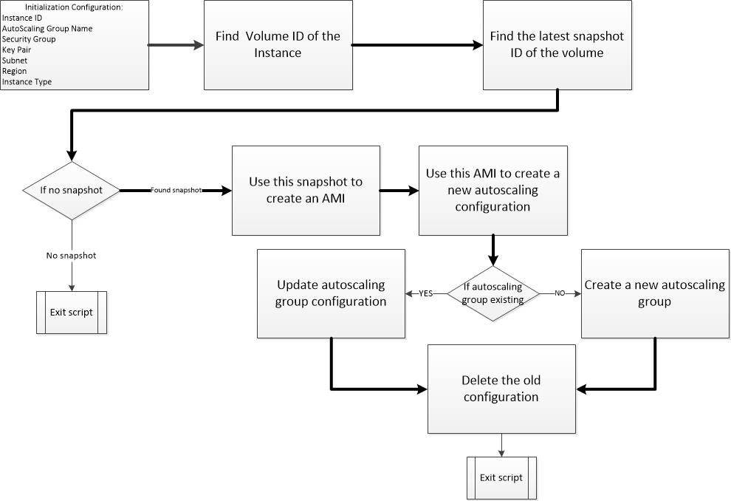

**Create script in your manager server.**

Input the following commands as text file and name xxx.sh.

!/bin/bash

#Autoscaling config name

AC_CONFIG="my-lc-bycli"

#Autoscaling group name

AC_GROUP_NAME="my-lb-asg-bycli"

#desired-capacity

DC="1"

#security group

SG="sg-9b3a8bfe"

#!/bin/bash

#Autoscaling config name

AC_CONFIG="my-lc-bycli"

#Autoscaling group name

AC_GROUP_NAME="my-lb-asg-bycli"

#desired-capacity

DC="1"

#security group

SG="sg-9b3a8bfe"

#!/bin/bash

#Autoscaling config name

AC_CONFIG="my-lc-bycli"

#Autoscaling group name

AC_GROUP_NAME="my-lb-asg-bycli"

#desired-capacity

DC="1"

#security group

SG="sg-9b3a8bfe"

#which key pari

KP="ELB"

#specify machine type

INSTANCE_TYPE="t2.micro"

#which AMI you wanna use in autoscaling

AMI_ID="ami-501a1402"

GP_MAX="1"

GP_MIN="1"

aws autoscaling create-launch-configuration --launch-configuration-name $AC_CONFIG \

--image-id $AMI_ID --instance-type $INSTANCE_TYPE \

--security-groups "$SG" \

--key-name $KP \

--associate-public-ip-address

aws autoscaling create-auto-scaling-group --auto-scaling-group-name $AC_GROUP_NAME \

--launch-configuration-name $AC_CONFIG \

--availability-zones "ap-southeast-1a" "ap-southeast-1b" \

--max-size $GP_MAX --min-size $GP_MIN --desired-capacity $DC \

--vpc-zone-identifier "subnet-07ee4c62"

#--load-balancer-names "my-lb"

In the script you need to modify 6 values

AC_CONFIG: this is AutoScaling configuration name, in Autoscaling Group will use it later.

AC_GROUP_NAME: this is your AutoScaling group name.

SG: is your EC2 security group name

KP: is your EC2 key pair, if without it you may cannot login to you EC2 instance.

INSTANCE_TYPE: what machine type you wanna launch

AMI_ID: your EC2 snapshot AMI ID

In “aws autoscaling create-auto-scaling-group” this command, you have to specify all of the AZ in your region and which subnet you wanna assign to your new instance. Otherwise you won’t get public IP if you don’t specify the right subnet.