Steps for Integrative Genomics Viewer (IGV) setup and visualization

- Go to the IGV home page at http://www.broadinstitute.org/software/igv/home

- To download the IGV application, a one-time free registration can be done at http://www.broadinstitute.org/software/igv/?q=registration

- For users with an IGV account, click on the Downloads tab from the home page and enter your email address. Logging in will take you to the download page.

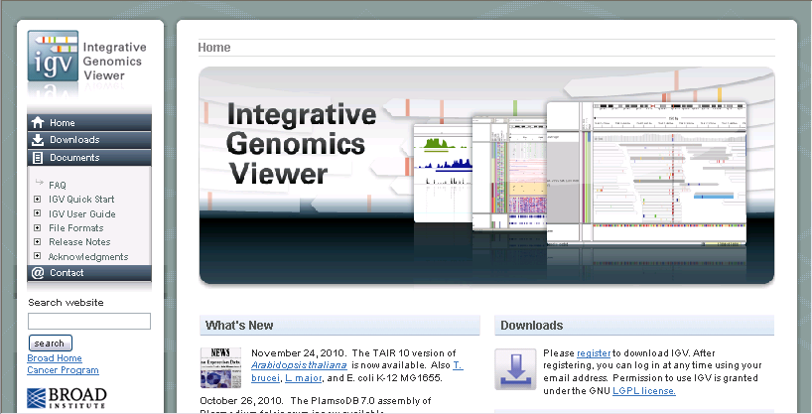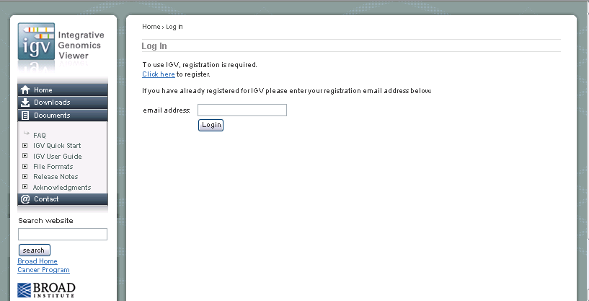
If you already have an IGV account, enter your email here
First time users need to register
Downloads tab

- Based on your operating system (OS), click on the Launch button for 32-bit Windows or 32-bit Mac. This will launch IGV and a short-cut to your desktop will also be created.
Launch IGV for Windows OS
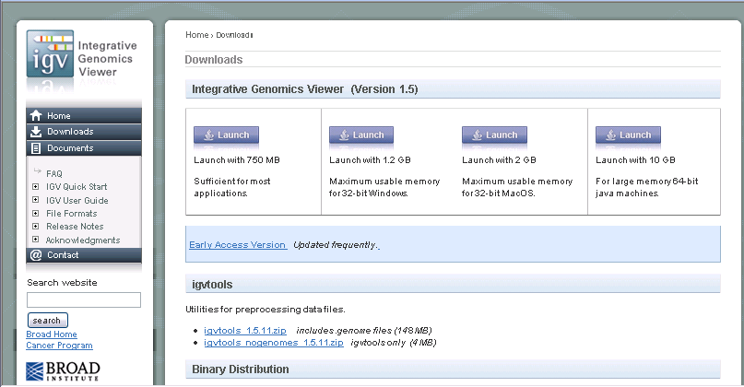
Launch IGV for Mac OS

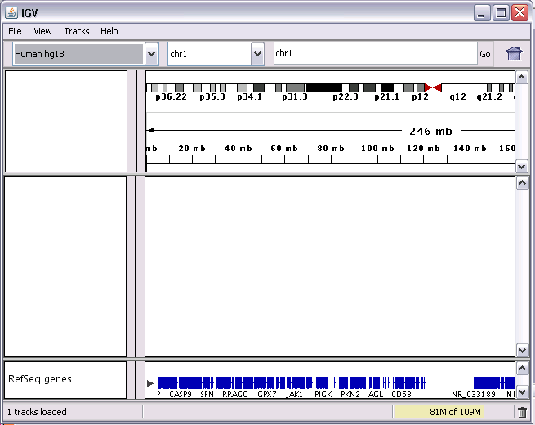
IGV home page

- Click on File → Open Session… and point it to the ‘igv_session.xml’ file downloaded to your desktop from the BIC delivery folder. This step will load your alignment data and annotation files. Tracks for each sample comprise of the alignment of reads as well as coverage of the location where the reads align.

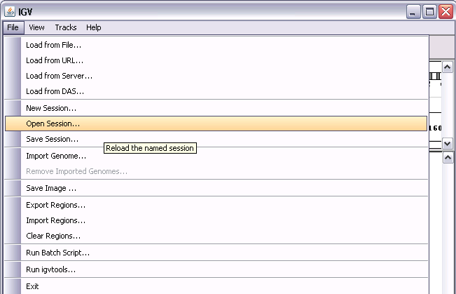
File → Open Session…

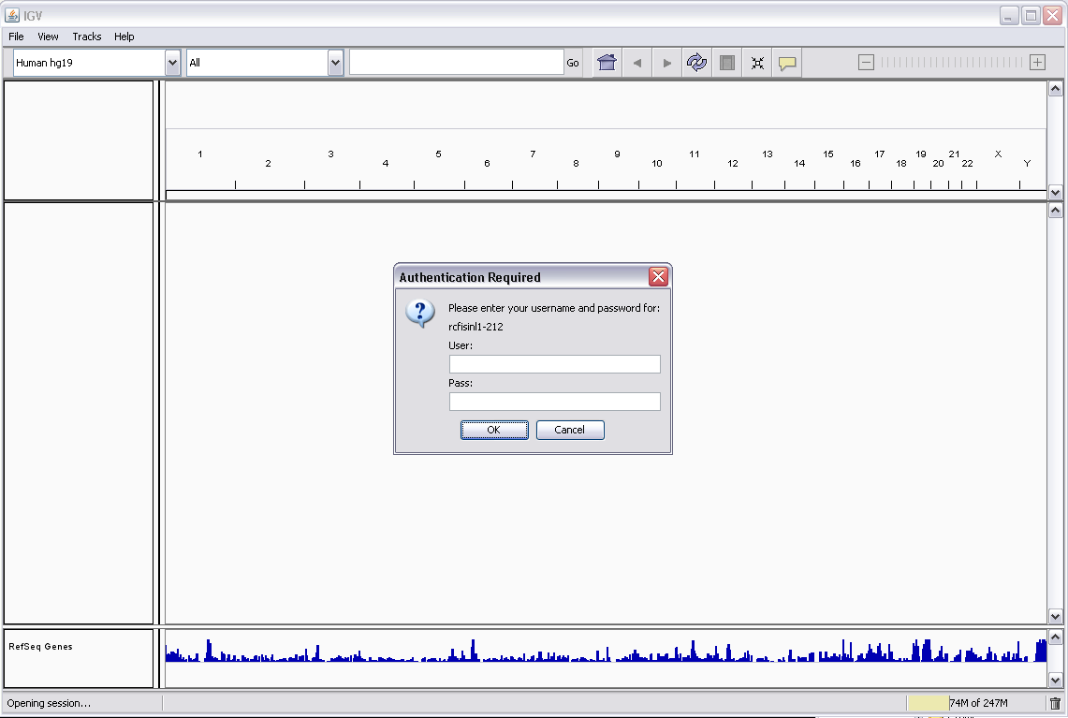
First layer of security
Please fill in as follows:-

User: mfad\your Mayo LANID
Pass: your password

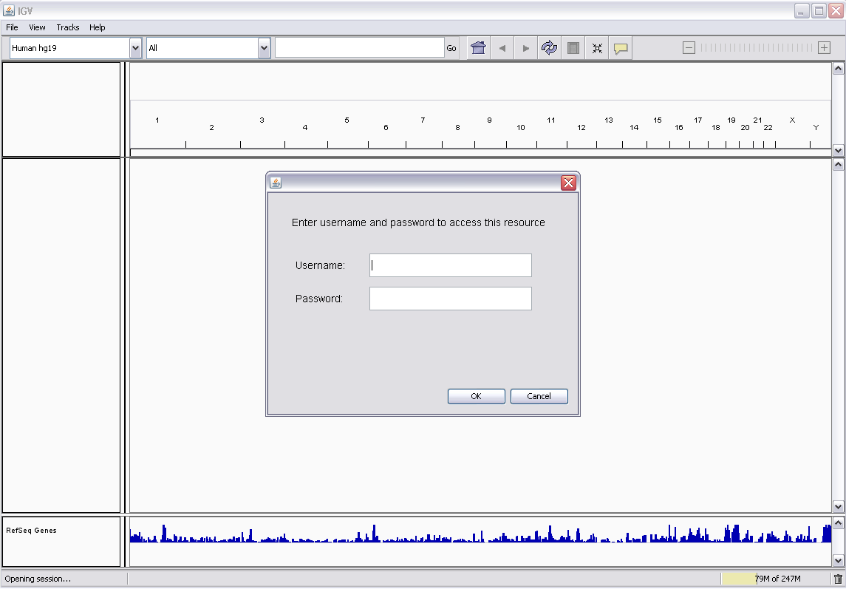
Second layer of security
Please fill in as follows:-

User: your Mayo LANID
Pass: your password

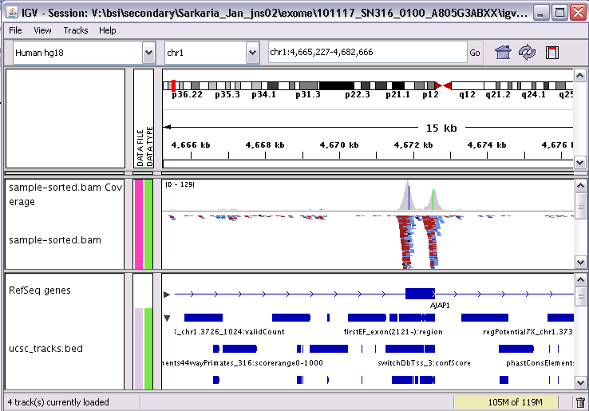
Snapshot of how the alignment data and annotation files look like after loading igv_session.xml file
Annotation files
sample coverage and alignment data

- Open the SNV report or INDEL report (works for both standard and filtered reports) and click on any link in the first column ‘IGV link’ of the report. IGV will pop up for that specific position where a SNV or INDEL was reported.

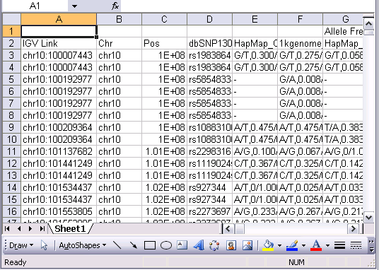
IGV link in SNV report

- Notice that SNVs at any given position follow the color coding of nucleotides A, C, G & T as seen along the RefSeq genes track. Deletions are represented by dashes while Insertions with the letter I.

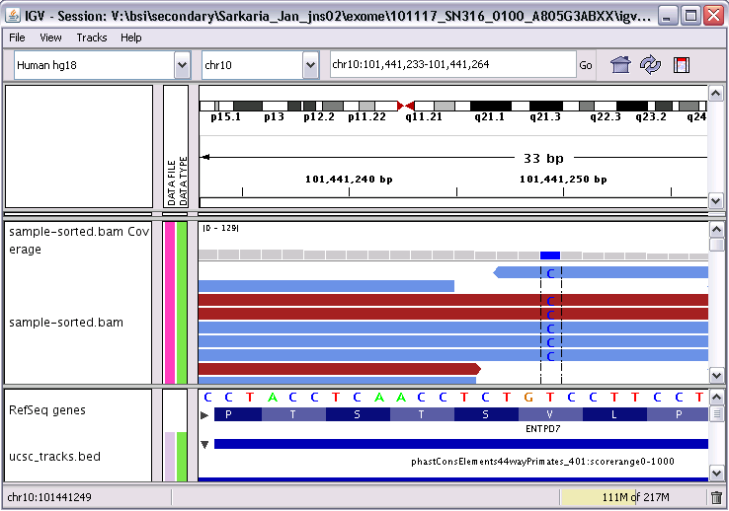
SNV position showing reference allele T and alternate allele C

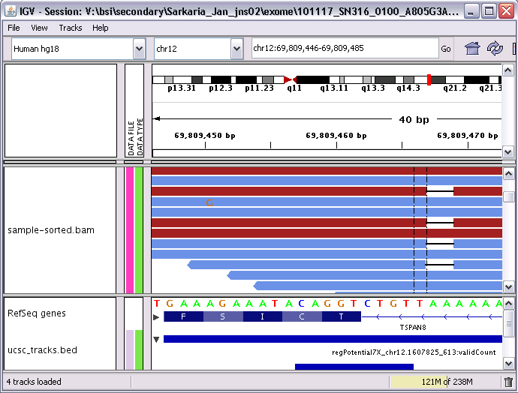
Deletion

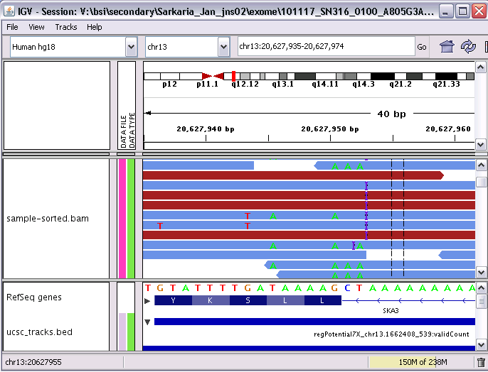
Insertion

- More instructions on how to use IGV can be found at their user guide: http://www.broadinstitute.org/software/igv/UserGuide

