在自己的电脑上跑BinaryConnect

配置数据库

参考资料：<http://www.cnblogs.com/tornadomeet/p/3424520.html>

1. 数据库路径
   1. 系统变量PYLEARN2_DATA_PATH:

C:\pylearn2-master\PYLEARN2_DATA_PATH

* 1. 这样放置数据库

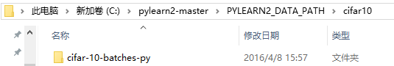

【2】数据库预处理是自己拿pylearn2自带的函数做的，不是BinaryConnect提供的。

运行

cd /d C:\pylearn2-master\pylearn2-master\pylearn2\scripts\datasets

python make_cifar10_gcn_whitened.py

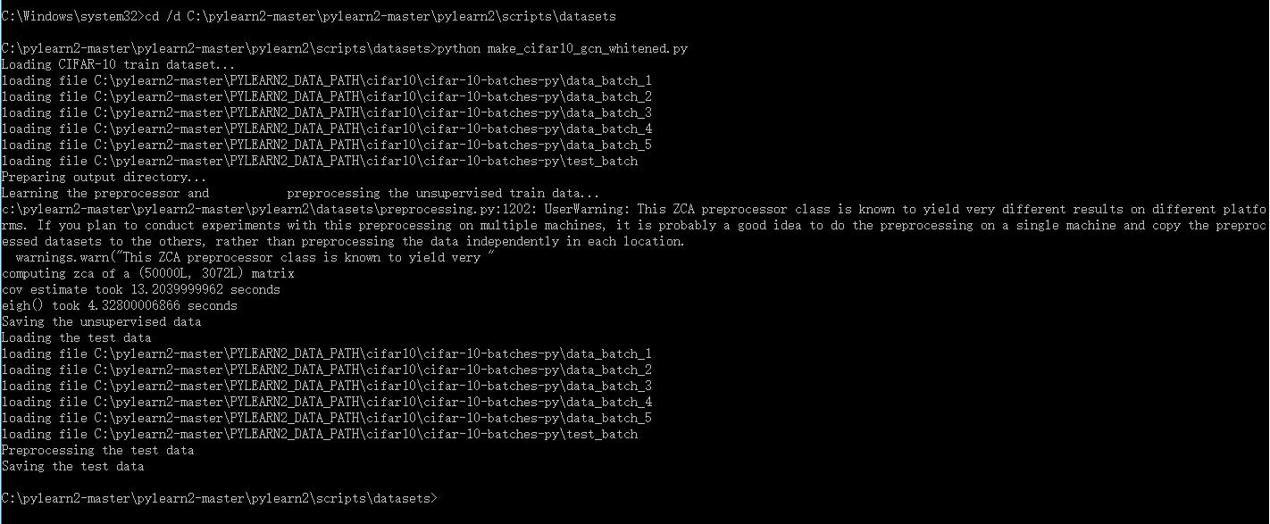

1. 跑的程序又出错了

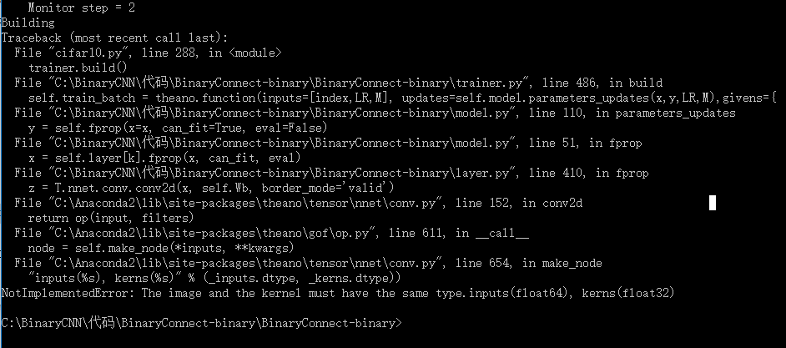

Building

Traceback (most recent call last):

File "C:\Users\User\Documents\Visual Studio 2013\Projects\My_Experiments_on_BianryConnect_2\My_Experiments_on_BianryConnect_2\My_Experiments_on_BianryConnect_2.py", line 288, in <module>

trainer.build()

File "C:\Users\User\Documents\Visual Studio 2013\Projects\My_Experiments_on_BianryConnect_2\My_Experiments_on_BianryConnect_2\trainer.py", line 486, in build

self.train_batch = theano.function(inputs=[index,LR,M], updates=self.model.parameters_updates(x,y,LR,M),givens={

File "C:\Users\User\Documents\Visual Studio 2013\Projects\My_Experiments_on_BianryConnect_2\My_Experiments_on_BianryConnect_2\model.py", line 110, in parameters_updates

y = self.fprop(x=x, can_fit=True, eval=False)

File "C:\Users\User\Documents\Visual Studio 2013\Projects\My_Experiments_on_BianryConnect_2\My_Experiments_on_BianryConnect_2\model.py", line 51, in fprop

x = self.layer[k].fprop(x, can_fit, eval)

File "C:\Users\User\Documents\Visual Studio 2013\Projects\My_Experiments_on_BianryConnect_2\My_Experiments_on_BianryConnect_2\layer.py", line 410, in fprop

z = T.nnet.conv.conv2d(x, self.Wb, border_mode='valid')

File "C:\Anaconda2\lib\site-packages\theano\tensor\nnet\conv.py", line 152, in conv2d

return op(input, filters)

File "C:\Anaconda2\lib\site-packages\theano\gof\op.py", line 611, in __call__

node = self.make_node(*inputs, **kwargs)

File "C:\Anaconda2\lib\site-packages\theano\tensor\nnet\conv.py", line 654, in make_node

"inputs(%s), kerns(%s)" % (_inputs.dtype, _kerns.dtype))

**NotImplementedError: The image and the kernel must have the same type.inputs(float64), kerns(float32)**

好像是因为theano 目前只支持float32，至少是用到gpu的话。

我的系统是win7 64的。参照theano 文档 config一节设置后这个问题就解决了。<http://deeplearning.net/software/theano/library/config.html>

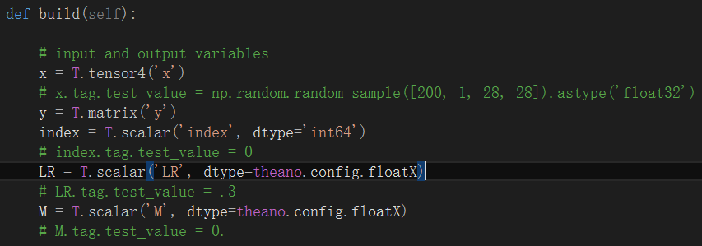

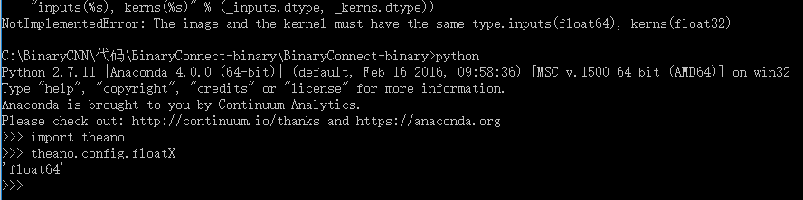

如何修改theano.config?

直接修改。。。

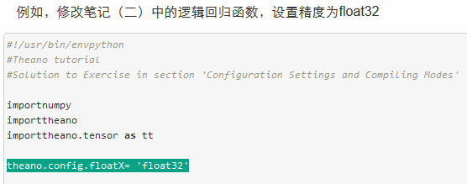

[**config**](http://deeplearning.net/software/theano/library/config.html#module-config) **– Theano Configuration**

**Guide**

The config module（config是一个module）

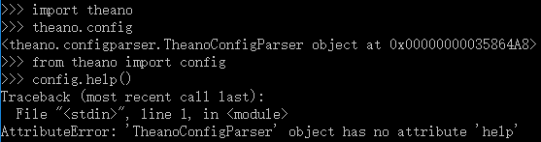

contains many attributes（vt.认为…是; 把…归于; 把…品质归于某人; 认为某事[物]属于某人[物] n.属性; （人或物的）特征; 价值; [语法学]定语） that modify Theano’s behavior. Many of these attributes are consulted during the import of the theano module and many are assumed to be read-only.

*As a rule, the attributes in this module should not be modified by user code.*

Theano’s code comes with default values for these attributes, but you can override（vt. 覆盖; 推翻，无视; 践踏; 优先于;n. 佣金; 超驰控制装置; 撤消，推翻;[网络] 重写; 重载; 方法重写;[例句]） them from your .theanorc file, and override those values in turn by the [THEANO_FLAGS](http://deeplearning.net/software/theano/library/config.html#envvar-THEANO_FLAGS) environment variable.

The order of precedence is:

1. an assignment to theano.config.<property>
2. an assignment in [THEANO_FLAGS](http://deeplearning.net/software/theano/library/config.html#envvar-THEANO_FLAGS)
3. an assignment in the .theanorc file (or the file indicated in [THEANORC](http://deeplearning.net/software/theano/library/config.html#envvar-THEANORC))

You can print out the current/effective configuration at any time by printing theano.config. For example, to see a list of all active configuration variables, type this from the command-line:

python -c 'import theano; print(theano.config)' | less

**Environment Variables**

THEANO_FLAGS

This is a list of comma-delimited key=value pairs that control Theano’s behavior.

For example, in bash, you can override your [THEANORC](http://deeplearning.net/software/theano/library/config.html#envvar-THEANORC) defaults for <myscript>.py by typing this:

THEANO_FLAGS='floatX=float32,device=gpu0,lib.cnmem=1' python <myscript>.py

If a value is defined several times in THEANO_FLAGS, the right-most definition is used. So, for instance, if THEANO_FLAGS='device=cpu,device=gpu0', then gpu0 will be used.

THEANORC

The location[s] of the .theanorc file[s] in ConfigParser format. It defaults to $HOME/.theanorc. On Windows, it defaults to $HOME/.theanorc:$HOME/.theanorc.txt to make Windows users’ life easier.



Here is the .theanorc equivalent to the THEANO_FLAGS in the example above:

[global]

floatX = float32

device = gpu0

[lib]

cnmem = 1

Configuration attributes that are available directly in config (e.g. config.device, config.mode) should be defined in the [global] section. Attributes from a subsection of config (e.g. config.lib.cnmem, config.dnn.conv.algo_fwd) should be defined in their corresponding section (e.g. [nvcc], [dnn.conv]).

【之后的一个报错】

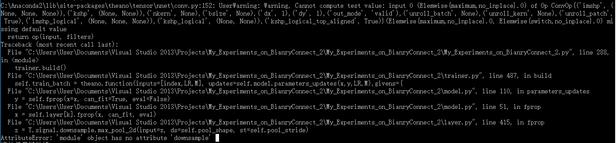

C:\Anaconda2\lib\site-packages\theano\tensor\nnet\conv.py:152: UserWarning: Warning, Cannot compute test value: input 0 (Elemwise{maximum,no_inplace}.0) of Op ConvOp{('imshp', (None, None, None)),('kshp', (None, None)),('nkern', None),('bsize', None),('dx', 1),('dy', 1),('out_mode', 'valid'),('unroll_batch', None),('unroll_kern', None),('unroll_patch', True),('imshp_logical', (None, None, None)),('kshp_logical', (None, None)),('kshp_logical_top_aligned', True)}(Elemwise{maximum,no_inplace}.0, Elemwise{switch,no_inplace}.0) missing default value

return op(input, filters)

Traceback (most recent call last):

File "C:\Users\User\Documents\Visual Studio 2013\Projects\My_Experiments_on_BianryConnect_2\My_Experiments_on_BianryConnect_2\**My_Experiments_on_BianryConnect_2.py**", line **288**, in <module>

trainer.build()

File "C:\Users\User\Documents\Visual Studio 2013\Projects\My_Experiments_on_BianryConnect_2\My_Experiments_on_BianryConnect_2\**trainer.py**", line **487**, in build

self.train_batch = theano.function(inputs=[index,LR,M], updates=self.model.parameters_updates(x,y,LR,M),givens={

File "C:\Users\User\Documents\Visual Studio 2013\Projects\My_Experiments_on_BianryConnect_2\My_Experiments_on_BianryConnect_2\**model.py**", line **110**, in parameters_updates

y = self.fprop(x=x, can_fit=True, eval=False)

File "C:\Users\User\Documents\Visual Studio 2013\Projects\My_Experiments_on_BianryConnect_2\My_Experiments_on_BianryConnect_2\**model.py**", line **51**, in fprop

x = self.layer[k].fprop(x, can_fit, eval)

File "C:\Users\User\Documents\Visual Studio 2013\Projects\My_Experiments_on_BianryConnect_2\My_Experiments_on_BianryConnect_2\**layer.py**", line **415**, in fprop

z = T.signal.downsample.max_pool_2d(input=z, ds=self.pool_shape, st=self.pool_stride)

AttributeError: 'module' object has no attribute 'downsample'  


# Maxpooling

if self.pool_shape != (1,1):

z = T.signal.downsample.max_pool_2d(input=z, ds=self.pool_shape, st=self.pool_stride)

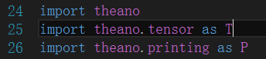

import theano.tensor as T

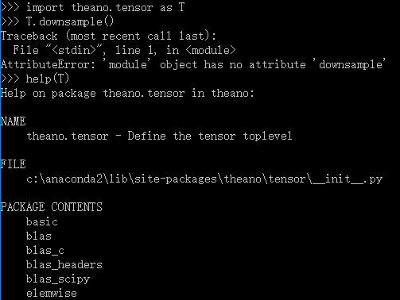

嗯嗯，很好，只是貌似tensor里面没有“signal”？

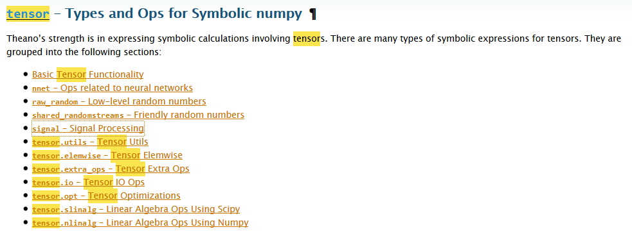

<http://stackoverflow.com/questions/30369287/theano-is-missing-signal-conv-module>

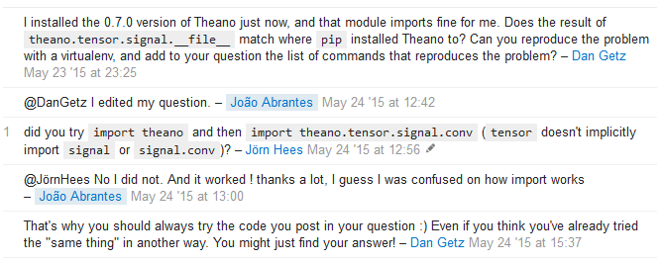

did you **try import theano and then import theano.tensor.signal.conv (tensor doesn't implicitly import signal or signal.conv)?** – Jörn Hees May 24 '15 at 12:56

@JörnHees No I did not. And it worked ! thanks a lot, I guess I was confused on how import works – João Abrantes May 24 '15 at 13:00

That's why you should always try the code you post in your question :) Even if you think you've already tried the "same thing" in another way. You might just find your answer! – Dan Getz May 24 '15 at 15:37



最后的结果就是：改成pool就好了233333

if self.pool_shape != (1,1):

z = T.signal.pool.max_pool_2d(input=z, ds=self.pool_shape, st=self.pool_stride)

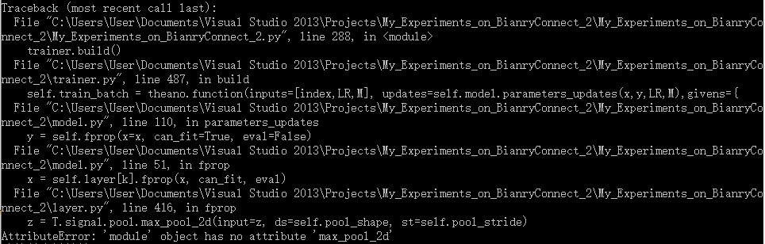

<http://deeplearning.net/software/theano/library/tensor/signal/pool.html?highlight=max_pool_2d#module-pool>

改成这样：

if self.pool_shape != (1,1):

z = **T.signal.pool.pool_2d**(input=z, ds=self.pool_shape, st=self.pool_stride, **mode='max'**)

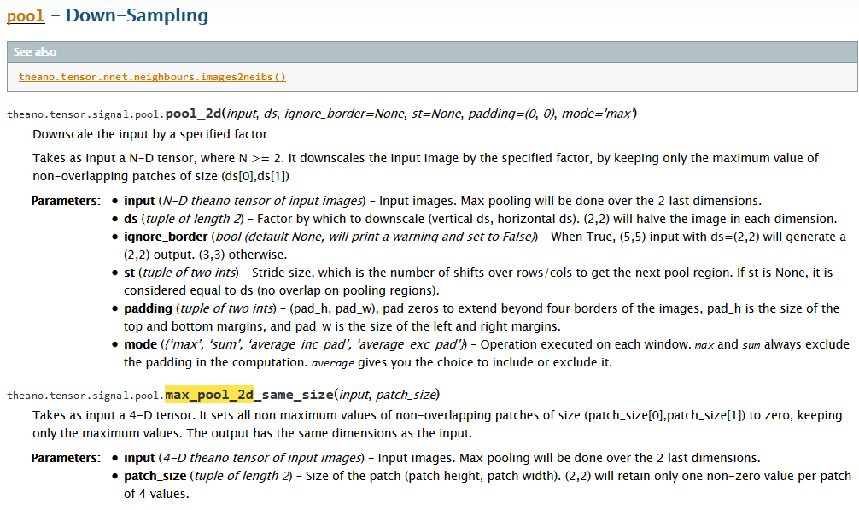

【又报错了。。。】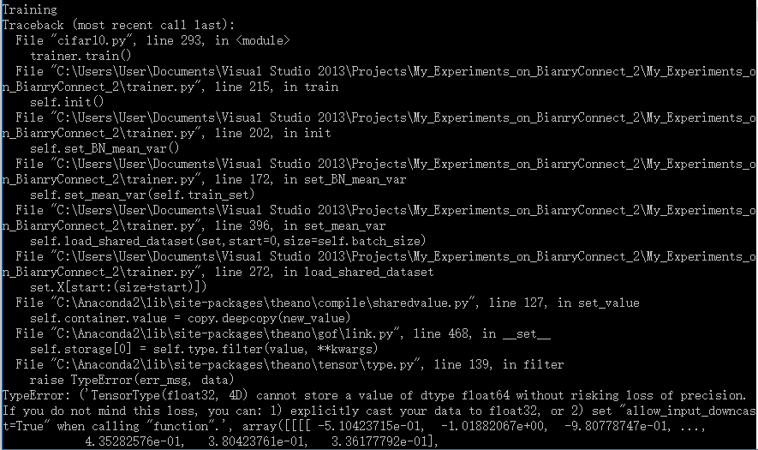

Training

Traceback (most recent call last):

File "cifar10.py", line 293, in <module>

trainer.train()

File "C:\Users\User\Documents\Visual Studio 2013\Projects\My_Experiments_on_BianryConnect_2\My_Experiments_on_BianryConnect_2\trainer.py", line 215, in train

self.init()

File "C:\Users\User\Documents\Visual Studio 2013\Projects\My_Experiments_on_BianryConnect_2\My_Experiments_on_BianryConnect_2\trainer.py", line 202, in init

self.set_BN_mean_var()

File "C:\Users\User\Documents\Visual Studio 2013\Projects\My_Experiments_on_BianryConnect_2\My_Experiments_on_BianryConnect_2\trainer.py", line 172, in set_BN_mean_var

self.set_mean_var(self.train_set)

File "C:\Users\User\Documents\Visual Studio 2013\Projects\My_Experiments_on_BianryConnect_2\My_Experiments_on_BianryConnect_2\trainer.py", line 396, in set_mean_var

self.load_shared_dataset(set,start=0,size=self.batch_size)

File "C:\Users\User\Documents\Visual Studio 2013\Projects\My_Experiments_on_BianryConnect_2\My_Experiments_on_BianryConnect_2\trainer.py", line 272, in load_shared_dataset

set.X[start:(size+start)])

File "C:\Anaconda2\lib\site-packages\theano\compile\sharedvalue.py", line 127, in set_value

self.container.value = copy.deepcopy(new_value)

File "C:\Anaconda2\lib\site-packages\theano\gof\link.py", line 468, in __set__

self.storage[0] = **self.type.filter**(value, **kwargs)

File "C:\Anaconda2\lib\site-packages\theano\tensor\type.py", line 139, in filter

raise TypeError(err_msg, data)

TypeError: ('TensorType(float32, 4D) cannot store a value of dtype float64 without risking loss of precision. If you do not mind this loss, you can: 1) explicitly cast your data to float32, or 2) set "allow_input_downcast=True" when calling "function".',

TypeError: ('TensorType(float32, 4D) cannot store a value of dtype float64 without risking loss of precision. If you do not mind this loss, you can: 1) explicitly cast your data to float32, or 2) set "allow_input_downcast=True" when calling "function".', array([[[[ -5.10423715e-01, -1.01882067e+00, -9.80778747e-01, ...,

<http://stackoverflow.com/questions/22914786/error-because-of-theano-and-numpy-variable-types>

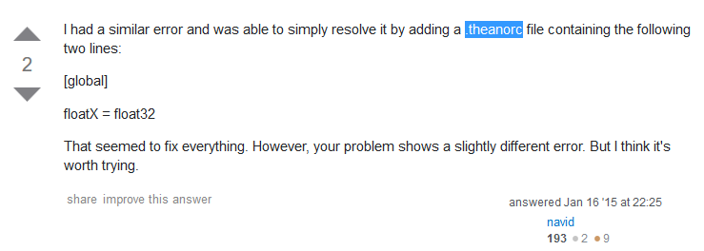

注意！！！这个东西必须只能是这个名字！！！注意后缀！！！其他的都不对！！！



我改成了这个：

[global]

openmp=False

floatX = float32

device = gpu0

[blas]

ldflags=

[gcc]

cxxflags=-I C:\Anaconda2\MinGW

import theano 之后是这个样子的：

