使用python做图像增强和锐化

1. Python Imaging Library (PIL)

<http://www.pythonware.com/products/pil/index.htm>

Downloads

The following downloads are currently available:

PIL 1.1.7

Python Imaging Library 1.1.7 Source Kit (all platforms) (November 15, 2009)

Python Imaging Library 1.1.7 for Python 2.4 (Windows only)

Python Imaging Library 1.1.7 for Python 2.5 (Windows only)

Python Imaging Library 1.1.7 for Python 2.6 (Windows only)

Python Imaging Library 1.1.7 for Python 2.7 (Windows only)

1.1 PIL：Python图像处理类库

PIL（Python Imaging Library Python，图像处理类库）提供了通用的图像处理功能，以及大量有用的基本图像操作，比如图像缩放、裁剪、旋转、颜色转换等。PIL 是免费的，可以从 http://www.pythonware.com/products/pil/ 下载。

利用 PIL 中的函数，我们可以从大多数图像格式的文件中读取数据，然后写入最常见的图像格式文件中。PIL 中最重要的模块为 Image 。要读取一幅图像，可以使用：

from PIL import Image

pil_im = Image.open('empire.jpg')

上述代码的返回值 pil_im 是一个 PIL 图像对象。

1. (2) Python Imaging Library (PIL)

下载压缩包

1. C:\Windows\system32>cd /d C:\All_Kinds_of_3rd_Libraries_for_Python\Imaging-1.1.7\Imaging-1.1.7
2. C:\All_Kinds_of_3rd_Libraries_for_Python\Imaging-1.1.7\Imaging-1.1.7>python setup.py install

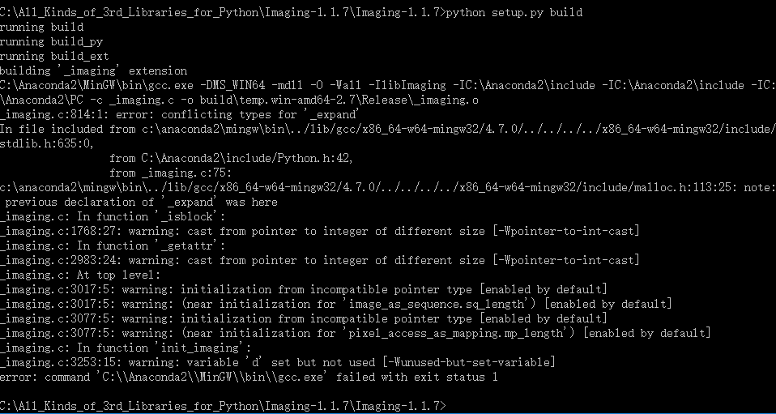

以下的解决方案失败了：

~~解决方案：安装MinGW（实测）~~

~~1、下载安装MinGW~~

~~2、在MinGW的安装目录下找到bin文件夹，找到mingw32-make.exe，复制一份更名为make.exe~~

~~3、把MinGW的路径添加到环境变量path中，比如我把MinGW安装到D:\MinGW\中，就把D:\MinGW\bin添加到path中；~~

~~4、在<python安装目录>\distutils增加文件distutils.cfg，在文件里输入~~

~~[build]~~

~~compiler=mingw32~~

~~保存；~~

~~5、执行原先的模块安装，发现还是报错，报错内容为：error: command ‘gcc’ failed: No such file or directory 解决方案是将D:\MinGW\lib再添加到PATH中。~~

~~6、如果安装过程中出现 error: Could not find ‘openssl.exe’ ，下载安装openssl即可。~~

~~6、再次执行时安装模块时，发现如下错误：~~

~~D:\MinGW\bin\gcc.exe -mno-cygwin -mdll -O -Wall “-ID:\Program Files\Python27\include” “-ID:\Program Files\Python27\include” “-ID:\Program Files\Python27\PC” –c ../libdasm.c -o build\temp.win32-2.7\Release\..\libdasm.o~~

~~cc1.exe: error:unrecognized command line option ‘-mno-cygwin’~~

~~error: command ‘gcc’ failed with exit status 1~~

~~原因是gcc 4.6.x 以后不再接受-mno-cygwin为了解决这个问题需要修改<python安装目录>\distutils\cygwinccompiler.py文件。找到：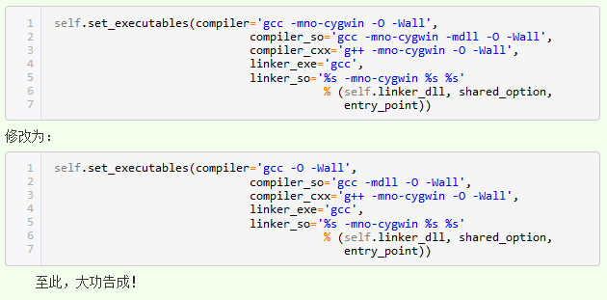~~

~~C:\Anaconda2\Lib\distutils~~

~~# Hard-code GCC because that's what this is all about.~~

~~# XXX optimization, warnings etc. should be customizable.~~

~~#self.set_executables(compiler='gcc -DMS_WIN64 -O -Wall',~~

~~# compiler_so='gcc -DMS_WIN64 -mdll -O -Wall',~~

~~# compiler_cxx='g++ -DMS_WIN64 -O -Wall',~~

~~# linker_exe='gcc -DMS_WIN64',~~

~~# linker_so=('%s -DMS_WIN64 %s' %~~

~~# (self.linker_dll, shared_option)))~~

~~self~~**~~.~~**~~set_executables~~**~~(~~**~~compiler~~**~~=~~**~~'gcc -O -Wall'~~**~~,~~**

~~compiler_so~~**~~=~~**~~'gcc -mdll -O -Wall'~~**~~,~~**

~~compiler_cxx~~**~~=~~**~~'g++ -O -Wall'~~**~~,~~**

~~linker_exe~~**~~=~~**~~'gcc '~~**~~,~~**

~~linker_so~~**~~=(~~**~~'%s %s'~~ **~~%~~**

**~~(~~**~~self~~**~~.~~**~~linker_dll~~**~~,~~** ~~shared_option~~**~~)))~~**

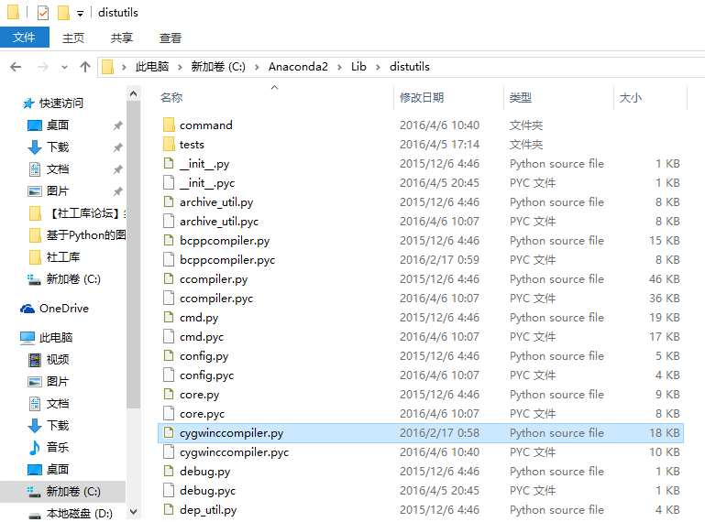

>>> import PIL

>>> from PIL import ImageEnhance

>>> help(ImageEnhance.sharpness)

Traceback (most recent call last):

File "<stdin>", line 1, in <module>

AttributeError: 'module' object has no attribute 'sharpness'

>>> help(ImageEnhance.Sharpness)

Help on class Sharpness in module PIL.ImageEnhance:

class Sharpness(_Enhance)

| Adjust image sharpness.

|

| This class can be used to adjust the sharpness of an image. An

| enhancement factor of 0.0 gives a blurred image, a factor of 1.0 gives the

| original image, and a factor of 2.0 gives a sharpened image.

|

| Method resolution order:

| Sharpness

| _Enhance

| __builtin__.object

|

| Methods defined here:

|

| __init__(self, image)

|

| ----------------------------------------------------------------------

| Methods inherited from _Enhance:

|

| enhance(self, factor)

| Returns an enhanced image.

|

| :param factor: A floating point value controlling the enhancement.

| Factor 1.0 always returns a copy of the original image,

| lower factors mean less color (brightness, contrast,

| etc), and higher values more. There are no restrictions

| on this value.

| :rtype: :py:class:`~PIL.Image.Image`

|

| ----------------------------------------------------------------------

| Data descriptors inherited from _Enhance:

|

| __dict__

| dictionary for instance variables (if defined)

|

| __weakref__

| list of weak references to the object (if defined)