Output Test Case 1

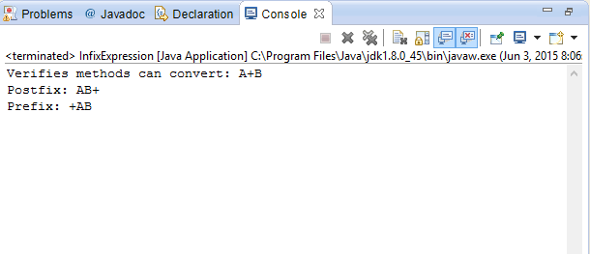

Output Test Case 2

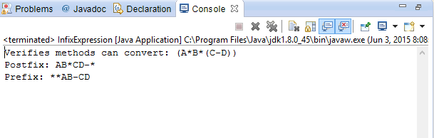

Output Test Case 3

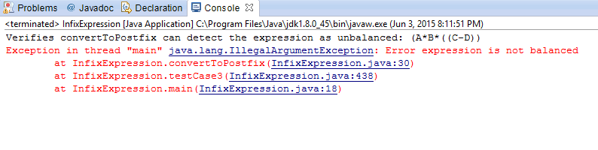

Output Test Case 4

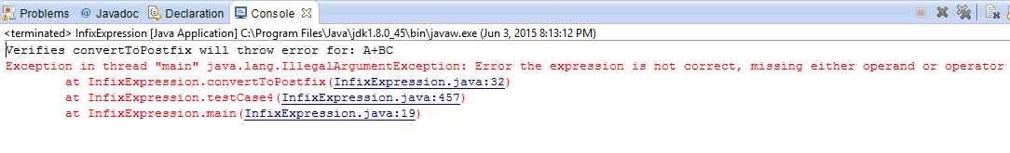

Output Test Case 5

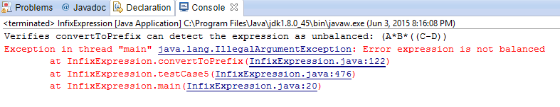

Output Test Case 6

