Abstraction

Nowadays, NoSQL databases have been rapidly becoming the popular data platform for big data and real-time web applications. Simpler horizontal scaling, flexible schema designing, high performance data access have made NoSQL databases to be alternative approaches for traditional relational databases . However, there are some disadvantages in NoSQL, among which the lack of effective suppprt for access control and privacy protection is the most serious ones. The huger data we have, the more challenge in data protection we have to face. In this thesis, we address this issue by implemeting a comprehensive framework for enforcing attribute-based security policies stored in JSON document. We use Polish notation for modeling conditional expressions which are the combination form of subject, resource, and environment attributes so that the policies are flexible, dynamic and fine grained. Moreover, with the approach of attribute-based access control, we have proposed a flexible model struture for privacy protection so that it can be evaluated not only by access purpose but also by subject, resource, environment attributes. We also build a web application which interacts to our framework so that administrators can easily define and review policies. The experiment is carried out to illustrate the relationship between the processing time for access decision and the complexity of policies.

1. Introduction

Nowadays, the quanity of data is increasing exponentially by the development of social media appications, sensor for data acquisitions and smart phone utilization. NoSQL databases is the most popular approach to handle those semi and unstructured data for a scalable application. Like relational database, security is highly considered in NoSQL database, especially when working with huge volume data. For the last decade, Discretionary Access Control (DAC), Mandatory Access Control (MAC), Role Based Access Control (RBAC) have been used almostly to handle security. However, because of the rapid development of large scale dynamic systems, those traditional access controls have gradually reveal their disadvantages, for example, applied for only closed system, role explosion and inflexibility in specifying dynamic policies and contextual conditions. To overcome those problems, Attribute Based Access Control models have been recently investigated and according to Gartner‘s prediction: “By 2020, 70% of all businesses will use attribute based access control as the dominant mechanism to protect critical assets.”[]

Based on the Hibert and Lopez assessment of global information storage over time, Figure[] shows the relative between the increasement of stored information from 1986 to 2007 and the trend of access control. Even when access control systems are successful in restricting unauthorized and unauthenticated users, they are ineffective as privacy protection for a large, decentralized system like the World Wide Web, where it is easy to copy or aggregate information.

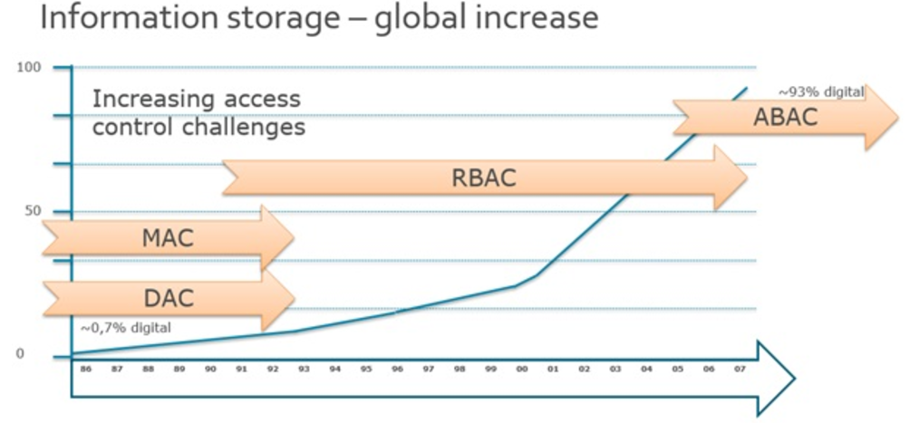

Most previous studies have considered privacy protection in access control models as constraints on purpose of data usage. In this thesis, our access control model is built on the principle of NIST Standard ABAC that an access decision is permitted only if the request satisfies conditions on attributes of subject, resource and environment specified in policies. Moreover, with the approach of attribute-based access control, we have proposed a flexible model struture for privacy protection so that it can be evaluated not only by access purpose but also by subject, resource, environment attributes. We use Polish notation for modeling conditional expressions so as to describe complex policies such as user, data, environment driven policies.

The rest of this thesis is organized as follows.

<https://www.avatier.com/products/identity-management/resources/gartner-iam-2020-predictions/>

https://www.tripwire.com/state-of-security/security-data-protection/security-controls/rbac-is-dead-now-what/