Abstract

NoSQL databases have recently become the popular data platform for big data and real-time web applications. Due to the simplicity in design but effectiveness in horizontal scaling and performance using NoSQL databases are alternative approaches for traditional relational databases. However, there are some disadvantages in NoSQL. The lack of a fine-grained access control system with data privacy protection is one of the most important considerations. The larger data set we have, the more challenge in data protection we have to face. In this thesis, we address this issue by researching and implementing a comprehensive framework for enforcing attribute-based security policies stored in JSON document together with the feature of data privacy protection in the fine-grained level. We use Polish notation for modeling conditional expressions which are the combination of subject, resource, and environment attributes so that the policies are flexible, dynamic and fine grained. Through the proposed flexible structure for privacy protection called as Attribute-Based Privacy Protection, it can be evaluated not only by access purpose but also by subject, resource, environment attributes. The experiment is carried out to illustrate the relationship between the processing time for access decision and the complexity of policies.

1. **Introduction**

Access Control is one of the essential and traditional security weapons of data protection. In recent years, many access control models and languages have proposed: Discretionary Access Control (DAC), Mandatory Access Control (MAC), Role Based Access Control (RBAC) have been used almost to handle security. However, because of the rapid development of large scale dynamic systems, those traditional access controls have gradually reveal their disadvantages, for example, applied for only closed system, role explosion and inflexibility in specifying dynamic policies and contextual conditions. To overcome those problems, Attribute Based Access Control model has been recently investigated and according to Gartner ‘s prediction: “By 2020, 70% of all businesses will use attribute based access control as the dominant mechanism to protect critical assets.” [11]

Even when access control systems are successful in blocking out unwanted viewers, they are ineffective as privacy protection for a large, decentralized system like the IoT, distributed system. These days, it is possible to infer sensitive information from publicly available information. For example, social security numbers (SSN) have always been closely guarded because they are used to identify individuals by most government and financial institutions. Private or sensitive information can be preserved by restricting the intended purpose of data access. According to “Data protection principles” [12] based on Data Protection Act Organization, purpose is considered as the second principle: “Personal data shall be obtained only for one or more specified and lawful purposes, and shall not be further processed in any manner incompatible with that purpose or those purposes.” Extending those approaches, we have proposed an Attribute-Based Privacy Protection (ABPP) model which will use not only access purpose attribute but also user, resource, environment attributes to evaluate privacy policies so that we can specify privacy policies more dynamically and flexibly.

1. **Related work**

Our research is related to several topics in access control and privacy protection for data management, namely policy specification, privacy-preserving data management systems. We now survey the most relevant approaches in these areas and point out the difference of our work with respect to these approaches.

Hua Wang, Lili Sun, and Vijay Varadharajan[7] have proposed a purpose-based framework for supporting privacy preserving access control policies and mechanisms. They have also developed algorithms to help a system to detect and analyze the conflicts when adding new policies. However, they don’t mention much about how to model the conditional expression and the algorithms they proposed just focused only on simple attributes which are lacked evaluating conditional expression.

Prosunjit Biswas, Ravi Sandhu, and Ram Krishman[10] have presented an attribute based protection model for JSON documents. Their approach is to add a new attribute called “security-label” to JSON elements and specify access control policies using these values. The advantage of the separation of labeling and authorization policies is that they can be specified and administered independently possibly by different level of administrators. However, the number of label assignments can be very large because it is calculated by the exponential function. Therefore, the space storage is a potential problem when the system is expanded.

IBM has proposed a formal language called Enterprise Privacy Authorization Language[13] called as EPAL for writing enterprise privacy policies to govern data handling practices in IT system. An EPAL policy defines lists of hierarchies of data-categories, user-categories and purpose. User-categories are the entities that use collected data, data-categories define different categories of collected data and purposes model the services for which data is intended to be used. An EPAL policy also defines sets of actions, obligations, and conditions. Actions model how the data is used and obligations define actions that must be taken by the environment EPAL. Lastly, conditions are Boolean expressions that evaluate the context. Privacy authorization rules are defined using these elements and each rule allows or denies actions on data-categories by user-categories for certain purposes under certain conditions while mandating certain obligations.

Ji-Won Byun, Ninghui Li[4] have presented a comprehensive approach for privacy preserving access control based on the notion of purpose. A key feature of their approach is that it allows multiple purposes to be associated with each data element and supports explicit prohibitions, thus allowing privacy officers to specify that some data should not be used for certain purposes.

1. **Attribute-Based Access Control and Privacy Protection Models**

In this section, we describe the base theory of this research. When a subject accesses an object, the authorization process is carried out though two stages called as 2-stage authorization:

* First stage: access control policy authorization verifies that the request is legitimate with rights for the subject to access data.
* Second stage: request is transfer to this stage for checking privacy compliance based on privacy policies.

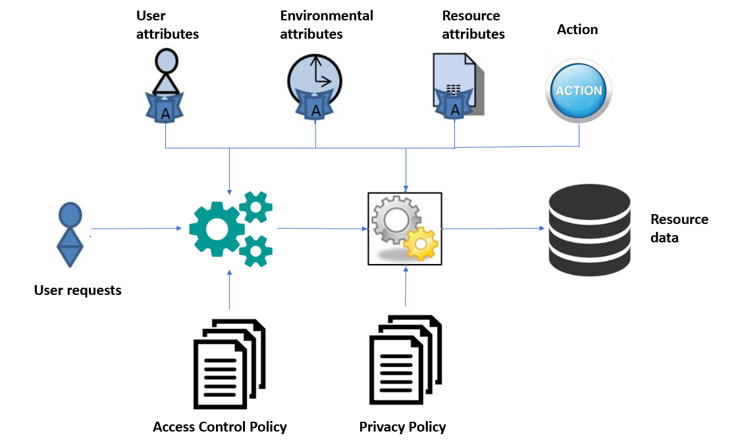

Figure 1. Attribute-Based Access Control and Privacy Protection Models

**Access Control Policies**: contain policies which are used to determine whether a subject can access resources. The decision is made based on rules inside policies which are the Boolean expressions evaluated by user’s defined function, subject, resource, environment attribute. Those policies are specified and managed by administrators.

**Privacy Policies**: contain policies which are used to determine whether some fields of a record in resources should be shown, hidden or blurred when a user access to it. The privacy protection is made based on rules inside policies which are the boolean expressions evaluated by user’s defined function, subject, resource, environment attribute. Those policies are specified and managed by administrators.

1. **Policy Structure:**

* Conditional Expression Construction:

Modeling rule expressions in access control is one of the most challenge things because the rules ensure that every access to a system and its resource is controlled and only those access that are satisfied the rules can only take place. To deal with complex expression, we treat each single expression and its parameter as a *function* structure and combine them using the tree structure.

|  |  |
| --- | --- |
| **Fields** | **Description** |
| function_name | The name of function. |
| value | If the value of this field is defined so it means that this function represents for a constant value or the JSON path to get data from resource (in this case "resource_id" field is also defined) |
| resource_id | The identifier or name of the resource |
| parameters | Parameters of each function can be a constant value, a value from environment, subject, resource or a value returned from another function. |

Using this approach, we can visualize a complex expression by a tree structure where each parent node is the name of function and leaf node is the constant value or non-parameter function.

For example, let consider the following rule:

“A user with role doctor cannot view those users who has Area Number of SSN field which equals LA.”

The equivalent expression will be:

*Exp*=“StringEqual (Subject.role, ‘doctor’) AND StringEqual (AreaNumber (Subject.ssn), ‘LA’)”

We can visualize it in the expression tree:

We also proposed an algorithm which converts the conditional expression in text format to the *Function* structure:

**Algorithm :** Algorithm for parsing conditional expression  
**Input**: *rawExpression*: string

**Output**: *function*: *Function* class

**1** Let *listToken*: List<string>**←** *getTokens*(*rawExpression*); /* gets tokens from *rawExpression*  
**2** Let *stackToken:* Stack<string> /* A stack stores names of functions */

**3** Let *queueToken:* Queue<string> /* A queue stores tokens in Reverse Polish Notation form */

**4** Let *queueFunction:* Queue<Function> /* A queue stores functions */

**5 begin**

**6 foreach** *token* **in** *listToken* **do**

**7 if** *IsFunctionName***(** *token )* **Or** *IsLogicalOperator***(** *token )* **Or** *token ==* "("**then**

**8** *stackToken*.**push** (*token*)

**9 else if** *token ==* ")"**then**

**10 while** *stackToken*.length > 0 **do**

**11 var** *temp* :*= stackToken*.pop()

**12 if** *temp ==* "("**then**

**13** *queueToken***.**enqueue**(***stackToken*.pop())

**14 *break***

**15 else** *queueToken***.**enqueue**(***temp*)

**16 end while**

**17 else** *queueToken.*enqueue (*token*)

**18 end foreach**

**19 while** *stackToken.*length > 0 **do** *queueToken.*enqueue (*stackToken.*pop())

**20 while** *queueToken.*length > 0 **do**

**21** *token* := *queueToken*.dequeue()

**22 if** *IsFunctionName***(** *token )* **do**

**23 var** *function* := Function.CreateFunction (token)

**24 for** i := 1 to *GetNumberParameters* (*function*) **do**

**25** *function.*Parameters.Add (*queueFunction.*dequeue())

**26 end for**

**27** *queueFunction*.enqueue (function)

**28 else** *queueFunction*.enqueue (Function.CreateConstantValue(*token*))

**29 end while**

**30 return** *queueFunction.*enqueue()

**31 end**

Next we apply the proposed algorithm to the rule in text format, the result will be a conditional expression in JSON format.

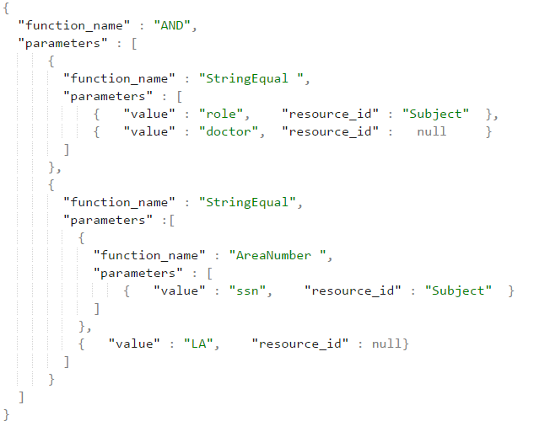

* 1. Access Control Policy:

In our system, an access control policy includes rules. Each rule defines a conditional expression that is modeled in *Function* structure. The rule returns a value specified in Effect if the condition is true. To avoid conflicts between policies and rules, the combining rule algorithms such as permit override, deny override, etc. are applied into the policy set and policies. The solution for using combining rule algorithm is inherited from XACML. The relationship diagram between policies and rules are illustrated in the Fig. 2

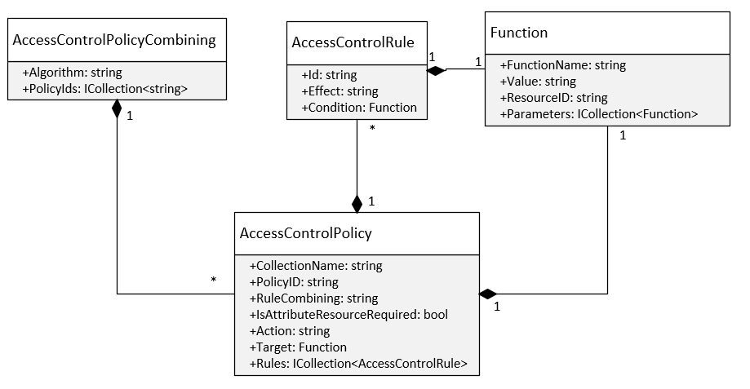

Figure 2. Access Control Policy class diagram

* Privacy Policy Structure:

To specify policies for privacy protection, access purpose is modeled as an attribute of  
environment and intended purpose is considered as an attribute of data objects in the  
resource content.

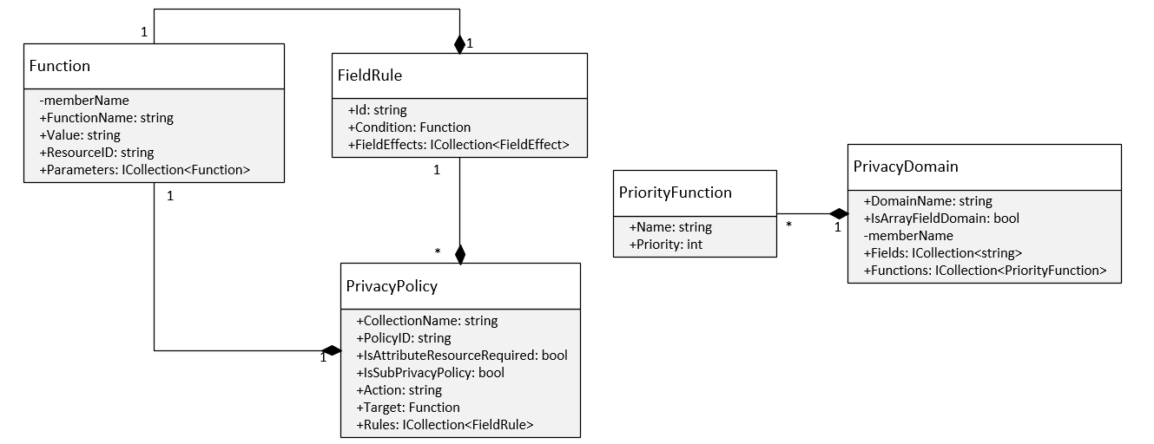

Figure 3. Privacy Policy class diagram

The conflict situation occurred when there are multiple rules in a privacy policy which are satisfied the condition. It results to that we have many privacy functions to be applied to one field of object. Therefore, we have added a new structure named “PrivacyDomain” to solve conflict. We also specify a constraint that a field in resource can only belong to at most two domains, one is default domain which contains two basic privacy functions: show and hide, another domain is configured by administrator.

Example:

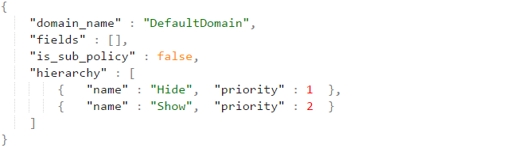

First, we will explain more detail about the “field_effects” field in privacy policy structure. It is an array field and the number of elements in this field is equal to the number of single value field in resource. Each element has the following structure:

"name": is the path to the single value field.

"effect_function": This field has only 2 value patterns. First is "Optional" value, second is "X.Y" value where X is privacy domain, and Y is name of privacy function in that domain.

For example, we have the conflict privacy table.

|  |  |
| --- | --- |
| **Fields** | **Conflict Privacy Functions** |
| name | Optional, DefaultDomain.Show |
| personal_info.birth_date | DateTimeDomain.ShowMonthAndYear,  DateTimeDomain.ShowYear,  DefaultDomainPrivacy.Show |
| personal_info.ssn | SsnDomain.AreaNumber, SsnDomain.SerialNumber, Optional |

The privacy function will be chosen using the following rule:

P(“Optional”) < P(“DefaultDomain.Show”) < P(X.Y1) < … < P(X.Yn) < P (“DefaultDomain.Hide”)

where P(X.Y) stands for priority of privacy function Y in domain X. The priority is configured by administrator in “PrivacyDomain” structure.

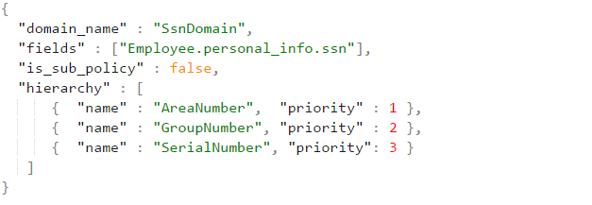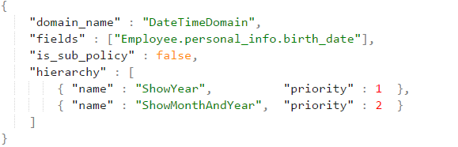

Applying this rule to above conflict table, we will have the following result:

|  |  |
| --- | --- |
| **Fields** | **Privacy Function Chosen** |
| name | DefaultDomain.Show |
| personal_info.birth_date | DateTimeDomain.ShowYear |
| personal_info.ssn | SsnDomain.AreaNumber. |

* Advanced privacy policy support for array of embedded subdocuments:

JSON object can contain not only single-value field (string, number, boolean value) but also contain an array of objects field (it’s also known as array of embedded subdocuments in mongoDB) which makes the JSON object more complex. To support privacy for array of objects field, we extend the value of "effect_function" field in Privacy Policy structure so that its value can be an identifer of another privacy policy which target to this array field.

For example:

A complex JSON Object named "Project Bonus":

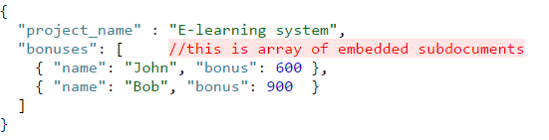

We have a privacy rule: "Employee can only view his/her bonus for each project. "

The equivalent sub-privacy policy will be specified as followings:

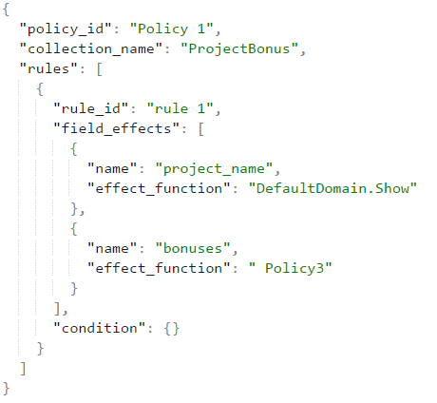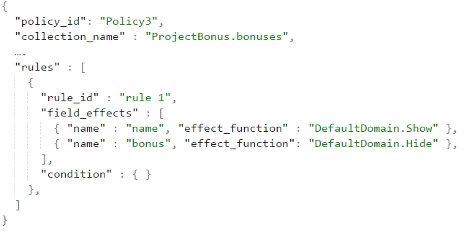

Then the main privacy policy for "ProjectBonus" collection will use the value of "policy_id" of this sub-privacy policy for the "effect_function" field:

Now, if John want to view "ProjectBonus" collection, the result will be:

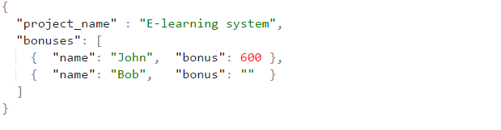

Bonus for Bob has been hidden due to sub-privacy policy.

1. **Experiment**

We carried out experiment about the relevance between processing time of authorization and complexity of documents. The system configuration for the experiments is Intel core i5-3230 M 2.60 GHz, 8 GB RAM. The prototype is implemented by C#, .NET Core and MongoDB for storing policies and data. All experiment include five access control polices and five privacy policies, each policy contains three rules and each rule required three attributes to evaluate. Each record in resource must carry out though 2-stage authorization.

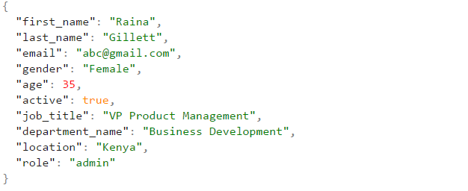

Figure 4. Example of subject data for experiment

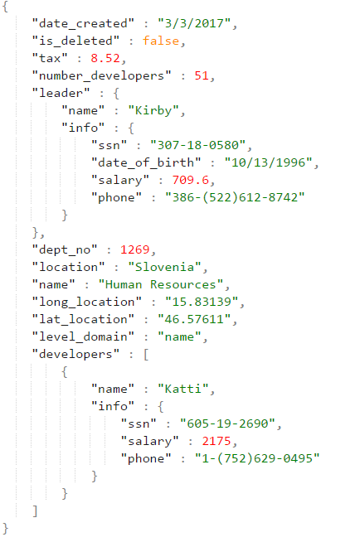

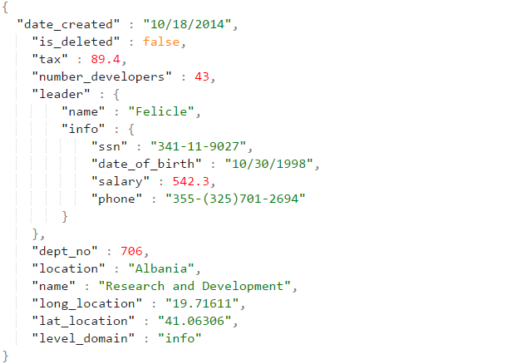



Figure 5. Example of resource data for experiment

The structure of subject data we used in experiment is described as follows:

* First experiment: The structure of resource in figure 5.a is used

|  |  |  |  |  |  |  |  |
| --- | --- | --- | --- | --- | --- | --- | --- |
| ID | Number records | T1(ms) | T2(ms) | T3(ms) | T4(ms) | T5(ms) | Average(ms) |
| 1 | 2000 | 2157 | 2274 | 2222 | 2189 | 2302 | **2228** |
| 2 | 4000 | 4501 | 4642 | 4644 | 4325 | 4494 | **4521** |
| 3 | 6000 | 6863 | 6690 | 6720 | 6761 | 6458 | **6698** |
| 4 | 8000 | 9022 | 8929 | 8908 | 9035 | 9010 | **8980** |
| 5 | 10000 | 11762 | 11619 | 11547 | 11273 | 11465 | **11533** |
| 6 | 12000 | 14290 | 13430 | 13643 | 13646 | 13980 | **13797** |

Table 1 Processing time of first experiment.

* Second experiment: The structure of resource in figure 5.b we used in second experiment is more complex than in first experiment which contains an array of embedded documents. Each record has an array of embedded documents field which contains at most five elements inside it.

|  |  |  |  |  |  |  |  |
| --- | --- | --- | --- | --- | --- | --- | --- |
| ID | Number records | T1(ms) | T2(ms) | T3(ms) | T4(ms) | T5(ms) | Average(ms) |
| 1 | 2000 | 2641 | 2775 | 2708 | 2611 | 2507 | **2648** |
| 2 | 4000 | 5141 | 5270 | 5260 | 5265 | 5253 | **5237** |
| 3 | 6000 | 7879 | 7931 | 7692 | 8141 | 8176 | **7963** |
| 4 | 8000 | 10946 | 11226 | 10712 | 10768 | 10830 | **10896** |
| 5 | 10000 | 13700 | 13344 | 13581 | 13716 | 13526 | **13573** |
| 6 | 12000 | 16269 | 16483 | 16085 | 16219 | 16111 | **16233** |

Table 2 Processing time of second experiment.

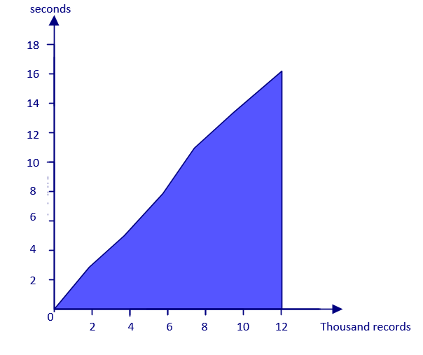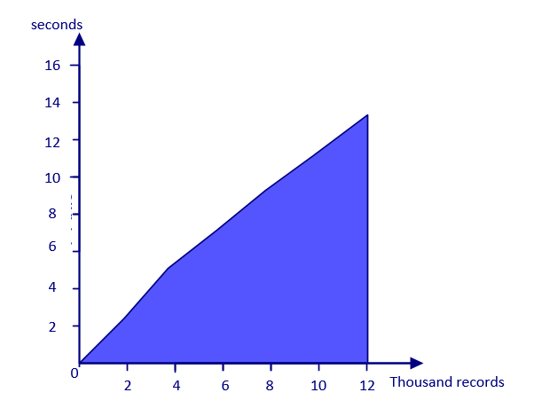

Figure 6. Chart of processing time in experiment.

From the result of two experiment, it indicates that the processing time increases with the complexity of data. In the first experiment, the average processing time for one record is approximately 1.1ms and in the second experiment which contains array of embeded documents is about 1.3ms per record.

1. **Conclusion**

In this research, we have proposed a comprehensive framework for enforcing attribute-based security policies stored in JSON document together with the feature of data privacy protection in the fine-grained level. We have used Polish notation for modeling conditional expressions which are the combination of subject, resource, and environment attributes so that the policies are flexible, dynamic and fine grained. Through the proposed flexible structure for privacy protection called as Attribute-Based Privacy Protection, it can be evaluated not only by access purpose but also by subject, resource, environment attributes. User can define and review policy through our application. In future, we will improve our framework to work with other NoSQL database document stores. Besides that, we will try to optimize the processing time by applying heuristic functions when evaluating conditional expression.

**References:**

1. Bertino, E., Ghinita, G., Kamra, A.: Access Control for Databases: Concepts and Systems.  
Now Publishers, Hanover (2011)

2. Hu, V.C., Ferraiolo, D., Kuhn, R., Friedman, A.R., Lang, A.J., Cogdell, M.M., Schnitzer, A.,  
Sandlin, K., Miller, R., Scarfone, K.: Guide to Attribute Based Access Control (ABAC)  
definition and considerations (draft). NIST Spec. Publ. 800, 162 (2013)

3. Byun, J.-W., Bertino, E., Li, N.: Purpose based access control of complex data for privacy  
protection. In: Proceedings of the Tenth ACM Symposium on Access Control Models and  
Technologies (2005)

4. Byun, J.W., Li, N.: Purpose based access control for privacy protection in relational database  
systems. VLDB J. 17(4), 603–619 (2008).

5. Colombo, P., Ferrari, E.: Enforcement of purpose based access control within relational  
database management systems. IEEE Trans. Knowl. Data Eng. 26(11), 2703–2716 (2014).

6. Rissanen, E.: eXtensible Access Control Markup Language (XACML) version 3.0  
(committee specification 01). Technical report, OASIS (2010). http://docs.oasisopen.org/  
xacml/3.0/xacml-3.0-core-spec-cd-03-en.Pdf

7. Hua, L.S., Vijay Varadharajan: Purpose-based access control policies and conflicting  
analysis. Security and Privacy - Silver Linings in the Cloud, 217-228(2010).

8. Colombo, Ferrari: Fine-Grained Access Control Within NoSQL Document-Oriented  
Datastores. Data Sci. Eng., 127–138 (2016).

9. InterNational Committee for Information Technology Standards: Information technology -  
Next Generation Access Control - Generic Operations and Data Structures. (2015)

10. Biswas, R.S., Krishnan: An Attribute-Based Protection Model for JSON Documents. Network and System Security, 303-317 (2016).

11. Gartner. Gartner says “By 2020, 70% of businesses will use attribute-based access control (ABAC) to protect critical assets”.[Online] Available at < <https://www.avatier.com/products/identity-management/resources/gartner-iam-2020-predictions/> >, 2016. [Accessed 3 March 2017].

### 12. Information Commissioner’s Office. Data Protection Principles. [Online] Available at <<https://ico.org.uk/for-organisations/guide-to-data-protection/data-protection-principles/> >

13. Enterprise Privacy Authorization Language. [Online] Available at < <https://www.w3.org/2003/p3p-ws/pp/ibm3.html> >