Make sure that .net core 2 is already installed.

First clone the source from: <https://github.com/raymondhuy/RhetosCore> .

Step 1: BUILD the solution:

* If VS 2017 version 15.3.3 is already installed: Open it with Vs 2017, waiting for it to restore Nuget packages then rebuild solution. (It will take a while).
* If VS 2017 version 15.3.3 is not installed: Open cmd where the RhetosCore.sln is placed and then run “dotnet build”. It will build the entire solution.

Step 2: RUN:

Navigate to “RhetosCore\Source\Rhetos”, open cmd then run:

dotnet publish

GetServerFiles.bat

Navigate to “RhetosCore\Source\Rhetos\bin\Debug\netcoreapp2.0\publish”, open cmd then run:

dotnet CreateAndSetDatabase.dll (local) "YourDbName".

It should have the result like this:

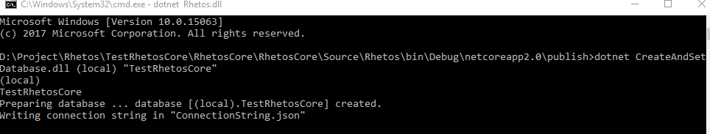

Copy the connection string generated in RhetosCore\Source\Rhetos\bin\Debug\netcoreapp2.0\publish \ConnectionString.json In my case is :

"ServerConnectionString":{"Value":"Data Source=(local);Initial Catalog=TestRhetosCoreGithub;Integrated Security=SSPI;","Provider":"Rhetos.MsSql"}

To replace the existing connection string in “RhetosCore\Source\Rhetos\bin\Debug\netcoreapp2.0\publish \ appsettings.json”. Then appsettings.json should content as following:

{

"Logging": {

"IncludeScopes": false,

"LogLevel": {

"Default": "Warning"

}

},

"ServerConnectionString":{"Value":"Data Source=(local);Initial Catalog=**TestRhetosCoreGithub**;Integrated Security=SSPI;","Provider":"Rhetos.MsSql"},

"AppSettings": {

"AssemblyGenerator.ErrorReportLimit": 5,

"EntityFramework.UseDatabaseNullSemantics": "false",

"DataMigration.SkipScriptsWithWrongOrder": "false",

"Security.LookupClientHostname": "false",

"AuthorizationAddUnregisteredPrincipals": "false",

"BuiltinAdminOverride": "true"

}

}

Then open cmd in “RhetosCore\Source\DeployPackages\bin\Debug\netcoreapp2.0\publish”

Run: dotnet DeployPackage.dll.

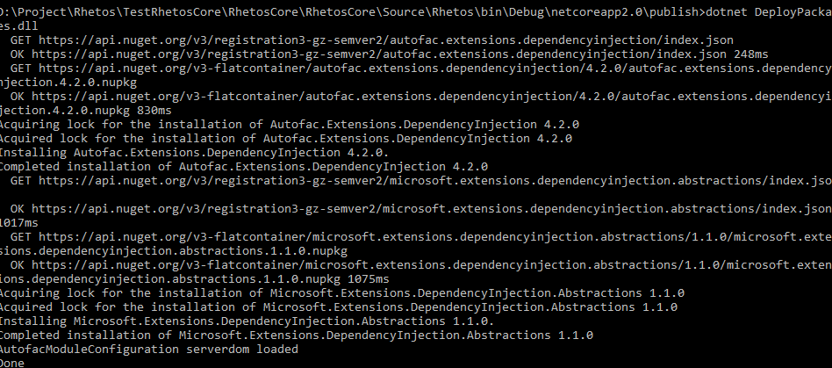

Run: dotnet Rhetos.dll

