Given that the Value column represents expenditure on education as a percentage of total government expenditure, we will focus our analysis on this column. We will analyze the distribution of this value across different years, countries, income groups and regions using the median as the central tendency measure. We will use line charts to visualize the trend of median Value over time for each region and Income group.

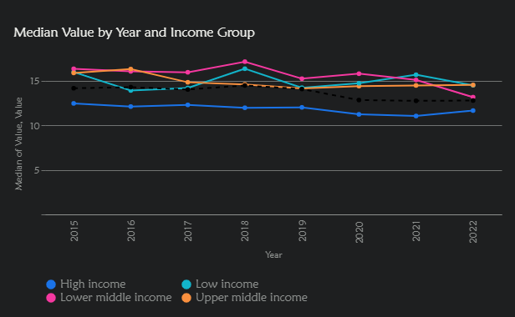

Based on the analysis of the dataset on education expenditure, we find the following insights:

1. **Summary Statistics:** The average expenditure on education as a percentage of total government expenditure is 14.27%, with a standard deviation of 4.69. This indicates a moderate degree of variation in education expenditure across the countries and years in the dataset. The minimum value is 1.7%, and the maximum is 35.01%, highlighting a wide range of investment levels in education. The median value is 13.83%, which is slightly lower than the mean, suggesting a slightly right-skewed distribution.
2. **Trends Over Time:** There is a slight decline in the median value of education expenditure over the years, suggesting a potential decrease in the prioritization of education in government budgets.
3. **Variation by Income Group:** Low-income and lower-middle-income countries tend to allocate a larger proportion of their government expenditure to education compared to high-income and upper-middle-income countries. This could be due to the higher perceived value of education in these countries as a means of economic development.
4. **Regional Differences:** Sub-Saharan Africa has the highest median expenditure on education, while North America has the lowest. This could be attributed to different socio-economic factors, government policies, and cultural values across regions.
5. **Country-Level Disparities:** There is significant variation in education expenditure at the country level. Sierra Leone, Turkmenistan, and Namibia are among the top spenders, while Somalia, South Sudan, and Monaco are among the lowest. These disparities could be due to a variety of factors, including economic conditions, political priorities, and the availability of resources.

The analysis of the line charts, supplemented by the calculated percentage changes, reveals several key insights:

1. **Overall Decline:** There has been a general decline in the median expenditure on education as a percentage of total government expenditure from 2015 to 2022, with an overall decrease of 9.75%. This suggests a potential shift in government priorities or budgetary constraints affecting education funding.
2. **Regional Variations:** The decline in education expenditure is not uniform across regions. While Europe & Central Asia saw a slight increase of 7.14%, all other regions experienced decreases, with East Asia & Pacific, Middle East & North Africa, and South Asia showing the most significant declines (over 20%). This highlights the diverse economic and political landscapes influencing education funding in different parts of the world.
3. **Income Group Disparities:** Lower-middle-income countries faced the most substantial decrease in education expenditure (-19.47%), followed by low-income countries (-9.3%). This raises concerns about the widening gap in educational opportunities between income groups, potentially exacerbating existing inequalities.

In conclusion, the analysis of the line charts and percentage changes underscores a concerning trend of declining investment in education globally, with significant variations across regions and income groups. These findings emphasize the need for policymakers and stakeholders to prioritize education funding and address the disparities to ensure equitable access to quality education for all.