A whole-systems approach to population ecology

NRES 470/670

Jan 19, 2018

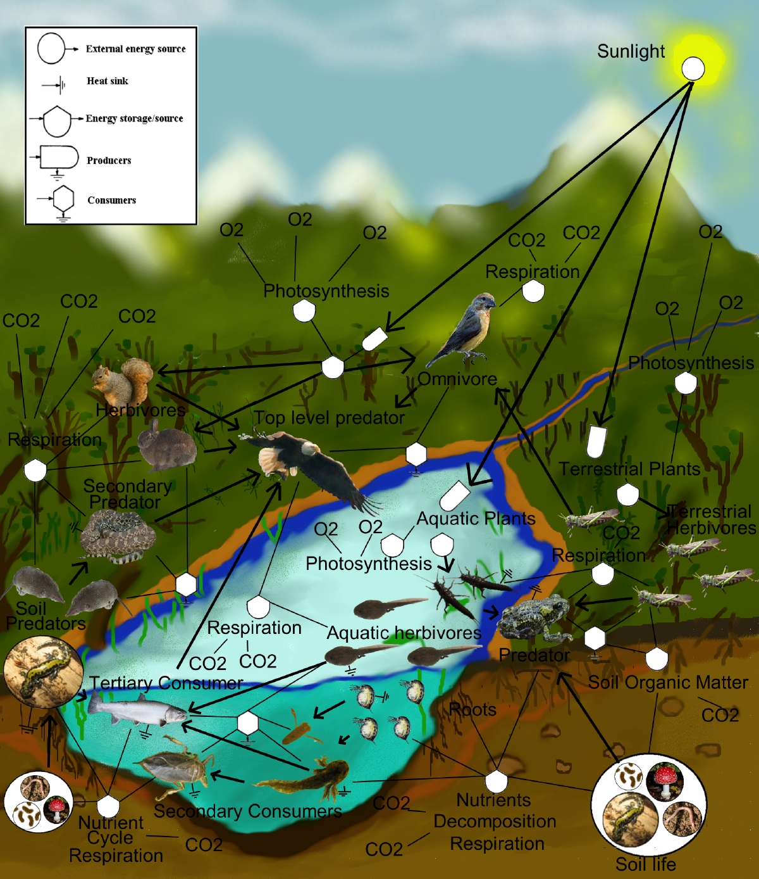

## Systems ecology: a way of thinking

Ecology is messy. When we work in natural environments, we are dealing with *inherently complex systems*. *All elements in a natural system are connected*, full of dynamic interactions. Interactions among organisms, between organisms and their environment to meet basic needs -- these linkages are what makes ecology messy, but also endlessly fascinating.

We can think of humans as just another element in these complex systems. And wildlife conservation and mangement is the task of manipulating these linkages to meet societal objectives for natural systems.

This is not a systems ecology class!

BUT, systems ecology provides a great framework for thinking about natural populations, understanding how linkages (abiotic and biotic environments) might affect them, and how to manage natural populations most effectively.

## Emergent properties

This is one of the most powerful ideas in whole-systems thinking -- when you put many interacting, linked parts together, systems often behave in interesting and unexpected ways!

Take a classic predator-prey system...

[Insightmaker Lynx-Hare example](https://insightmaker.com/insight/68437/)

This is a classic example in population ecology, which we will revisit in great detail in this course - but for now it serves as an example of an interacting system that exhibits an emergent property -- regular oscillations!

And here's a more abstract example that illustrates some really cool and complex emergent properties.

[Lorenz attractor](https://insightmaker.com/insight/1829/Lorenz-Attractor)

## *InsightMaker*: a modeling framework for systems thinking!

[InsightMaker](insightmaker.com) is a flexible web-based software for defining interacting systems and for modeling the behavior of inter-connected systems.

Both of the above examples were constructed in InsightMaker.

We will make extensive use of InsightMaker, both during class and in lab- this will give you a chance to play around with complex and dynamic systems without needing a background in computer programming!

## Computer programming and systems thinking

Modern computers have reduced or eliminated many of the barriers to understanding how complex systems behave, and as a result **specialized software and computer programming** are a critical component to modern whole-systems analysis, including **ecosystems** analyses. Armed with basic facility with computer programming, ecologists and natural resource professionals can formalize their understanding of the natural systems in which they work, accounting for complex biological realities that may have been ignored if these tools were not available. **In this course, we will learn to harness the power of computer simulations for understanding and managing natural populations**.

By the end of this course, students will have the ability to program their own *whole-systems models* in InsightMaker, and use specialized software for parameterizing these models (e.g., Program MARK, various **R** packages)

**The course motto**: *Get messy*! This might sound funny for a computer-based class. But just as ecological systems are complex and messy, models sometimes get messy. Don't be afraid to model messy systems. And above all, **don't be afraid to be wrong** (especially at first)- that attitude is the enemy of successful computer programming, and of good wildlife management! When we build our own algorithms, we can be entering uncharted territory. And this can be difficult and dangerous, but ultimately rewarding! Keep trying, and stay positive!

Of course, getting messy means not just reading and listening to lectures, it means *learning by doing*! Instructor-led lectures will be kept short, and we will spend significant class time (and pretty much all of lab time) on our computers, working through problems.

## In-class Exercise: InsightMaker

A [Stock] of stuff increases over time via what [Flows] in. Imagine our stock represents *Moose*! *Moose Births* would then be the input [Flow] to the population of *Moose* over time.

A [Stock] of stuff decreases over time via what [Flows] out. For example, *Moose Deaths* could represent the [Flow] out of the population of *Moose*.

If the [Flow] in is larger than the [Flow] out then the [Stock] increases over time.

If the [Flow] out is larger than the [Flow] in then the [Stock] decreases over time.

If the [Flow] in equals the [Flow] out then the amount in the [Stock] will not change over time.

The important takeaway is that a [Stock] represents a quantity of something. The [Stock] only changes over time via [Flows In] or [Flows Out]. A [Stock] doesn't change instantaneously, with hand waving, magic, or smoke and mirrors.

1. Open up [InsightMaker](https://insightmaker.com/). If you have never used it before you need to sign up first with a username and password. *InsightMaker is free!*
2. Create a new Insight (the button to do this should be obvious!) and clear the demo model.
3. Right click in the center of the screen and select **Create Stock** from the popup. Notice that the name is *New Stock* and is selected. Type in a name for what this is an accumulation of. Note the **Configuration Panel** on the right is now for a [Stock]. In the configuration panel, set the *Initial Value* to 50. That is, there will be 50 moose at the start of the simulation!
4. Select [Flow] in the upper left corner of your screen under [Connections]. Now notice that when you mouse over the [Stock] a small right-arrow displays. Click on the right-arrow and drag a couple inches to the left of the [Stock] and release. This is how you create a [Flow] out of a [Stock]. To create a [Flow] into a [Stock] click the **Reverse** button in the **Connections** menu. Please do that now. You can name the [Flow] as you wish. Also in the **Configuration Panel** set **Flow Rate** = 1.
5. Now click **Run Simulation** and you have just finished your first simulation model.
6. Can you figure out how to change the settings to run the model for 50 years? Try this and click **Run Simulation**.
7. Use the same methods as *step 4* to create a [Flow Out], representing moose deaths. Re-run the model. Is the population increasing or declining? Why?
8. Change the **Configuration Panel** for the [Stock] and for the [Flow In] and [Flow Out] so that "Show Value Slider" is set to "Yes". You can change the model parameterization easily using these sliders. Try it a couple times, re-running the simulation after each change.

**Q**: Is this Moose model realistic? What is the first thing you would like to change to make the model more realistic?

1. Take a few minutes to check out "Insights" made by others using the "explore insights" link at the top of the webpage. You can search the database of Insights. We can (and will) add to this database as part of this class!

Finally, just for fun, here is a cool video of the Lorenz Attractor, which we saw earlier!

[Lorenz attractor video!](https://www.youtube.com/watch?v=iu4RdmBVdps)

[--go to next lecture--](LECTURE2.html)