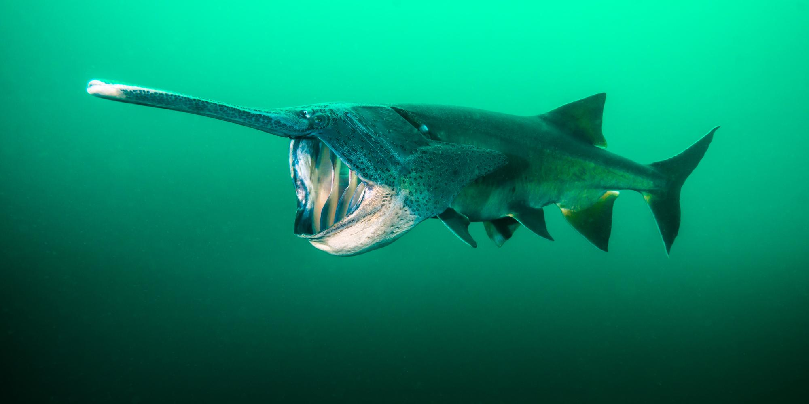

**A Synopsis on Paddlefish Populations in the Mississippi Basin and Factors Affecting their Viability**

James Golden, Travis Chapman, Brianna Jones, Stevie Applewhite

University of Nevada, Reno

NRES 470: Population Dynamics

Dr. Kevin Shoemaker

April 15, 2020

**Introduction:**

The North American paddlefish (*Polyodon spathula*) is one of the longest lived and largest species of freshwater fish in North America (Zigler, 2009). It inhabits lakes, large rivers, and tributaries along the Mississippi river and once inhabited 26 states (Graham, 1997). However, its populations have been extirpated from 4 states, declared extinct in Canada, and have been greatly reduced in every state (Graham, 1997). It is now listed as a vulnerable species on the IUCN red list, but data concerning populations of paddlefish is lacking (Grady, 2019). The paddlefish shares similar characteristics to the order Chondrichthyes, but the identifying feature of the paddlefish is its paddle-like rostra protruding from its snout (Zigler, 1997). *Polyodon spathula* can live up to thirty years old, weigh up to 72 kilograms, and grow to lengths exceeding 2.2 meters (Zigler, 2009). A well adapted planktivore, the paddlefish uses modified gill rakers along gill arches that serve as sieves to filter zooplankton in the water column as they are carried by current (Rosen & Hales, 1981). Young fish actively select particulates in the water column, but it is unknown at what stage the young fish begin filter feeding (Michaletz et al., 1982). To filter feed, paddlefish swim with their mouths gaped, making them highly susceptible to bycatch and seines (Rosen & Hales, 1981).

The family Polyodontidae split from the Acipenseridae family (the sturgeon family) around 200 million years ago prior to the Late Cretaceous period (Birstein et al., 1997). The American paddlefish had one sister species in it’s family known as the Chinese Paddlefish (Birstein et al., 1997). The Chinese paddlefish was declared extinct in 2019 in a study conducted by Hui Zhang of the Chinese Academy of Fishery Sciences. The study concluded that the Chinese paddlefish’s extinction was the result of overfishing, dam construction, and habitat degradation which led to a reduced spawning probability and their eventual extinction (Zhang et al., 2020). These causes are identical to factors affecting paddlefish in North America. Along with this, the extinction of the Chinese paddlefish makes the North American paddlefish the final remainder of the family Polyodontidae, a lineage that has persisted for 200 million years.

Similar to Salmonidae species, paddlefish require specific spawning conditions which have made them highly susceptible to river alterations (Douglas & Bonislawsky, 1981). Alterations to rivers such as straightening, channelization, pollution, and dams have led to the destruction of spawning grounds, blockage of migration routes, and elimination of backwater areas (Douglas & Bonislawsky, 1981). Unfortunately, due to the Caspian Sea caviar market crash, paddlefish have been identified as a new source of caviar income (Mims et al., 2000). A reproductive female weighing 40 pounds can produce up to 4-6 pounds of roe and generate an income of 900 dollars (Mims et al., 2000). Due to this, all species in the order Acipenseriformes (25 sturgeon and the two species of paddlefish) were placed under CITES (Raymakers, 2002). Paddlefish caviar poaching primarily takes the form of gill nets and seines on spawning beds, where the reproductive females are removed and killed in order to obtain their roe (Mims et al., 2000). This practice has been suspected of contributing to the decline of paddlefish populations across the United States (Raymakers, 2002). Paddlefish are also valued for their boneless meat (Mims et al., 2000), which has resulted in many states regulating sport and commercial fisheries for younger individuals under thirty inches. However, the effects of these negative factors on paddlefish populations are understudied. Large ranges of values exist for birth rates, death rates due to caviar poaching, maturity, and size. Along with the lack of sufficient data for vital rates and size, there is lacking data for habitat quality, carrying capacity, and initial population size.

The purpose of this study was to design a population viability analysis to test specific management practices on paddlefish in the Mississippi Basin, consisting of the states; Arkansas, Illinois, Iowa, Louisiana, Minnesota, Missouri, Mississippi, Oklahoma, Tennessee, and Wisconsin. Through this population viability model, we sought to identify major factors that were affecting paddlefish populations and formulate management plans that would improve their populations. Given that caviar poaching leads to a decrease in eggs produced at spawning grounds (Mims et al., 2000); we wanted to test levels of caviar poaching to determine its overall effect on the paddlefish populations. We also looked at the effects of paddlefish harvesting by sport and commercial fisheries, as well as spawning habitat quality and dam removal on paddlefish populations.

The choice of the North American paddlefish for this study was the result of many reasons. For one, the North American paddlefish could become an important aspect of the midwestern economy. We hypothesize that the paddlefish could provide a sustainable harvest for both individual fish as well as caviar if regulated correctly. We also hypothesize that if populations are sustained, caviar can bring large amounts of income while being obtained in a way that does not kill reproductive adults ie. fish milking. Fish milking can be legally performed on many species of trout and salmon, but we believe it can be done with paddlefish as well. With improved and sustainable populations of paddlefish, sport fishing may serve as a valuable recreational economy. The final reason we chose to study the American paddlefish is the fact they are part of a lineage that emerged from the Earth's fourth mass extinction and survived the Cretaceous mass extinction that wiped out an estimated 75% of all life on earth (Jablonski, 1994). The american paddlefish represents a historic lineage that now faces the risk of forever disappearing due to anthropogenic change.

**Methods:**

In making this model we were unable to identify one study that attempted to look at the life stages and their associated transition and death rates; forcing this model to be incredibly complex and subject to increased amounts of referencing other species data (primarily sturgeon), estimation, and guess work. Paddlefish live to be around 14-18 years old and due to differences in life history traits at different ages, they have multiple stages of development. As the population has a roughly 1:1 sex ratio (Hupfeld, 2014) this model displays only the females of the population. We determined that there were seven total age classes that the paddlefish follow: juveniles, subadults (multi-five-staged period with only time, sexaul reproduction and weight leading to adulthood), and adults each age class determined by weight classes, and reproductive maturity. For the model we split up the subadults into five varying sub adult classes due to the differing mortality rates and because female paddlefish reach sexual maturity around age 6 (Zigler, 1997). Each stage (aside from adulthood) takes one year to transition between and thus any paddlefish older than 6 is simply classed as an adult. It was also found that females do not reproduce every year, rather once every 2-4 years (Zigler, S. J., 2009, Kramer et al., 2018). To incorporate this, we took the upper bound of 4 years, which equates to roughly 25% of the female populations reproducing every year.

Spawning rituals of the North American paddlefish are comparable to that of many salmonidae species. Paddlefish require gravel substrates, specific photoperiods, water temperature, and water flow in order to successfully spawn (Zigler, 1997). Male paddlefish reach sexual maturity anywhere from age 4 to 9 and females reach sexual maturity anywhere from age 6 to 12 (Zigler, 1997). Female paddlefish spawn every four years and may lay anywhere from 9,000 to 26,000 eggs per kilogram (Zigler, 1997). Primarily, paddlefish look for slow moving or deep water for both spawning and feeding (Zigler, 1997). Spawning is initiated by increased flows during the spring, in correlation to the rising of water temperatures above 10 degrees celsius and below 20 degrees celsius (Zigler, 1997). Using the USGS water database, the primary time for these conditions in the Mississippi range are from late April into late May. If these regional conditions are not met at the right time, females will absorb their eggs and not spawn in order to conserve energy, which leads to large, unpredictable fluctuations in recruitment of juveniles (Zigler, 1997). Life stages of paddlefish are considered to be widely unknown (Grady et al. 2005). In light of this, for the study we concluded that there would be a total of seven life stages ranging from juveniles, 5 sub adult stages, and a reproductive adult stage.

Zigler et al. 1997 states that if the correct water conditions, temperature, water flow, and photoperiod were not met, then female paddlefish would not spawn and would instead absorb the eggs. Spawning water temperature requirements for paddlefish are located in a range between 10-20ᐤC (Zigler, 2009).To mimic this, in our model we added the condition that there would be no eggs produced if these water temperature requirements were not met that year (done by incorporating a water temperature variable with RandNormal(14.5, 1.75) as the input, and linked to the effective per-capita eggs) . In addition, we added the flow velocity that would need to be met between late April to late May. However, we could not find these values in any literature. To mitigate this, we took data from ([waterdata.usgs.gov](https://waterdata.usgs.gov/monitoring-location/05331000/#parameterCode=00060&period=P1Y)) and averaged the flow velocity records in the Mississippi basin portion of the Mississippi river for late April to late May from 2010-2015 (data past this point no data could not be found). We found that the water velocity would likely need to be above 61,000, but were unable to determine what would be too high of a flow. Due to the lack of variability of photoperiod from year to year we did not include this variable.

To determine the average fecundity of paddlefish, we had to go solely off of their average egg production. This was due to the lack of information from any peer reviewed source, study or organization for how many juveniles survived past the egg stage as well as no given number for fecundity. Paddlefish on average lay 9,000-26,000 eggs per kg of body weight with average female weight around 18.7 kg in the central United states (Zigler, 2009). Reproductive female paddlefish far exceed 18.7 kg meaning that many more eggs could be produced than the lowest and highest bound. By using the upper bound of average eggs we obtained the per capita birth rate of 4862.60. In addition to this we imposed a random normal distribution with a variance of 85, by keeping egg production on the higher end in order to keep in consideration the larger reproductive females in the wild.

Looking at the survival and mortality rates for the various age classes was problematic because for most age classes there was either no data, data that was ill defined, or data had merged age classes. As such, we used what data we had along with parameter data from sturgeon (another related and heavily exploited species of fish) (Jaric, 2018). We tested these parameters, making sure that the inputs would result in numbers that could be reasonably expected from the population. Data that we were able to obtain through various papers included the average annual mortality rate of various populations, ranging from 0.237 with a standard deviation of 0.036 and the annual mortality of the lower Wisconsin river being 0.267 (Pierce et al. 2015). Conditional natural mortality rate for adults was modeled for Lake of the Ozarks as 19%, Harry S. Truman Reservoir as 18%, and Table Rock Lake as 21%. Total annual mortality rates between locations were similar. Specifically, Lake of the Ozarks had an annual mortality rate of 23.9%, Harry S. Truman Reservoir with 25.1%, and Table Rock Lake with 27.8%. (Hupfield, 2014). Additional data from the MICRA database allowed us to use the various sources data to calculate survivorship of adults in the Mississippi river, yielding a natural mortality of 54%.

|  |
| --- |
| **Life matrix of Paddlefish without human interference (**fishing, overharvesting, and caviar harvesting or the added numbers from stocking from hatcheries) |

|  |  |  |  |  |  |  |  |  |
| --- | --- | --- | --- | --- | --- | --- | --- | --- |
|  | ***Egg*** | ***Juvenile*** | ***Subadult 1*** | ***Subadult 2*** | ***Subadult 3*** | ***Subadult 4*** | ***Subadult 5*** | ***Adult*** |
| ***Egg*** | 0 | 0 | 0 | 0 | 0 | 0 | 0 | 4862.60 |
| ***Juvenile*** | 0.01 | 0 | 0 | 0 | 0 | 0 | 0 | 0 |
| ***Subadult 1*** | 0 | 0.09 | 0 | 0 | 0 | 0 | 0 | 0 |
| ***Subadult 2*** | 0 | 0 | 0.4 | 0 | 0 | 0 | 0 | 0 |
| ***Subadult 3*** | 0 | 0 | 0 | 0.6 | 0 | 0 | 0 | 0 |
| ***Subadult 4*** | 0 | 0 | 0 | 0 | 0.6 | 0 | 0 | 0 |
| ***Subadult 5*** | 0 | 0 | 0 | 0 | 0 | 0.8 | 0 | 0 |
| ***Adult*** | 0 | 0 | 0 | 0 | 0 | 0 | 0.9 | 0.54 |

For this matrix, it was determined that this cohort would start out with 48,626 eggs by using the already determined per capita birth rate, 4862.60, and multiplying it by 10. This number was chosen for ease of applying it to the population. It was found that by the end we would end up with 35 surviving adults. For many of the survival and mortality rates used sturgeon data (Jaric, 2018) was used along with assumptions made about the species from the little data known about the species, see Figure 1. From the 48,626 eggs we assumed, with consideration of lacking data that was not provided by conservation sources and using data from sturgeons, that there would be a 0.99 mortality rate, providing a survival and transition rate of 0.01, which tells us that the percentage would move onto the juvenile stage. Using this survival rate we can also find the mortality rate of stages that were not provided in the literature. From there, due to the lack of data, we make an assumption based on sturgeon data (Jaric, 2018) that of those juveniles, 900 would survive and move onto the first sub adult stage, giving us the survival rate of 0.09 and a mortality rate of 0.91. From the first sub adult stage we anticipated that 180 would survive to sub adult stage 2 giving a survival and transition rate of around 0.2 and a mortality rate of 0.8 from sub adult stage 2 we inferred that 72 would survive to go onto sub adult stage 3, giving a transition and survival rate of around 0.4 individuals and a mortality rate of 0.6. For the transition of sub adult stage 3 to sub adult stage 4 we anticipated that approximately 43 members would survive providing a transition and survival rate of around 0.6, and a mortality rate of 0.4. From sub adult stage 4 to sub adult stage 5 we inferred that 35 would survive, giving us a transition and survival rate of around 0.8 and a mortality rate of 0.2. From there the sub adult 5 individuals would reach the last stage, adults. We assumed that subadults in this age class will mostly all survive to transition to adulthood with a 0.9 transition and survival rate and a 0.1 mortality rate. We assumed survivorship would greatly increase as subadult stages progressed because the paddlefish would begin to outgrow predation from fish and birds. We found that the mortality for adults would likely be around 0.54, giving them a survival rate of 0.46 (MICRA). While initially this seems high, this is due to the lack of predators, with the only exception being the American alligator (*Alligator mississippiensis*), adult paddlefish have (Gilland et al., 2018), and because the adult age class accounts for all paddlefish individuals over the age of six instead of just one year of the paddlefish’s life. The complete lack of literature and data for paddlefish life history, stage survival rates, stage death rates, and fecundity forced us to make very conservative and assumptious values for what survivorship of each life stage was. There was little we could infer from sturgeon data as these values are incredibly spread out due to sturgeon distribution and their lack of study as well, but we were able to use the data to make some inferences about a few parameters.

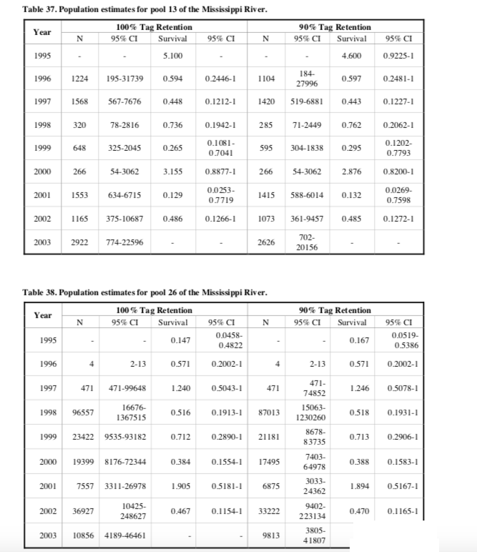

**Figure 1: MIRCA Population estimates and survival rate calculations of adult paddlefish (Grady et al., 2005)**

With these rates we can determine how the values chosen for carrying capacity (K) would affect the population and mortality rates if the population goes above K. This is operating under the assumption that survival rates and mortality rates are density dependent as this population is limited to streams and rivers as habitat, meaning that both space and food are limited. First we needed to explain what our values for K are and how they were obtained. There is no data nor mention in any paper of a potential carrying capacity for this species and any related species of sturgeon or the extinct Chinese paddlefish. However, we did impose a carrying capacity, due to the fact that we are dealing with a species of fish and their various life stages. We found that we had to create a carrying capacity for juveniles and eggs in order to enforce the population from reaching astronomical numbers due to their high rates of production. From this, we found ourselves imposing a carrying capacity that would be above any of the population's ability to exceed in order to control for uncontrollable exponential growth. We used a maximum of 10,000 individuals for the carrying capacity of the whole population and a maximum 200,000,000 individuals for the total subadult carrying capacity to adjust for high levels of subadult one recruitment that occur from the high amount of juveniles that survive.

When the paddlefish population reaches carrying capacity, we assumed that the population would be negatively affected due to lack of food and space. For eggs, we deduced that mortality would go from 0.9943... to 0.99... if total population exceeded carrying capacity. For the juveniles, we gathered that the mortality rate would increase to 0.99, then for sub-adult age class one we inferred that the mortality rate would go up to 0.99. For sub-adult age class two we assumed that it would go up to 0.95-0.99, for sub-adult age class three we assumed that it would go up to 0.85-0.99, for sub-adult age class four we assumed that it would go up to 0.70-0.99, for sub-adult age class five we assumed that it would go up to 0.50-0.99, and for the adults, we assumed that it would range from 0.46-0.99 depending upon on how the species could respond. These are all arbitrary assumptions meant to avoid runaway exponential growth. This is due to a lack of available knowledge on whether this population would heavily crash or not when reaching K and thus we preferred to er on the side of caution, and thus why we made the calculations for such high numbers to be chosen.

Another factor that needs to be added into the model is that this population is consistently stocked with juveniles from hatcheries. Using data obtained from various hatcheries in the Grady et al., 2005 paper we determined that if there were between 10 and 20 adults in a hatchery’s location then the hatchery likely released around 600 juvenile fish into the area. If there were less than 10 adults then the hatchery only released around 300 juvenile fish into the basin. If the hatchery had above 20 adults then there was an average of 18,565 juveniles released into the basin. Along with this, the stocking death was calculated to be 0.8 with a standard deviation of 0.025. The variance was added to represent fluctuations in the survival of stocked individuals. Multiplying the number stocked with the stocking death and then minusing that number by 1 gave us the stocking rate of juveniles in the population, or how many juveniles were actually added in. This data comes from using the average amount of juveniles stocked across the Mississippi basin over the course of 11 years (Figure 2).

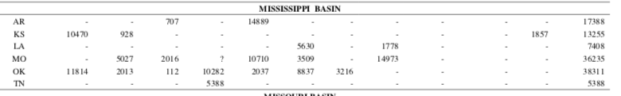

**Figure 2. Average stocking rate in the Mississippi Basin over 11 years (Grady et al., 2005)**

Another important variable that needed to be included into this model was the amount of paddlefish being taken out of the system via sport and commercial fishing. Using data provided by the MICRA database (Grady et al., 2005), we determined which states had a sport of commercial harvest and then averaged out the number of fish being removed via each type of fishing and then combined them to come up with a total amount of fish removed. Sportfishing in the Mississippi basin removed an average of 2935 individuals a year while commercial fishing removed an average of 3238 individuals per year. This gave us a total of 6173 individuals on average being removed from the Mississippi basin every year. It should also be noted that the regulation makes it so only paddlefish under 30” can be kept making the majority of legal fishing impacting the juvenile population but not the reproductive adults (MDWFP). We know this because the average size of female paddlefish at reproductive maturity was 926mm (Reed et al., 1992).

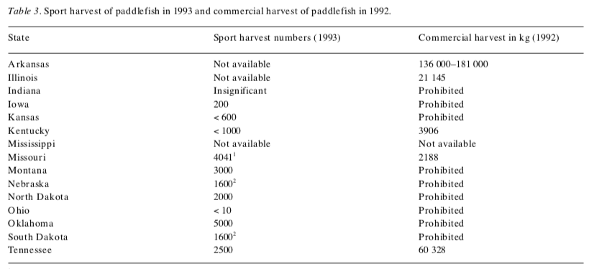

**Figure 3: Sport Harvesting of Paddlefish in 1993, MIRCA. (Grady et. al, 2005)**

Determining initial abundance of paddlefish using literature was quickly found to be one of the most unreliable variables of this model. Runstrom et al. 2001 put the initial abundance of paddlefish of the lower Wisconsin river as 1,353 paddlefish and MIRCA put the initial abundance of the Mississippi basin as 10,270. No considerable efforts have been made by any conservation groups to determine current population size estimates. The estimates that could be found reigned from specific pools in rivers or tributaries. As much as we would have liked to have begun the model with a set abundance in each stage, this would have been impossible. Instead, we initialized all values possible within the model and used these to predict realistic outcomes of a population of paddlefish of 80 adults. This then allowed us to determine the adult population estimates that were obtained from the paper by Grady et al., 2005, as viable. From there we could then use those population estimates as a starting point in determining the minimum viable population for this species.

The scenarios we tested revolve around testing how caviar harvest and fishing mortalities affect the population and if lessening their impacts would help improve the population numbers. Along with this we wanted to see how poaching of eggs for caviar would affect the population on top of the known caviar harvested from this species. The model has the caviar harvest set at 0.9 units of eggs with a standard deviation of 0.025 units of eggs(Timmons & Hughbanks, 2000) as long as there is one female sturgeon in the river.

The first scenario we tested was the removal of dams from the river basin. This scenario assumed that the removal of dams would increase river flows, river connectivity, and the overall quality of spawning habitat. These assumptions were based on the results from current dam removal sites and literature about it (Stanley & Doyle, 2003). To test this, we assumed there would be an overall increase in the spawning success of females. With the original rate of spawning females at 0.4, we arbitrarily chose to increase this rate 0.7 based off of the fact that more females would be able to make it to their spawning grounds due to dams no longer blocking older spawning grounds.

The following scenario tested the effect that the addition of dams would have on this population given the potential for the system to have new dams installed. We assume just the opposite of the circumstances for the removal of dams, that is decreased flows, increased connectivity, and increased spawning habitat qualities. This assumption was based on current fishery knowledge about the effects of dams on fish populations (Richter et al., 2010). We again chose an arbitrary decrease in original spawning rates that changed them from 0.4 to 0.2, with the assumption that less females would be able to make it up the river .

The third scenario that was tested for was the reduction of fishing, both commercial and sport. This scenario reduced the total average fishing number per year, or the amount of fish removed from the system by fishing per year, from 6,173 to 0. This was based on the assumption that fishing would be illegal for these fish based on their potential future conservation status, such as listing under the ESA.

Another scenario we tested was the effects of using fish milking as the preferred method of caviar harvest rather than seining and gill netting, which are the current main methods. To test this we implemented an increase in the amount of eggs harvested from those that have been produced from females, while also removing the existing caviar harvest on adults.

The final scenario that was tested for was the reduction of the harvest of caviar. To simulate this we assumed that the paddlefish eggs are only being harvested via the seining and gill netting of reproductive adults and that these methods are now made illegal due to conservation efforts. As this is a destructive form of harvest, we imposed a reduced death rate of 0.54 from the original 0.69 that assumed caviar harvest.

**Results:**

We found that the minimum viable population (MVP) for the population under normal circumstances, with fishing and with caviar harvest, is to be 1,175 individuals by running a sensitivity analysis using the given parameters in Insight Maker. We used our population viability analysis model to test several different scenarios under circumstances in which dams are removed or added, caviar harvest via gill netting and seining is reduced, caviar harvest via fish milking replaces gill netting and seining, and fishing is reduced.

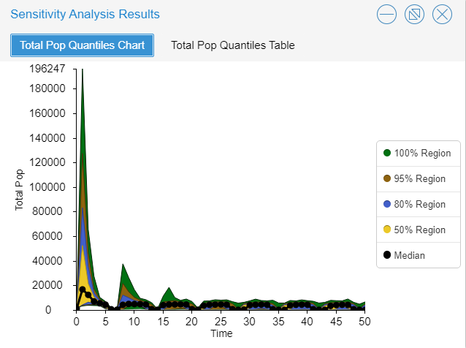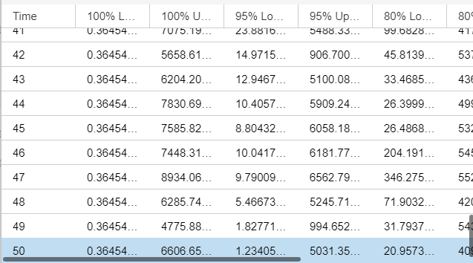

**Figure 5: Graph of population under normal circumstances showing the total population over 50 years at the initial minimum viable population of 1,175 individuals. The table on the right shows that the population stayed above zero individuals for 50 years with a 95% confidence interval.**

The first scenario we tested was the outcome of the population if dams were to be removed from the river basin. In this scenario the MVP decreased from 1,175 to 515, a 56% decrease, showing that the removal of these dams would help these individuals sustain themselves at much lower population levels.

The next scenario tested the effect that the addition of dams would have on this population. This change in spawning resulted in a MVP of 1,950, which is a 66% increase from the original 1,175. This shows that the addition of these dams would be harmful to this population.

Another scenario that was tested for is the reduction of fishing. Using this method, the MVP was reduced only to 1,100, a decrease of only 6%. While this decrease does mean improvement for the success of the population, it is not much of an improvement comparatively.

The next scenario tests the effects of using fish milking as the preferred method of caviar harvest rather than seining and gill netting. This method caused a reduction of MVP from 1,175 to 123, a 90% change. This increase in success is likely due to the fact that this non-destructive harvest of eggs does not kill adults, allowing the adults to still produce large amounts of eggs.

The final scenario that was tested for was the reduction of caviar harvesting. With this the MVP reduced from 1,175 to only just 70 individuals. This was a reduction of 94% which is the greatest reduction of minimum viable population of all scenarios tested.

|  |  |  |
| --- | --- | --- |
| **Method** | **Minimum Viable Population** | **% Change** |
| Control | 1,175 | 0% |
| Dam Removal | 515 | -56% |
| Dam Addition | 1,950 | 66% |
| No Fishing | 1,100 | -6% |
| Fish Milking | 123 | -90% |
| No Caviar Harvest | 70 | -94% |

**Discussion:**

In this study we found that dam removal, fish milking, and bannine of seining and gill netting all caused an increase in population and a decrease in MVP, while the creation of new dams caused a decrease in population and an increase in the MVP.

Results from the model show that damming of rivers in the current range along with caviar harvesting and poaching are some of the biggest contributors to the decline in the American Paddlefish populations. Fishing was found to have some impact, however, this impact was nowhere near as destructive to the population. Upon testing these methods via modeling how implementing fish milking for caviar, removing dams, and restriction/banning current caviar practices would affect the population we found that the best method on its own was restricting/banning current caviar practices with fish milking being close to having the same benefits and removing dams being the third best option. Each option being implemented has their own problems and benefits, making the choice of one as a management strategy is a bit tricky and dependent upon what area is being managed.

Dam removal is perhaps the most difficult management option of the three that could be undertaken. Politics, money, and the time it would take to remove certain dams all interfere. Public disapproval and the cost of removing large dams being removed are perhaps the largest reasons. Costs quickly add up, the removal of an 8ft dam 100 ft across would end up costing $380,960 by the first estimates calculation and an even higher $456,348 with the second (Blachly & Uchida, 2017), now scale that up to an average dam size ranging in the double or even triple digits. States looking to remove dams tend to be those that rely heavily on agriculture. For example, Mississippi's current main industry is forestry, Wisconsin's is manufacturing, Oklahoma’s is bioscience, all three states’ largest industries are agriculture (Forbes, 2019). This means that dams that are responsible for large reservoirs, are not going to have a lot of public or federal support for removal. In addition, 29 dams along the Mississippi river are lock and dam type dams allowing ships to pass through the river system safely by creating a series of steps (Argent & Kimmel, 2011). It is unlikely that these dams will be removed due to their economic importance of carrying goods along the west, despite their impacts on the river. As some dams are close enough to one another that their removal would unlikely have the benefits that we predicted within the model as the parameter we guessed for dam removal was based on the removal of small, medium, and large dams, further field research would be needed. Removing smaller dams that have become degraded or obsolete may be the most viable option, but would require further testing to see if the gains would outweigh the costs, this goes for larger dams and where each is located as well. Current data so far suggests, using this option as a management strategy by itself is unlikely to achieve the optimal results for increasing the population.

However, through modeling we have determined that there is a potential danger if more dams were created along the river. Modeling the installation of new dams shows us that there would be a decrease in the current poulation’s numbers (the opposite of what we are aiming to achieve). Thus managers and other wildlife advocates should try to prevent the installation of new dams in the paddlefish’s current range.

Fish milking is another option that we looked at that, unfortunately, had very little scientific data on the effects of such a process over time and has no recorded attempts on paddlefish that could be found. This process has been successfully used on trout and sturgeon however, which leads us to make an educated presumption that it would be successful on paddlefish given their similarities to sturgeon. However, as this is a relatively new method, side effects may be present and simply unknown at this time (Main, 2019). Two options could be considered to implement this process, both having had some success. One is to create a specialized farm for paddlefish egg harvest using fish milking, or rather caviar industries practicing fish milking in general, potentially becoming an extremely beneficial solution as it creates an industry that does not rely on the wild population. This would subvert direct effects upon wild Paddlefish populations. This would only require a few individuals for a large amount of caviar, as these fish are long lived. Currently this is practiced on sturgeon by one farm, the California Caviar Company, who strive to be the leaders in sustainable caviar in North America. However, this does create some worry that these farms may run into the same problems that farmed salmon can create in the ecosystem. Salmon farms are known to have problems with disease, causing decreased survival in the wild salmon in the same area (Ford & Myers, 2008). This method would have to be managed such that the beneficial effects of fish milking aren’t countered by potential negative effects. The alternative would be for people to simply milk wild paddlefish which, while better than current caviar practices, does have more evident problems than creating a farm. This could create an issue that the eggs may not be ready, as caviar eggs need to be a certain age, and that the potential stress to the paddlefish may reduce its survival or kill it outright (Main, 2019). Now, the stress aspect is pure speculation as there is no evidence or papers suggesting that handling paddlefish like this could cause any stress. A study has found that there is increased mortality among fish that have been spot fished and released, but the study conducted was on red snapper, a fish common in recreational fishing on the Gulf of Mexico and as such may not accurately indicate the risk with paddlefish (Campbell et al., 2010). Both of these approaches have great potential, but would take time to implement as caviar harvesters would have to be persuaded to use this method. As of right now it does face resistance from those that harvest sturgeon caviar, some saying that caviar produced from this method is not the same and produces lower grade caviar (Main, 2019). This mentality and issue would have to be overcome in order to be viable and it needs to be seen as better than the current (harmful) strategies.

Making the current methods of caviar harvest illegal (seining and gill netting) produces the best results from the model, but may be tricky to implement. In our model we did account for the fact that banning these would lead to some poaching as people ignored the new ban, but this method is a bit of a wild card that is going to heavily depend on public and state perception. If this is implemented we do face the potential risk that the law will be ignored and/or not properly enforced in some areas, making it an unenforced law. The potential problem in banning these methods is that it could create an increase in poaching of paddlefish eggs while supply decreases and demand increases with the price following. Sturgeon are facing this problem as their high value caviar leads to poaching (Becker, 2016). With sturgeon facing such an issue we can assume that when paddlefish caviar goes up in value due to reduced availability this problem will increase. Implementing such a policy may face public backlash due to the reduced amount of caviar produced by banning these methods. In order to implement this method it would need public support, the support of local legislatures, law enforcement and state fish and wildlife services to ensure the laws are enforced.

While these solutions have the best outcomes, they are the most unpredictable due to the nature of politics in general and human error. Lastly, it is inevitable that if this species becomes endangered in the near future that we will likely see a ban or reduction in harmful practices..

**Conclusion:**

In the end it is likely that the best management solution for both the long term and the near future would be to implement more than one strategy. If we implement both fish milking and banning seining and gill netting then there still will be a production of caviar and this method could replace the jobs of those that relied on old methods to harvest caviar. This also means that there would be less potential for poaching of paddlefish due to caviar as there would be less reduction in the available caviar for consumers. Dam removal is also a process that will take a long time and as such shouldn’t be relied on as the only option. This also gives managers some room for errors as while you may not be able to implement one method fully, for example simply restricting seining and gill netting and not banning them, but using that in combination with other methods may make up for that problem. And there is also the chance that one method may not work at all due to politics and public opinion against it, such as dam removal, thus making it better to incorporate other ideas instead of relying on one that may fail. Banning seining and gill netting and using fish milking as the main caviar harvest method have the best potential to work together as both can help overcome some of the problems that occur if just one method is used. The removal of dams is more of an additional method to the two as white it certainly helps increase paddlefish numbers, it is a method that easily stands on its own.

Throughout all of this, the biggest hurdle that this species ultimately faces is a lack of knowledge. During our research we found that many parameters either weren’t known for this species or were highly generalized, such as the survival rates and mortality rates for different age classes. There was also a lack of data about the total population left in North America with many papers having outdated information or simply focusing on the population of one area of the range. This was another common issue that we ran into, that most of the papers were focused on only one small area for study, which made it so that there were some areas of the range that had more data for them while others had none that we could find. Along with that when researching alternative methods to help increase the paddlefish population there was a problem of there being little information about some of the methods. Fish milking is a new method and thus had no scientific papers talking about it, making most of the knowledge about it coming from companies that implement the technique, which are not the most reliable resource. Removing dams, while not a new idea, is something that has only really started happening for environmental benefits recently as well. Data is much more readily available for this method though, which does help us better predict how implementation of this method would pan out in the long run, but we still have to acknowledge that long term data simply isn’t available. Banning current caviar harvesting methods, seining and gill netting, is also something that has no real data on how that would go and a large part of implementing such a thing would likely also be dependent on the political climate of the time.

**Acknowledgements:**

This model would not have proceeded if it was not for the work of the Mississippi Interstate Cooperative Resource Association and their database dedicated to the study of paddlefish. The MICRA database provided us with the best estimates for adult vital rates, stocking rates, and effects of commercial fishing. We would also like to thank Dr. Kevin Shoemaker and Megan Osterhout for providing counseling and guiding through the model making process. Given the obscurity and pure absence of data, this model would not have been nearly as accurate if it was not for their help.

**Literature Cited:**

Argent, D. G., & Kimmel, W. G. (2011). Influence of navigational lock and dam structures on adjacent fish communities in a major river system. *River research and applications*, *27*(10), 1325-1333.

Birstein, V. J., Hanner, R., & DeSalle, R. (1997). Phylogeny of the Acipenseriformes: cytogenetic and molecular approaches. In *sturgeon biodiversity and conservation* (pp. 127-155). Springer, Dordrecht.

Becker, Rachel A., (July 2016) *Black Market Caviar Threatens California's Giant Fish.* [https://www.nationalgeographic.com/news/2016/07/wildlife-sturgeon-california- caviar-poa](https://www.nationalgeographic.com/news/2016/07/wildlife-sturgeon-california-%09caviar-poa)ching/

Blachly, B., & Uchida, E. (2017). Estimating the marginal cost of dam removal.

Campbell, M. D., Patino, R., Tolan, J., Strauss, R., & Diamond, S. L. (2010). Sublethal effects of catch-and-release fishing: measuring capture stress, fish impairment, and predation risk using a condition index. *ICES Journal of Marine Science*, *67*(3), 513-521.

Carlson, D. M., & Bonislawsky, P. S. (1981). The paddlefish (Polyodon spathula) fisheries of the

midwestern United States. *Fisheries*, *6*(2), 17-27.

Forbes. *Best States for Business 2019 Ranking* (2019). April 20, 2020. <https://www.forbes.com/places>

Ford, J. S., & Myers, R. A. (2008). A global assessment of salmon aquaculture impacts on wild salmonids. *PLoS Biology*, *6*(2).

Gilliland, C. R., Colvin, M. E., Rush, S. A., & Reagan, S. (2018). American alligators are predators of paddlefish: An undocumented predator-prey linkage affecting paddlefish population dynamics. *Food Webs, 16*, e00087. doi:10.1016/j.fooweb.2018.e00087

Grady, J. (U.S. Fish & Wildlife Service) 2019. *Polyodon spathula* (amended version of 2004

assessment). *The IUCN Red List of Threatened Species* 2019: e.T17938A160475605.

Grady, J., Utrup, N., Bergthold, C., Conover, G., & Caswell, N. (2005). A summary of the national paddlefish stock assessment project 1995–2004. *Report prepared for the Mississippi Interstate Cooperative Resource Association. US Fish and Wildlife Service, Columbia, Missouri*.

Graham, K. (1997). Contemporary status of the North American paddlefish, Polyodon spathula.

*Environmental biology of fishes*, *48*(1-4), 279-289.

Hubert, W. A. (1984). *Habitat suitability index models and instream flow suitability curves: paddlefish*. The Service.

Hupfeld, R. N. (2014). *Characteristics of paddlefish populations in major midwestern rivers and reservoirs* (Order No. 1561048). Available from ProQuest Dissertations & Theses Global. (1560881382). Retrieved from ["INHS padfish"](http://wwx.inhs.illinois.edu/resources/inhsreports/spring-02/padfish/). Prairie Research Institute, University of Illinois at Urbana-Champaign. [Archived](https://web.archive.org/web/20140529051611/http://wwx.inhs.illinois.edu/resources/inhsreports/spring-02/padfish/) from the original on May 29, 2014. Retrieved May 28, 2014 <http://unr.idm.oclc.org/login?url=https://search-proquest-> com.unr.idm.oclc.org/docview/560881382?accountid=452

Jablonski, D. (1994). Extinctions in the fossil record. *Philosophical Transactions of the Royal*

*Society of London. Series B: Biological Sciences*, *344*(1307), 11-17.

Jarić, I., Riepe, C., & Gessner, J. (2018). Sturgeon and paddlefish life history and management: Experts' knowledge and beliefs. *Journal of Applied Ichthyology*, *34*(2), 244-257.

Kramer N, Phelps Q, Tripp S, Herzog D. Exploitation of paddlefish Polyodon spathula (Walbaum, 1792) in the Mississippi River. J Appl Ichthyol. 2018;00:1–5. https:// doi.org/10.1111/jai.13617

Main, D. (2019, March 18). How To Produce Caviar Without Killing: Sturgeon Massage. Retrieved April 21, 2020, from [https://www.popsci.com/article/science/how-produce- caviar-without-killing-sturgeon-massage/](https://www.popsci.com/article/science/how-produce-caviar-without-killing-sturgeon-massage/)

Michaletz, P. H., Rabeni, C. F., Taylor, W. W., & Russell, T. R. (1982). Feeding ecology and

growth of young-of-the-year paddlefish in hatchery ponds. *Transactions of the American*

*Fisheries Society*, *111*(6), 700-709.

Mims, S. D., Shelton, W. L., Wynne, F. S., & Onders, R. J. (2000). *Production of paddlefish*.

Southern Regional Aquaculture Center.

Onders, R. J., Mims, S. D., Wang, C., & Pearson, W. D. (2001). Reservoir ranching of

paddlefish. *North American Journal of Aquaculture*, *63*(3), 179-190.

Pierce, L.L., Graeb, B.D., Willis, D.W., & Sorensen, J.S. (2015). Evaluating Effects of

Exploitation on Annual Apparent Mortality Rates of Paddlefish Using Mark–Recapture Data.

Raymakers, C. (2002). International trade in sturgeon and paddlefish species–the effect of CITES

listing. *International Review of Hydrobiology: A Journal Covering all Aspects of*

*Limnology and Marine Biology*, *87*(5‐6), 525-537.

Reed, B. C., Kelso, W. E., & Rutherford, D. A. (1992). Growth, fecundity, and mortality of paddlefish in Louisiana. *Transactions of the American Fisheries Society*, *121*(3), 378-384.

Richter, B. D., Postel, S., Revenga, C., Scudder, T., Lehner, B., Churchill, A., & Chow, M. (2010). Lost in development's shadow: the downstream human consequences of dams. *Water Alternatives*, *3*(2).

Rosen, R. A., & Hales, D. C. (1981). Feeding of paddlefish, Polyodon spathula. *Copeia*, 441-455.

Runstrom, A. L., Vondracek, B., & Jennings, C. A. (2001). Population statistics for paddlefish in the Wisconsin River. *Transactions of the American Fisheries Society*, *130*(4), 546-556.

Scholten, G. D., & Bettoli, P. W. (2005). Population characteristics and assessment of overfishing for an exploited paddlefish population in the lower Tennessee River. *Transactions of the American Fisheries Society*, *134*(5), 1285-1298.

Stanley, E. H., & Doyle, M. W. (2003). Trading off: the ecological effects of dam removal. *Frontiers in Ecology and the Environment*, *1*(1), 15-22.

Timmons, T. J., & Hughbanks, T. A. (2000). Exploitation and mortality of paddlefish in the

lower Tennessee and Cumberland rivers. *Transactions of the American Fisheries Society*,

*129*(5), 1171-1180.

Warren, M. L., & Burr, B. M. (Eds.). (2014). *Freshwater fishes of North America: volume 1: Petromyzontidae to Catostomidae* (Vol. 1). JHU Press.

Zhang, H., Jarić, I., Roberts, D. L., He, Y., Du, H., Wu, J., ... & Wei, Q. (2020). Extinction of one of the world's largest freshwater fishes: Lessons for conserving the endangered Yangtze fauna. *Science of The Total Environment*, *710*, 136242.

ZIGLER, S. J. (2009). Biology and life history of paddlefish in North America: an update. In *American Fisheries Society Symposium* (Vol. 66, pp. 1-22).