**Task**

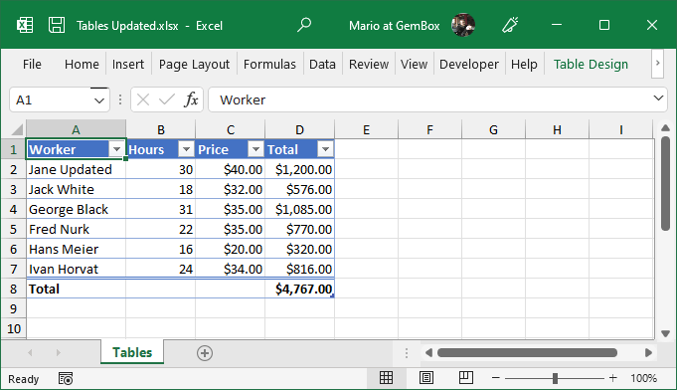

**Instruction:**

1. Create a database in SQL Server. then create and design a table
2. Insert the data from the above snap to the SQL Server database table
3. After inserting the data now write sql quries for the following questions to get result :--
4. Who worked the most hours?
5. What is the total amount paid to all workers?
6. Which workers earned more than $1000?
7. List all workers with their hourly price sorted in descending order.
8. What is the average hourly rate of all workers?