Fault-Tolerant Storage System

Fangzheng Guo

Zihang Zeng

1. Introduction to metrics

In testing, we measured the system’s performance with following metrics:

1. Number of messages exchanged in the whole process.

2. Number of bytes transferred in the whole process.

3. The average response time per client for search and obtain request.

1. Arguments

M: number of files in the system after initialization.

N: total number of requests

F: request frequency in the system

C: number of clients making concurrent requests

We measured the system with different M, N, F, and C based on the rule of control variates method. We tested the system with directory server failure, storage nodes failure and no fault.

1. Experiment result and discussion
   1. The relationship between M and performance (N = 30, F = 10/s, C = 1)

When the number of files increases, there will be more message exchanged and bytes transferred during the file-initialization process. Since we let all the files evenly distribute in the nodes, the increment of those 2 metrics is nearly linear. When there is a directory server failed, there will be less message exchanged since we cannot synchronize 2 servers. As a result, there will also be less bytes transferred.

We can see an increasing trend on response time while M increase. The reason is since some manipulations on system include searching through local files to find a match. When there are more files, the searching will take longer time.

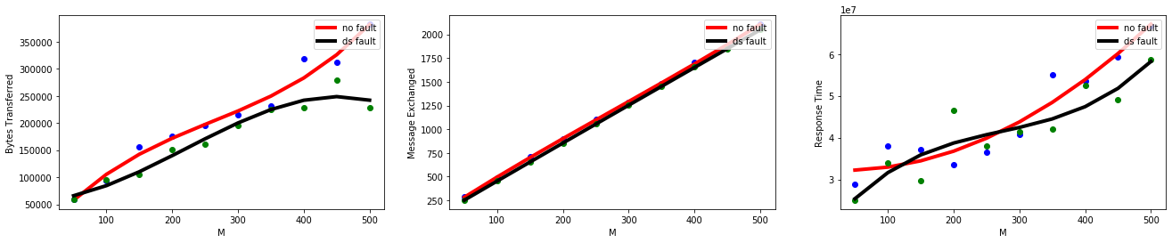

Pic 1. System performance with different M (no fault vs directory server failure)

We also set up 2 nodes failure in the system to test the fault-tolerance performance. There should be less message exchanged totally in the system with failure, since every time a new file is added to the system, the node which is connected to the client needs to send less replicas. However, since we test the system with a small number of requests, this is not obviously shown on data. We can see that when there happens some nodes failure after initialization, there are more messages exchanged to let the client connected to a new node and also let the server delete the failed nodes from its node list. The file synchronization will influence the average response time. The system with nodes failure has a lower average response time because the node needs to send less replicas to others after a ‘add file’ operation is finished so it could respond to next request earlier.

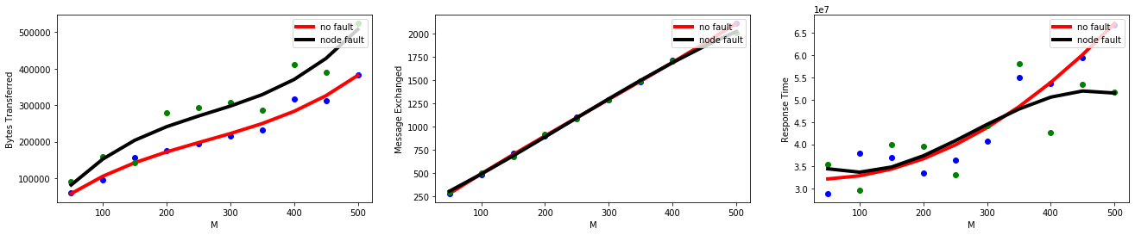

Pic 2. System performance with different M (no fault vs nodes failure)

3.2 The relationship between N and performance (M = 100, F = 10/s, C = 1)

When there are more requests, there will be clearly more message exchanged in the system. Moreover, following the discussion, the increment of it will be nearly linear. Why there is no change on bytes transferred? (system with failure). Since there are only 1 active client (C = 1), the response time is proportional to number of requests.

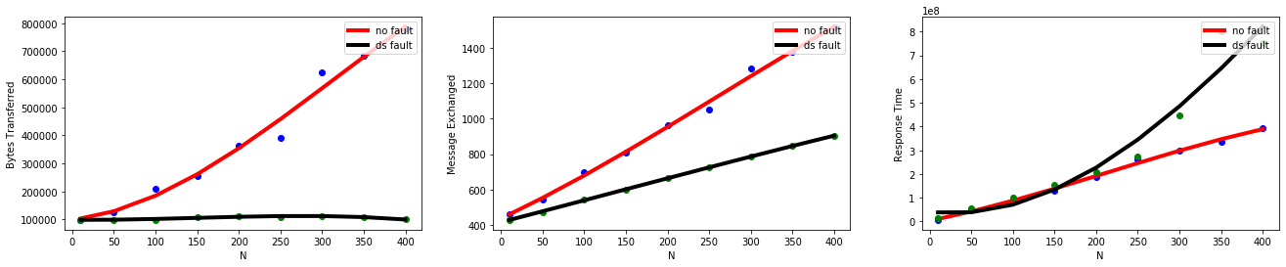

Pic 3. System performance with different N (no fault vs directory server failure)

When there exists nodes failure in the system, following discussion above, there is likely to be less message exchanged in the system. Less nodes means less replicas to send, when N is big, the response time will decrease.

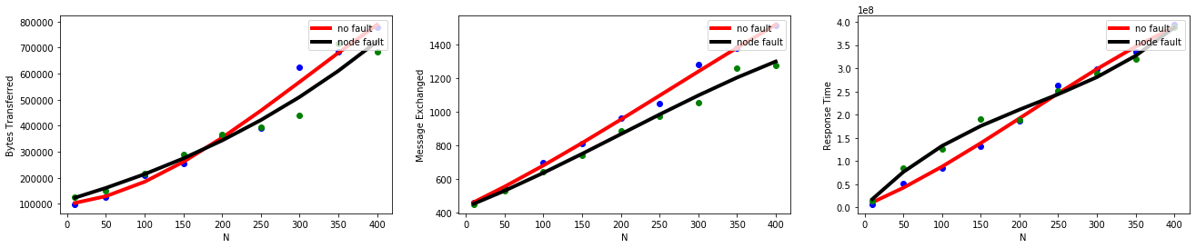

Pic 4. System performance with different N (no fault vs nodes failure)

3.3 The relationship between F and performance (M = 100, N = 100, C = 1)

F is a main factor of average response time. From the experiment result, we can clearly find out that the system with directory failure is unable to process intensive requests. However, when both directory server is on, if the main server is too busy to accept new message, the sender will send this message to the back-up server again. This will lead to more message exchanged in the system, but the response time is stable.

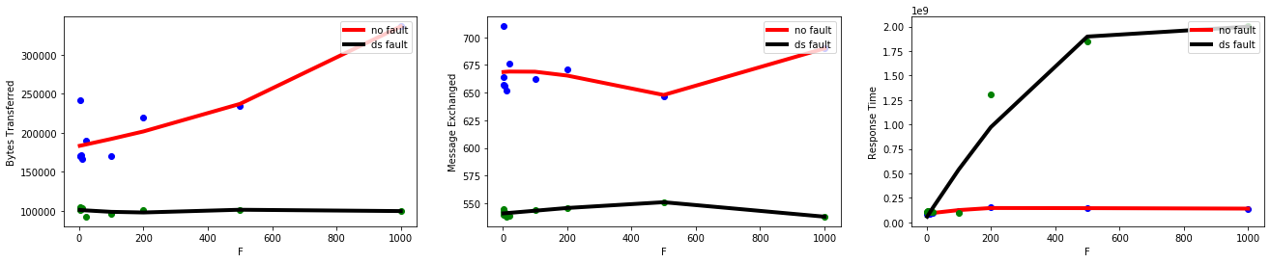

Pic 5. System performance with different F (no fault vs directory server failure)

When there is less nodes in the system, the average response time is lower than normal system. F is not relevant to the number of nodes, because the client will connect to a single storage node.

Pic 6. System performance with different F (no fault vs nodes failure)

3.4 The relationship between C and performance (M = 100, N = 100, F = 10/s)

When there are multiple clients connected to the system, more nodes will be redeemed, so that the response time will decrease.

Pic 7. System performance with different C (no fault vs directory server failure)

The system also allows 2 clients to be connected to the same storage node concurrently. When there is less node in the system, the average response time will decrease even if there are concurrent request. This characteristic reveal that our system is robust. This is because our design is file-oriented, not request-oriented.

Pic 8. System performance with different C (no fault vs nodes failure)