Screen Shot

Group: David, Raymond

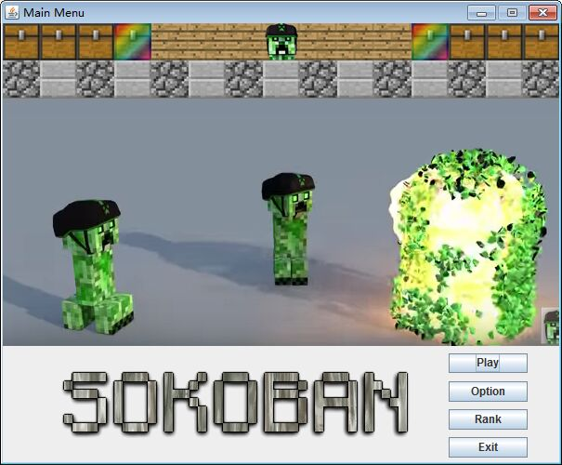

This is the menu screen of our game and it shows the name of our game which is SOKOBAN. On this screen, there are 4 buttons which are “Play”, “Option”, “Rank” and “Exit”. PLAY button is used to let the player play this game. The OPTION button will introduce the rule of this game and let player choose certain level they want to play. RANK button shows the rank of player which is the rank of the time he/she uses to win each level. EXIT is let player exit the window.

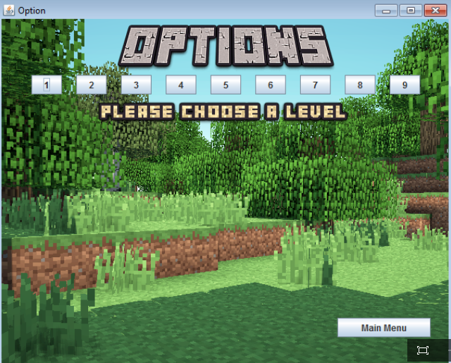 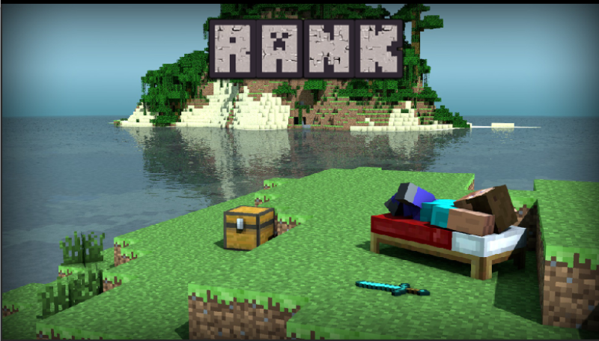

This is the option screen shot. The player can choose the level he/she wants to play and there is also the introduction of the game (rules) on this screen. And the player can click the main menu button to return to the main menu.

The rank screen shows the rank of players and this rank is ranked by time. The less time used the higher mark the player gets.

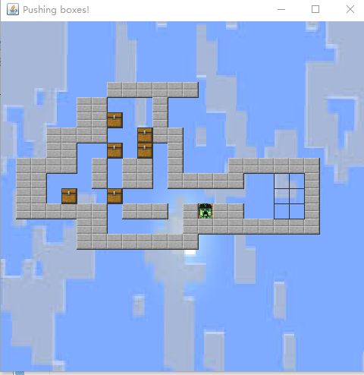

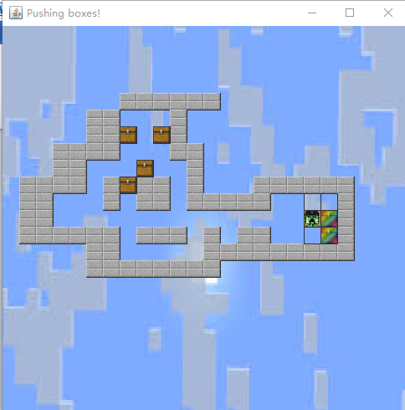

This is the screen of the game if you click paly button. You need to push the box to the certain area like the wood area.

There will also be a timer on the right corner to record the time of the player, if the time exceeds some certain limit, then the player will lose.

When the box is pushed into certain areas like the rectangles, the color of the image will change.

The second screen shot shows the colorful boxes in the certain areas.

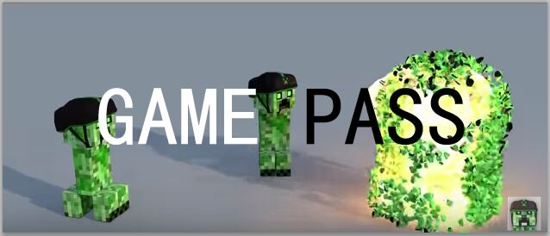

This screen shot is the situation that the player passes the level.

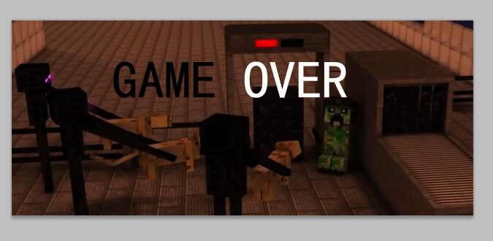

The screen shot is the situation that the player loses the game.

Memory Diagram

Level:

1. ArrayList levelList : the list contains all the level
2. String level : the string represents the map

Player

1. Int x : the x-coordinate of the player
2. Int y : x-coordinate of the player
3. Image a : the image of the player

Box

1. Int x : the x-coordinate of the box
2. Int y : x-coordinate of the box
3. Image a : the image of the box

Area

1. Int x : the x-coordinate of the area
2. Int y : x-coordinate of the area
3. Image a : the image of the area

Wall

1. Int x : the x-coordinate of the wall
2. Int y : x-coordinate of the wall
3. Image a : the image of the wall

Board

1. ArrayList walls
2. ArrayList areas
3. ArrayList boxes
4. Player h
5. Level a