Game Design Document

(Midterm preliminary report)

Dead Man’s Maze

Team Number: cm3030-tg1-t9

**Team Members**

Raymond Woon (190126210)

Ernesto Arakaki (210168615)

Daniel Rodriguez ()

Isabela de Oliveira ()

Alwin Wong ()

Contents

1. Game Description 3

1.1 Elevator Pitch 3

1.2 Summary 3

1.3 Unique Selling Points (USPs) 3

2. Design 4

2.1 Key Mechanics 4

2.2 Characters and Settings 4

3. Gameplay 6

3.1 Beginning the Game 6

3.2 First 2-5 minutes 6

4.0 Visual Audio 8

4.1 Art Style 8

4.2 Audio 10

4.3 Front End 10

5. Production 12

5.1 SWOT Analysis 12

5.2 Production Schedule 13

6. Protyping 14

7. List of All Assets 17

8. The Team 18

# Game Description

## 1.1 Elevator Pitch

An atmospheric difficulty increasing horror first-person shooter in which the player must escape a maze by first finding the keys to the exit and then surviving the path to the exit.

## 1.2 Summary

The game consists of having the player inside a randomly generated maze with very limited lighting. The atmosphere will be set mainly through sound where the player will constantly hear moans, steps, and scratching sounds ‘coming from’ the monsters within, which the player must either avoid or take out.

The player will have limited ammunition for self-defense which will only increase from randomly placed pickups within the maze or from the keys needed to be collected to exit the maze and complete the level.

The game has high playability since the mazes are randomly generated, hence making the game increasingly challenging.

## 1.3 Unique Selling Points (USPs)

* The mazes are randomly generated which means players will theoretically obtain endless variations of the experience.
* The horror atmosphere will be conveyed by having sound be the most predominant way for the player to immerse themselves.
* Customizable experience. The player will be able to select how they wish to experience the game. They can make it extremely easy, lengthy or nerve wracking, through selection of preset maze sizes, starting ammo amount and/or enemy difficulty (heath and speed).

# 2. Design

## 2.1 Key Mechanics

The player controls the main character, and the game is viewed from a first-person perspective. The character can move forwards and backwards, strafe to the sides, rotate, look up and down. The player will also have a small set of weapons to fight back the enemies.

To achieve the game's goal of getting all the collectables and reaching the exit, the player will navigate the maze, eliminating or avoiding the threats that will populate the environment. Eliminating the threats will require skill, as the player will not have too much ammunition to spare; in case the player runs out of firing power, the only option available will be to avoid combat completely, increasing the difficulty of traversing the maze.

The most relevant game mechanics will be familiar to most people with gaming experience: navigating new environments to find key items and shooting at enemies. The novelty of this proposal is that the maze is generated at random for each new game. While FPS shooting games and survival horror games are very popular, Dead Man’s Maze will combine elements from both genres, and also remove the certainty of knowing the map. The possibility to quickly start a new game and get a new maze to explore will be appealing to both experienced players that look for a different challenge where they can use their already honed skills, and also deal with many unknowns, and to new players that can start a game and get into it without the need to know too many mechanics or have an understanding of the game's world.

The game will be an immersive experience where the odds are against the player.

## 2.2 Characters and Settings

The game is set in the modern day. Earth is close to being decimated by a debilitating virus that has caused the infected to turn into zombie-like creatures. Dr. Alex Fleming, an army medical doctor, is tasked with coming up with a cure, and he thinks he just needs one more ingredient, in order for the cure to be effective – the sweet-smelling herb Athelas.

The only problem, Athelas, is only known to be cultivated in one place in the world… a remote farm in the south of France, whose owner had the twisted idea of growing the lifesaving plant in the middle of a maze that he personally constructed, to keep it out of everyone’s reach.

Dr. Fleming and his team travelled to the farm, and cautiously began to enter the maze to retrieve the Athelas, when they realized the farm has been overran with zombies! It’s up to the play to help Dr. Fleming work his way through the maze, using the few weapons in his arsenal, and most importantly his wits, to survive and not only retrieve the Athelas, but make it out alive, and in time to save humanity!

# 3. Gameplay

## 3.1 Beginning the Game

The player is greeted by a dark screen with eerie music, where they have the options to play, read the instructions or customize various aspects of the game. It would be similar to the image below.

**Figure 1**: *Start Screen*

## 3.2 First 2-5 minutes

The player is placed at the entrance to the maze, a cut scene is displayed, explaining the lore and why the player is there. The player will have the option to continue the game with the default settings, or go to the ‘Main Menu’, where the game parameters can be changed to make the game more or less challenging.

From the initial scene, when the player selects ‘Continue’, the game begins. Initially the player has a flashlight that will flicker from time to time, giving the situation a sense of uncertainty and helplessness. Sound will be atmospheric, having muffled groans, scratching against walls, uneven footsteps and dragging across the floor, giving the player a sense that they are not alone in this maze.

The player will begin to move the character forwards, backwards and sideways, using the WASD or arrow keys on the keyboard and moving the camera using the mouse. Upon encountering the enemy or zombie, the player may choose to turn around, and find an alternate route or fight.

During the game, the player will have a certain amount of health which can be quantified like the ‘Call of Duty’, where the bloodier/redder the screen became as the health of the player declined.

The player will walk or run around, shooting or escaping from the enemies in tight corridors (help generate the common fear of claustrophobia) and will search for keys or items required to open the exit. The player may be able to find the exit but without the keys, they would not be able to win the game or complete the level.

The player will get a very dim sound prompt when they are within close proximity of a key and it would intensify or diminish, the closer they get. This ‘hot/cold’ mechanic can help relieve some of the frustrations a player may feel, thus making the game appealing to a broader audience while still retaining an unsettling feeling.

# 4.0 Visual Audio

## 4.1 Art Style

The art style will be a 3D polygon style which offers a timeless art style with colourful theme, making the game unique and conveys a playful feel. The game will use 3D polygon assets by Synty as much as possible to provide a consistent art style throughout the entire game, including characters, items, building and the environment. Where a specific asset is unavailable, a custom model with texture will be made to resemble the art style as much as possible, for consistency.

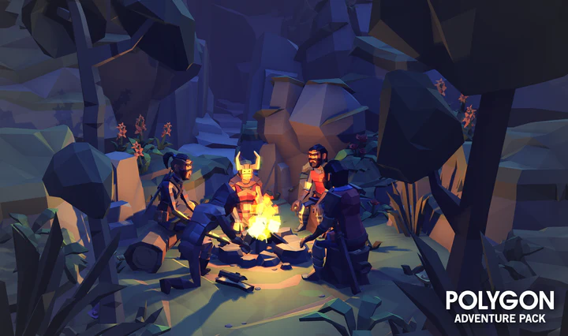

**Figure 2**: *Polygon Adventure Pack (Campfire). Preview by Synty*

The gameplay style will be similar to POLYGON, and both are tactical first-person shooter genre. The game will feature responsive controls coupled with fast and fluid animation. The player can control the character to move, sprint, jump, crouch and shoot with polygon weapons to match the game’s art style. The game will put heavy emphasis on gunplay with impactful shots at every bullet strike, shells ejecting from the gun, coupled with satisfying reload animations.

**Figure 3**: *POLYGON*

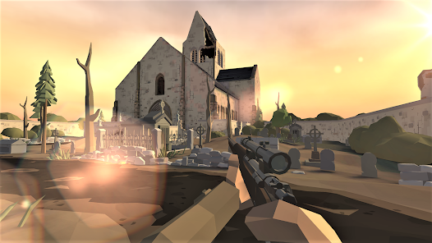

**Figure 4**: *World War Polygon*

## 4.2 Audio

On the start menu, the game will play orchestral music to set the mood of the player to get ready to play, similar to polyfield. Once in the game, the music will change between two states depending on the player’s activity. If the player has encountered an enemy, the music will get louder with a fast tempo, otherwise the music will be almost quiet with a mellow tone.

As for the environment, the sound will portray a feeling of an isolated scene. The game will rely heavily on atmospheric sound, giving the player a sense of dread and ‘stress’ that there may be something right round the corner. Most of the sounds will play at random intervals so that the player may not find the audio cues predictable, but with random intervals to make them organic and not part of a predictable algorithm.

## 4.3 Front End

Upon starting the game, the player will be greeted with the start menu and beautiful artwork in the background to invite the player to play the game. The menu UI will consist of a ‘Start’, ‘Settings’ and ‘Exit’ buttons. These buttons lead to a second menu page as shown in the wireframe below:

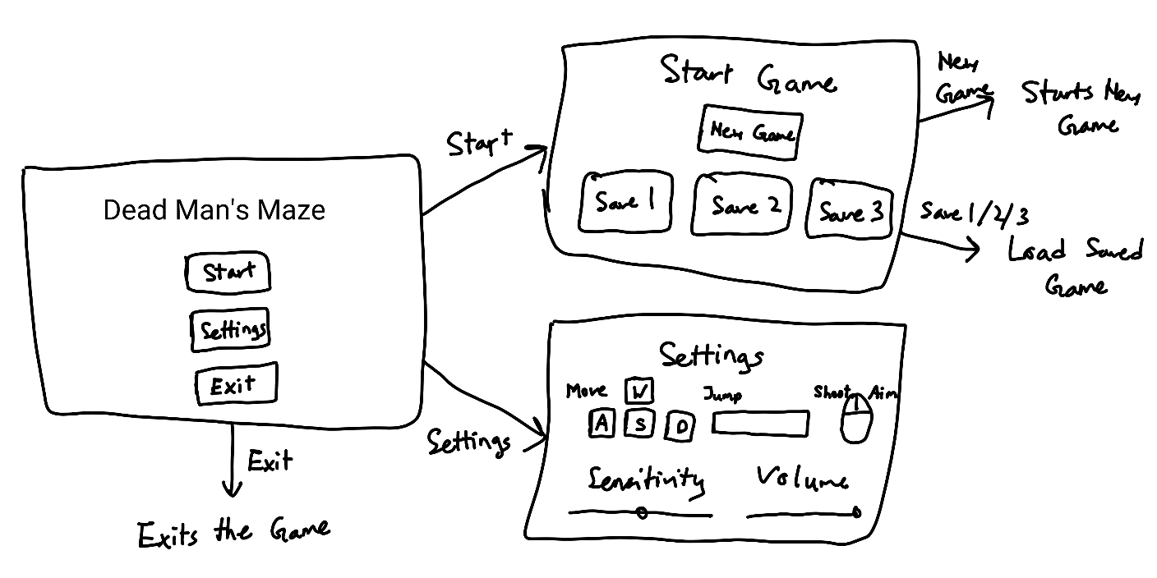

**Figure 5**: *Start Menu Wireframe*

The game will feature a simple HUD system with slight transparency to allow the players to immerse themselves in the gameplay without being distracted by a complicated HUD. It consists of the health bar, ammo bar and weapon selection slots as shown in the illustration below:

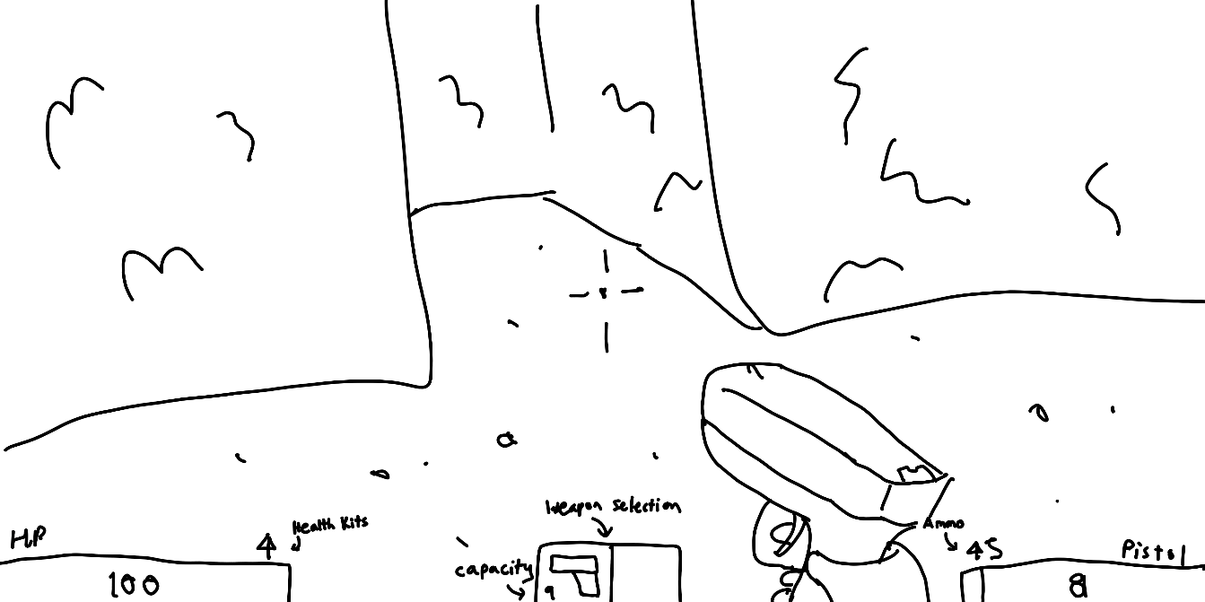

**Figure 6**: *Gameplay with HUD illustration*

# 5. Production

## 5.1 SWOT Analysis

The following SWOT analysis will offer a snapshot of our game’s potential, highlighting areas for optimization and the challenges that lie ahead.

Strengths

1. **Unpredictability**: This is our big win! The randomly generated maze layout ensures that players will experience a unique challenge each time they play – they cannot just memorize and breeze through. Thereby, enhancing playability.
2. **Tense Atmosphere**: Limited lighting and a focus on sound provide an intense, suspenseful atmosphere that is likely to engage fans of the horror genre.
3. **Resource Management**. By limiting the ammunition available to players and distributing it randomly throughout the maze, strategic thinking and maze exploration is encouraged, increasing the possibility of the player encountering more enemies.

Weaknesses

1. **Potential for Repetitiveness**: Despite the random maze generation, if gameplay mechanics and enemy encounters don’t provide adequate variety, players may find the experience monotonous over time. We are considering some ideas that help on this point, for example, multiple kinds of zombies, power-ups, multiple weapons and multiple skins. Bear in mind, these are future ideas and not currently planned features.
2. **Niche Market**: Not everyone is a fan of horror, and not everyone loves first-person shooters, so the combination of the horror genre with a first-person shooter may limit the game’s appeal.
3. **Accessibility Concerns**: Relying heavily on limited visual cues and auditory information could make the game less accessible to players with visual or auditory impairments. Incorporating accessibility options would be a possible future improvement.

Opportunities

1. **Continuous Improvement**: The nature of random generation allows for an evolving gameplay experience. The maze-generating algorithm can be constantly improved which means the game can grow and get more complex over time.
2. **Community Engagement**: If the game is well-received, there is potential for the formation of a dedicated player community. This community would share experiences, tips and strategies, promoting the game.

Threats

1. **Technical Challenges**: Random generation can lead to some bugs or imbalances in gameplay, needing constant testing and debugging.
2. **Market Competition**: There are a lot of horror games out there, and a lot of shooters too, so standing out in that crowd can be a challenge.
3. **Team Inexperience**: As our team does not have any prior experience in game development, there could potentially be unforeseen difficulties.

## 5.2 Production Schedule

For the development of our game we created a high level production schedule covering project management, programming, art, design and quality assurance. We will virtually meet every Wednesday to discuss progress and adjust tasks as needed. Also, we would continue to communicate via Slack. The following timeline provides a roadmap, but we are prepared to adapt as needed in case of unexpected issues or necessary changes after feedback.

|  |  |  |  |  |  |
| --- | --- | --- | --- | --- | --- |
| Week Starting | Isabela Louli | Raymond Woon | Alwin  Wong | Ernesto Arakaki | Daniel Rodriguez |
| Week 1 (July 24) | Project planning | Project planning | Concept art/design | Concept art/design | Project planning |
| Week 2 (July 31) | Player | Maze generation programming | Enemies generation | Maze components | Weapons |
| Week 3 (August 7) | Player interactions | Level design | Texture and assets | Menu | Bullets |
| Week 4 (August 14) | Game sounds | Gameplay programming | Lights and atmosphere | Inventory | Weapons and bullets interactions |
| Week 5 (August 21) | Buffer/Rest week | Buffer/Rest week | Buffer/Rest week | Buffer/Rest week | Buffer/Rest week |
| Week 6 (August 28) | Feedback and iteration | Feedback and iteration | Feedback and iteration | Feedback and iteration | Feedback and iteration |
| Week 7 (Sept 4) | Finalize game mechanics | Finalize game mechanics | Finalize game mechanics | Finalize game mechanics | Finalize game mechanics |
| Week 8 (Sept 11) | Final polish and testing | Final polish and testing | Final polish and testing | Final polish and testing | Final polish and testing |

# 6. Protyping

During this process, we researched and developed the following phases:

1. Generate the basic maze container based on variable width and depth via the Inspector. This is achieved using primitive cube elements.

**Figure 7**: *Basic maze container*

1. Create a basic menu system where the user can configure the dimensions of the maze.

**Figure 8**: *Start menu*

**Figure 9**: *Options menu*

1. Use various maze dimensions, generate random mazes

**Figure 10**: *20 x 20 maze*

**Figure 11**: *30 x 20 maze*

# 7. List of All Assets

Below is a list of potential assets that are been considered:

|  |  |  |
| --- | --- | --- |
| Type | Name | Description |
| Prefab | Maze components | Components and skin(s) of the maze |
| Prefab | Weapons | Bundle of weapon’s appearance, animation, sound |
| Prefab | Key | Key’s appearance and behaviour |
| Prefab | Enemy | Enemy’s appearance and behaviour |
| Script | Player controller | Handles user input and controls in-game actions |
| Script | Maze generator | Generates the layout of the maze |
| Script | Sound controller | Controls the sounds. |
| Script | Game controller | Keeps state of the game. |
| Script | Inventory | Keeps state of the player's items. |
| Script | Lights controller | Generates lights and lighting effects. |
| Script | Menu | Options on starting the game |
| Script | UIManager | Manages the game state |
| Script | Bullet controller | Handles interactions between bullets and game objects. |
| Script | Enemy spawner | Creates new enemies. |
| Script | Enemy controller | Handles enemy behaviour. |
| Art | Sounds | Environment, enemies' and weapons' sounds. |
| Art | Textures | Materials to add texture to ground, ceiling and walls. |
| Art | Music | Music for the main menu. |

Source of audio/visual assets:

1. Unity store – freely available assets such as Synty
2. Mixamo – free 3D animated characters
3. Sound – www.freesound.org

# 8. The Team

|  |  |  |
| --- | --- | --- |
| **Role** | **Name** | **ID** |
| Project Manager | Isabela de Oliveira |  |
| Programming | Raymond Woon | 190126210 |
| Art | Alwin Wong | 200195717 |
| Design | Ernesto Arakaki |  |
| Quality Assurance (QA) | Daniel Rodriguez | 200103527 |

Appendices:

1. Github Repository:

https://github.com/RaymondWoon/Dead-Mans-Maze