***CURRICULUM VITAE OF RAYMOND SEREKWANE***

**PROFESSIONAL SKILLS**

implementing system security, performing systems updates, interface configurations, network troubleshooting, server configurations, HTML, CSS, JavaScript, C# and Sql.

**SKILLS & COMPETENCIES**

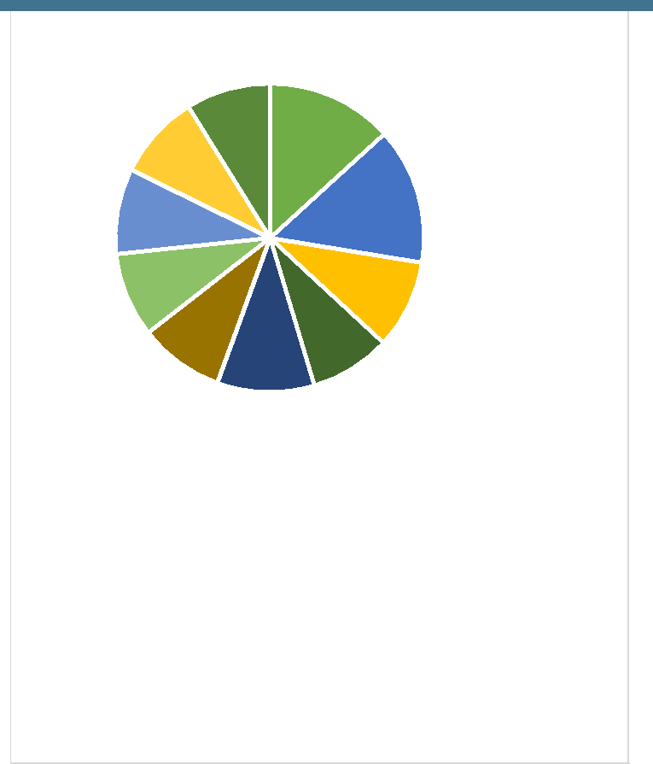

 network trobleshouting

 implementing system security

 performing systems updates

 interface configurations

 server configurations

 HTML

 CSS

 JavaScript

 C#

 SQL

**LANGUAGES**

English, Sepedi, Setswana and isiZulu.

**RESIDENTIAL AREA**

*787 Lounde street, Diepkloof zone 1, Soweto, Johannesburg, 1862 (Gauteng)*



 RAYMOND SEREKWANE CV_ 2019



**PERSONAL DETAILS**

**Name & surname:** Raymond Serekwane

**ID No:** 9001165299081

**Email:** raymonds338@gmail.com

**EDUCATION**

**qualification**: Cisco CCENT (ICND1)

**Name of institution**:*Torque IT*

**qualification**: IIE Higher certificate in IT in(Support Services)

**Name of institution**:*Rosebank College*

**ACHIEVEMENTS**

My IIE Higher Certificate from Rosebank, it’s one of my best achievements because I never had financial support from home due to the situation at home, but I managed to find a job and save up to go study IT by myself*.*

**PROJECTS**

*-packet tracer projects (computer troubleshooting, large network configuration & wireless networks e.g. Smart house (IoT). -Server configurations.*

*-web profile for my Online CV.*

*-ASP.NET MVC web applications.*

**EXPERIENCE**

**Company: UPD (CDM)**

**Position: Picker LB**

**Year:** 2016 - 2018



EMAIL ADDRESS: RAYMONDS338@GMAIL.COM 

