SoC Design Lab1

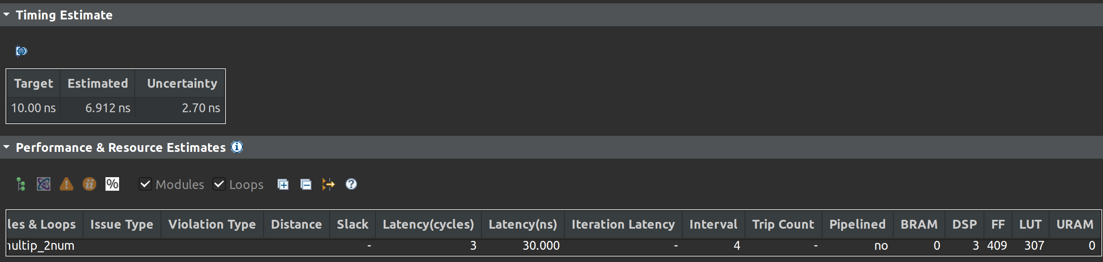
1. Performance:

2. Utilization:
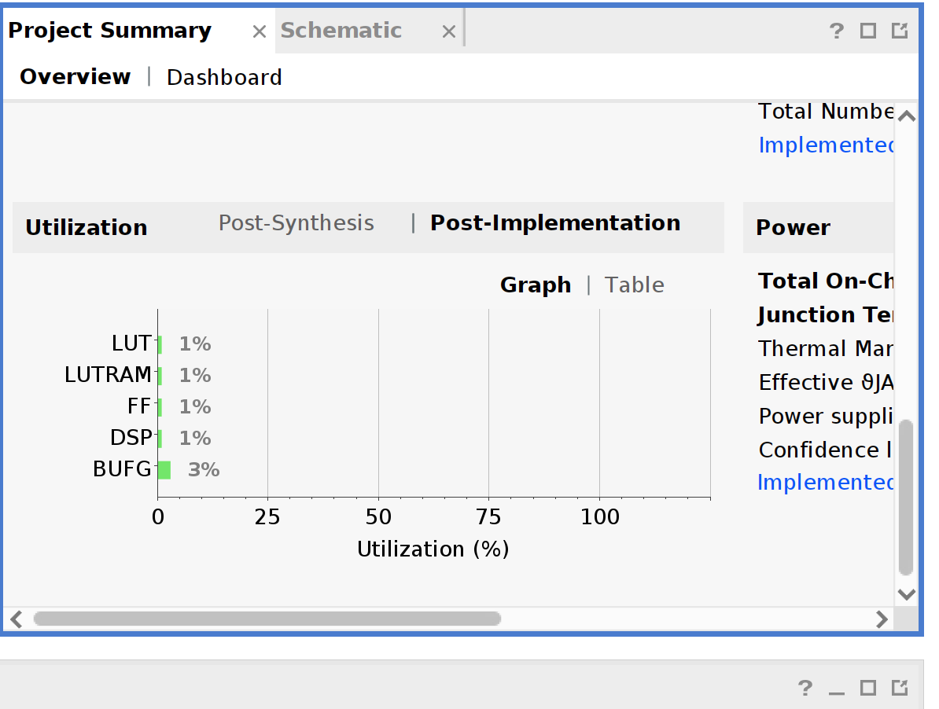

3. Interface

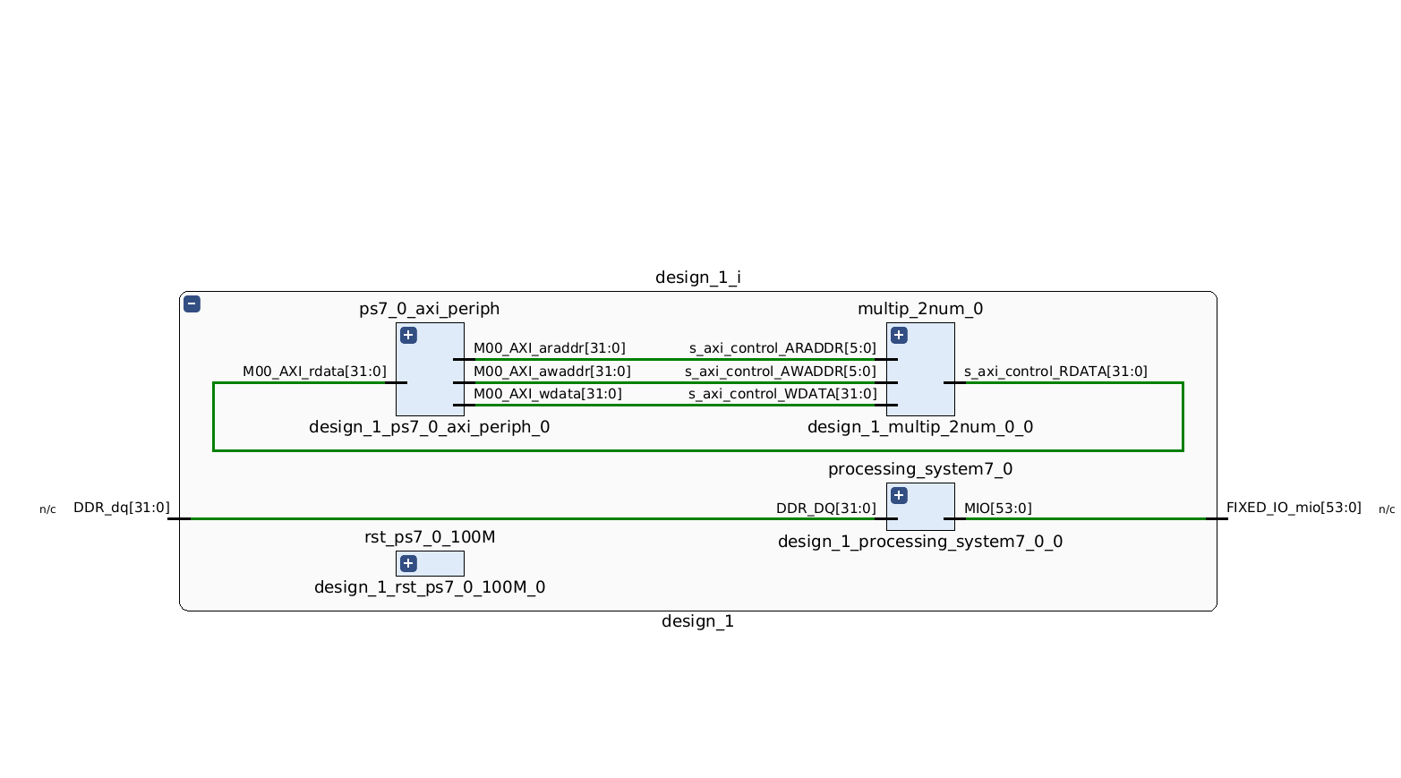
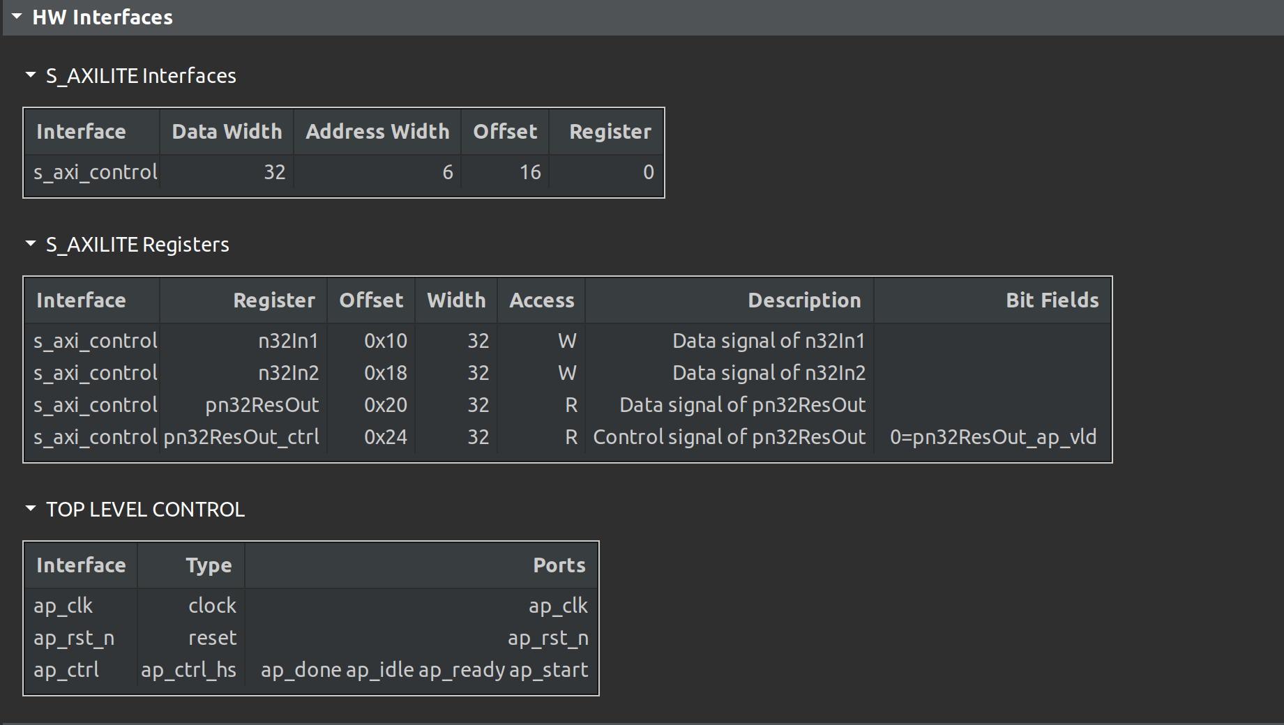

4. Jupyter notebook result
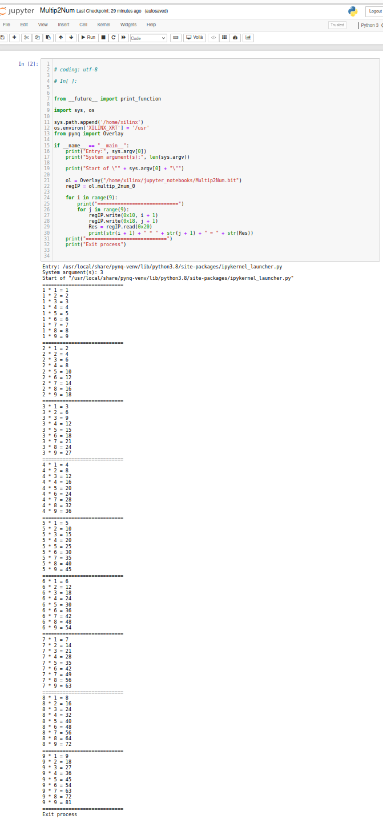

5. Cosimulation & waveform

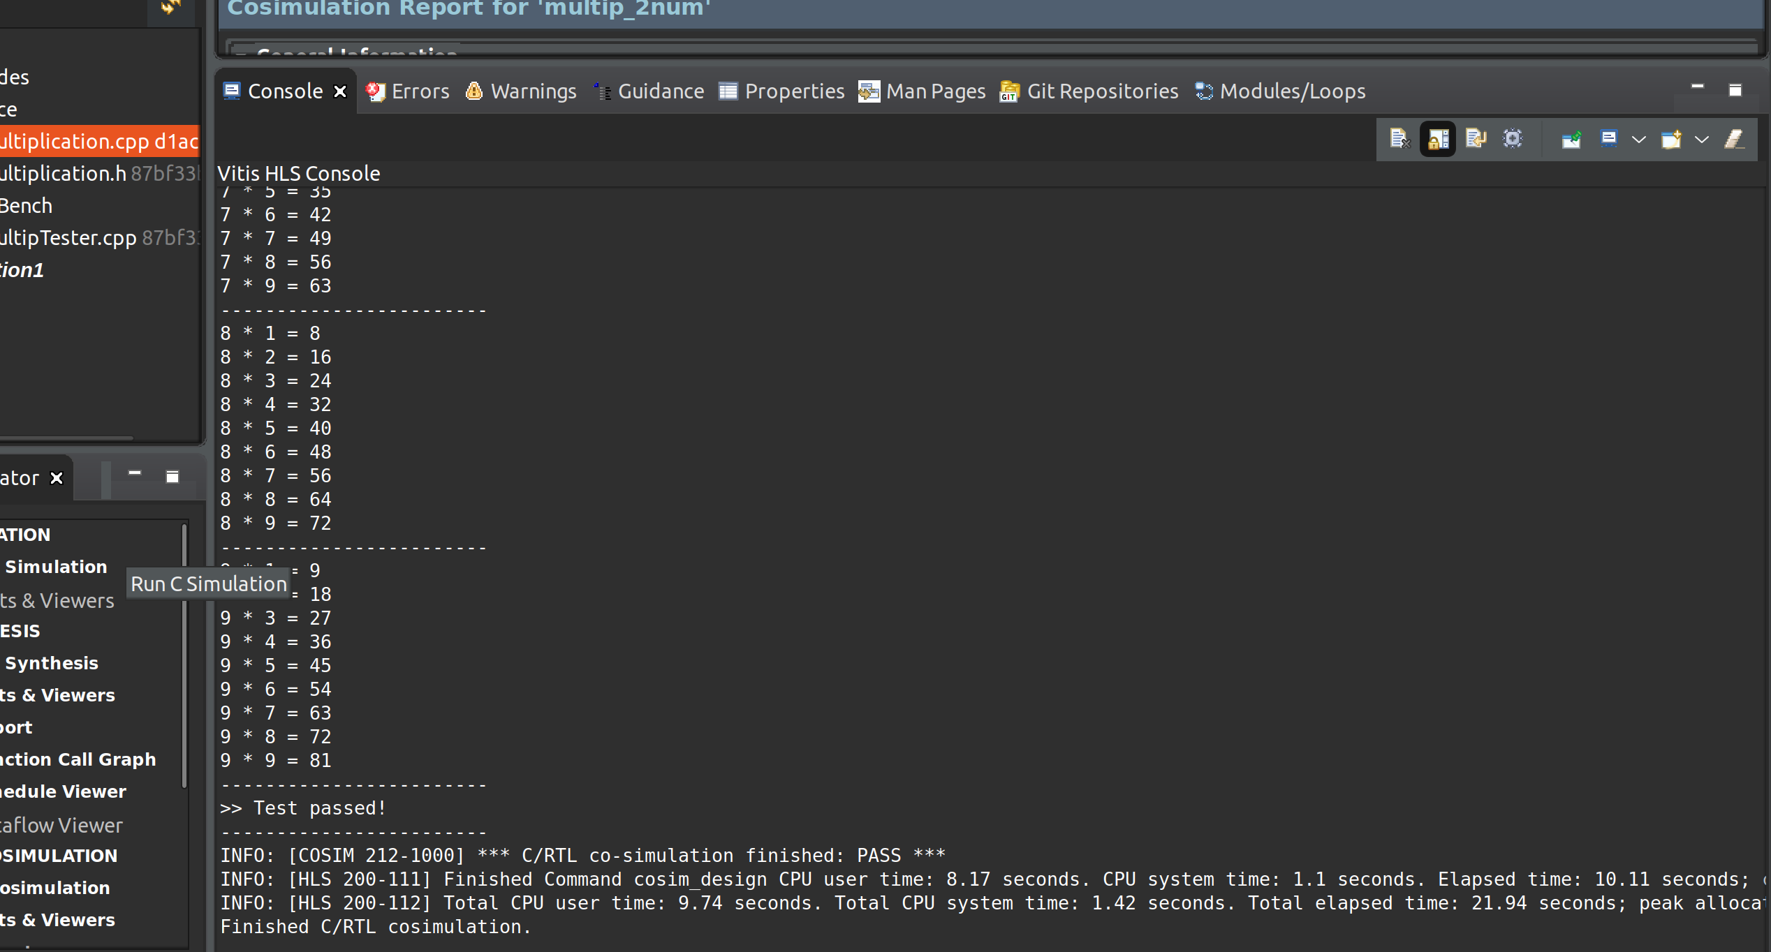

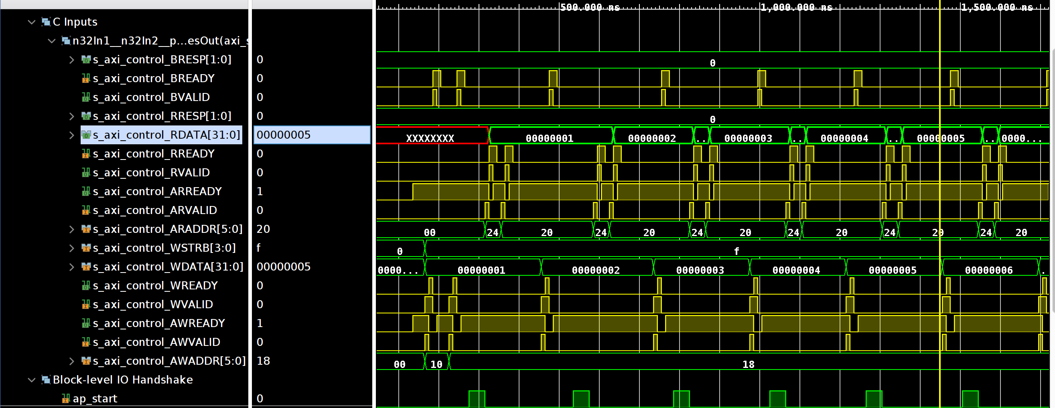

6. Introduction of the system:

In this practice, the codes provided is to create a multiplication module, and use AXILite bus to communicate with zynq processing system. The zynq processing system is as follow:
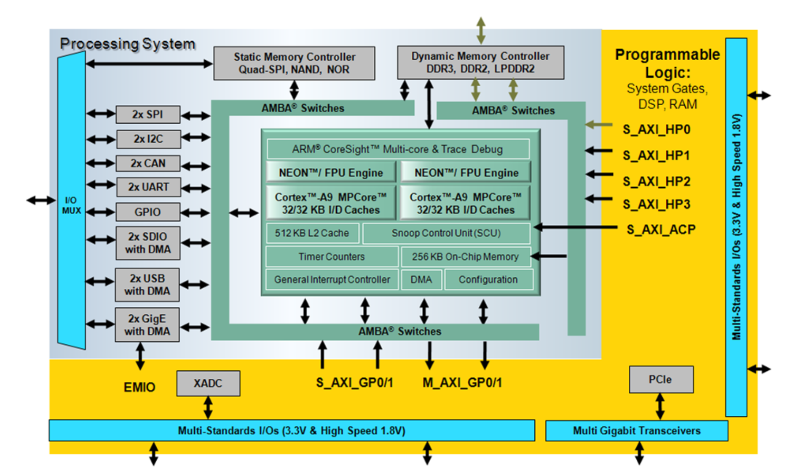

7. Observation & Learned:
Checking the waveform, we could observe how the data transfers and is received through the axilite bus. Let’s take a look at the example for i = 5 and j = 1~4, the waveform shown as below,

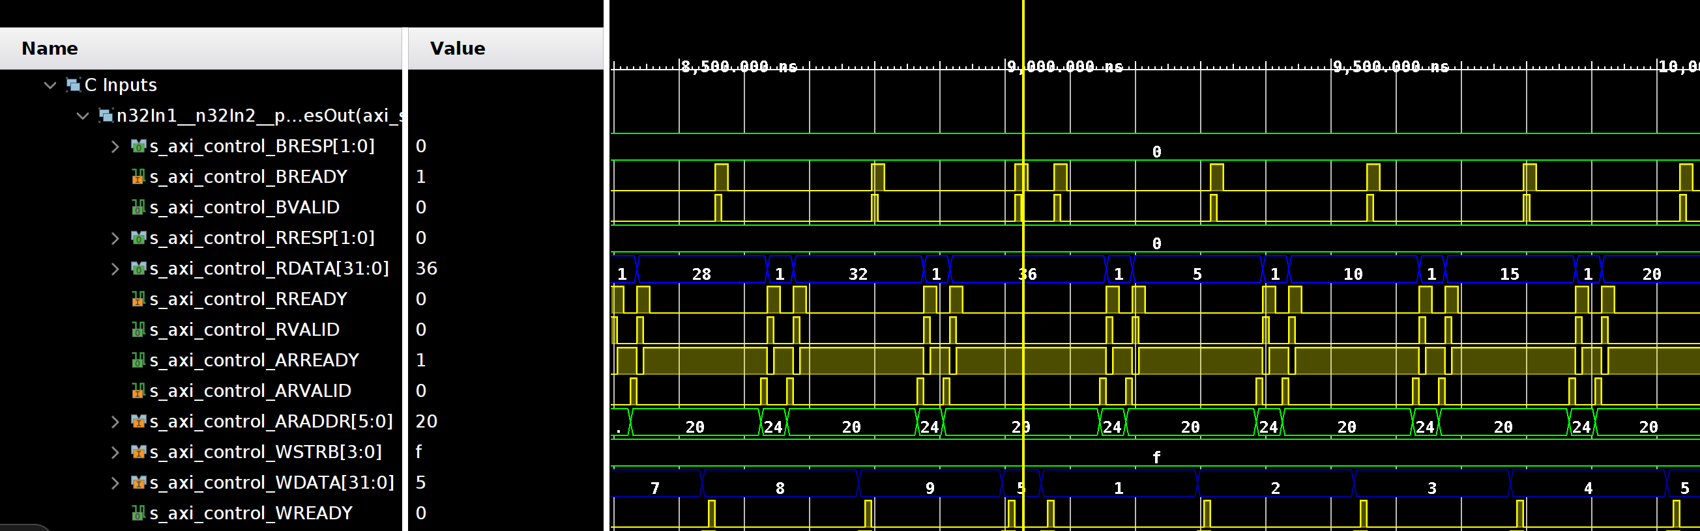
Taking a look at the blue signal, the input is the “s_axi_control__WDATA” and the value is 5 and then set from 1 to 4 as shown in the picture, and after passing 13 cycles, the value of “s_axi_control_RDATA” becomes 5, which is the output in our case.

After looking at the signals shown in the waveform, I begin to interest in the structure of verilog code it generates. Following is the code it generates after running cosimulation.
We could see that there are three modules: multip_2num_control_s_axi(control the bus control signal), multip_2num_mul_32s_32s_32_2_1, and multip_2num(which calls the multip_2num_control_s_axi and multip_2num_mul_32s_32s_32_2_1), and we could see that how it generate the corresponding axi bus control signals in this case.

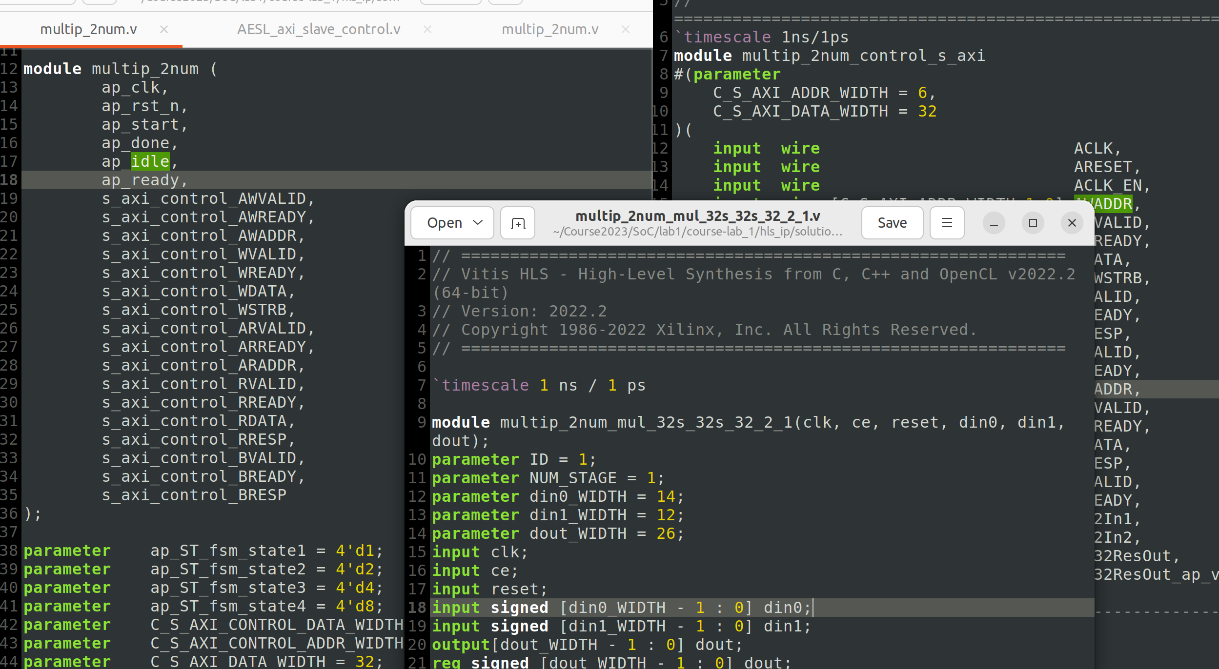

And one thing I notice is the block-level control signals as professor has mentioned in class, although I don’t see it shows in pragma syntax or the directive, it indeed exists in the code, which is the module “multip_2num”, and the code is as follows,
...
input ap_start;
output ap_done;
output ap_idle;
output ap_ready;
…

Based on the structure of the fpga, including the design of cache policy and implemented network on chip within it, we calculate the related workload of each operations, such as HADD, HMUL, and ROTATE. As for the GPU part, we compute the workload of each operation based on the imperial experiment.

