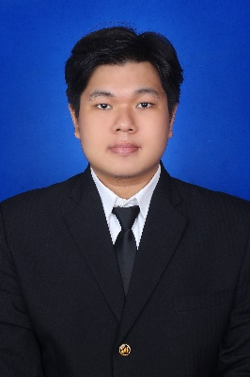

**Raynald Saputra**

**Electrical and Computer Engineering**

Bandar Lampung, Lampung | +62 877-9879-0096 | raynaldsaputra25@gmail.com

<https://www.linkedin.com/in/raynaldsaputra/>

# About me

Graduated from Electrical and Computer Engineering, Satya Wacana Christian University (UKSW) in 2022. Throughout my education, I established a strong foundation in electrical and computer engineering, especially in building a website based on HTML, and CSS. Possessed programming language skills such as C++, Python, Arduino and low level ones such as Assembly, and machine level language. I was involved in student leadership training as a leader in 2017. That valuable experience has strengthened my leadership, teamwork, public speaking, critical thinking, and problem solving skills.

**Personal Information**

Place/Date and Birth : Bandar Lampung / 2 Mei 1997

Age : 25 years old

Gender : Male

Nationality : Indonesia

# Experience

* **Participated in Progate Frontend Developer Course in 2022**
  + Learnt about HTML, CSS, JavaScript, and Git for building a Website
* **Participated in Digital Talent Scholarship by KOMINFO in 2019 about Machine Learning** 
  + Learnt basic Machine Learning using Python programming language and AWS Products.
* **Internship at FX.Marsudirini 78 Primary School** as **Electrical & Robotic Teacher**

**(May 2018 – August 2018)**

* + Created electronic and robotic mini projects to enthuse students to be interested in electronic or robotic fields.
  + Created a teaching method for students to understand electronic and robotic fields more easily.
* **Student Body functionary of Faculty of Electrical and Computer Engineering – SWCU**

**(Apr 2017 – Jul 2018)**

* Optimize intership program by restructuring and regulating the Student Body’s guidelines.
* Created activity point system to grow student interactivity, and to increase cadres’ involvement in campus organization.
* Learn to work both in teams and at individual level to quickly adapt in new environment. Practised analytical thinking and sharpened robust work ethic.

• **Coordinator of Student Leadership Basic Training (2017) in the FTEK SWCU**

* Arranged basic student leadership training for 45 students which was held for 4 days.
* Led and managed about 15 people to achieve event goals and complete programs.
* Collaborated with team to grow student sense of leadership especially in critical thinking, leading team, time management and teamwork by adding team building sessions.
* Achieved Leadership skill, people coordinating ability, both team and individual work. Strengthened public speaking, analytical thinking and critical thinking skills to solve problems.

# Skills

* Embedded Systems
* HTML 5
* CSS 3
* C++
* Python (Basic)
* Microcontroller and IOT (Arduino, ESP8266)
* PLC (Basic)
* Digital/Analog Electronic
* Circuit Design (Altium Circuit Maker, Fritzing)

# Education

Satya Wacana Christian University (2015-2022)

S1-Electrical Engineer (with GPA 3.08)

# Final Year Project

# Prototype of Microgreen Cultivation Automation based on IOT

Built a prototype of Microgreen Cultivation Automation based on Microcontroller Arduino and IOT integrated with various sensors and devices. Users can control and monitor the system via a touch screen LCD or via smartphone with BLYNK App.