Analysis Case Studies: Notes
Advanced Data Analytics Week 5

Slide 5
The following analyses are descriptive examinations of the final design of each system, not prescriptive statements that the particular choices made by these designers are the only good solution that fits the requirements. As you read through this chapter, it is a useful exercise to generate a set of alternatives for each choice made by these designers and to consider the pros and cons of each
Slide 8
The nine scagnostics measures that describe scatterplot shape, with examples of real-world datasets rated low, medium, and high for each of the nine measures.
Slide 14
Summary of VisDB analysis
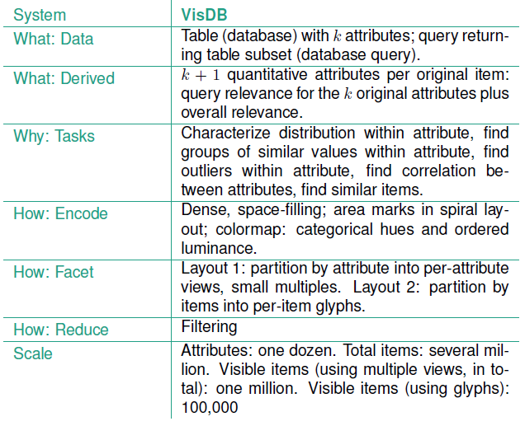

Slide 16
The overview cluster heatmap at the top uses an aggregated representation where an entire dataset of 3614 genes is shown with fewer than 1500 pixels by replacing individual leaves with the average values of adjacent leaves. The density level of the overview can be interactively changed by the user, for a tradeoff between an aggregate view where some detail is lost but the entire display is visible at once, and a more zoomed-in view where only some of the columns are visible simultaneously and navigation by horizontal panning is required to see the rest. The horizontal line through the dendrogram labelled Minimum Similarity is an interactive filtering control. Dragging it down vertically dynamically filters out the columns in the heatmap that correspond to the parts of the dendrogram above the bar and partitions the heatmap into pieces that correspond to the number of clusters just below the bar.
The detail view at the bottom shows a heatmap of the cluster selected in the top overview. It also shows the second dendrogram for hierarchical clustering of the rows on the side; this dendrogram is not shown above in order to maximize the number of columns that can fit within the overview. The background of the selected cluster is highlighted in yellow in the overview, and the correspondence between the views is emphasized by colouring the column labels along the top of the detail view yellow as well, for linked highlighting.

Slide 17
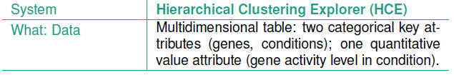
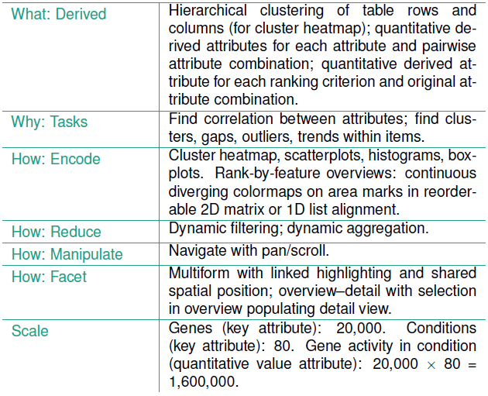

References
Case Study 1: Scagnostics
L. Wilkinson, A. Anand, and R. Grossman, “Graph-Theoretic Scagnostics”, In Proceedings of the IEEE Symposium on Information Visualization (InfoVis), (2005), 157-164.
Case Study 2: VisDB
D. A. Keim and H-P. Kriegel, VisDB: Database Exploration Using Multidimensional Visualization.” IEEE Computer Graphics and Applications, 14 (1994), 40-49.
Case Study 3: HCE
J. Seo and B. Shneiderman, “Interactively Exploring Hierarchical Clustering Results”, IEEE Computer 35, (2002), 80-86/

