CampusBot – AI Campus Assistant Chatbot

1. Project Title
CampusBot – AI Powered Campus Assistant Chatbot

2. Project Objective & Description

Objective:
The objective of CampusBot is to develop an interactive chatbot that helps students, faculty, and visitors get quick answers related to campus services.
The chatbot reduces the need for manually searching information by providing instant automated responses.

Description:
CampusBot is a university assistant chatbot designed to answer common student queries. It provides information about:
- Admissions
- Library facilities
- Fee structure
- Examination schedules
- Hostel accommodation
- Placement information
- Campus events
- Contact details
The chatbot understands user inputs, matches them with predefined knowledge categories, and generates appropriate responses. If the chatbot does not understand a query, it provides a fallback message guiding the user.

3. Technologies Used

HTML
Used for creating the chatbot interface structure including:
- Chat window
- Input box
- Send button
- Message layout

CSS
Used for designing the chatbot UI:
- Chat bubbles
- Colors and theme
- Responsive layout
- Buttons and animations

JavaScript
Used for chatbot logic:
- Processing user input
- Keyword matching
- Generating responses
- Quick option buttons
- Fallback handling

Knowledge Base Logic
A rule-based chatbot approach was implemented where keywords are mapped with predefined responses.

4. Screenshots With Explanation

Screenshot 1: Chatbot Home Interface
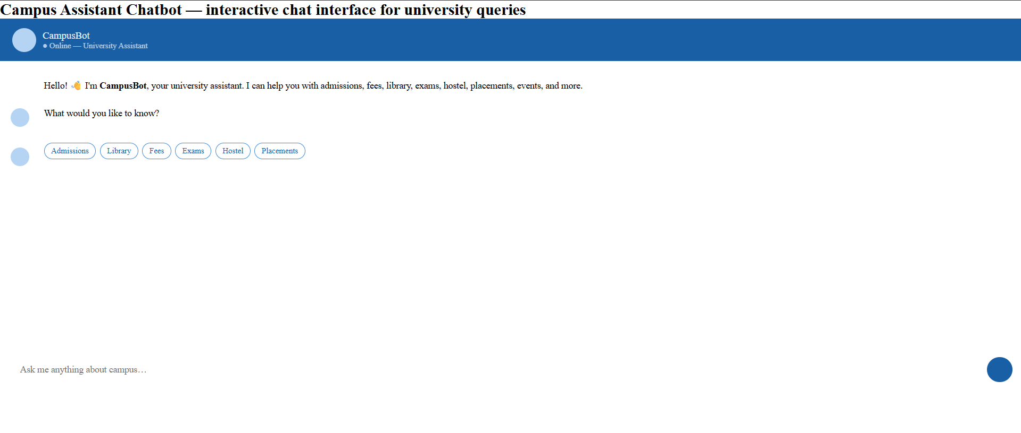
Explanation:
This screenshot shows the CampusBot user interface. The chatbot starts with a welcome message and introduces itself as a university assistant. Users can type questions or select quick options.

Screenshot 2: Library Query Interaction
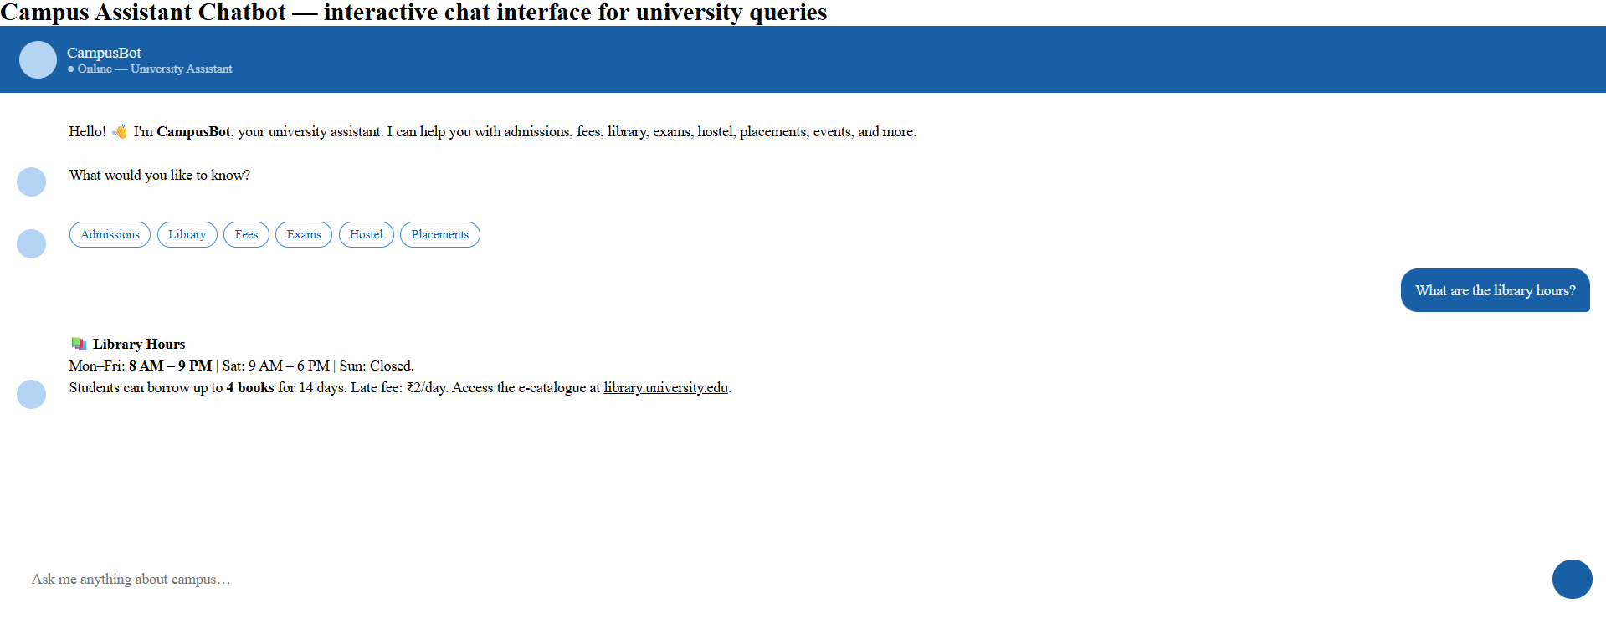Example:
User:
"What are library timings?"
Bot:
Provides library opening hours, borrowing details, and resource information.
Explanation:
The chatbot detects library-related keywords and returns the correct response from its knowledge base.

Screenshot 3: Examination Query
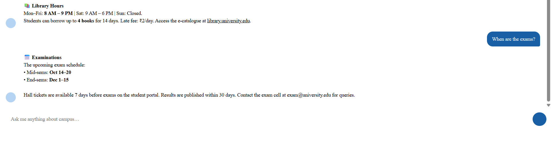Example:
User:
"When are exams?"
Bot:
Displays examination schedule and related information.
Explanation:
This demonstrates the chatbot's ability to handle academic queries.

Screenshot 4: Placement Information
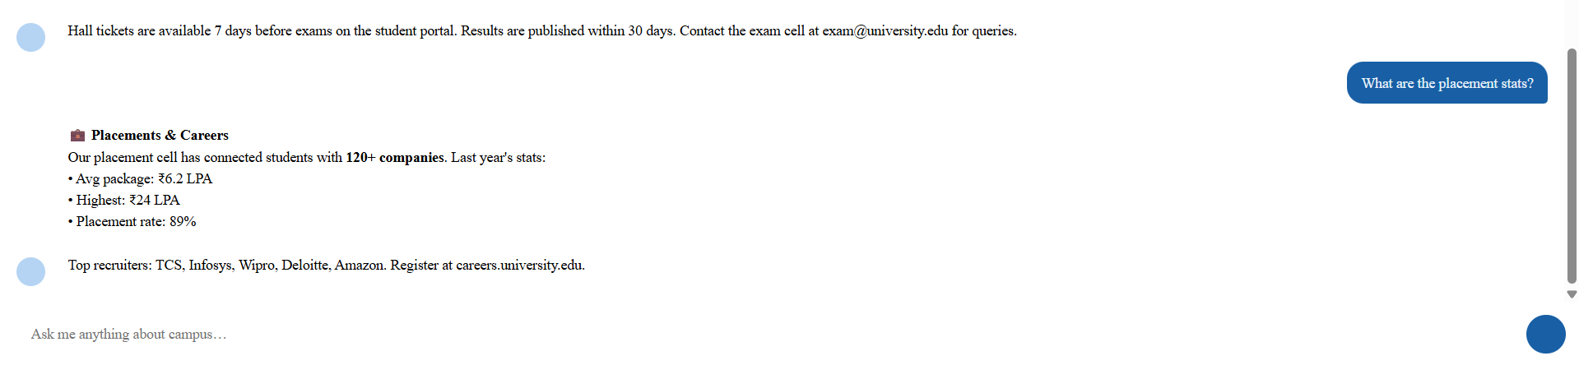Example:
User:
"Tell me about placements"
Bot:
Shows placement statistics and career information.
Explanation:
CampusBot helps students access placement-related information instantly.

Screenshot 5: Fallback Response
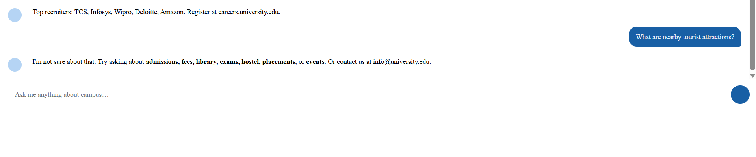 Example:
User:
"Random unknown question"
Bot:
"I'm not sure about that. Try asking about admissions, fees, library, exams, hostel, placements, or events."
Explanation:
The fallback feature prevents conversation failure when unknown inputs are entered.

5. Project Links
GitHub Repository:
(Add your GitHub link)
Live Chatbot Link:
(Add hosted project link)
Project File:
Campus Assistant Chatbot HTML file
Video Demonstration:
(Add video link if available)

6. Conclusion & Summary
CampusBot successfully demonstrates how a chatbot can automate communication between students and campus services.
Through this project, I learned:
- How chatbot systems work
- Designing conversation flows
- Creating interactive web interfaces
- Implementing rule-based response systems
- Handling unknown user queries using fallback responses
The project can be further improved by integrating AI models, natural language processing, voice assistance, and database connectivity.

