LOGZILLA
A log analyzer for very large files
Feature overview and use cases • Version 3.1.0 • Rayon Narain

What it is
Logzilla is a Windows desktop application for reading log files that are too big, too many, or too noisy to work through by hand. It opens multi-gigabyte logs in seconds, merges several of them onto a single timeline, and turns machine-readable JSON logs back into sentences a person can read.
It runs entirely on your own machine. Nothing is uploaded anywhere unless you turn on the optional AI assistant and ask it a question, which matters when logs contain customer device IDs, hostnames and internal addresses.
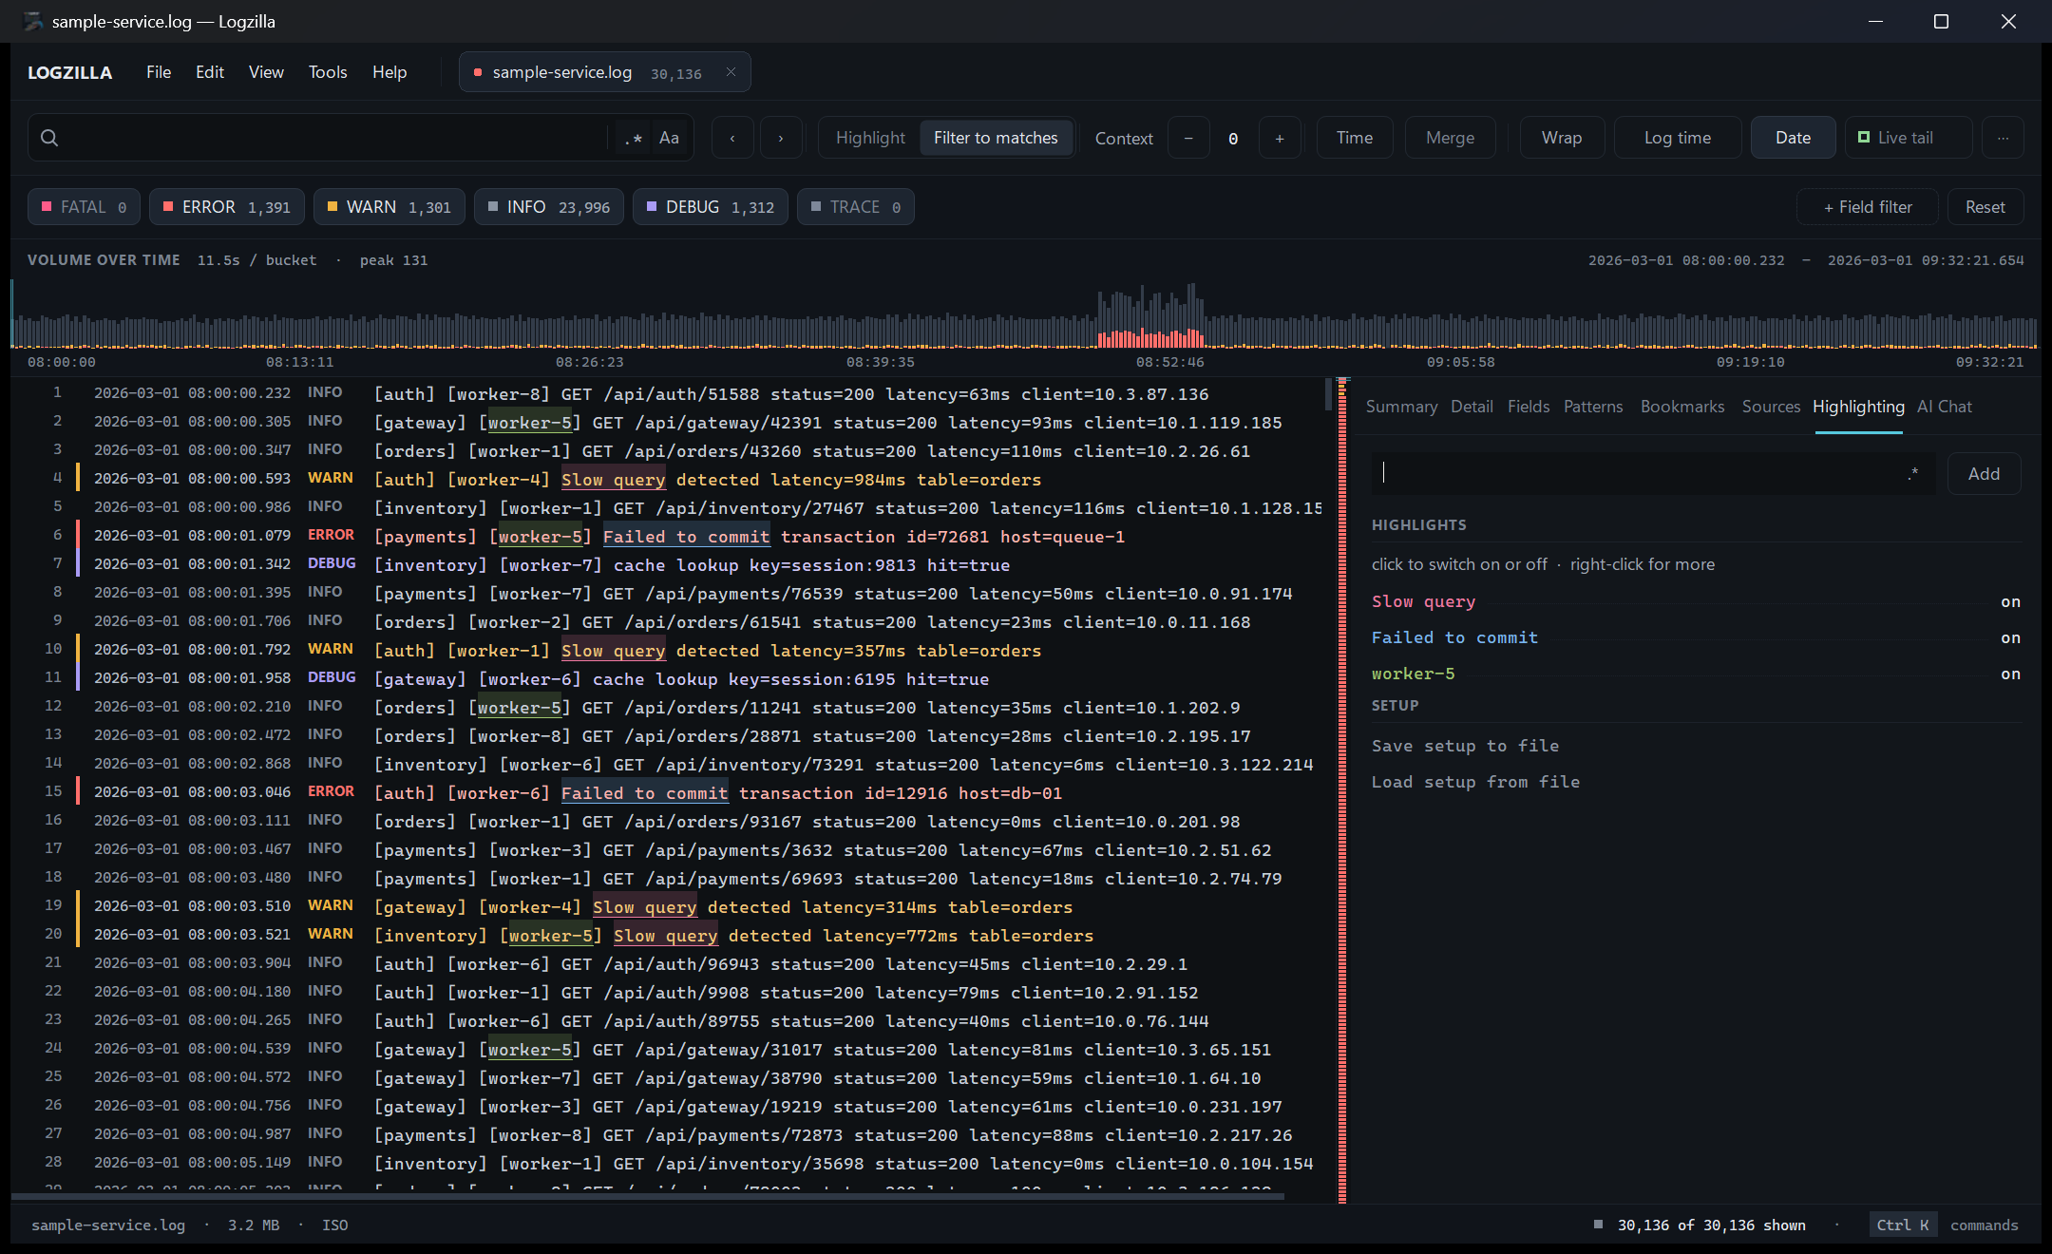
The main window: the command bar and severity chips across the top, the volume timeline below them, the log grid on the left, the inspector on the right, and the error minimap in the narrow strip between them.
The problem it solves
Notepad and Notepad++ load the whole file into memory, so a 2 GB log either takes minutes or fails outright. Even when it opens, you are scrolling through a million lines looking for the handful that matter, in one file at a time, with no way to line it up against what another service was doing at the same moment.

At a glance
Capability | What it means in practice
Speed | A 1 GB log is ready in about nine seconds; file size is limited by disk, not memory
Merge | Several logs interleaved onto one timeline, even in different formats
JSON logs | Serilog CLEF, pino, bunyan, ECS and NDJSON rendered as readable text
Analysis | Eight panels — summary, detail, fields, patterns, bookmarks, sources, highlighting and AI Chat — on Ctrl+1 to Ctrl+8
Live files | Live tail keeps reading a log while it is still being written
Search | Terms, phrases, exclusions and regular expressions, matched across a whole multi-line entry
Field filters | Filter on any field — CorrelationId, Feature, a status code — with is, contains or is not, and stack as many as you need
AI Chat | Ask about the log in plain words and get answers that cite their lines — GitHub Copilot, Claude or OpenAI, off until you turn it on
Install | One self-contained installer, per-user, no admin rights, no prerequisites

Core features

Opens very large files
The file is never fully loaded. Logzilla builds an index of where each line starts and only converts the rows currently on screen into text. The practical effect is that a log ten times bigger takes ten times longer to index and no more memory to browse.
- Roughly nine seconds to index a 1 GB log.
- Scrolling, searching and filtering stay responsive on files of any size.
- Typing in the search box never freezes the window; scans run in the background and are abandoned the moment you change the query.

Understands your timestamps automatically
The format is detected from the file itself, with no configuration. Supported shapes include:
Format | Example
ISO 8601 | 2026-03-01 08:14:02.113
Slash dates | 2026/03/01 08:14:02
Apache / IIS (CLF) | 01/Mar/2026:08:14:02 +0000
US short date | 3/1/2026 8:14:02 AM
Syslog | Mar 1 08:14:02
Time only | 08:14:02.113 (rolls over correctly at midnight)
Severity is read from the line and shown in its own colour-coded column, so ERROR and WARN stand out without you searching for them.

Merging several logs onto one timeline
Open as many logs as you like and press the Merge button in the command bar, or Ctrl+M. Entries interleave by timestamp with a colour-coded source column, so you can read one continuous story instead of flicking between windows.
- Works across formats — an ISO application log, an Apache access log and a syslog file merge cleanly together.
- Stack traces stay attached to the error line they belong to, rather than being scattered by the sort.
- Sources can be shown or hidden individually when one chatty service is drowning out the rest.

Why this is the feature that pays for itself
On its own, "the gateway logged an upstream timeout" and "the service logged a connection reset" are two unrelated lines in two files. Merged, they land in the same second against the same host, and the cause is obvious. That correlation is invisible when the logs sit side by side.

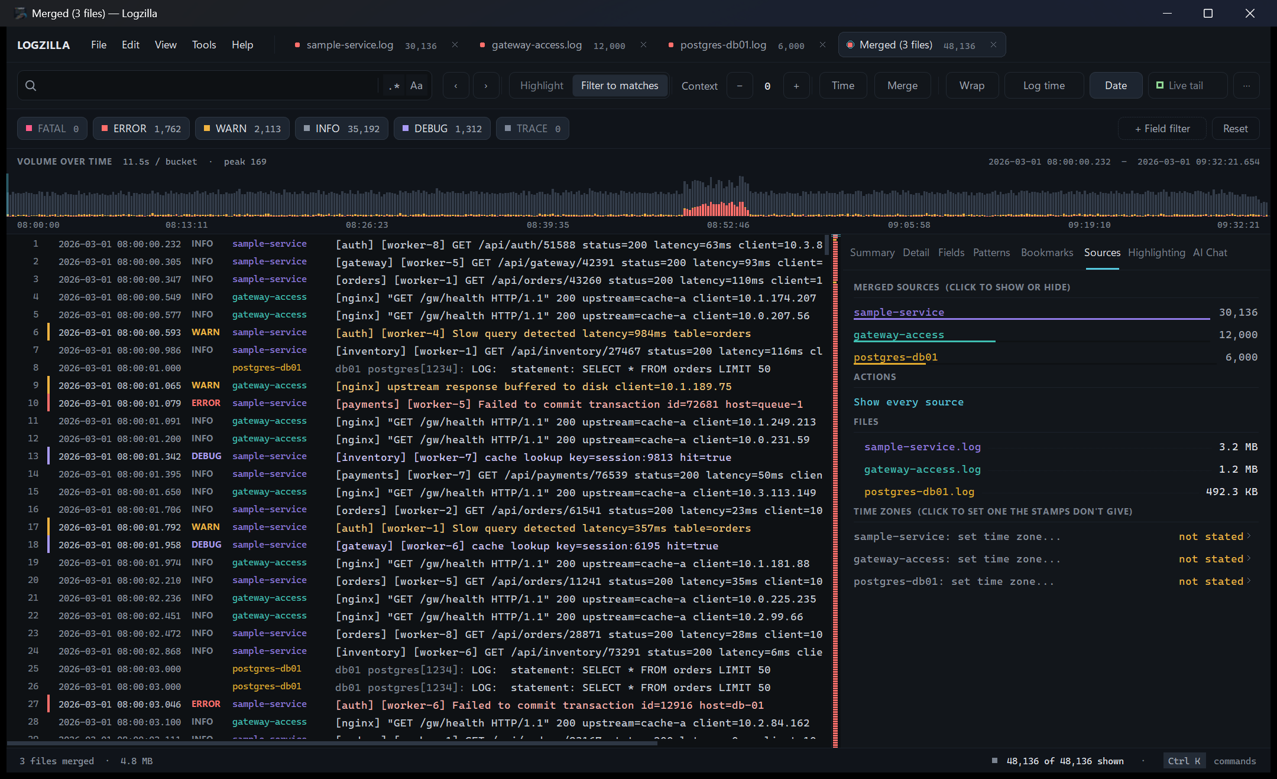
Three logs merged onto one timeline. Each line carries the colour and name of the file it came from, the timeline and severity counts cover all three, and the Sources tab on the right shows how much each file contributed.

JSON and structured logs
Modern services write one JSON object per line, which is fine for machines and miserable to read. Logzilla detects these files automatically and renders them properly.
- Message templates are filled in, so {Name}.ProcessMaintenance: {CommandType} displays as MaintenanceCommandManager.ProcessMaintenance: DeviceInformation.
- Properties such as SourceContext, CorrelationId and ThreadId can be filtered on directly — see Filtering by field.
- Exceptions and stack traces are unescaped into readable text instead of a wall of \r\n.
- Serilog CLEF, pino, bunyan, Elastic ECS and plain NDJSON are all supported.
- A "Show raw lines" toggle puts the original JSON back whenever you need it.

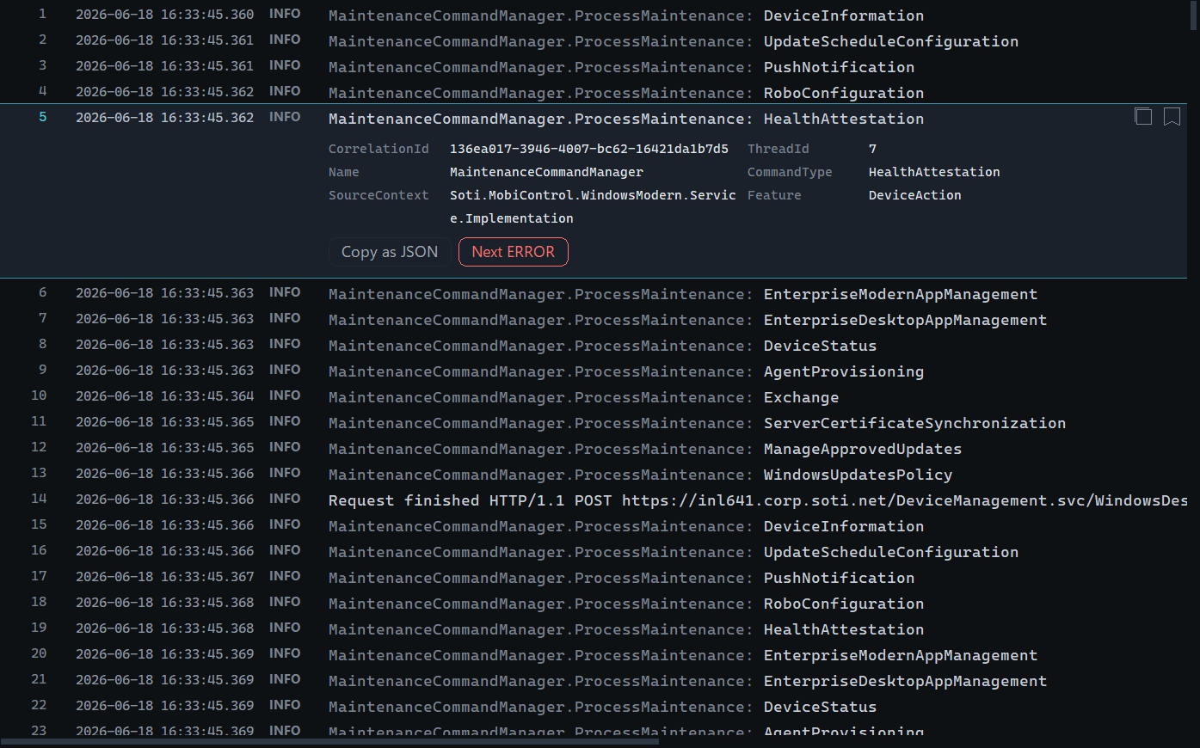
A JSON log reads as plain sentences. Selecting an entry opens its fields underneath — CorrelationId and ThreadId first — and clicking any value copies it.

Live tail
Turn on Live tail and the file keeps being read as it is written, like tail -f, with the view staying at the newest entries. Useful for watching a deployment or reproducing an issue live.

Search and filtering
Query | Meaning
timeout retry | Entries containing both words
"connection reset" | Exact phrase
-heartbeat | Exclude entries containing this
.* button | Treat the whole query as a regular expression
- The Highlight / Filter to matches switch decides whether entries that do not match are hidden or simply left unmarked.
- A query is answered against the whole entry, so a term buried in a stack trace or a wrapped payload still finds the error line it belongs to, and two terms count even when they are several lines apart.
- Context lines can be shown around each match.
- Severity buttons isolate a level with a single click.
- Highlights colour anything you care about — an error code, a host name, a customer ID — without filtering the rest away. Add them on the Highlighting tab.
- Each tab keeps its own search. Switching to another log never carries your query, severity chips or filters with it, and switching back brings them back.
- Changing the filter keeps your place. Pick an entry while showing only errors, switch the other severities back on, and it stays where it was with its neighbours around it.
The command bar and the severity chips beneath it: the find box with its match count and the .* and Aa toggles, match navigation, the Highlight / Filter to matches switch, context lines and the time range; Merge, Wrap, Date and Live tail sit on the right. Each severity chip carries its own live count.
How to search
1. Click in the FIND box or press Ctrl+F.
2. Type your terms. Results narrow as you type — there is no need to press Enter.
3. Use Enter and Shift+Enter (or the ‹ and › buttons) to step through matches one at a time; the box shows which match you are on.
4. Press the × beside the box, or Esc, to clear it.
5. Click the Filter button to switch it to Highlight when you want to keep the surrounding entries visible.

How to focus on errors
1. Click a severity chip — ERROR, WARN and so on — to switch that level off or back on. Each chip shows how many entries it holds.
2. Right-click a chip to isolate that level and switch every other one off.
3. Press W to jump straight to warnings and anything worse.
4. Press Reset (or Ctrl+R) to clear the query, levels, field filters and time range together — it shows how many filters are active.

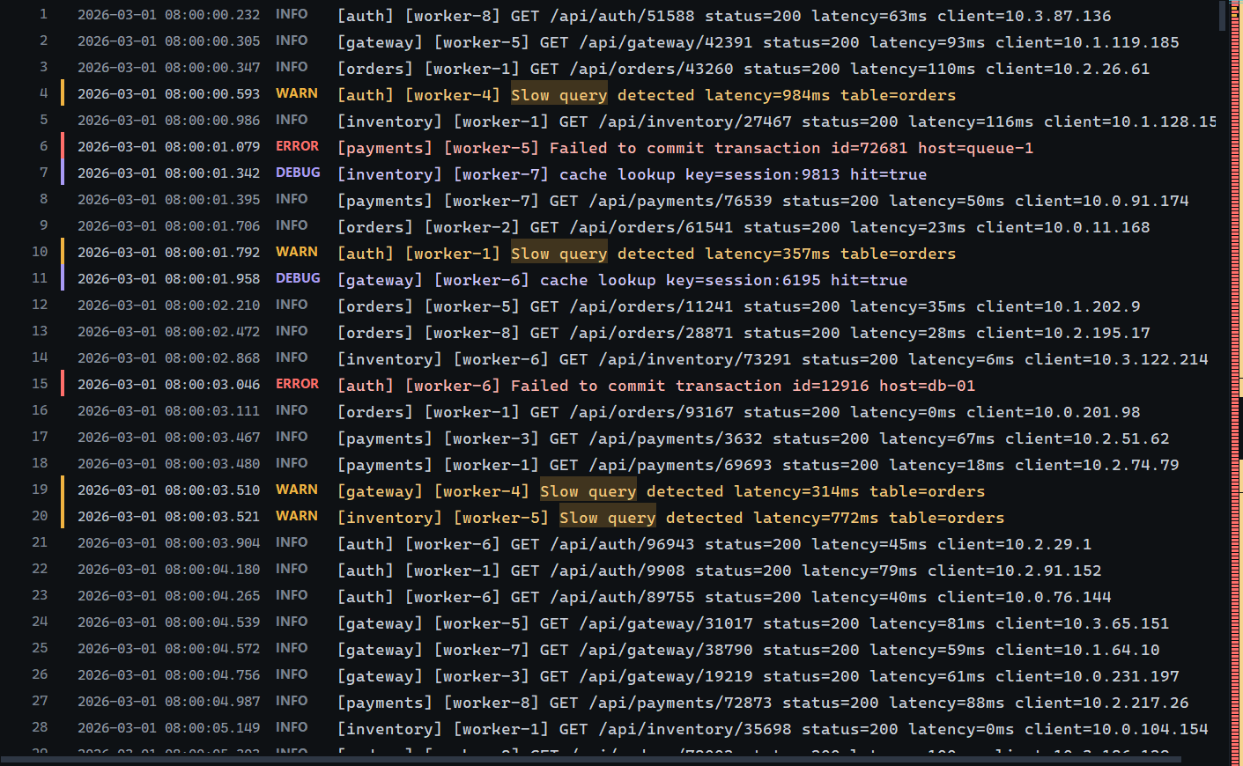
Highlight mode keeps every line and marks each match, here “Slow query”. Small marks down the right edge of the strip beside the log show where the other matches are in the file.

Filtering by field
The search box finds text anywhere in an entry. Field filters answer a narrower question: which entries carry this value in this field? Pick a field the log actually records — CorrelationId, Feature, RequestPath, a tenant or a status code — and Logzilla keeps only the entries where it holds. Add more and the view narrows with each one, while the search box keeps working on top of them.
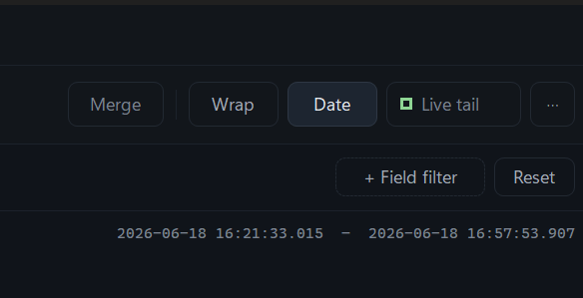
The + Field filter button sits at the right of the severity row, next to Reset. Ctrl+Shift+F opens the same editor from anywhere.
- Three ways to compare: is matches the whole value, contains matches part of it, and is not hides entries with that value. Field names and values ignore case.
- Several values on one field match any of them — Feature is DeviceAction or Sync. Filters on different fields must all hold.
- An entry is judged as a whole, so a field logged on a stack-trace line counts for the entry above it. Nested JSON properties are found too.
- Works on JSON properties and on key=value pairs in plain-text logs alike.
- Fast on big files: a field filter over a 330 MB log comes back in under half a second.
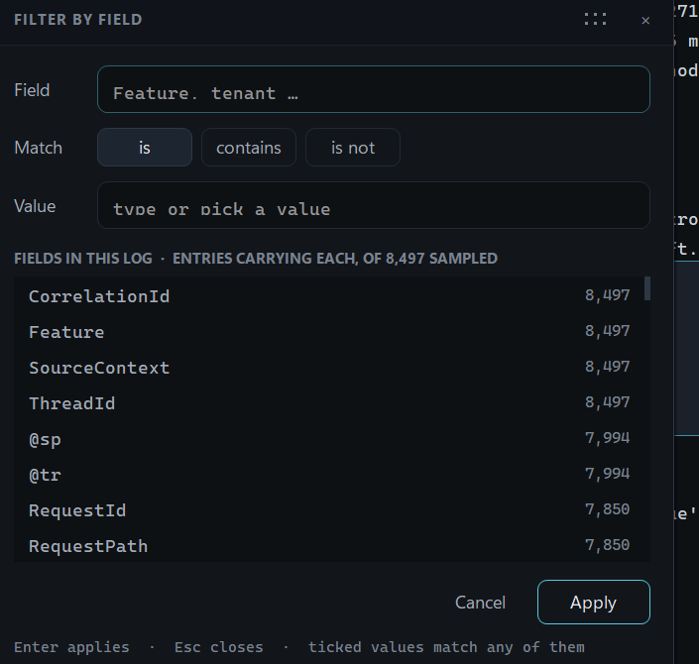
The field filter editor lists the fields this log actually carries, most common first, with how many entries carry each. Pick one and the list becomes that field's values, again with counts. Drag the editor by its header to move it; it reopens where you left it.
How to filter by field
1. Click + Field filter, or press Ctrl+Shift+F.
2. Start typing the field name — the list narrows as you type, so corr finds CorrelationId. Press Enter or click it.
3. Choose is, contains or is not (Alt+I, Alt+C, Alt+N).
4. Type a value or pick one from the list. Tick several to match any of them.
5. Press Enter or Apply. The filter appears as a chip under the severity row and the grid updates at once.

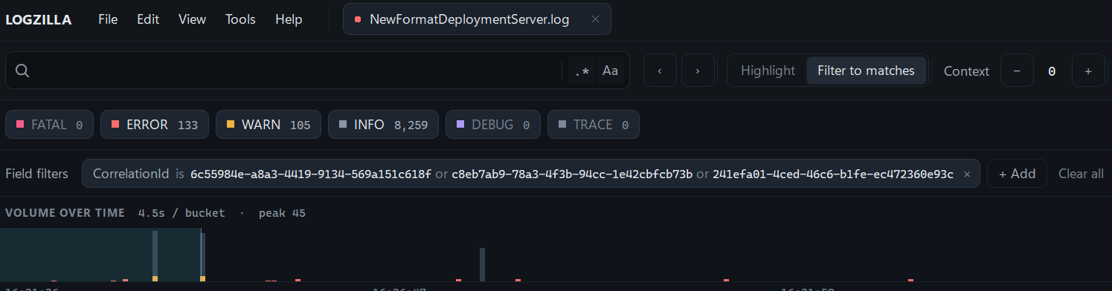
Active field filters show as chips under the severity row — here, three requests at once. Click a chip to change it, × to remove it, and right-click to switch between is and is not. Clear all removes every field filter.
Quicker ways in
- Right-click any entry and choose Show only where… or Hide where… — the menu lists that entry's own fields, correlation ids first.
- In the Fields panel, click a value to filter to it, or Ctrl+click to hide it.
How to follow several requests at once
1. Add a filter for the first CorrelationId.
2. Click its chip. The editor lists every CorrelationId in the log with its entry count.
3. Tick the others you want and press Update. The chip now reads CorrelationId is A or B or C.

Selecting and copying entries
Anything on screen can be taken with you. Click an entry to select it, then drag down the rows, Shift+click a second entry, or hold Shift with the arrow, Page and Home/End keys to stretch the selection into a run.
- Ctrl+A selects every entry the current filter has left showing.
- Ctrl+C copies the selection, one entry per line, rendered as it reads on screen rather than as the raw record. In a merged view each line carries its source label.
- A drag held past the top or bottom edge keeps scrolling and selecting, so a run can be longer than the window.
- Click the selected entry again, or press Esc, to fold it back to one line; click once more to open it.
- M bookmarks the whole selection at once, or removes its bookmarks — the quickest way to collect the lines that belong in a ticket.
- The Copy command and the right-click menu name the number of entries they are about to take, and the status bar says how many are selected.

How to lift a sequence out of a log
1. Click the first entry of the sequence.
2. Shift+click the last one, or drag down to it.
3. Press Ctrl+C. The whole run is on the clipboard in order, ready to paste into a ticket.
4. Or press M first to bookmark the run, keep digging, and copy every bookmarked entry later from the Bookmarks tab.

Narrowing by time
Most investigations start with "what happened around half past four?". There are three ways to get there, and they all work together with whatever else you have filtered.

Drag the timeline
The histogram along the top shows entry volume over time, with warnings and errors stacked in colour. Drag across the part you care about and the whole view narrows to that range.
How to zoom into a moment
1. Drag left-to-right across the timeline to select a range.
2. Everything — the grid, the panels and the counts — updates to that window only.
3. Hover anywhere on the timeline to read the exact entry, warning and error counts for that slice.
4. Click once (without dragging) to jump the grid to that moment without filtering.
5. Double-click the timeline to clear the range and go back to the whole file.

The timeline after narrowing to fifteen minutes: the chart zooms to the window you chose, with the exact range at the top right, and Reset zoom goes back to the whole log.

Type a time in the TIME box
The TIME box in the toolbar narrows the view by time without dragging, which is handy when a ticket gives you an exact timestamp to look at. The × beside it clears the range, as does Reset.

Jump from the summary
The Summary panel lists the busiest error windows in the file. Clicking one takes you straight to that moment — usually the quickest way to find the start of an incident when you have no timestamp to go on.

The analysis panels
The panel on the right is where most of the value sits. Each tab answers a different question about the entries currently shown, and respects whatever filter you have applied. All eight — Summary, Detail, Fields, Patterns, Bookmarks, Sources, Highlighting and AI Chat — have a tab of their own, in that order, and Ctrl+1 to Ctrl+8 switch between them. AI Chat has a section of its own, after this one.

Summary — what am I looking at?
The orientation tab. Entry counts, file size, the time span covered, the rate of entries per minute, and how many errors there are as both a count and a percentage.
- A severity breakdown on a log scale, so a handful of errors beside thousands of routine lines is still visible at a glance.
- Click any severity to isolate it.
- A "busiest error windows" list showing the moments with the most errors — click one to jump straight there.
Use it when: you have just opened a log and want to know whether anything went wrong, and roughly when.
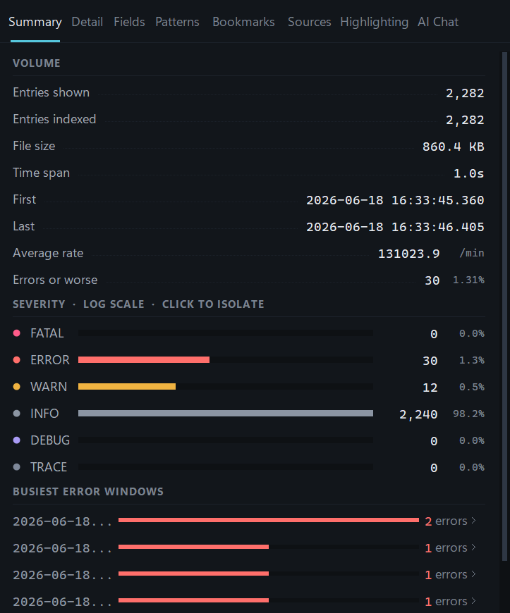
Summary: 2,282 entries, 30 of them errors (1.31%), with the severity breakdown on a log scale and the busiest error windows underneath. Click a severity to isolate it.

Detail — show me everything about this line
Full detail for the selected entry: line number, timestamp, severity, byte offset and source file.
- For JSON logs, the message, a tidy table of properties, and the exception with its real line breaks restored.
- The raw original line is always shown underneath.
- Copy the entry, bookmark it, or reset the filters and see it in context.
- XML payloads — a plist, a SOAP body, a device response — are indented one element per line instead of running together into a single unreadable string.
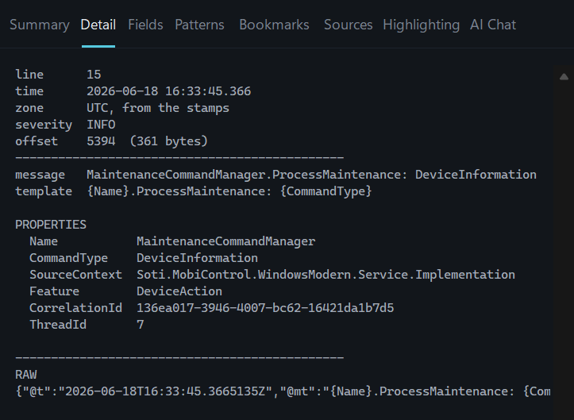
Detail: the line, its time and time zone, the rendered message and the template it came from, every property laid out, and the raw record underneath.

Fields — what values appear in this log?
Extracts the structured parts of each entry and lists the distinct values with counts, most frequent first.
- Picks up key=value pairs, IP addresses, [bracketed tags] and severity levels.
- For JSON logs it uses the real property names — SourceContext, CorrelationId, DeviceId, ThreadId and so on.
- Click any value to filter to it instantly, or Ctrl+click to hide it. Click a field's name to open the field filter editor on it.
Use it when: you want every entry for one correlation ID, one device, one host or one client address — without typing it out or knowing the exact spelling.
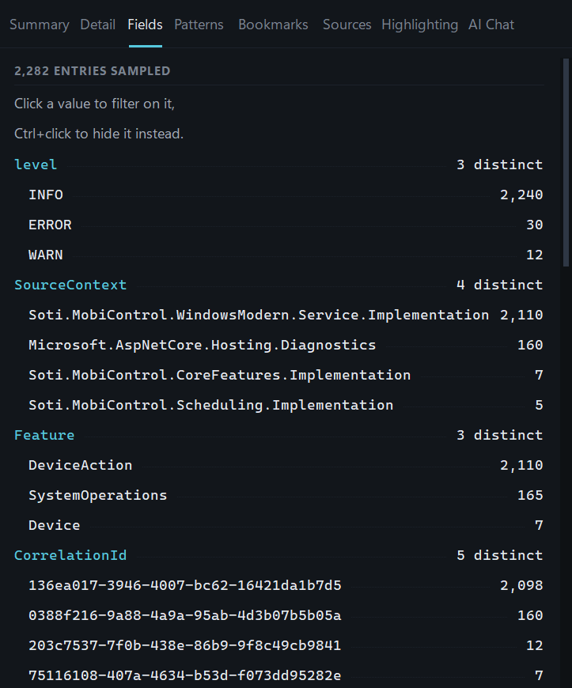
Fields: level, SourceContext, Feature and CorrelationId pulled straight out of 2,282 entries, each value with how often it appears. Click a value to filter to it.
How to trace one request
1. Open the Fields tab and find CorrelationId (or RequestId).
2. Click the value you are interested in — it becomes a field filter.
3. The grid now shows only that request, across every merged source.
4. Add values of other fields to narrow further; each one is another filter, and all of them must hold.

Patterns — what is actually in this file?
The tab that does the most work. It groups entries that are identical apart from their variable parts, so latency=812ms and latency=41ms count as the same message, and ranks the results by frequency.
- A million lines typically collapse to a few dozen distinct shapes.
- Each shape is coloured by its worst severity and shows a count and percentage.
- Click a shape to jump to its first occurrence, or Ctrl+click to filter to it.
- For JSON logs the grouping is exact rather than approximate, because the log already carries the message template.

A real example
A 2,282-line deployment server log collapsed to six distinct shapes. Routine maintenance accounted for 91% of it, and the three genuine error templates sat at the bottom of the list at 0.8%, 0.3% and 0.2% — visible immediately, rather than buried somewhere in two thousand lines.

Use it when: you do not yet know what you are looking for. The rare entries sort to the bottom, and the rare entries are usually the problem.
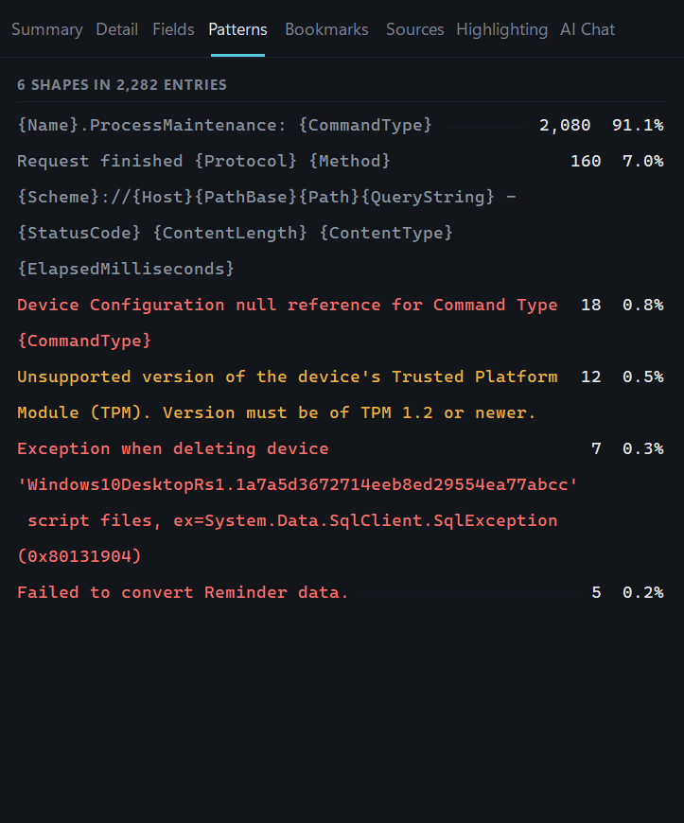
Patterns: 2,282 entries reduced to 6 shapes. One routine message makes up 91% of the file; the rare failures sit further down, coloured by severity.
How to find what is really in a log
1. Open the Patterns tab — it groups entries that differ only in their variable parts.
2. Read the top of the list to see what is normal and noisy.
3. Scroll to the bottom for the rare entries, which are usually the interesting ones.
4. Click a shape to jump to its first occurrence, or Ctrl+click to filter to it.

Bookmarks — keep the lines that matter
Press M on any entry to bookmark it. The Bookmarks tab collects them in order with timestamps.
- Copy all bookmarked entries in one go — ready to paste into a ticket, an email or a post-mortem.
- Select a run of entries and press M once to bookmark the lot.
- Bookmarks show as amber line numbers in the grid and on the minimap, so you can find your way back.
Use it when: you are assembling the handful of lines that prove what happened, while still digging through the rest.

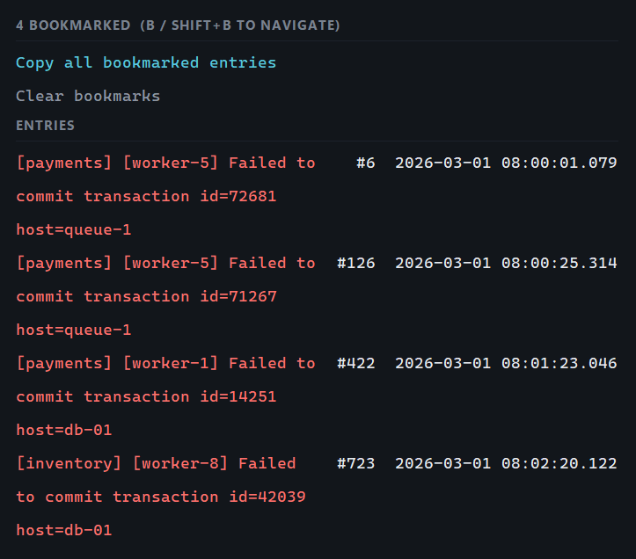
Bookmarks: four errors kept aside while reading, each with its line number and time. Click one to jump to it, or copy them all at once.

Sources — which file did this come from?
Appears once you have merged files. Lists every source with its entry count and a coloured bar showing its share of the total.
- Click a source to show or hide it without redoing the merge.
- Counts update as you filter, so you can see which service produced the errors you are looking at.
Use it when: a merged view is dominated by one noisy service, or you want to confirm which component an error actually came from.

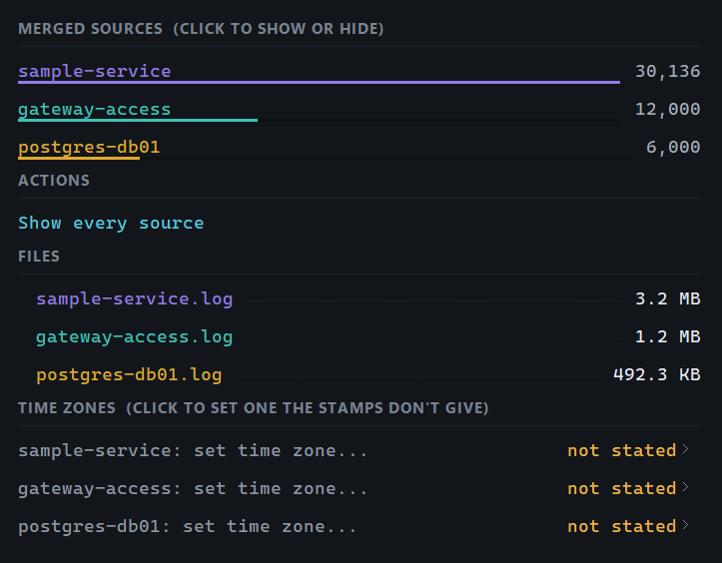
Sources in a merged view: click a file to show or hide its lines, see each file's size, and set a time zone for files whose timestamps don't say which zone they are in.

Highlighting — make your own highlights
Highlight any word, phrase or regular expression in a colour of its own, anywhere in the log, without filtering anything out. Type it at the top of the tab and press Enter. Nothing is highlighted until you choose.
- Click a highlight to switch it off and on again; right-click it to change its colour, match it as a regular expression, or remove it.
- Save your highlights, query, level filters and field filters to a small setup file.
- Share that file so a whole team triages an incident with exactly the same view.
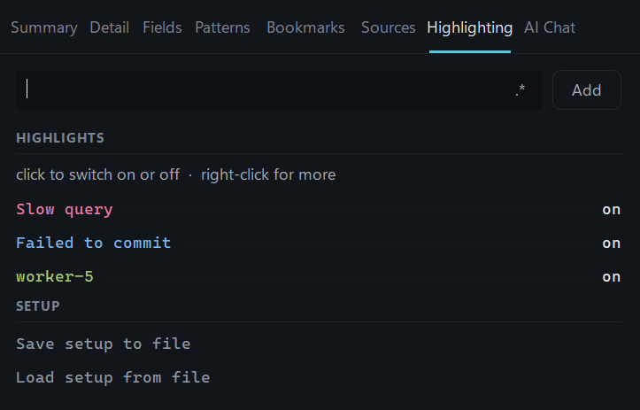
Highlighting: type at the top and press Enter to add a highlight. Each keeps a colour of its own; click one to switch it off, right-click to recolour or remove it.

Asking about a log
The AI Chat tab lets you ask about a log in plain words — “what went wrong around half past four?”, “which service failed first?” — and answers from the log itself. Every answer points to the lines it relies on, so you can check it with a click instead of taking it on trust.
It works with GitHub Copilot, Claude or OpenAI, and you choose the model. It is off until you turn it on, and nothing leaves your computer until you ask a question.
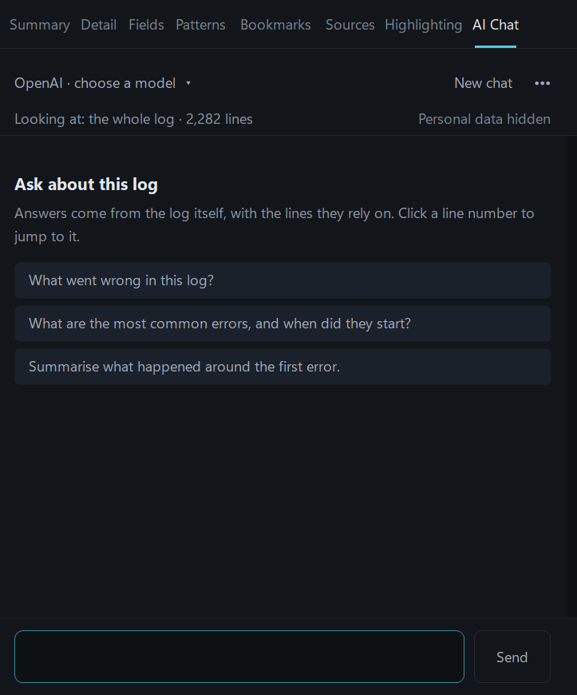
The AI Chat tab, the eighth tab in the panel on the right: the model answering at the top, what it can see beneath that, suggested questions to start with, and the box to type in.

What it can do
- Answers from the log, not guesswork. The assistant reads the log through the same search, patterns, fields and timeline you use, so counts and times come from the log, not from the model.
- Every claim points to its evidence. Line numbers such as #4,211 in an answer are links — click one to jump straight to that entry.
- Its searches become yours. When the assistant searches the log, click Apply next to that step to turn it into your own filters.
- Explain one entry. Right-click any entry and choose Ask AI about this entry.
- Follow-up questions keep the thread. Ask “and what happened just before that?” and it carries on from its last answer. New chat starts afresh.
- You decide what it sees. Looking at switches between the whole log and only what your current filters show.

Part of the tab | What it does
Model (top left) | Which provider and model answers. Click it to choose from the models your account offers.
New chat | Starts a fresh conversation.
••• menu | Usage in this conversation, What was sent, and AI settings.
Looking at | Click to switch between the whole log and only what your filters show.
Personal data hidden | Confirms personal data is hidden before anything is sent, followed by the tokens this conversation has used.
Suggested questions | A quick way to start on a log you have just opened.
Question box | Enter sends; Shift+Enter starts a new line. Send becomes Stop while an answer is arriving.
How to turn it on
1. Open Tools › AI settings.
2. Tick Turn on the AI assistant.
3. Connect at least one provider — see the table below.
4. Click Save.
5. Open the AI Chat tab (Ctrl+8, or View › AI Chat), click the model name at the top and choose a provider and model.

Provider | How to connect it
GitHub Copilot | Uses your own Copilot subscription and offers every model your plan allows. Install the GitHub Copilot CLI (winget install GitHub.Copilot, or npm install -g @github/copilot), run copilot in a terminal and type /login once, then restart Logzilla. AI settings shows these steps, and which GitHub account is in use.
Claude | Paste an API key from your Anthropic account into AI settings. An optional endpoint points it at your organisation's own gateway.
OpenAI | Paste an API key from your OpenAI account into AI settings. An optional endpoint points it at Azure OpenAI or another compatible service.
How to investigate an incident with AI Chat
1. Open the log — or merge the logs involved. If you know roughly when it happened, narrow the time range and set Looking at to what your filters show.
2. Start broad: “What went wrong in this log?”
3. Click the line numbers in the answer to check each point against the log itself.
4. Follow up: “What happened in the minute before #4,211?” or “Which request does this error belong to?”
5. Click Apply on a search the assistant ran to keep it as your own filter, then bookmark the lines that matter for the ticket.

Questions that work well
- “What went wrong in this log, and when did it start?”
- “What is the most common warning, and does it matter?”
- “Follow CorrelationId 136ea017 and tell me what happened to that request.”
- “Summarise what the payments service did between 08:00 and 08:15.”
- “Which errors only appear after 14:00?”
Keep in mind: answers are only as good as the log. When the log does not say, the assistant says so rather than guessing — and the line numbers let you check every point.

Privacy and security
Logs often hold customer device IDs, hostnames and internal addresses, so the assistant is careful about what leaves your computer.
- Off by default. Nothing is sent until the assistant is turned on and you ask a question.
- Only what the question needs. Search results and the entries around them are sent — never the whole file.
- Personal data is hidden. Email and IP addresses, IDs, passwords, keys and tokens are replaced with placeholders such as «IP_1» before anything is sent. You still see the real values; the AI never does.
- Read-only. The assistant can read the open log and nothing else. It cannot change files, run commands or browse the web.
- Not steerable from the log. Instructions hidden inside log lines are ignored.
- Nothing hidden from you. ••• › What was sent shows exactly what left your computer, and AI settings can keep a record of everything sent on disk.
- Keys stay private. API keys are encrypted for your Windows account and never written to setup files.

For organisations
Administrators can control the assistant through Group Policy or Intune: turn it off entirely, allow only certain providers, require personal data to be hidden, require a record of everything sent, point Claude or OpenAI at the organisation's own endpoint, or use the organisation's own GitHub app for Copilot. Users cannot override these settings.
The README lists the exact policy values.

Seeing what it uses
- Under each answer: the tokens sent and received, and how many calls to the model it took.
- At the top right of the tab: the running total for the conversation.
- ••• › Usage in this conversation: tokens sent, received and cached, GitHub Copilot premium requests, and how full the model's context window is.

Getting around

Timeline
A histogram across the top showing entry volume over time, with warnings and errors stacked in colour. Drag across it to narrow the view to a time range, double-click to clear, or click once to jump to that moment. Hovering shows the exact counts for that slice.

Minimap
A narrow strip between the grid and the inspector showing error density for the whole file, not just the part on screen. Clusters of red are visible instantly even in a multi-million-line log; click to jump.

Tabs
Each open file gets a tab with its entry count. Ctrl+Tab cycles through them; merged views appear as their own tab alongside the originals.

Typical use cases
Situation | How Logzilla helps
Production incident | Merge the application, gateway and database logs, filter to ERROR, and read the failure as one sequence across all three services
"It was slow yesterday" | Drag the timeline to the reported window and check the summary rate and busiest error windows for that period
Unfamiliar log file | Open Patterns to see what the file actually contains before reading a single line
Short on time | Ask “What went wrong in this log?” and click the line numbers in the answer to check each point
A cryptic error message | Right-click the entry and choose Ask AI about this entry to learn what it means and what led up to it
Tracing one request | Right-click an entry and choose Show only where… › CorrelationId to isolate every entry for that request across every merged source
Chasing one device | Add a field filter on the device ID and follow its whole history end to end
Watching a deployment | Turn on Live tail and watch entries arrive live, with errors highlighted as they appear
Writing up a post-mortem | Bookmark the key lines as you go, then copy them all out in order
Handing over to a colleague | Save your setup file so they open the log with the same filters and highlights
Noisy recurring warning | Patterns shows how often it really happens, so you can judge whether it matters
Exporting evidence | Export exactly the filtered entries to a new file, preserving the original text

Everyday conveniences
- Accessibility — Screen readers get a name and role for every control, and the log grid announces the selected entry as you move through it. High-contrast mode hands colour choices back to Windows.
- Display scaling — The whole interface is sized from measured text, so it stays readable at 150% and 200% scaling and with larger system fonts.
- Keyboard — Everything reachable with the mouse is reachable from the keyboard. Ctrl+F to search, Ctrl+Shift+F to filter by field, Enter and Shift+Enter for next and previous match, E for the next error, M to bookmark, Ctrl+A and Ctrl+C to select and copy, Ctrl+1 to Ctrl+8 for the panels (Ctrl+8 is AI Chat), Ctrl+M to merge, F1 for the full list.
- Long lines — A horizontal scrollbar reaches anything that runs off the right edge and Shift+wheel scrolls it, or the Wrap chip folds long messages onto as many lines as they need instead.
- Columns — The Date chip collapses the date-and-time column and hands its width to the message; a once-a-day band keeps the date visible while it is closed.
- Memory — Window size, highlights and recent files are remembered between sessions.
- Encodings — UTF-8, ANSI and UTF-16 files are all handled, with byte order marks detected automatically.

Installing
Run Logzilla-Setup.exe. It installs for the current user only, so there is no administrator prompt, and it needs no other software installed — not even the .NET runtime. Both the application and the installer carry full version information, so Windows names the publisher and the version in file properties, in Task Manager and in the trust prompt. It appears in Settings › Apps like any other program, and the installer also supports /silent and /uninstall for scripted rollouts.

One manual step
To open .log files by double-clicking, right-click any log file, choose Open with › Choose another app, pick Logzilla and tick "Always use this app". Windows deliberately prevents installers from claiming a file type on your behalf, so this step cannot be automated — Notepad++ and other editors require exactly the same thing.

Questions, bugs or requests are welcome.

