Note Taker Manual

Joe Jarvis (@rayquaza01)

Table of Contents
Using Note Taker 2
Main Display 2
Notes Menu 2
Options 4
Theme 4
Background and Font Colors 4
Width and Height 4
Font 4
Custom Font CSS 4
Font Size 5
Default Display 5
Site Notes in Private Browsing 5
Subdomains Mode 5
Ignore/Enforce Subdomains On 5
Notification Badge 6
Notification Badge Color 6
Bullet Types 6
URL Parameters in Site Notes 6
Number of Tabs 7
Padding 7
Text Direction 7
Shortcuts 7
Code Descriptions 8
Finding the Current Note 8

Using Note Taker

Main Display
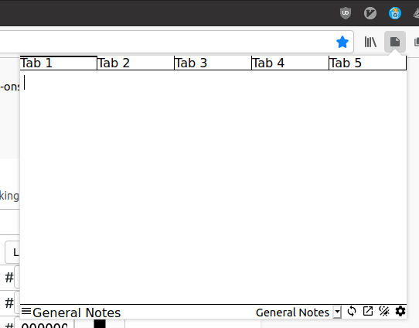
1
3
2
4
- The tab strip – contains however many tabs the user wants. This is disabled by default. A tab is written in bold if it contains a note. The currently selected tab has a strip on the top.
- The text box – contains the notes that are for the current tab.
- Menu / Current Note Indicator – the text shows what the currently displayed note is. Clicking it will open a menu containing other notes.
- Buttons – contains buttons that control certain actions. From left to right: syncing, open notes in new tab, toggle theme, and open settings.

Notes Menu
TBA

Options

Theme
Theme is a dropdown to select which theme to use. Options are light and dark.
Default: Light

Background and Font Colors
These four options decide the background and font colors of the popup. The values must be a valid color hex code. The colors that are used in the popup are chosen by the Theme (pg 4) option.
Default (Background Light): FFFFFF
Default (Font Light): 000000
Default (Background Dark): FFFFFF
Default (Font Dark): 000000

Width and Height
The width and height options are the width and height of the popup in pixels.
Default (Width): 400
Default (Height): 300

Font
The font to use in the text box. What each option is depends on the font choices in about:preferences. See Change the fonts and colors websites use | Firefox Help.
The options are Default, Sans Serif, Serif, Monospace, and Custom (pg. 4)
Default: Default

Custom Font CSS
The font to use as written as a CSS property. Must be a valid font-family value. The Font (pg. 4) option must be set to Custom for this to have an effect.
For example, setting this value to "Comic Sans MS" would make the font in the text area be comic sans.
Default:

Font Size
The size of the font in the text box in pixels.
Default: 16

Default Display
The display to show in the popup when it is opened. The options are General Notes, Domain, and URL notes.
Default: General Notes

Site Notes in Private Browsing
Whether to allow site notes in private windows. Falls back to general notes if set to disable.
Default: Disabled

Subdomains Mode
Whether to ignore (whitelist) or enforce (blacklist) subdomains.
Setting this to whitelist will make Site Notes ignore subdomains unless the domain is listed in the Ignore/Enforce Subdomains option.
The opposite is true for blacklist.
Example:
- When set to whitelist, addons.mozilla.org and developer.mozilla.org will return the same notes (mozilla.org).
- When set to blacklist, addons.mozilla.org and developer.mozilla.org will return different notes.
Default: Blacklist

Ignore/Enforce Subdomains On
A list of domains (separated by spaces) to whitelist or blacklist subdomains on. Blacklisting or Whitelisting depends on the Subdomains Mode option.
Example:
- When set to whitelist and mozilla.org is in the list, addons.mozilla.org and developer.mozilla.org will return different notes.
Default:

Notification Badge
Whether or not to show a badge on the toolbar icon. There are 4 modes.
- Disabled will make the badge never appear.
- Enabled will make a ! appear on the icon on the icon for sites that have a note.
- Bullets will count the number of lines starting with a bullet (see Bullet Types) and display that number in the badge. If a note doesn't contain a bullet, there will be no badge.
- Enabled + Bullets will make a ! appear on the icon on the icon for sites that have a note unless there are bullets in the note. If there are bullets, the number of lines starting with a bullet will be displayed on the badge.
This option respects Site Notes in Private Browsing and Default Display.
Default: Disabled

Notification Badge Color
The color of the badge on the toolbar icon. No affect if Notification Badge is set to Disabled.
Default: D90000

Bullet Types
A space separated list of bullets to detect in notes. No effect unless Notification Badge is set to Bullets or Enabled + Bullets.
Default: * + -

URL Parameters in Site Notes
URL parameters to include in per-URL notes. Separated by spaces.
In a URL, everything after the ? is a parameter. They are formatted like this: ?param1=value1&param2=value2&...
This option takes parameters (ex param1, param2) to whitelist in URL notes.
A YouTube video URL looks like this: https://www.youtube.com/watch?v=dQw4w9WgXcQ.
The parameter, v, designates which video you are on, and without it every YouTube video would be assigned to the note www.youtube.com/watch. Having v in the parameters allows each video to have its own note.
A different parameter, for example, the t in https://www.youtube.com/watch?v=dQw4w9WgXcQ&t=108s, will not appear in the notes unless it is also whitelisted in this option.
q is the parameter for search terms on most search engines (Google, Bing, DuckDuckGo, etc.), so it allows different searches to have their own notes.
Default: q v

Number of Tabs
Number of tabs to display for notes.
Default: 1 (Disabled)

Padding
Padding for text box in pixels.
Default: 5

Text Direction
Direction of text in text area.
Default: Left To Right

Shortcuts
Keyboard shortcuts for the sidebar and popup. Possible values for shortcuts.
Popup Shortcut Default: Ctrl+Alt+N
Sidebar Shortcut Default: Alt+Shift+N

Code Descriptions
This section contains explanations of certain parts of the code written in pseudo code or plain English.

Finding the Current Note
When the notes popup is loaded, the current note is decided based on the current information:
- The URL of the current tab
- The default display option
- The subdomains options
- The URL parameters in site notes option

If the default display option is “General Notes”, the current note will be “General Notes”
If the URL given is not a valid URL, the current note will be whatever the note is named.
If the default display is Domain, we look at the subdomain settings.
- If the protocol of the URL is about:, the current note will be the current URL.
- If the protocol of the URL is not about:, http:, or https:, the current note will be “General Notes”.
- The hostname/domain of the URL is split to the domain and subdomains.
- If Subdomain Mode is set to enforce (whitelist)
  - If the current domain is listed in the Enforce Subdomains On option, the current note will be the full hostname.
  - If the current domain is not listed in the Enforce Subdomains On option, the current note will be the current domain (without the subdomains).
- If Subdomain Mode is set to ignore (blacklist)
  - If the current domain is listed in the Ignore Subdomains On option, the current note will be the current domain (without the subdomains).
  - If the current domain is not listed in the Ignore Subdomains On option, the current note will be the full hostname.
If the default display is URL
- If the protocol of the URL is about:, the current note will be the current URL.
- If the protocol of the URL is not about:, http:, or https:, the current note will be “General Notes”.
- The parameters of the notes are considered. The intersection of the parameters in the current URL and the allowed parameter are used in the current note.
- The current note is the protocol + the hostname + the path + the filtered parameters.

Options: Default Display (pg. 5)
Options: Subdomains Mode (pg. 5) and Options: Ignore/Enforce Subdomains On (pg. 5)
Options: URL Parameters in Site Notes (pg. 6)

