Quick Tab Switcher Help
Joe Jarvis
v1.2.0 – Updated 2023-07-25
Github – AMO
Table of Contents
Basic Usage 2
Settings 3
Shortcut 3
Search 3
Recently Closed Tabs 4
UI 4

Basic Usage
This is the main display for Quick Tab Switcher:
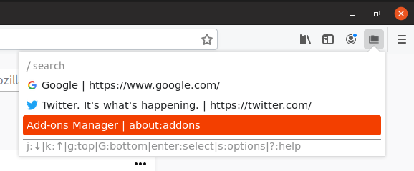
It displays the tabs that are open in the current window, with their favicons, page title and URL.
You can navigate with keyboard shortcuts (shown at the bottom of the popup).
- Pressing J or ↓ will select the next (below) tab, and pressing K or ↑ will select the previous (above) tab.
  - These will wrap around. (ex: Pressing J or ↓ on the last tab will select the first tab and vice versa).
- Pressing g will select the top tab, and G will select the bottom tab.
- Pressing Enter will switch to the selected tab and close the popup.
- Pressing s will open the settings for the extension.
- Pressing ? will open this page.
- Pressing / will focus the search box.
When the popup is out of focus, you can’t use keyboard shortcuts. An error will show alerting you that the popup is out of focus:
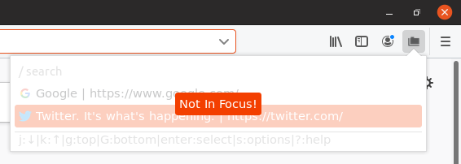
When this happens, close and reopen the popup, or click inside the popup to focus it.

Settings
The settings page looks like this:

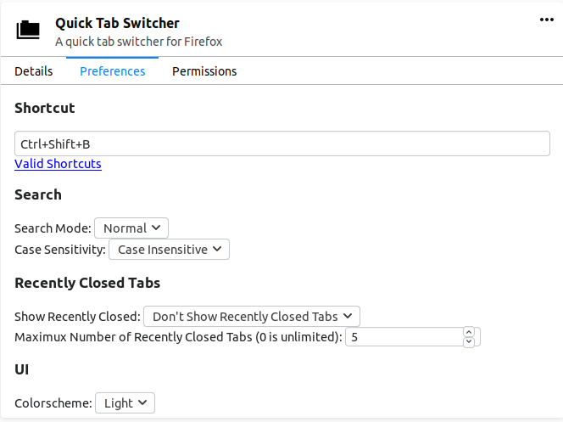
Shortcut
The shortcut option decides which keyboard shortcut opens the popup. It defaults to Ctrl+Shift+B.
You can see what makes up a valid shortcut on MDN.

Search
The search options affect how the search box in the popup works. The search is run on the page title and URL for each tab.
Press Enter after you enter your search term to put the cursor back on the tab list.
If search mode is Normal (default), it will show only the items that contain the search term. If search mode is regex, you can use regular expressions in your search terms.
Here is an example of the search (RegEx mode) showing only tabs with http or https in the title or URL:

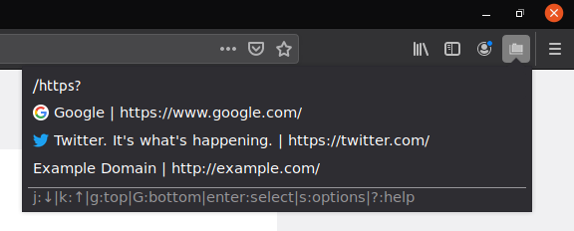
If the search auto focus option is set to enabled, the search bar will automatically be focused when opening the popup, without the need to press / first.

Recently Closed Tabs
If you enable recently closed tabs, you can see tabs that you recently closed. They will be shown with red text and strikethrough to show that they were closed. Selecting one of these will open the tab again.
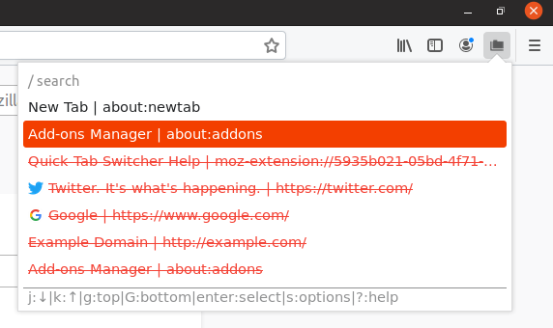
You can select how many recently closed tabs to show in the list at a time (Default 5). 0 is unlimited recently closed tabs.

UI
You can select the theme of the extension. The light theme was shown above, here is an example of the dark theme:
You can set the theme to follow your system theme preferences. If the color scheme is set to follow system, the dark theme will be used if your operating system is set to use a dark theme. Otherwise, the light theme will be used.
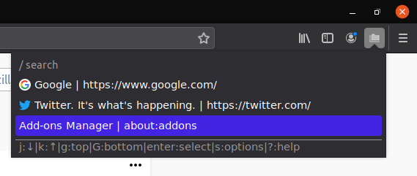
If the sort mode is set to “Tab Order”, the tabs will be displayed in the same order as they are in the tab bar. If sort mode is set to “Last Accessed”, the tabs will be displayed in the order they were last used (with the currently selected tab always appearing at the top).

