Elements ( Tags ) in HTML : Hyper Text MarkUp Language

<h1> header style 1

<h2> header style 2 ( and more )

</h1> close the header element style

<p> paragraph

<b> bold style or

<i> italic

<u> underline

<strong> similar to bold but not exactly in browser

<em> enhance element

<section> group all into one section

<ul> un-ordered list

<li> list items

<ol> ordered - list

<br> insert a new line

<!-- a Comment [ visible in " page source " ]

-->

<a> Anchor Element

[ need to specify an attribute ,e.g. <a href="receipe.html" ]

<a href="index.html">Home</a> [ this will insert a " Back" link ]

<img> Image(s) src = source

example: [ <img src="Brand.jpg"> ]

[ <img src="Menu.jpg" width="500" height="250"> ]

<img src="TradeMark.jpg" width="500" height="250" alt="Company TradeMark" >

<https://www.youtube.com/watch?v=G3e-cpL7ofc>

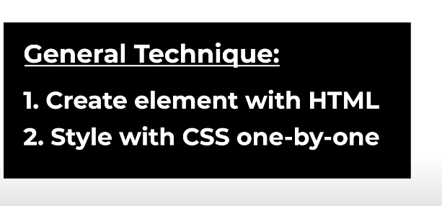

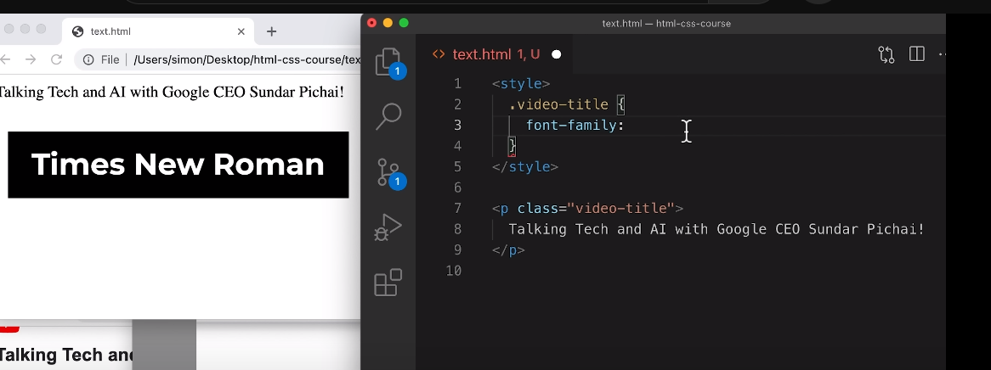

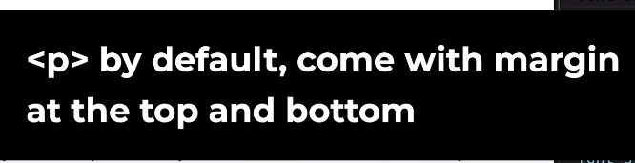

<style>

p {

font-family: Arial;

margin-top: 0;

margin-bottom: 0;

}

.video-stats {

font-size: 14px;

color: rgb(96, 96, 96);

margin-bottom: 20px;

}

.video-title {

font-weight: bold;

font-size: 18px;

width: 280px;

line-height: 24px;

margin-bottom: 5px;

}

.video-author {

font-size: 14px;

color: rgb(96, 96, 96);

margin-bottom: 20px;

}

.video-description {

font-size: 14px;

color: rgb(96, 96, 96);

width: 280px;

line-height: 22px;

margin-bottom: 100px;

}

.apple-text {

margin-bottom: 50px;

font-size: 14px;

background-color: rgb(227, 65, 64);

color: white;

text-align: center;

padding-top: 18px;

padding-bottom: 18px;

}

.span-example {

color: red;

}

.span-example:hover {

text-decoration: underline;

}

.shop-link {

cursor: pointer;

}

.shop-link:hover {

text-decoration: underline;

}

</style>

<p class="video-title">

Talking Tech and AI with Google CEO Sundar Pichai!

</p>

<p class="video-stats">

3.4M views &#183; 6 months ago

</p>

<p class="video-author">

Marques Brownlee &#10003;

</p>

<p class="video-description">

Talking tech and AI on the heels of Google I/O. Also a daily driver phone reveal from Google's CEO. Shoutout to Sundar!

</p>

<p class="apple-text">

Shop early for the best selection of holiday favourites. <span class="shop-link">Shop now &#62;</span>

</p>

<p>

Shop early for the <strong>best selection</strong> of <u>holiday</u> favourites. <span class="span-example">Shop now</span>

</p>

<!DOCTYPE html>

Tells the browser this is a web page and use the latest browser to read it .

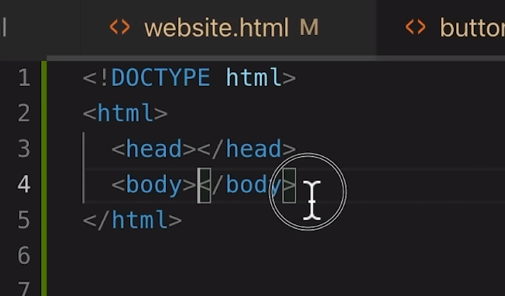

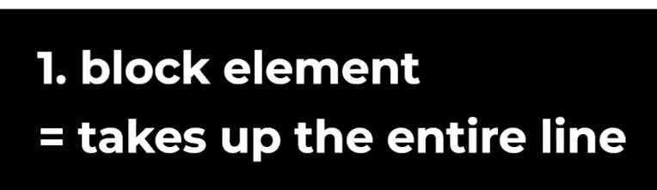

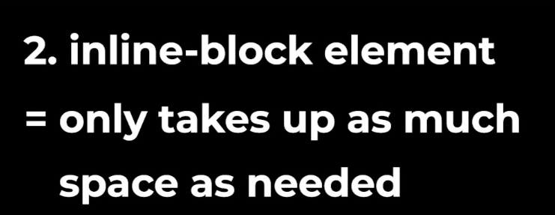

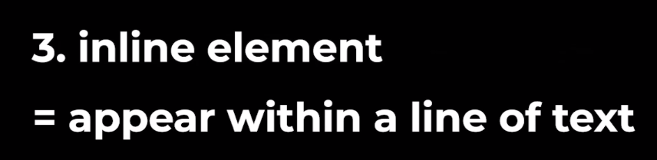

=======================================

<div> division , is a “ block” element

