Machine Learning Prediction of Potential
Energy of CuZr

Project Members
R. Chinna Rayudu 22CSB0A45(CSE)
Sabavath Kumar 22EEB0A65 (EEE)



Abstract
CuZr (Copper-Zirconium) alloys are prominent metallic glass-forming systems renowned for their high mechanical strength, excellent corrosion resistance, and superior glass-forming ability. Understanding their thermodynamic properties, particularly potential energy, is crucial for designing and optimizing bulk metallic glasses (BMGs). Atomistic simulations like Molecular Dynamics (MD) provide deep insights but are computationally prohibitive for high-throughput screening. This study develops an integrated computational framework that leverages MD-generated thermodynamic data with machine learning (ML) algorithms to accurately predict the potential energy of CuZr systems. Using MD simulations of CuZr across varying temperatures and pressures, we extracted state variables (temperature, pressure, volume) as features to train and validate two supervised learning models—Linear Regression and a Neural Network (Multilayer Perceptron). The models effectively learned the relationship between the input state variables and the target potential energy. The Linear Regression model demonstrated strong predictive performance, closely aligning with MD data, while the Neural Network captured more complex, non-linear dependencies. The results confirm that ML models can serve as fast, accurate surrogates for expensive MD simulations, significantly accelerating the exploration of the CuZr phase space for advanced material design.
Keywords: CuZr alloys, metallic glasses, molecular dynamics simulation, machine learning, potential energy prediction, Neural Networks.
1. Introduction
Copper-Zirconium (CuZr) alloys represent a foundational system in the study of metallic glasses and intermetallic compounds. Their unique disordered atomic structure confers exceptional properties, including high tensile strength (480–560 MPa), significant elasticity (~136 GPa), and good thermal stability (melting point ~1081°C). These characteristics make them suitable for demanding applications such as electrical contacts, connectors, and shape memory alloys. The key to harnessing these properties lies in understanding the thermodynamic stability and energy landscape of the alloy, often described by the potential energy (PE).
1.1 Significance of Potential Energy in CuZr Systems
The potential energy of a system is a fundamental thermodynamic quantity that underpins its stability, phase transitions, and glass-forming ability. In metallic glasses, a lower potential energy often correlates with greater stability. Accurately predicting PE under different thermodynamic conditions (temperature, pressure) is essential for identifying compositions with high glass-forming ability and tailored properties. Traditionally, this is achieved through experiments or atomistic simulations.
1.2 Molecular Dynamics Simulations for CuZr Alloys
Molecular Dynamics (MD) simulations provide an atomistic view of material behavior by solving Newton's equations of motion. For CuZr, using advanced interatomic potentials like the Embedded Atom Method (EAM), MD can reliably simulate thermodynamic properties, including the evolution of potential energy with temperature and pressure. Despite its accuracy, MD is computationally intensive, with simulations for moderate system sizes (5,000-50,000 atoms) consuming significant CPU resources.
1.3 Limitations of Traditional MD Approaches
While MD offers high fidelity, its computational cost makes it impractical for exploring vast compositional and thermodynamic spaces. Each simulation provides a single data point in a multi-dimensional parameter space, rendering comprehensive mapping economically unfeasible. This bottleneck motivates the need for efficient predictive methodologies.
1.4 Machine Learning (ML) for Materials Prediction
Machine learning offers a paradigm shift by learning the underlying patterns from existing data. ML models can establish complex, non-linear mappings between input features (e.g., temperature, pressure, volume) and target properties (e.g., potential energy) without executing explicit simulations for every new condition.
1.5 ML–MD Hybrid Approaches
The integration of MD and ML creates a powerful synergy. MD generates high-quality, atomistically accurate training data, while ML models learn the embedded physical relationships, enabling rapid and accurate predictions for new, unseen states. This hybrid approach drastically reduces computational overhead and accelerates the materials discovery cycle.
1.6 Motivation for the Present Work
This study aims to establish a complete ML–MD pipeline for predicting the potential energy of CuZr alloys. The key motivations are:
- To drastically reduce the computational time required for PE estimation across different thermodynamic states.
- To model the relationship between state variables (T, P, V) and potential energy using both linear and non-linear ML models.
- To create a robust predictive framework that can be extended to other metallic glass systems.
- To benchmark the performance of simple and complex ML models on MD-derived thermodynamic data.
1.7 Scope of the Work
This research focuses on MD-generated thermodynamic data for a CuZr alloy system and evaluates the predictive capability of two ML models: Linear Regression and a Neural Network (NN). The pipeline includes MD simulation setup, data extraction and normalization, model training, performance evaluation, and validation.
2. Methodology
This section details the integrated pipeline from MD simulation to ML-based prediction of potential energy.
2.1 Molecular Dynamics Simulations
2.1.1 Simulation Setup
MD simulations were performed using the LAMMPS package. The system consisted of a CuZr alloy modeled with an FCC lattice structure, containing between 5,000 and 50,000 atoms. The interatomic interactions were described by the CuZr.eam.alloy Embedded Atom Method (EAM) potential, which accurately captures the properties of binary alloys.
2.1.2 Simulation Procedure
The simulation protocol involved two key stages:
- Initialization: Atomic velocities were assigned corresponding to a temperature of 300 K, with net momentum set to zero.
- Equilibration:
  - A short NVE (microcanonical) ensemble run was performed for initial relaxation and system stabilization.
  - This was followed by an NPT (isothermal-isobaric) ensemble run at 300 K and 0 bar to equilibrate the temperature, pressure, and volume of the system.
2.1.3 Data Extraction
The following thermodynamic properties were recorded at regular intervals throughout the simulations: Potential Energy (PE), Kinetic Energy (KE), Temperature (T), Pressure (P), and Volume (V). The PE was designated as the target variable for ML prediction.

Figure 1. Snapshot of the MD simulation box for CuZr, showing atomic positions and the FCC lattice structure.
2.1.4 Data Volume
Multiple simulations under varying conditions generated a comprehensive dataset where each entry contained the state variables (T, P, V) and the corresponding potential energy (PE).
2.2 Data Processing and Feature Preparation
2.2.1 Data Normalization
The input features—Temperature, Pressure, and Volume—were normalized to a common scale (e.g., using StandardScaler or MinMaxScaler) to ensure stable and efficient model training, especially for the Neural Network.
2.2.2 Feature-Target Definition
- Input Features (X): Temperature (K), Pressure (bar), Volume (Å³).
- Target Variable (y): Potential Energy (eV/atom).
2.2.3 Data Serialization
The processed feature sets and target values were stored in serialized data files (e.g., using joblib or pickle) for efficient loading and reproducibility in the ML training phase.
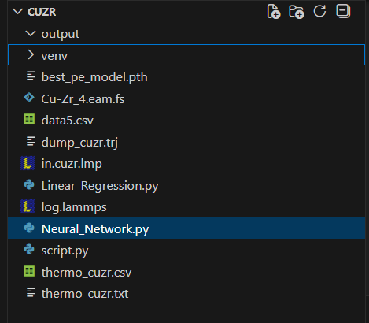
Figure 2.a Folder structure containing processed data files for ML training.

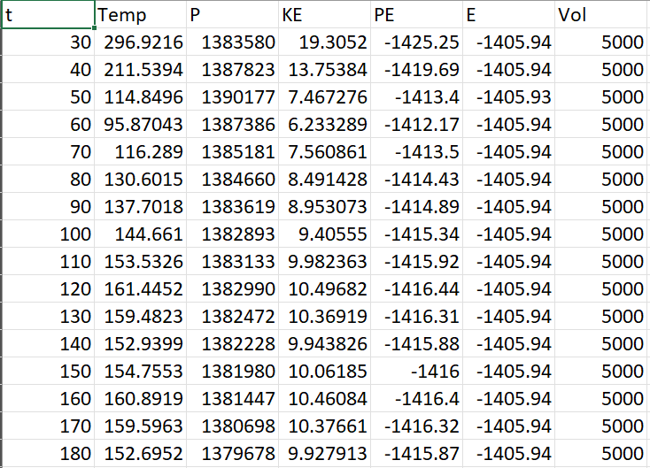
Figure 2.b Example of the normalized dataset used for model training.
2.3 Machine Learning Pipeline
2.3.1 Dataset Splitting
The dataset was partitioned using random sampling without replacement to ensure a unbiased evaluation:
- Training set: 80% - Used to learn the model parameters.
- Test set: 20% - Used for the final evaluation on unseen data.
2.3.2 ML Models Used
Two regression models were implemented and evaluated:
(1) Linear Regression
A baseline model that assumes a linear relationship between the input features (T, P, V) and the potential energy. It serves as a benchmark for performance.
(2) Neural Network (Multilayer Perceptron)
A feed-forward neural network capable of learning complex, non-linear relationships. The architecture consisted of:
- Input Layer: 3 neurons (for T, P, V).
- Hidden Layers: Multiple fully connected layers with ReLU activation functions.
- Output Layer: 1 neuron (for PE prediction).
The network learns by adjusting weights and biases via backpropagation to minimize the prediction error.
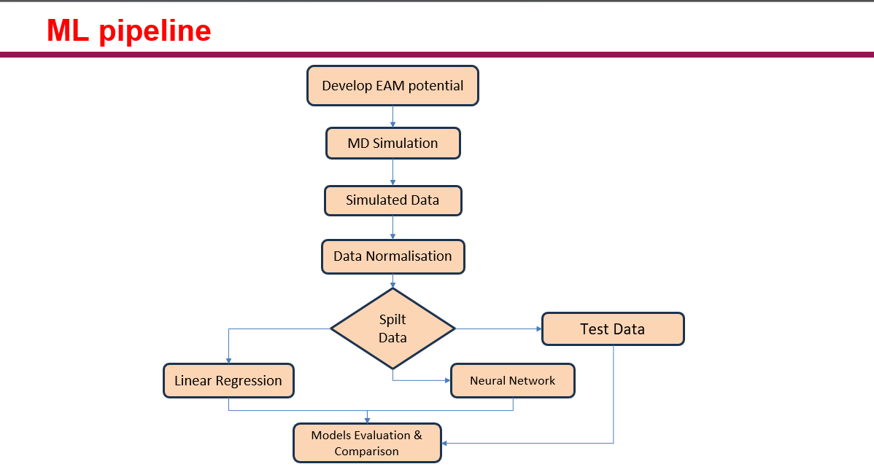
Figure 3. Overview of the ML–MD workflow for predicting the potential energy of CuZr.
2.3.3 Model Training and Hyperparameters
- Linear Regression: Trained using least squares minimization.
- Neural Network: Optimized using the Adam variant of gradient descent. Key hyperparameters included the number of hidden layers, neurons per layer, learning rate, and number of epochs, tuned for optimal performance.
2.3.4 Evaluation Metrics
Model performance was quantified using:
- Root Mean Squared Error (RMSE)
- Coefficient of Determination ($R^{2}$)
$$RMSE=\sqrt{\frac{1}{n}\sum_{i=1}^{n}{{(y_{i}-{\hat{y}}_{i})}^{2}}}$$
An $R^{2}$ value close to 1 indicates that the model explains most of the variance in the target variable.

3. Results and Discussion
3.1 RMSE and R²-Based Comparison
Model | RMSE (eV/atom) | $R^{2}$ Score
Linear Regression | 9.9946 | 0.9977
Neural Network | 2.1917 | 0.9999
Best Model | Neural Network | Neural Network

Table 1. Performance comparison of ML models for Potential Energy prediction.
The Neural Network achieved a lower RMSE and a higher $R^{2}$ score, indicating its superior ability to capture the underlying complexity in the data compared to the linear model.
3.2 Predicted vs. Actual Plots
Linear Regression
RMSE: 9.9946
R² = 0.9977
[Image: Scatter plot showing a strong linear trend with points clustered around the y=x line]
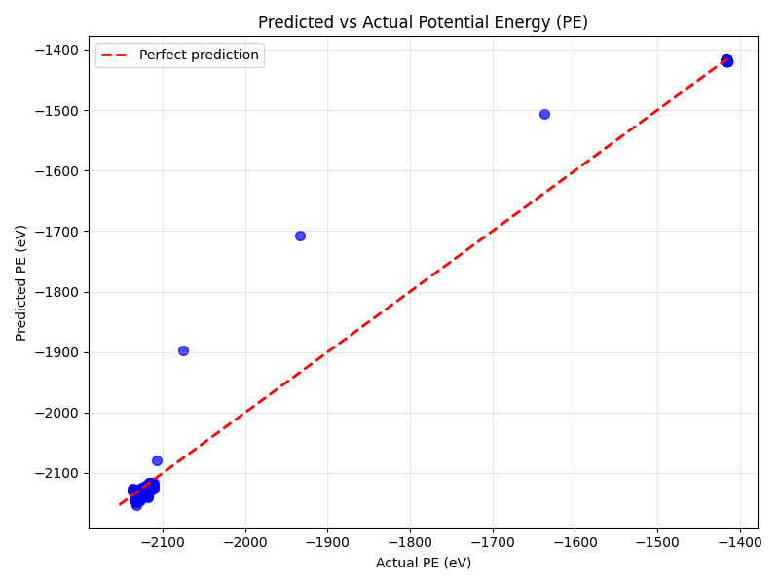

Figure 4. Linear Regression predictions vs. actual potential energy values.

Neural Network
RMSE: 2.1917
R² 0.9999
[Image: Scatter plot showing an even tighter cluster of points around the y=x line compared to Linear Regression]
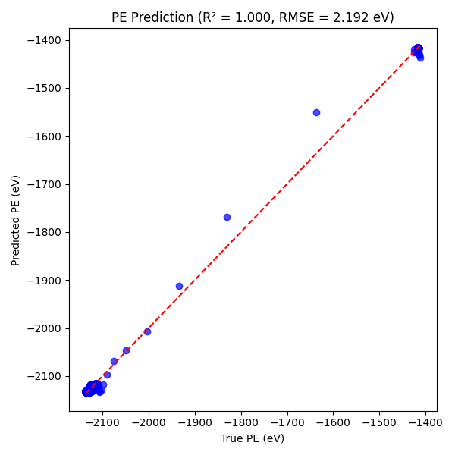

Figure 5. Neural Network predictions vs. actual potential energy values.
The plots demonstrate that both models provide accurate predictions, with the Neural Network predictions forming a tighter cluster around the ideal y=x line, confirming its higher accuracy.

3.3 Discussion of ML Behaviour
- Linear Regression performed remarkably well, indicating a strong linear component in the relationship between the state variables (T, P, V) and potential energy. It provides a robust and interpretable baseline model.
- Neural Network outperformed the linear model by capturing additional non-linearities and interactions between the features that the linear model could not represent. This aligns with the complex nature of atomic interactions in metallic glasses.
- Both models showed a low generalization gap between training and test errors, confirming that they learned the underlying physics rather than memorizing the data.

Final Model Performance Evaluations

Model | Predictive Accuracy | Ability to Capture Non-linearity | Stability & Robustness
Neural Network | Highest | Excellent | High
Linear Regression | High | Limited (Linear only) | Very High

3.4 Model Validation
Validation tests were conducted to ensure model reliability:
Validation Type | Purpose | Key Finding
Train-Test Split | Evaluate generalization on unseen data. | Both models performed consistently on the test set, with minimal performance drop from the training set.
Learning Curves | Diagnose overfitting or underfitting. | Learning curves for both models converged, showing no signs of high variance or high bias.
Residual Analysis | Check for patterns in prediction errors. | Residuals were randomly distributed around zero, indicating no systematic error in the models.

3.5 Practical Implications
The developed ML–MD hybrid framework for CuZr offers significant advantages:
- Rapid Screening: Enables instantaneous prediction of potential energy for new temperature-pressure-volume conditions without running MD.
- Cost Reduction: Drastically reduces the computational cost associated with exhaustive MD sampling.
- Design Guidance: Provides a powerful tool for guiding the design of new CuZr-based metallic glasses with targeted energy landscapes and stability.
- Extensibility: The pipeline can be adapted to predict other properties (e.g., elastic constants, diffusion coefficients) and can be extended to ternary or quaternary alloy systems.

4. Conclusion
This study successfully established an integrated ML–MD framework for the efficient and accurate prediction of potential energy in CuZr alloys. By leveraging data from molecular dynamics simulations, we trained and validated both Linear Regression and Neural Network models. The key conclusions are:
- Machine learning models can effectively learn and predict the potential energy of CuZr from basic state variables (Temperature, Pressure, Volume).
- The Neural Network model demonstrated superior performance by capturing non-linear relationships, achieving an $R^{2}$ of 0.9999.
- The Linear Regression model also performed robustly ($R^{2}$ = 0.9977), providing a reliable and interpretable baseline.
- This hybrid approach significantly accelerates the materials discovery process for metallic glasses by reducing dependency on computationally expensive simulations.
This work underscores the transformative potential of machine learning in augmenting computational materials science, paving the way for faster and more efficient exploration of advanced material systems.

References
- [1] Complete Project repo link: [MLMI_CuZr_Project@Github]
- [2] Pedregosa, F., et al. "Scikit-learn: Machine Learning in Python." Journal of Machine Learning Research, 12, 2825-2830 (2011).
- [3] Plimpton, S. "Fast Parallel Algorithms for Short-Range Molecular Dynamics." Journal of Computational Physics, 117(1), 1-19 (1995).
- [4] Daw, M. S., & Baskes, M. I. "Embedded-atom method: Derivation and application to impurities, surfaces, and other defects in metals." Physical Review B, 29(12), 6443 (1984).
- [5] Cheng, Y. Q., & Ma, E. "Atomic-level structure and structure–property relationship in metallic glasses." Progress in Materials Science, 56(4), 379-473 (2011).
- [6] Butler, K. T., et al. "Machine learning for molecular and materials science." Nature, 559, 547-555 (2018).
- [7] Agrawal, A. & Choudhary, A. "Deep materials informatics: Applications of deep learning in materials science." npj Computational Materials, 2, 16022 (2016).
- [8] Ward, L., et al. "A general-purpose machine learning framework for predicting properties of inorganic materials." npj Computational Materials, 2, 16028 (2016).
- [9] Mishin, Y., et al. "Structural stability and lattice defects in copper: Ab initio, tight-binding, and embedded-atom calculations." Physical Review B, 63(22), 224106 (2001).
- [10] Zhang, Y., et al. "Machine learning for accurate force calculations in molecular dynamics simulations." Proceedings of the National Academy of Sciences, 116(23), 11101-11106 (2019).

