TCS
- First, the candidate has to log in to the TCS Next Step Portal.
- Then, the candidate will have to register and apply to drive.
- The candidate should choose the IT category and then must fill in the details in the form that opens up.
- After filling out the form, Submit the application and click Apply For Drive.
- Now, the candidate will be asked to choose the test mode. Choose your test mode, either in-center or remote, and then click Apply.
- Also note once you confirm/choose your mode of the test, you will not be able to make any changes.
After completing all these steps, go to the Track Your Application tab to check whether you have successfully applied for the drive or not.

TCS Hiring Process :

Round 1: TCS Online Assessment Test
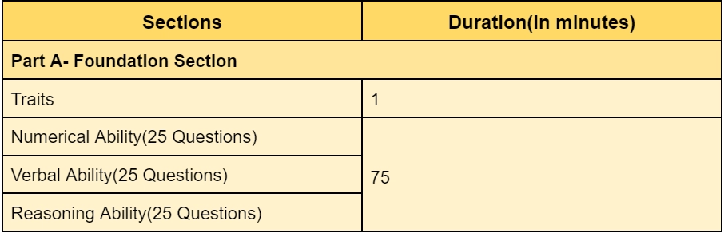
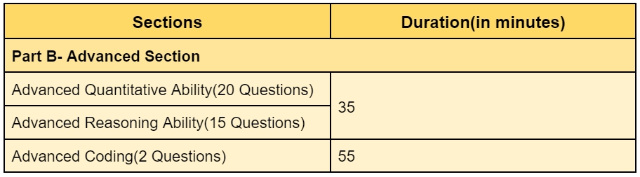

Round 2: TCS Technical Interview

Round 3: TCS HR Intervie

Sample Questions :
  - What do you know about TCS?
  - Why TCS?
  - What is failure to you?
  - What are your strengths and weaknesses?
  - How do you cope with disappointments?
  - Will you be able to relocate?

Accenture
Hiring info: https://www.accenture.com/in-en/careers/explore-careers/area-of-interest/journey-to-accenture

