---PyTorch---

- The torch.cuda.is_available() function returns a boolean value indicating whether CUDA (Compute Unified Device Architecture) is available or not on your system. CUDA is a parallel computing platform and application programming interface model created by Nvidia.
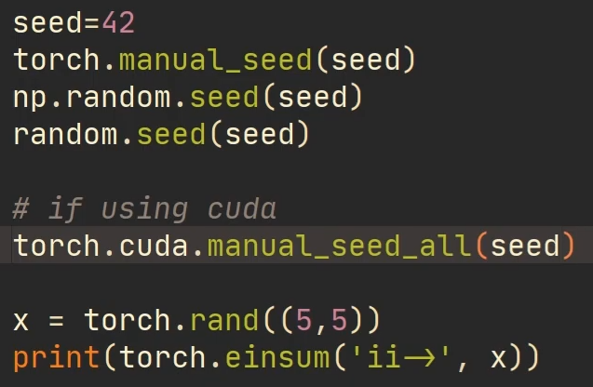
- torch.cuda.manual_seed(seed) sets the ‘seed’ for generating random numbers for the current GPU. It’s safe to call this function if CUDA is not available; in that case, it is silently ignored.

If you are working with a multi-GPU model, this function is insufficient to get determinism. To seed all GPUs, use manual_seed_all()

- A torch.device() is an object representing the device on which a torch.Tensor is or will be allocated. The torch.device contains a device type ('cpu', 'cuda' or 'mps') and optional device ordinal for the device type.

- cuDNN (NVIDIA's deep learning library) offers various algorithms for convolution operations. cudnn.benchmark = True allows cuDNN to automatically benchmark and choose the fastest algorithm for your specific hardware and model configuration. This can significantly improve training speed, especially on large datasets.

If your model does not change and your input sizes remain the same - then you may benefit from setting torch.backends.cudnn.benchmark = True. However, if your model changes: for instance, if you have layers that are only "activated" when certain conditions are met, or you have layers inside a loop that can be iterated a different number of times, then setting torch.backends.cudnn.benchmark = True might stall your execution
- torchvision.datasets is a module within the PyTorch ecosystem that provides a collection of popular datasets specifically designed for computer vision tasks.
- torchvision.transforms is a module within the PyTorch that provides a rich collection of pre-built transformations as well as the ability to create custom ones.
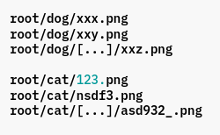
- torchvision.datasets.ImageFolder() is a generic data loader where the images are arranged in this way by default ---→
it has parameters like root, transform, target_transform, is_valid_file .

root (string) – Root directory path.
transform (callable, optional) – A function/transform that takes in a PIL image and returns a transformed version.

- dataset = torchvision.datasets.ImageFolder() creates a dataset containing each image as a datapoint. Each element represents an image and label

- torchvision.transforms.Compose(list of transformations) this function chains multiple image transformations together, applying them sequentially to each image.

- transforms.Resize(size) resizes all images in the dataset to a specified size. If size is a sequence like (h, w), output size will be matched to this. If size is an int, smaller edge of the image will be matched to this number. i.e, if height > width, then image will be rescaled to (size * height / width, size).

- transforms.ToTensor() Converts a PIL Image or numpy.ndarray (H x W x C) in the range [0, 255] to a torch.FloatTensor of shape (C x H x W) in the range [0.0, 1.0] if the PIL Image belongs to one of the modes (L, LA, P, I, F, RGB, YCbCr, RGBA, CMYK, 1) or if the numpy.ndarray has dtype = np.uint8 This is essential for feeding images into deep learning models.

- PIL is the Python Imaging Library which provides the python interpreter with image editing capabilities

- torchvision.transforms.Normalize(mean, std, inplace=False) normalizes a tensor image with mean and standard deviation. This transform does not support PIL Image. Given mean: (mean[1],...,mean[n]) and std: (std[1],..,std[n]) for n channels, this transform will normalize each channel of the input torch.*Tensor i.e. output[channel]=(input[channel] - mean[channel]) / std[channel]

- torch.utils.data.DataLoader class represents a Python iterable over a dataset, with support for → map-style and iterable-style datasets, customizing data loading order, automatic batching, single- and multi-process data loading, automatic memory pinning.
- Sigmoid Function: It is an activation function that takes multiple inputs and gives output ranging from 0-1 .

- ReLU Function: In Rectified Linear Unit (ReLU) activation function if the input is negative it will convert it to zero otherwise the output will be same as input.
- Leaky ReLU Function: It is the improved version of the ReLU. It converts negative values to make them close to 0 but not actually 0, solving the dying ReLU issue that arises from using the standard ReLU function.

- The "dying ReLU" problem refers to a situation when the input to a ReLU neuron is consistently negative, causing the neuron to always output zero. During the backpropagation phase of training, if the gradients flowing through that neuron are consistently zero, the weights connected to that neuron may not be updated, and the neuron essentially becomes "dead" or "dormant." Once a neuron is in this state, it will continue to output zero for all inputs, and it won't contribute to the learning process.

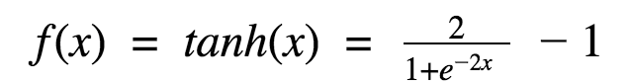
- Tanh Function: works almost always better than sigmoid function. Also known as Tangent Hyperbolic Function. It’s actually mathematically shifted version of the sigmoid function. Both are similar and can be derived from each other. It gives output ranging from -1 to 1

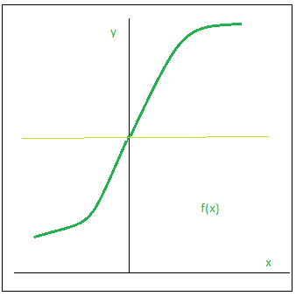
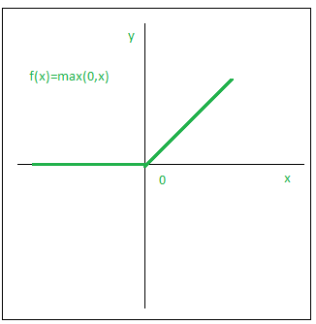
Sigmoid ReLU

Leaky ReLU Tanh
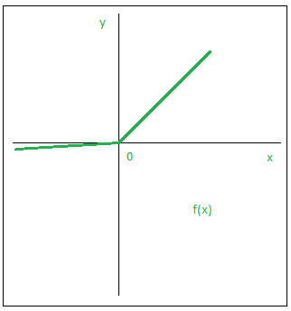
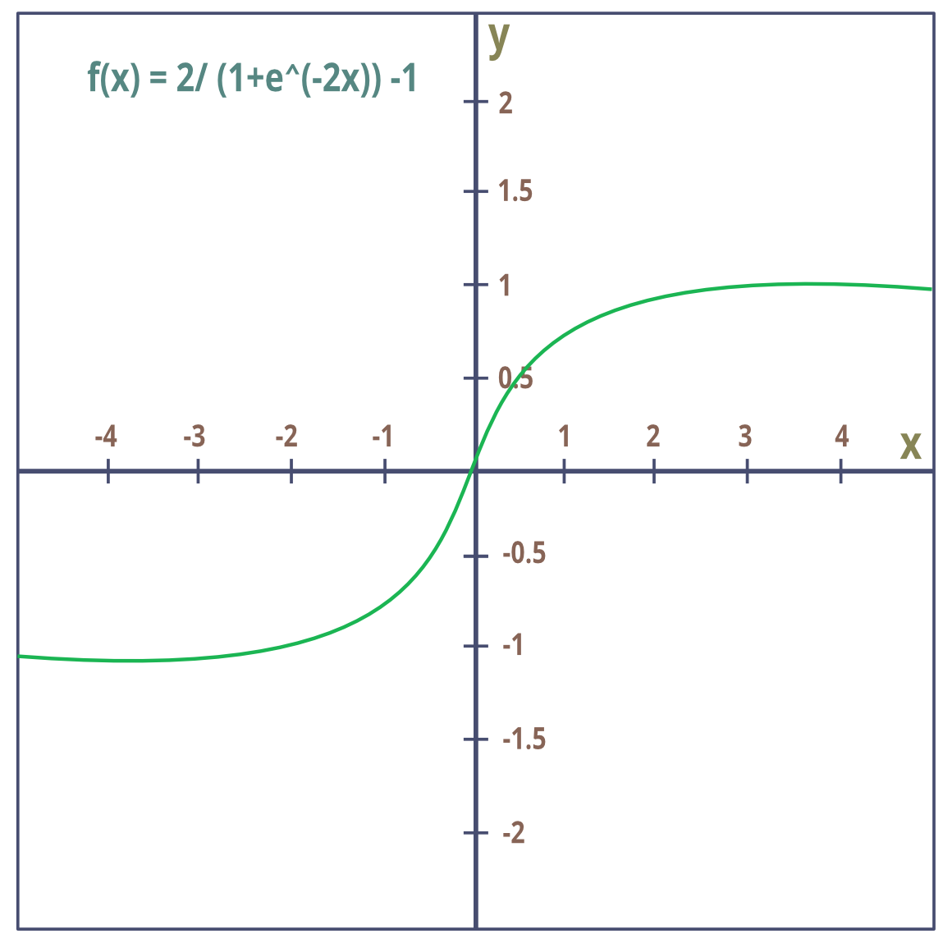

- Convolution Layer: Extracts features from input data and outputs a smaller image due to downsampling .

- Transposed Convolution Layer: Upsamples data to increase its spatial resolution. (Increases image size)

- torch.nn.Conv2d() Applies a 2D convolution over an input. 2D convolution means the convolution layer will take 2D inputs . In 2D convolutions the convolution kernel size can be 1D or 2D.

- torch.nn.ConvTranspose2d() applies a 2D transposed convolution operator over an input image composed of several input planes.

This module can be seen as the gradient of Conv2d() with respect to its input. It is also known as a fractionally-strided convolution or a deconvolution (although it is not an actual deconvolution operation as it does not compute a true inverse of convolution).

Both torch.nn.Conv2d() and torch.nn.ConvTranspose2d() use the same parameters.

Used Parameters:
  - in_channels: Number of input channels ( 3 for RGB images)

  - out_channels: Number of output channels (64 for intermediate features )

  - kernel_size: Size of the filter kernel ( (3, 3) for a 3x3 filter).

  - stride: Stride value that controls the step size between filter applications ( 2 for upsampling by 2x )

  - padding: Number of zeros to pad around the input ( 1 for preserving input dimensions during upsampling)

  - output_padding: Additional padding added to the output ( 1 to ensure specific output dimensions )

- All the generator,discriminator,downsampler classes in our code are manually created to implement neural network layers.

- the downsampler class takes 4D tensor as input, the 4th dimension in a tensor represents the batch size. The class then takes the 4D tensor and passses each batch of images/tensors to the network individually. The output is a 4D tensor maintaining the batch size and order.

- Relation Between inpunt/output size, kernel, stride, padding:
Out_width = ( in_width – Kernel + 2 * padding ) / stride + 1
Out_height = ( in_height – Kernel + 2 * padding ) / stride + 1

