Use DBML to define your database structure

Docs: https:dbml.dbdiagram.io/docs

Table users {

id INT [primary key, increment]

username VARCHAR(50) [not null, unique]

password VARCHAR(255) [not null]

role VARCHAR(50) [not null]

permissions TEXT

}

Table medicines {

id INT [primary key, increment]

name VARCHAR(255) [not null]

inventory_price DECIMAL(10, 2) [not null]

sale_price DECIMAL(10, 2) [not null]

stock INT [not null]

prescription_needed BOOLEAN [default: false]

created_at TIMESTAMP [default: `CURRENT_TIMESTAMP`]

}

Table sales {

id INT [primary key, increment]

medicine_id INT [not null]

quantity INT [not null]

unit_price DECIMAL(10, 2) [not null]

total_price DECIMAL(10, 2) [not null]

profit DECIMAL(10, 2) [not null]

customer_name VARCHAR(255) [not null]

sale_date TIMESTAMP [default: `CURRENT_TIMESTAMP`]

}

Table expiration_management {

id INT [primary key, increment]

medicine_id INT [not null]

batch_number VARCHAR(255) [not null]

expiration_date DATE [not null]

quantity INT [not null]

}

Table suppliers {

id INT [primary key, increment]

name VARCHAR(255) [not null]

contact_person VARCHAR(255) [not null]

email VARCHAR(255) [not null]

phone VARCHAR(20) [not null]

address TEXT [not null]

}

Table prescriptions {

id INT [primary key, increment]

prescription_id VARCHAR(255) [not null]

patient_name VARCHAR(255) [not null]

doctor_name VARCHAR(255) [not null]

prescription_date DATE [not null]

status ENUM('Pending', 'Filled') [default: 'Pending']

notes TEXT

created_at TIMESTAMP [default: `CURRENT_TIMESTAMP`]

}

Table prescribed_medicines {

id INT [primary key, increment]

prescription_id INT [not null]

medicine_id INT [not null]

quantity INT [not null]

dosage VARCHAR(255) [not null]

}

Relationships

Ref: sales.medicine_id > medicines.id

Ref: expiration_management.medicine_id > medicines.id

Ref: prescribed_medicines.prescription_id > prescriptions.id

Ref: prescribed_medicines.medicine_id > medicines.id

// Queries for Different Functionalities

// Update Stock

UPDATE medicines SET stock = stock + 10 WHERE id = 1;

// Check Stock

SELECT name, stock FROM medicines;

// Inventory Report

SELECT

m.name,

m.inventory_price,

m.sale_price,

m.stock,

(m.inventory_price * m.stock) AS total_value,

m.prescription_needed

FROM medicines m;

// Sales Records

SELECT

s.sale_date,

m.name AS medicine_name,

s.customer_name,

s.quantity,

s.total_price,

s.profit

FROM sales s

JOIN medicines m ON s.medicine_id = m.id;

// Top Selling Analysis

SELECT

m.name AS medicine_name,

SUM(s.quantity) AS total_quantity_sold,

SUM(s.total_price) AS total_revenue,

SUM(s.profit) AS total_profit

FROM sales s

JOIN medicines m ON s.medicine_id = m.id

GROUP BY m.name

ORDER BY total_quantity_sold DESC;

// Statistics

SELECT

(SELECT COUNT(*) FROM medicines) AS total_medicines,

(SELECT SUM(stock) FROM medicines) AS total_stock,

(SELECT COUNT(*) FROM medicines WHERE stock < 50) AS low_stock_items,

(SELECT SUM(inventory_price * stock) FROM medicines) AS total_stock_value,

(SELECT COUNT(*) FROM sales) AS total_sales_count,

(SELECT SUM(total_price) FROM sales) AS total_sales_revenue,

(SELECT SUM(profit) FROM sales) AS total_sales_profit,

(SELECT (SUM(profit) / SUM(total_price)) * 100 FROM sales) AS profit_margin;

**SCHEMA DIAGRAM:**  
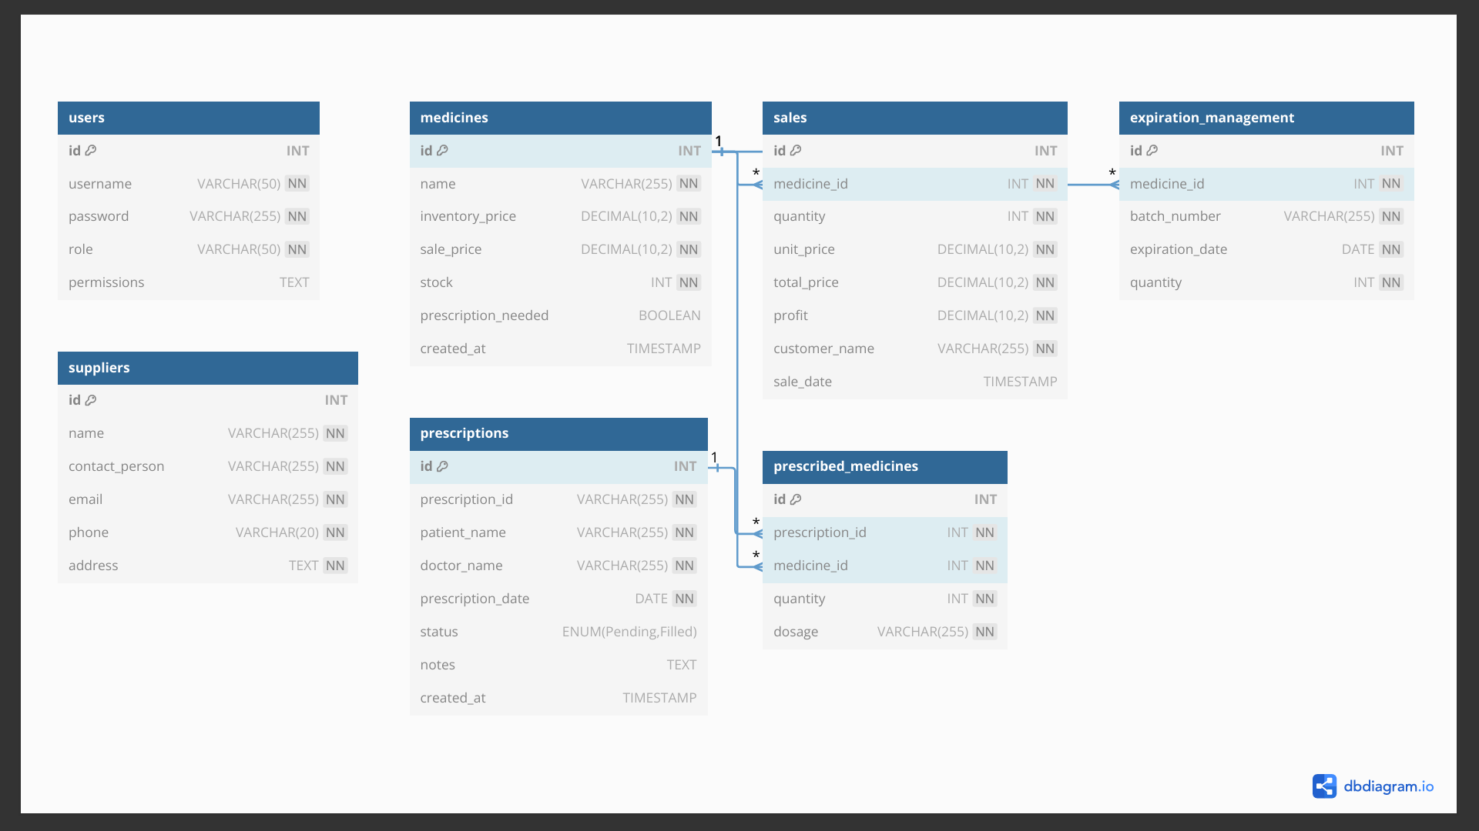

**ER MODEL:**

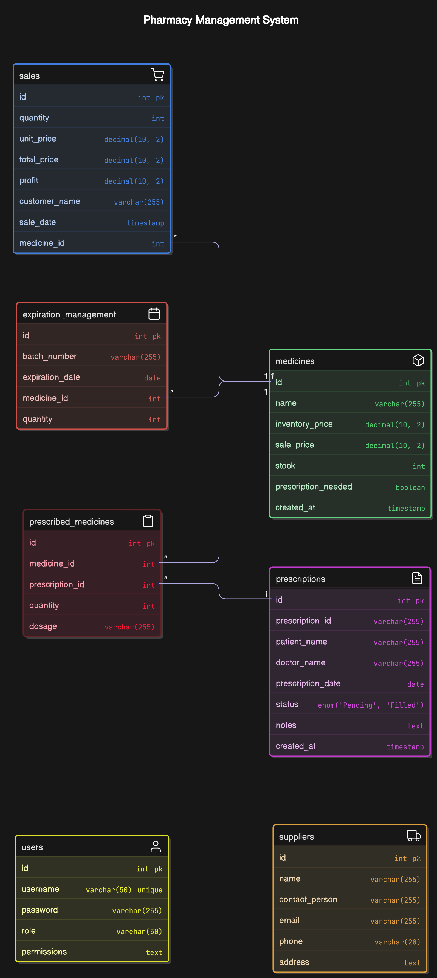

**SEQUENCE DIAGRAM CODE:**  
title Database Operations Sequence Diagram

participant User

participant UsersTable

participant MedicinesTable

participant SalesTable

participant ExpirationManagementTable

participant SuppliersTable

participant PrescriptionsTable

participant PrescribedMedicinesTable

== User Registration ==

User->UsersTable: Register(username, password, role, permissions)

UsersTable-->User: User registered successfully

== Medicine Management ==

User->MedicinesTable: AddMedicine(name, inventory_price, sale_price, stock, prescription_needed)

MedicinesTable-->User: Medicine added successfully

User->MedicinesTable: UpdateStock(medicine_id, quantity)

MedicinesTable-->User: Stock updated successfully

User->MedicinesTable: CheckStock()

MedicinesTable-->User: Return stock information

== Sales Management ==

User->SalesTable: RecordSale(medicine_id, quantity, unit_price, total_price, profit, customer_name)

SalesTable->MedicinesTable: UpdateStock(medicine_id, -quantity)

MedicinesTable-->SalesTable: Stock updated

SalesTable-->User: Sale recorded successfully

== Expiration Management ==

User->ExpirationManagementTable: AddBatch(medicine_id, batch_number, expiration_date, quantity)

ExpirationManagementTable-->User: Batch added successfully

== Supplier Management ==

User->SuppliersTable: AddSupplier(name, contact_person, email, phone, address)

SuppliersTable-->User: Supplier added successfully

== Prescription Management ==

User->PrescriptionsTable: AddPrescription(prescription_id, patient_name, doctor_name, prescription_date, status, notes)

PrescriptionsTable-->User: Prescription added successfully

User->PrescribedMedicinesTable: AddPrescribedMedicine(prescription_id, medicine_id, quantity, dosage)

PrescribedMedicinesTable-->User: Prescribed medicine added successfully

== Reports and Analytics ==

User->MedicinesTable: GenerateInventoryReport()

MedicinesTable-->User: Return inventory report

User->SalesTable: GenerateSalesRecords()

SalesTable-->User: Return sales records

User->SalesTable: GenerateTopSellingAnalysis()

SalesTable-->User: Return top selling analysis

User->SalesTable: GenerateStatistics()

SalesTable-->User: Return statistics

**ACTIVITY DIAGRAM:**

