# Seek bar

*<?*xml version="1.0" encoding="utf-8"*?>*<androidx.constraintlayout.widget.ConstraintLayout xmlns:android="http://schemas.android.com/apk/res/android"  
 xmlns:app="http://schemas.android.com/apk/res-auto"  
xmlns:tools="http://schemas.android.com/tools"  
android:layout_width="match_parent"  
android:layout_height="match_parent"  
tools:context="com.example.seekbar.MainActivity">  
  
  
<SeekBar  
 android:id="@+id/seekBar"  
 android:layout_width="match_parent"  
 android:layout_height="wrap_content"  
 android:layout_marginEnd="8dp"  
 android:layout_marginStart="8dp"  
 android:layout_marginTop="372dp"  
 app:layout_constraintEnd_toEndOf="parent"  
 app:layout_constraintStart_toStartOf="parent"  
 app:layout_constraintTop_toTopOf="parent" />  
 </androidx.constraintlayout.widget.ConstraintLayout>

package com.example.seekbar;  
import androidx.appcompat.app.AppCompatActivity;  
import android.os.Bundle;  
import android.widget.SeekBar;  
import android.widget.Toast;  
  
public class MainActivity extends AppCompatActivity {  
 SeekBar seekBar;  
 @Override  
 protected void onCreate(Bundle savedInstanceState) {  
 super.onCreate(savedInstanceState);  
 setContentView(R.layout.activity_main);  
  
 seekBar=(SeekBar)findViewById(R.id.seekBar);  
 seekBar.setOnSeekBarChangeListener(new SeekBar.OnSeekBarChangeListener() {  
 @Override  
 public void onProgressChanged(SeekBar seekBar, int progress,  
 boolean fromUser) {  
 Toast.makeText(getApplicationContext(),"seekbar progress: "+progress, Toast.LENGTH_SHORT).show();  
 }  
  
 @Override  
 public void onStartTrackingTouch(SeekBar seekBar) {  
 Toast.makeText(getApplicationContext(),"seekbar touch started!", Toast.LENGTH_SHORT).show();  
 }  
  
 @Override  
 public void onStopTrackingTouch(SeekBar seekBar) {  
 Toast.makeText(getApplicationContext(),"seekbar touch stopped!", Toast.LENGTH_SHORT).show();  
 }  
 });  
 }  
}

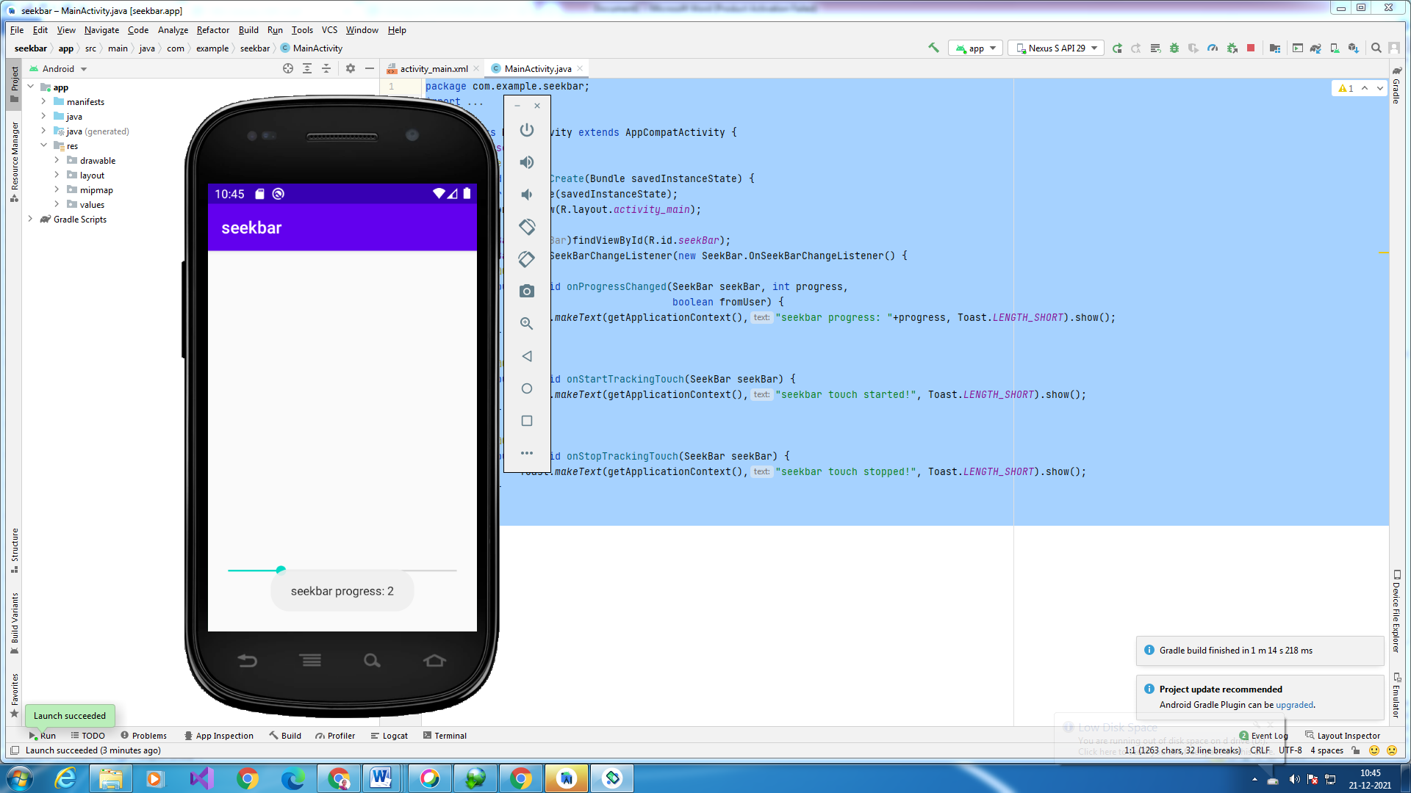

Intent explicit

Activity_main.xml

*<?*xml version="1.0" encoding="utf-8"*?>*<androidx.constraintlayout.widget.ConstraintLayout xmlns:android="http://schemas.android.com/apk/res/android"  
 xmlns:app="http://schemas.android.com/apk/res-auto"  
xmlns:tools="http://schemas.android.com/tools"  
android:layout_width="match_parent"  
android:layout_height="match_parent"  
>  
<TextView  
 android:layout_width="wrap_content"  
 android:layout_height="wrap_content"  
 android:layout_marginEnd="8dp"  
 android:layout_marginStart="8dp"  
 android:layout_marginTop="8dp"  
 android:text="First Activity"  
 app:layout_constraintBottom_toBottomOf="parent"  
 app:layout_constraintEnd_toEndOf="parent"  
 app:layout_constraintHorizontal_bias="0.454"  
 app:layout_constraintLeft_toLeftOf="parent"  
 app:layout_constraintRight_toRightOf="parent"  
 app:layout_constraintStart_toStartOf="parent"  
 app:layout_constraintTop_toTopOf="parent"  
 app:layout_constraintVertical_bias="0.06" />  
<Button  
 android:id="@+id/button"  
 android:layout_width="wrap_content"  
 android:layout_height="wrap_content"  
 android:layout_marginEnd="8dp"  
 android:layout_marginStart="8dp"  
 android:layout_marginTop="392dp"  
 android:onClick="callSecondActivity"  
 android:text="Call second activity"  
 app:layout_constraintEnd_toEndOf="parent"  
 app:layout_constraintStart_toStartOf="parent"  
 app:layout_constraintTop_toTopOf="parent" />

Activity_main2.xml

*<?*xml version="1.0" encoding="utf-8"*?>*<androidx.constraintlayout.widget.ConstraintLayout xmlns:android="http://schemas.android.com/apk/res/android"  
  
xmlns:app="http://schemas.android.com/apk/res-auto"  
xmlns:tools="http://schemas.android.com/tools"  
android:layout_width="match_parent"  
android:layout_height="match_parent">  
  
<TextView  
 android:layout_width="wrap_content"  
 android:layout_height="wrap_content"  
 android:layout_marginEnd="8dp"  
 android:layout_marginStart="8dp"  
 android:layout_marginTop="8dp"  
 android:text="Second Activity"  
 app:layout_constraintBottom_toBottomOf="parent"  
 app:layout_constraintEnd_toEndOf="parent"  
 app:layout_constraintHorizontal_bias="0.454"  
 app:layout_constraintLeft_toLeftOf="parent"  
 app:layout_constraintRight_toRightOf="parent"  
 app:layout_constraintStart_toStartOf="parent"  
 app:layout_constraintTop_toTopOf="parent"  
 app:layout_constraintVertical_bias="0.06" />  
  
<Button  
 android:id="@+id/button"  
 android:layout_width="wrap_content"  
 android:layout_height="wrap_content"  
 android:layout_marginEnd="8dp"  
 android:layout_marginStart="8dp"  
 android:layout_marginTop="392dp"  
 android:onClick="callFirstActivity"  
 android:text="Call first activity"  
 app:layout_constraintEnd_toEndOf="parent"  
 app:layout_constraintStart_toStartOf="parent"  
 app:layout_constraintTop_toTopOf="parent" />  
  
 </androidx.constraintlayout.widget.ConstraintLayout>

Mainactivity2.java

package com.example.intent2;  
import androidx.appcompat.app.AppCompatActivity;  
import android.os.Bundle;  
import android.content.Intent;  
import android.view.View;  
import android.widget.Toast;  
public class MainActivity2 extends AppCompatActivity {  
  
 @Override  
 protected void onCreate(Bundle savedInstanceState) {  
 super.onCreate(savedInstanceState);  
 setContentView(R.layout.*activity_main2*);  
 Bundle extras = getIntent().getExtras();  
 String value1 = extras.getString("Value1");  
 String value2 = extras.getString("Value2");  
 Toast.*makeText*(getApplicationContext(),"Values are:\n First value: "+value1+  
 "\n Second Value: "+value2, Toast.*LENGTH_LONG*).show();  
 }  
 public void callFirstActivity(View view){  
 Intent i = new Intent(getApplicationContext(), MainActivity.class);  
 startActivity(i);  
 }  
  
}

mainactivity.java

package com.example.intent2;  
import androidx.appcompat.app.AppCompatActivity;  
import android.os.Bundle;  
import android.content.Intent;  
import android.view.View;  
  
public class MainActivity extends AppCompatActivity {  
  
 @Override  
 protected void onCreate(Bundle savedInstanceState) {  
 super.onCreate(savedInstanceState);  
 setContentView(R.layout.*activity_main*);  
 }  
 public void callSecondActivity(View view){  
 Intent i = new Intent(getApplicationContext(), MainActivity2.class);  
 i.putExtra("Value1", "Android By 1st activity for intent");  
 i.putExtra("Value2", "hello students");  
 *// Set the request code to any code you like, you can identify the  
 // callback via this code* startActivity(i);  
 }  
  
}

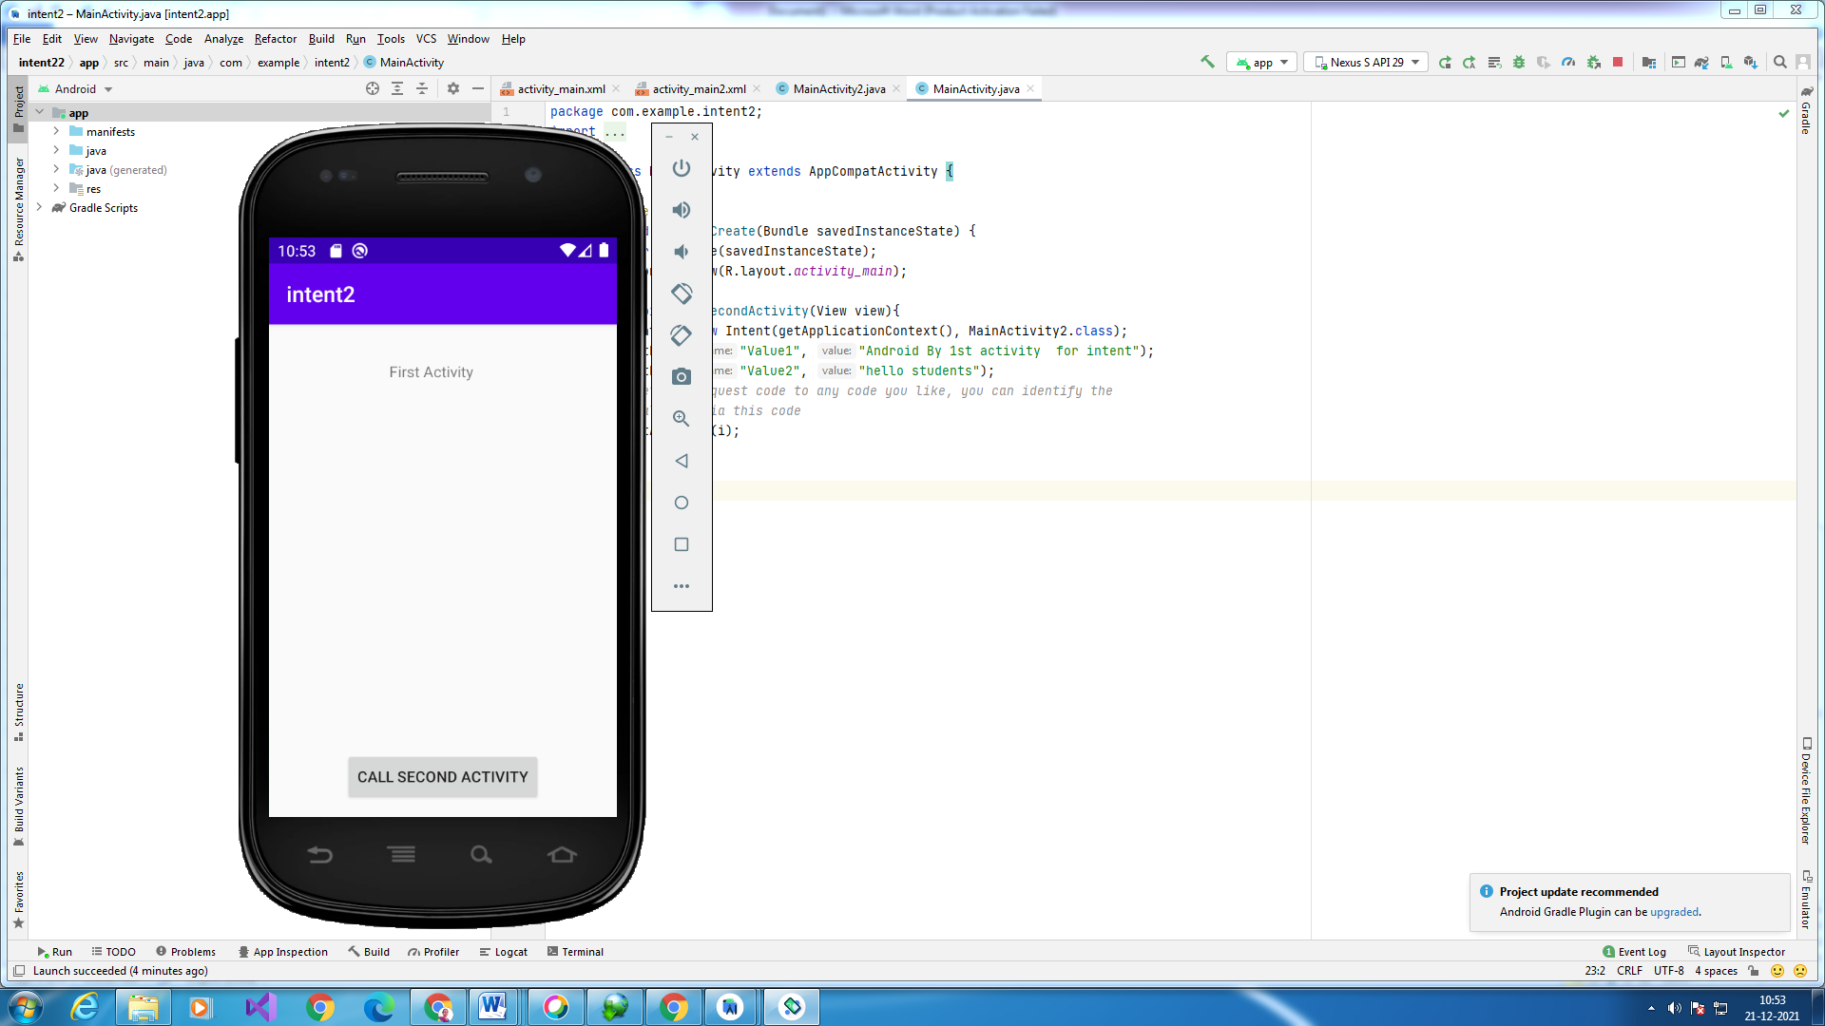

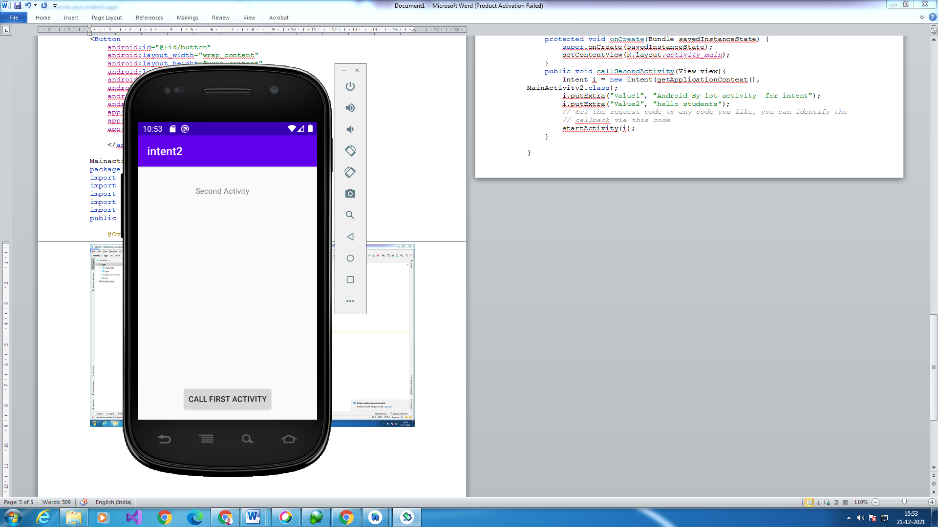

**Explicit and Implict Intent**

**Activity_main.xml**

*<?*xml version="1.0" encoding="utf-8"*?>*<RelativeLayout xmlns:android="http://schemas.android.com/apk/res/android"  
xmlns:tools="http://schemas.android.com/tools" android:layout_width="match_parent"  
 tools:context=".MainActivity" android:layout_height="match_parent">  
<TextView  
 android:layout_width="wrap_content"  
 android:layout_height="wrap_content"  
 android:textAppearance="?android:attr/textAppearanceMedium"  
 android:text="Intent example"  
 android:clickable="false"  
 android:layout_alignParentTop="true"  
 android:layout_marginTop="42dp"  
 android:layout_centerHorizontal="true"  
 android:background="#3e7d02"  
 android:textColor="#ffffff" />  
<Button  
 android:layout_width="wrap_content"  
 android:layout_height="wrap_content"  
 android:text="Explicit Intent Example"  
 android:id="@+id/explicit_Intent"  
 android:layout_alignParentTop="true"  
 android:layout_centerHorizontal="true"  
 android:layout_marginTop="147dp" />  
<Button  
 android:layout_width="wrap_content"  
 android:layout_height="wrap_content"  
 android:text="Implicit Intent Example"  
 android:id="@+id/implicit_Intent"  
 android:layout_centerVertical="true"  
 android:layout_centerHorizontal="true" />  
</RelativeLayout>

**Activity_second.xml**

*<?*xml version="1.0" encoding="utf-8"*?>*<RelativeLayout xmlns:android="http://schemas.android.com/apk/res/android"  
 xmlns:tools="http://schemas.android.com/tools" android:layout_width="match_parent"  
 android:layout_height="match_parent"  
 android:background="#CCEEAA"  
 >  
  
 <TextView  
 android:layout_width="wrap_content"  
 android:layout_height="wrap_content"  
 android:textAppearance="?android:attr/textAppearanceLarge"  
 android:text="This is Second Activity"  
 android:id="@+id/textView"  
 android:layout_centerVertical="true"  
 android:layout_centerHorizontal="true" />  
</RelativeLayout>

Activity_second.java

package com.example.intent4;  
import androidx.appcompat.app.AppCompatActivity;  
import android.os.Bundle;  
import android.widget.Toast;  
  
public class activity_second extends AppCompatActivity {  
  
 @Override  
 protected void onCreate(Bundle savedInstanceState) {  
 super.onCreate(savedInstanceState);  
 setContentView(R.layout.*activity_second*);  
  
 Toast.*makeText*(getApplicationContext(), "We are moved to second Activity",Toast.*LENGTH_LONG*).show();  
 }  
}

mainactivity.java

package com.example.intent4;  
  
import androidx.appcompat.app.AppCompatActivity;  
import android.os.Bundle;  
import android.content.Intent;  
import android.net.Uri;  
import android.view.View;  
import android.widget.Button;  
public class MainActivity extends AppCompatActivity {  
  
  
 Button explicit_btn, implicit_btn;  
 @Override  
 protected void onCreate(Bundle savedInstanceState) {  
 super.onCreate(savedInstanceState);  
 setContentView(R.layout.*activity_main*);  
  
  
 explicit_btn = (Button)findViewById(R.id.*explicit_Intent*);  
 implicit_btn = (Button) findViewById(R.id.*implicit_Intent*);  
  
 *//implement Onclick event for Explicit Intent* explicit_btn.setOnClickListener(new View.OnClickListener() {  
 @Override  
 public void onClick(View v) {  
  
 Intent intent = new Intent(getBaseContext(), activity_second.class);  
 startActivity(intent);  
  
  
 }  
 });  
  
 *//implement onClick event for Implicit Intent* implicit_btn.setOnClickListener(new View.OnClickListener() {  
 @Override  
 public void onClick(View v) {  
  
 Intent intent = new Intent(Intent.*ACTION_VIEW*);  
 intent.setData(Uri.*parse*("https://www.google.com"));  
 startActivity(intent);  
 }  
 });  
  
  
 }

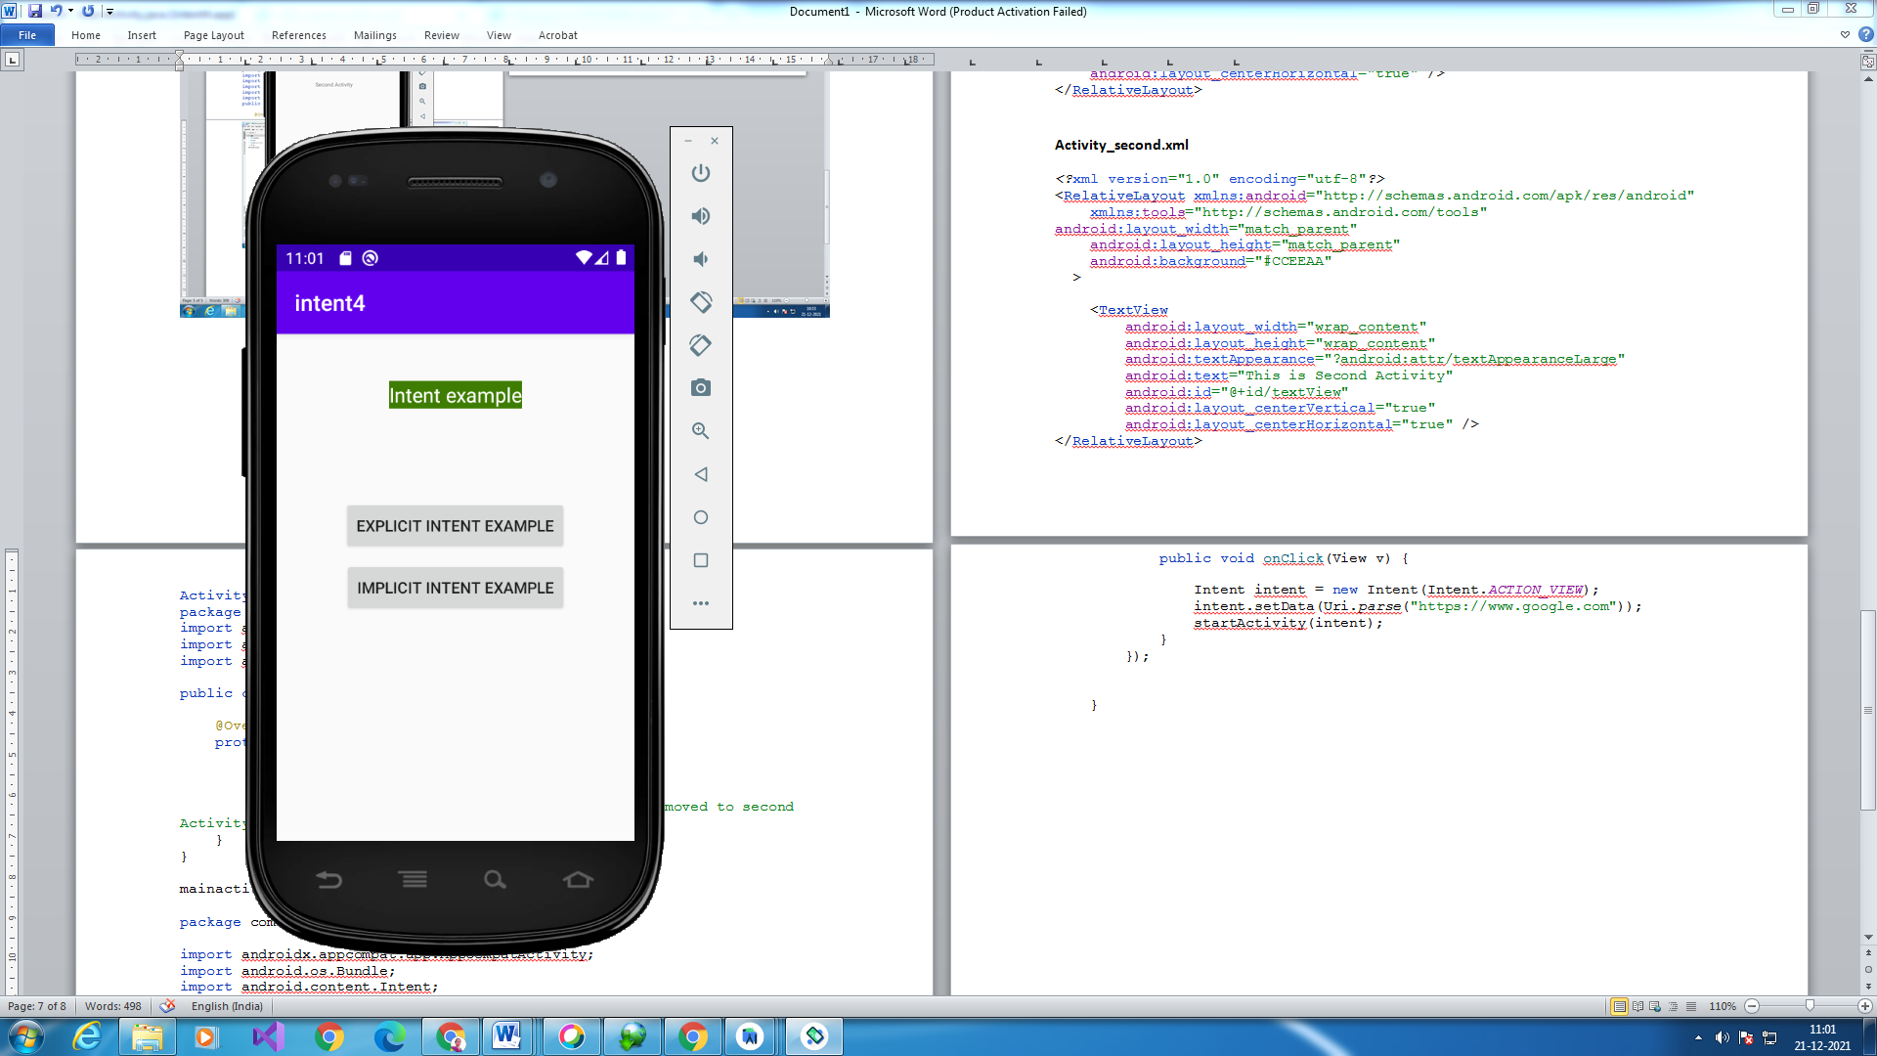

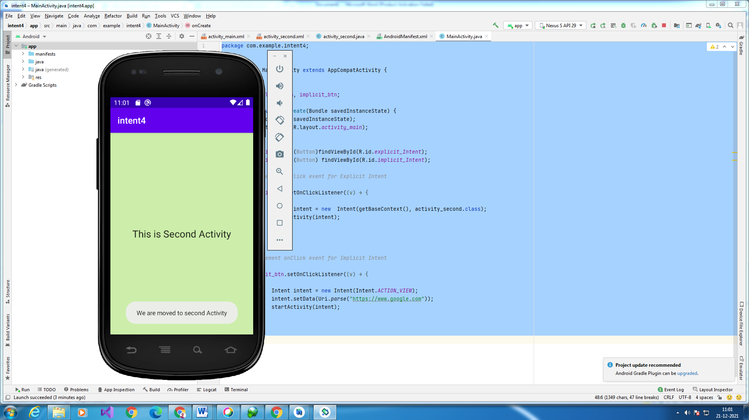

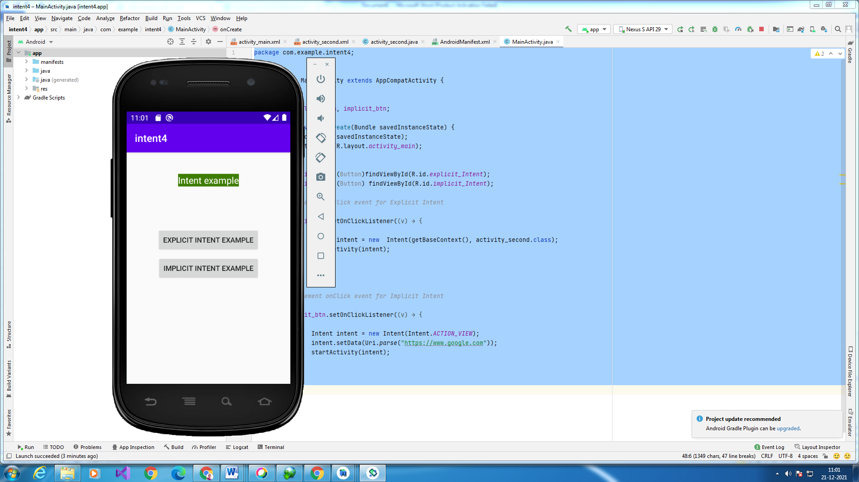

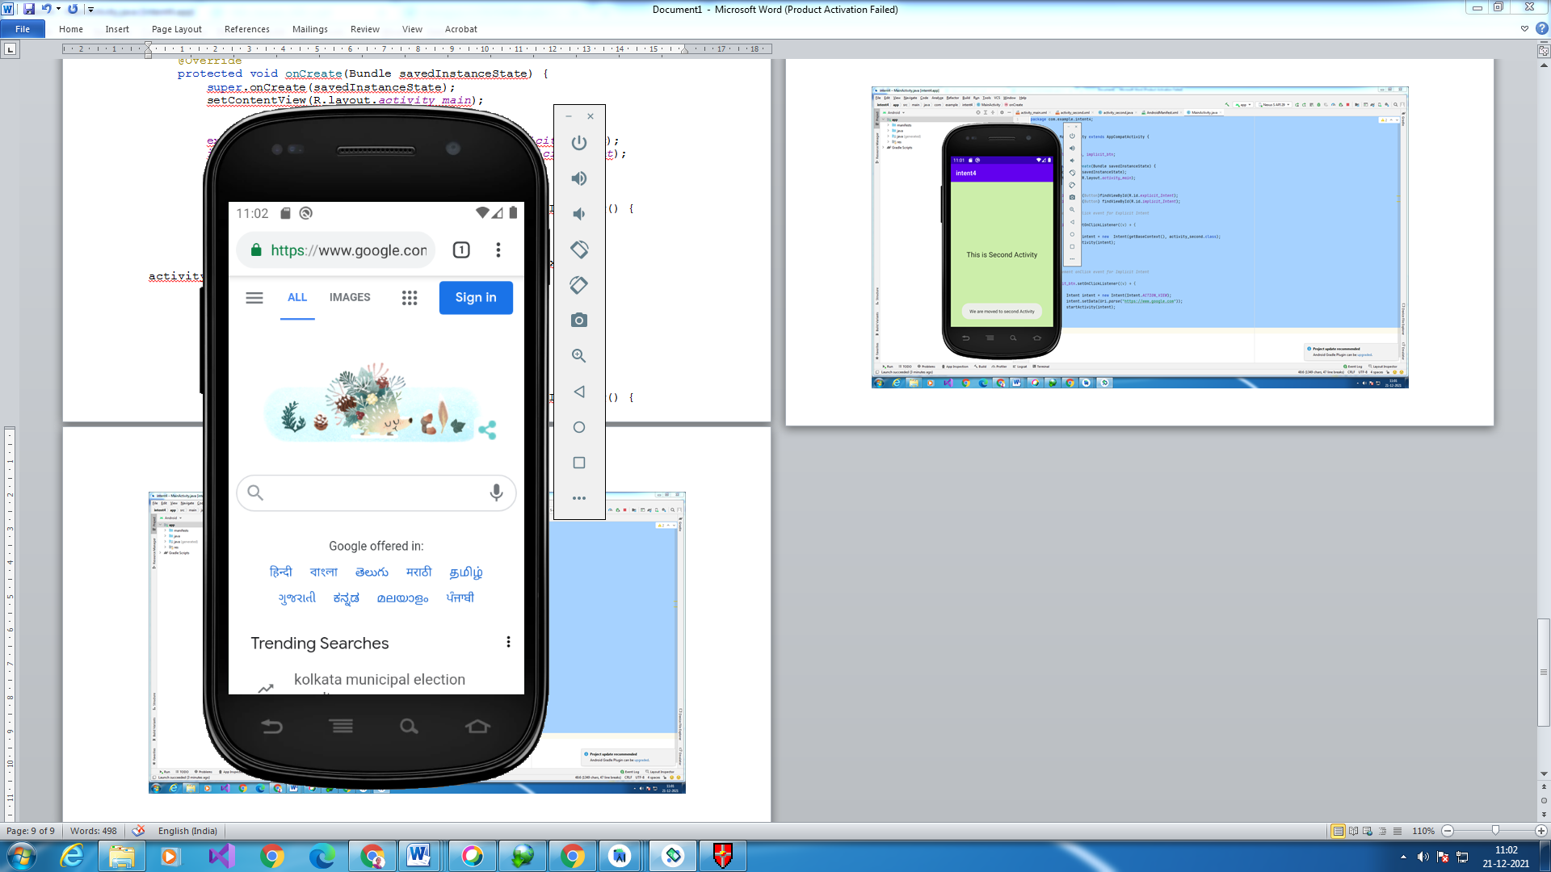

**SPINNER**

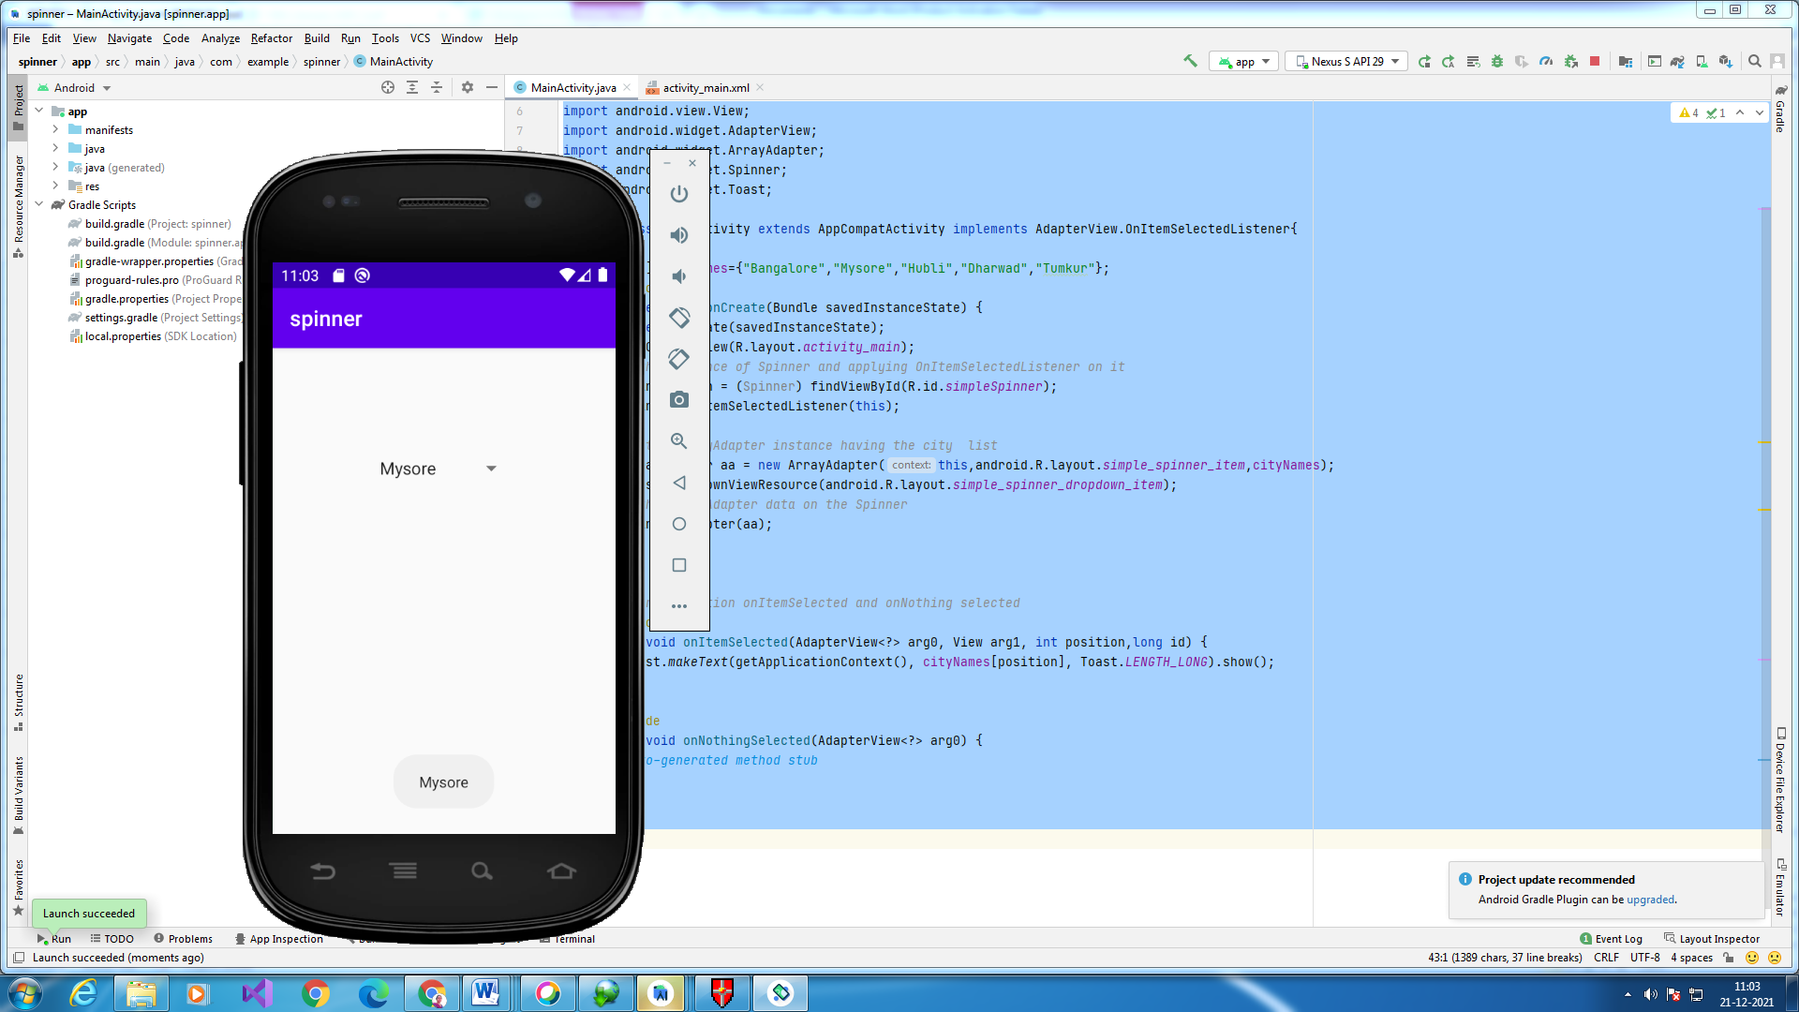

<RelativeLayout xmlns:android="http://schemas.android.com/apk/res/android"  
 xmlns:tools="http://schemas.android.com/tools"  
 android:layout_width="match_parent"  
 android:layout_height="match_parent"  
 tools:context=".MainActivity">  
  
 <Spinner  
 android:id="@+id/simpleSpinner"  
 android:layout_width="wrap_content"  
 android:layout_height="wrap_content"  
 android:layout_centerHorizontal="true"  
 android:layout_marginTop="100dp" />  
  
</RelativeLayout>

import android.view.View;  
import android.widget.AdapterView;  
import android.widget.ArrayAdapter;  
import android.widget.Spinner;  
import android.widget.Toast;  
  
public class MainActivity extends AppCompatActivity implements AdapterView.OnItemSelectedListener{  
  
 String[] cityNames={"Bangalore","Mysore","Hubli","Dharwad","Tumkur"};  
 @Override  
 protected void onCreate(Bundle savedInstanceState) {  
 super.onCreate(savedInstanceState);  
 setContentView(R.layout.*activity_main*);  
*//Getting the instance of Spinner and applying OnItemSelectedListener on it* Spinner spin = (Spinner) findViewById(R.id.*simpleSpinner*);  
 spin.setOnItemSelectedListener(this);  
  
*//Creating the ArrayAdapter instance having the city list* ArrayAdapter aa = new ArrayAdapter(this,android.R.layout.*simple_spinner_item*,cityNames);  
 aa.setDropDownViewResource(android.R.layout.*simple_spinner_dropdown_item*);  
*//Setting the ArrayAdapter data on the Spinner* spin.setAdapter(aa);  
 }  
  
  
 *//Performing action onItemSelected and onNothing selected* @Override  
 public void onItemSelected(AdapterView<?> arg0, View arg1, int position,long id) {  
 Toast.*makeText*(getApplicationContext(), cityNames[position], Toast.*LENGTH_LONG*).show();  
 }  
  
 @Override  
 public void onNothingSelected(AdapterView<?> arg0) {  
*// TODO Auto-generated method stub* }  
}