

**NATIONAL UNIVERSITY OF COMPUTER AND EMERGING SCIENCES**

**Software Design and Architecture**

**Group**  **Project**

**NAME :** **Rayyan Ahmed (22I-2489)**

**Fayyaz Khan (22I-2713)**

**Safdar Jan (22I-8804)**

**SECTION:** **SE(F)**

**SUBMITTED ON: 5** ,**June, 2024**

**SUBMITTED TO:** **Dr Kubaib Amjad Alam**

Topic : Project Code + Report

### **Project Report: Online Shopping System (OSS)**

### 

### **1. Introduction**

The Online Shopping System (OSS) project aimed to develop a comprehensive e-commerce platform to streamline the online shopping experience for both customers and administrators. The system was designed to address the challenges and inefficiencies associated with traditional online shopping platforms, offering a user-friendly interface, robust features, and enhanced security measures.

**1.1 Purpose**

The primary purpose of the OSS project was to create an efficient and convenient platform for users to browse, select, and purchase products online. The system aimed to improve the overall shopping experience by simplifying the browsing and checkout processes, providing secure payment options, and enabling effective order management.

**1.2 Scope**

The scope of the OSS project encompassed the development of a client-server architecture that interacts with a management database. The system's core functionalities included:

* Product browsing and selection
* Order placement and tracking
* Secure payment processing
* Order cancellation and customer support
* Administrative functions (inventory management, order processing, etc.)

**1.3 Definitions, Acronyms, Abbreviations**

* OSS: Online Shopping System
* API: Application Programming Interface
* SSL: Secure Sockets Layer

**1.4 References**

The project team referred to existing e-commerce platforms such as Amazon.com, eBay.com, and Shopify.com for inspiration and best practices in online shopping system design and implementation.

**2. Positioning**

**2.1 Business Opportunities**

The OSS project recognized the growing demand for online shopping platforms, especially in the wake of the COVID-19 pandemic. The project aimed to capitalize on this opportunity by offering a streamlined and user-friendly platform that minimizes human errors and enhances the overall shopping experience.

**2.2 Problem Statement**

The problem addressed by the OSS project was the time-consuming and inefficient nature of traditional online shopping processes. Users often faced difficulties in browsing products, placing orders, and completing transactions, leading to frustration and potential loss of sales. The project aimed to solve this problem by providing a more intuitive and efficient platform that simplifies these processes.

**3. Product Features**

The OSS incorporated a wide range of features to cater to both customers and administrators:

**3.1 Customer Features**

* New Arrivals for purchase
* Sign in to access order history
* Request faster checkout options
* Manage pickup points for delivery
* Manage product types and 3D layouts
* Pre-order products
* Make urgent payments via QR code
* Contact customer support
* Reserve special delivery services
* Make online payments using various methods
* Create shortcuts for frequently purchased items
* Cancel orders in emergencies
* Review orders and delivery experiences

**3.2 Administrator Features**

* Manage product categories and products
* Manage customer accounts and blacklist
* Modify product prices
* Manage new brands and special offers
* Check inventory levels and delivery schedules
* Assign couriers and manage customer support agents
* Check sales and profit margins
* Cancel orders and track delivery status
* Check product quality reports and communicate with suppliers

**4. Product Overview**

**4.1 Product Perspective**

The OSS was envisioned as a comprehensive e-commerce platform built using a component-based approach. The system was designed to be user-friendly, efficient, and secure, catering to the needs of both customers and administrators.

**4.2 Dependencies and Assumptions**

The project team assumed that users would have access to a reliable internet connection and compatible devices to utilize the platform effectively. The system's implementation depended on various technologies, including Java for the Java EE application, data structures like Linked Lists and ArrayLists, and a relational database for data storage.

**5. Constraints**

The OSS project faced several constraints, including:

* **Security:** The system needed to implement robust security measures to protect user data and financial transactions.
* **Usability:** The user interface had to be intuitive and easy to navigate for users of varying technical expertise.
* **Performance:** The system needed to be responsive and handle a large volume of users and transactions efficiently.

**6. Cost and Pricing**

The estimated cost for developing the OSS was approximately 382,000, including expenses for developers, marketing, and other resources. The pricing model for the platform would depend on various factors, such as transaction fees, subscription fees, and advertising revenue.

**7. Licensing and Installation**

Due to the complexity of the system, installation was to be handled by certified and licensed professionals. The system would be subject to legal regulations and unauthorized access or data manipulation would be strictly prohibited.

**8. Use Case Diagram:**

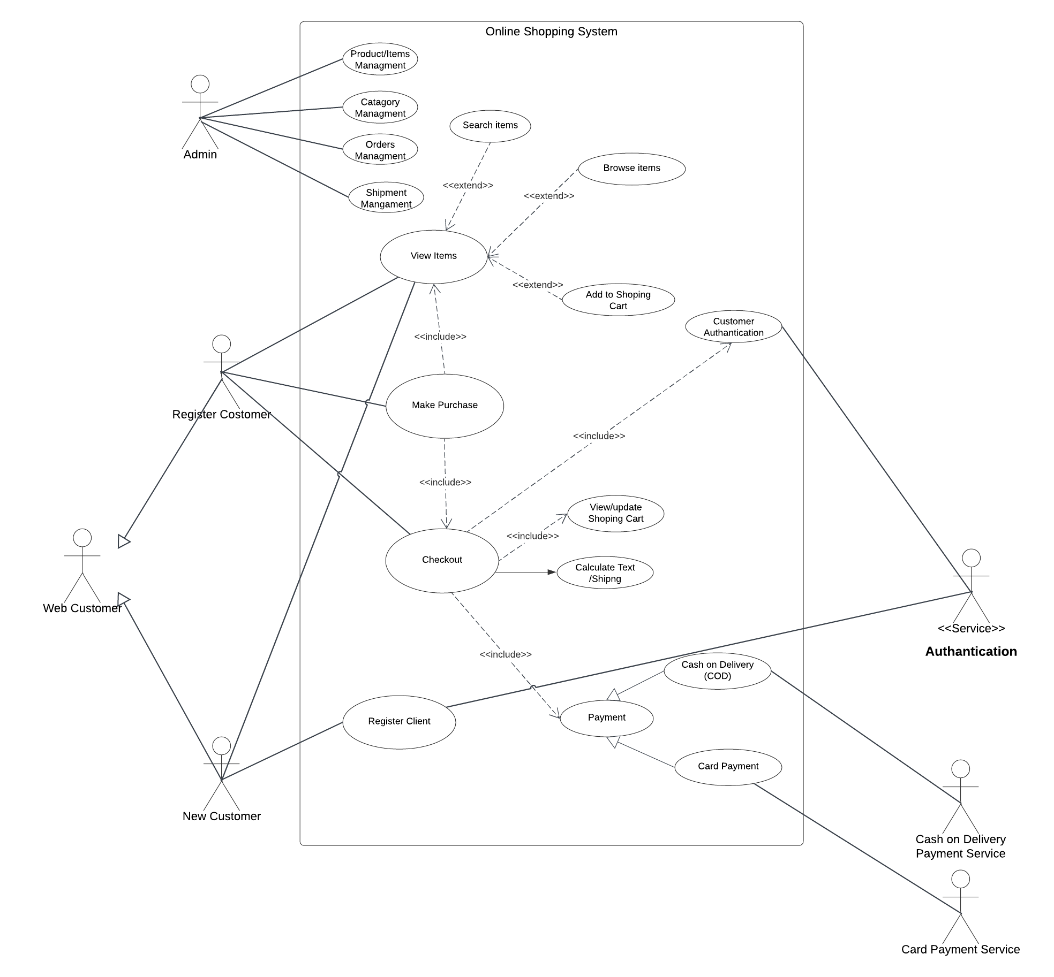

**9. Expanded Use Cases:**

**Refers to Assignment 2**

**10. System Sequence Diagrams (SSDs) and Sequence Diagrams (SDs)**

**( refer Deliverable 3)**

**11. Domain Model**

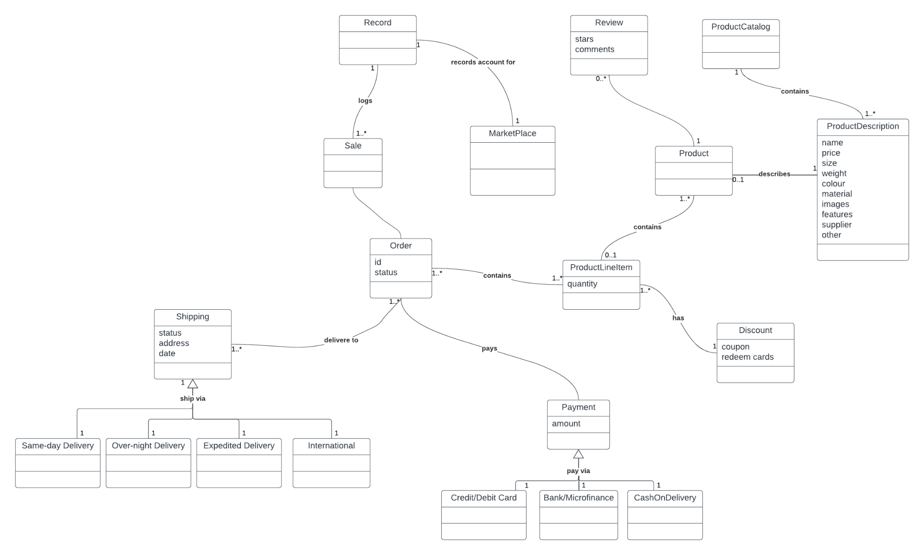

**12. Class Diagram**

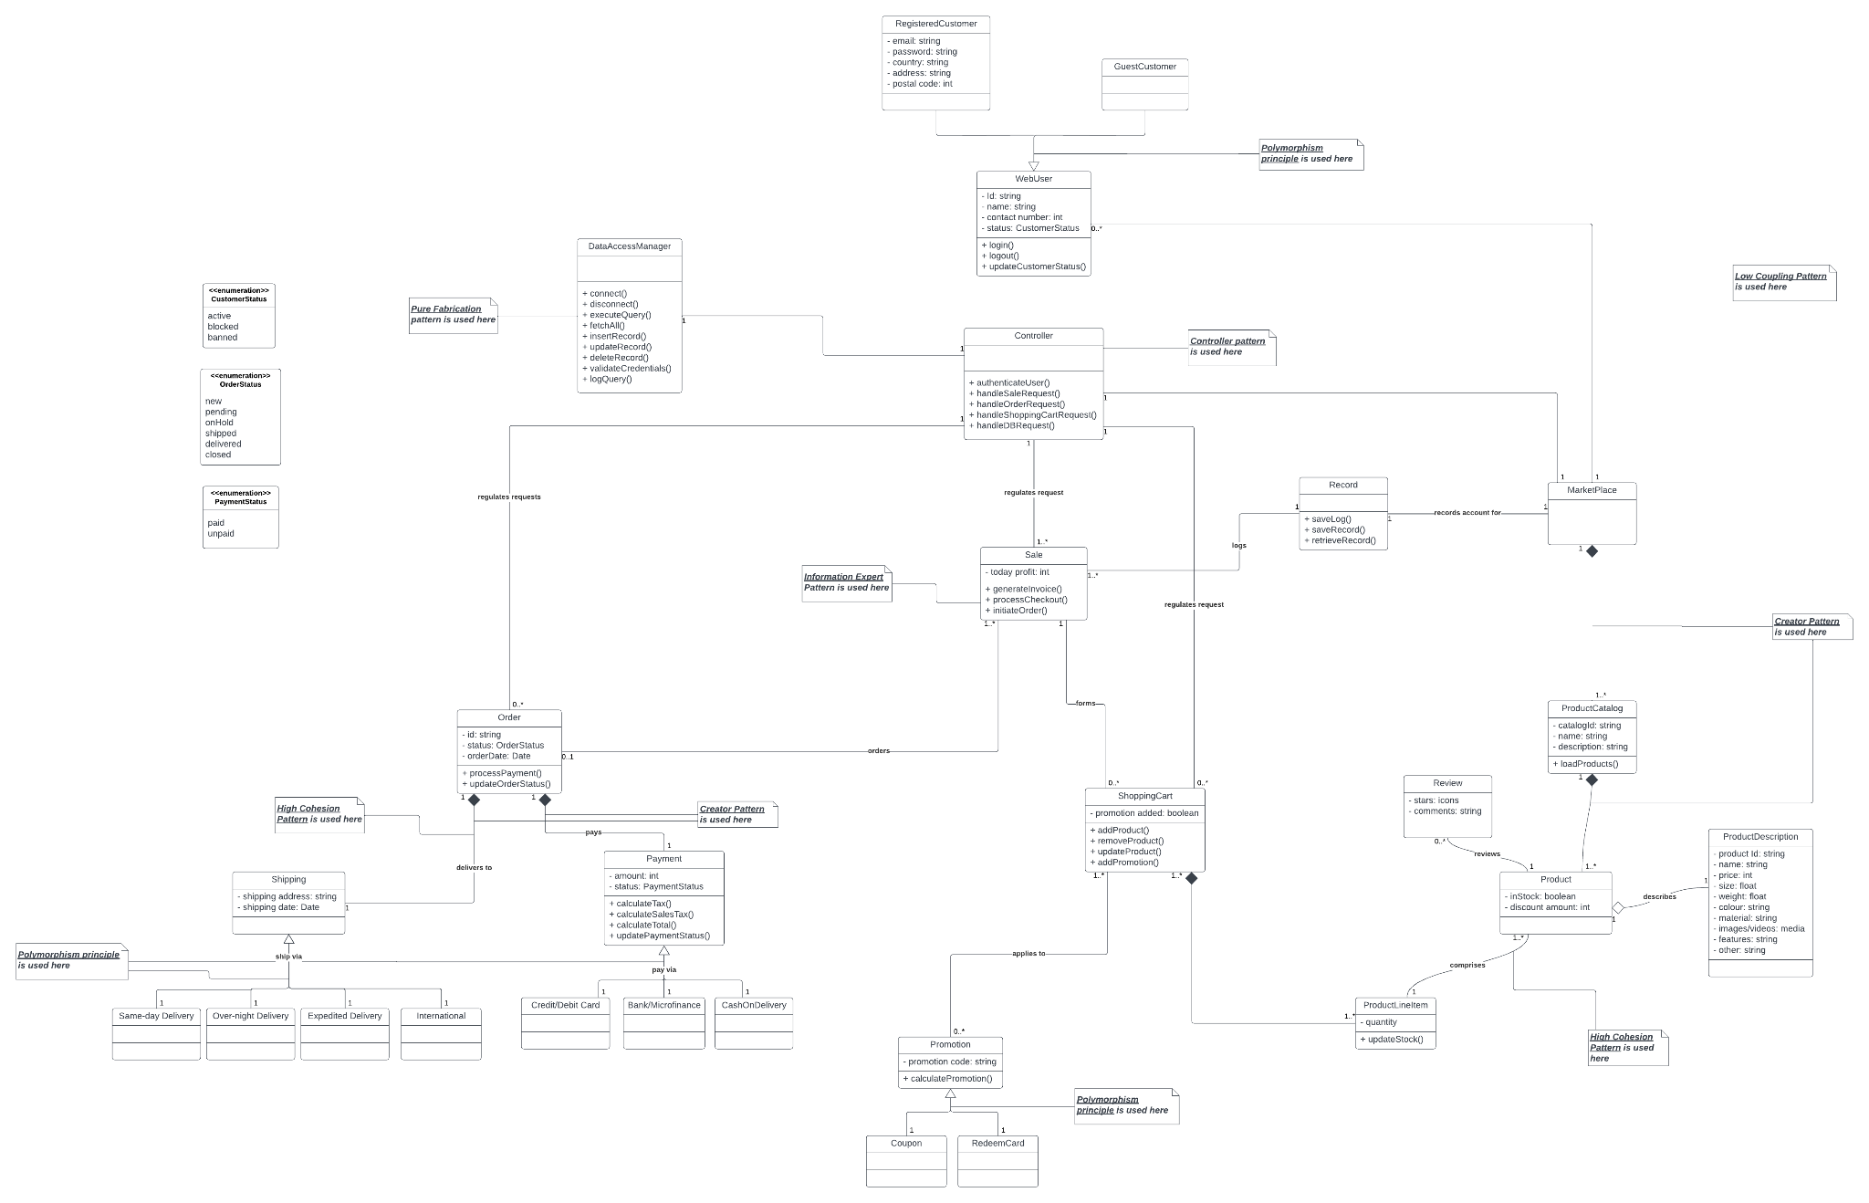

13. **High Level Architecture:**

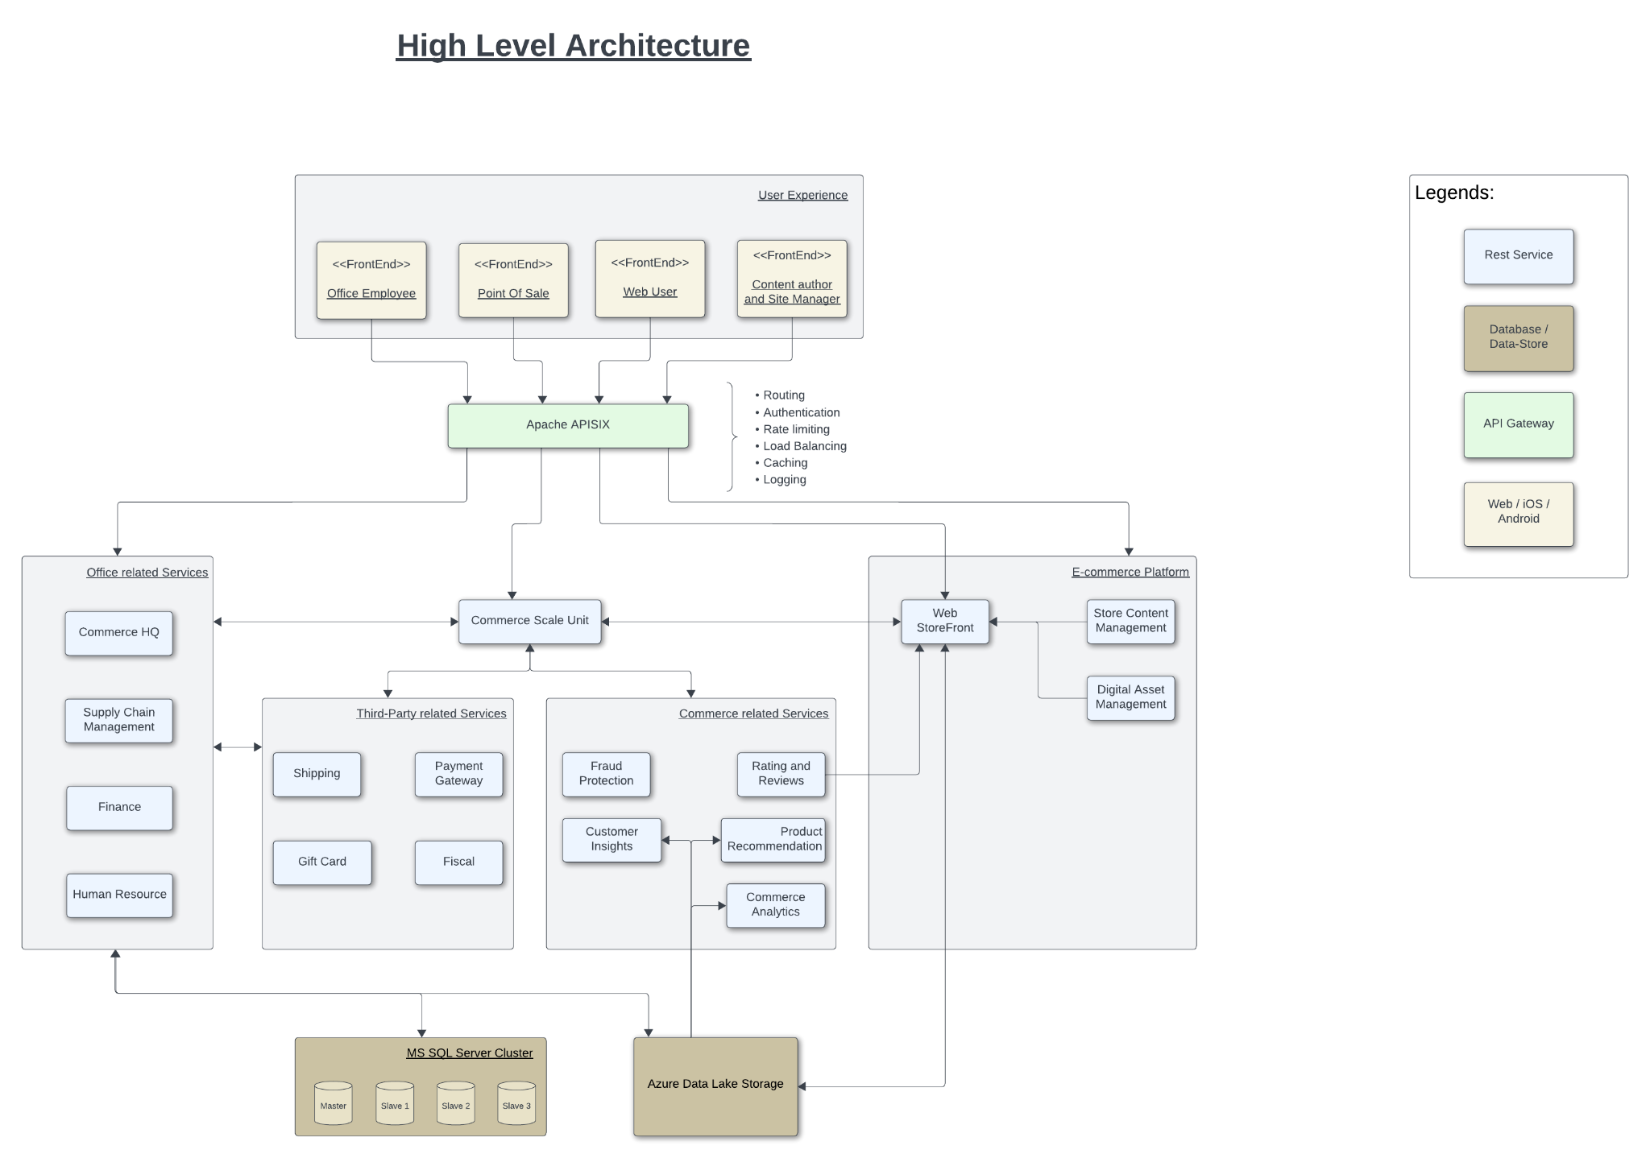

**13.1 Logical View:**

Class Diagram is attached above.

Then we made Package Diagram:

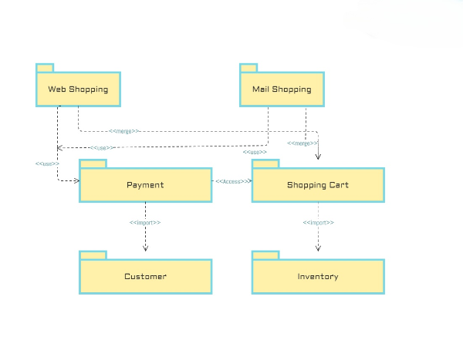

**13.2 Process View:**

Sequence Diagram:

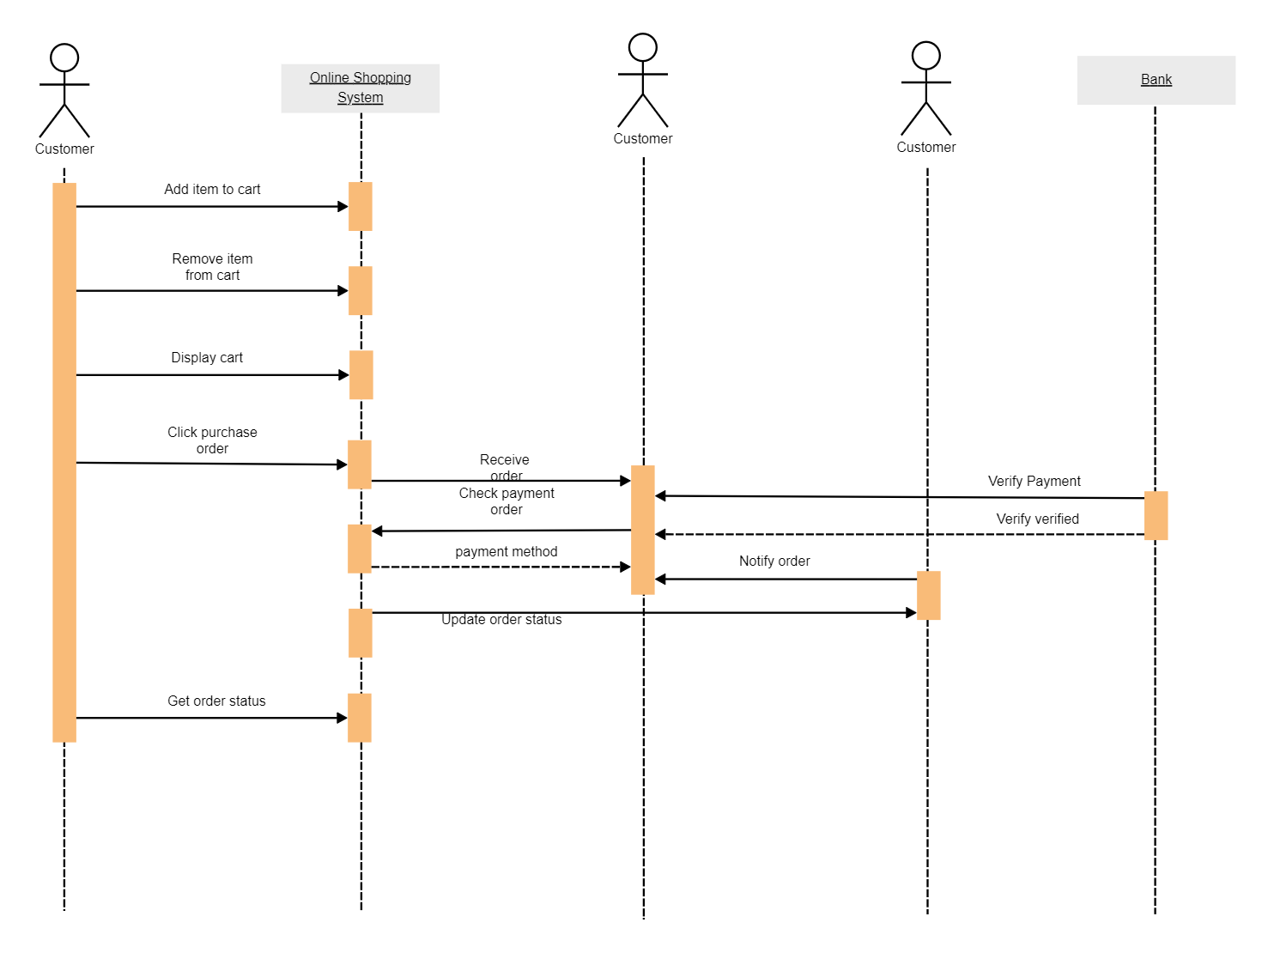

Activity Diagram: 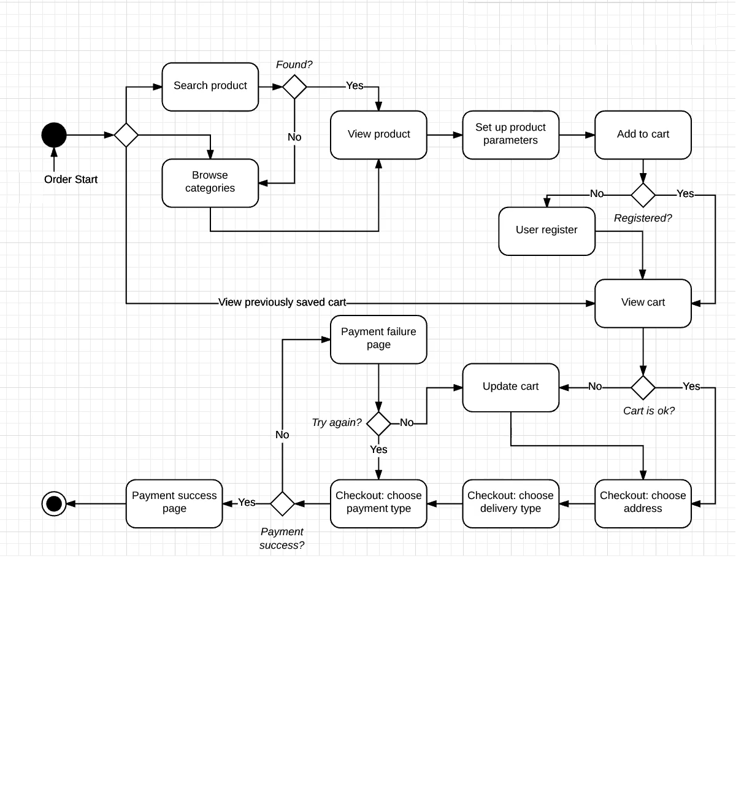

**13.3 Implementation View:**

Component Diagram: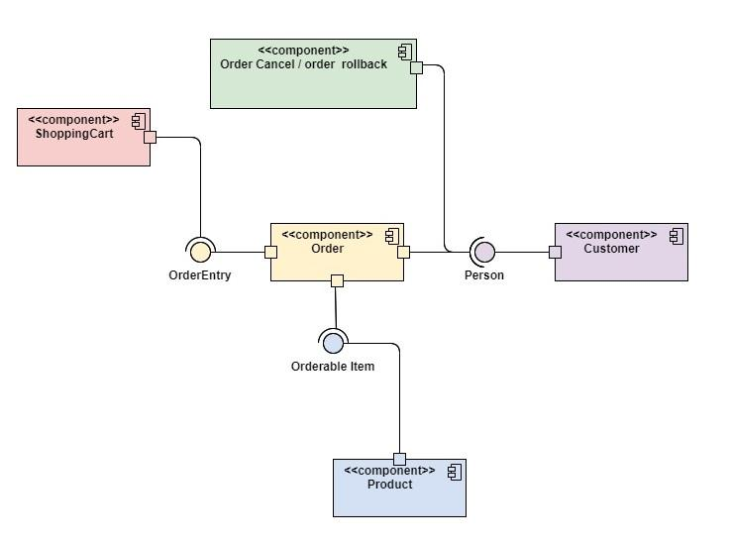

Deployment View:

Deployment Diagram:

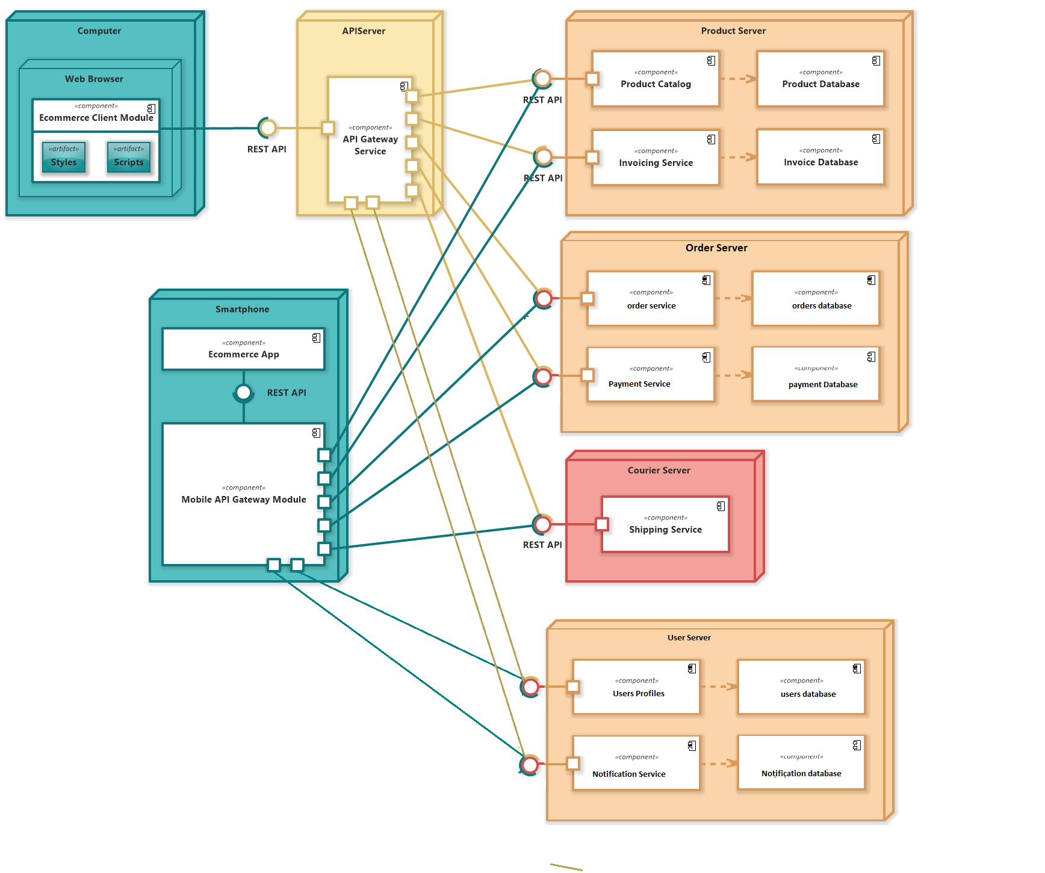

**14. Conclusion:**

The Online Shopping System project aimed to revolutionize the e-commerce landscape by providing a comprehensive, user-friendly, and secure platform for online shopping. The project's deliverables outlined the system's requirements, features, design, and implementation details. While the provided documents offer a substantial overview of the project, a complete final project report would include additional sections such as an executive summary, project timeline, risk assessment, lessons learned, and future enhancements.