

RIPHAH INTERNATIONAL UNIVERSITY
Campus: Islamabad

Lab 04
Data Structures

Submitted To:
Sir Junaid Khan

Submitted By:
Muhammad Rayyan Anees
75531

Date of Submission:
23rd September 2026

Output of Activity 1:
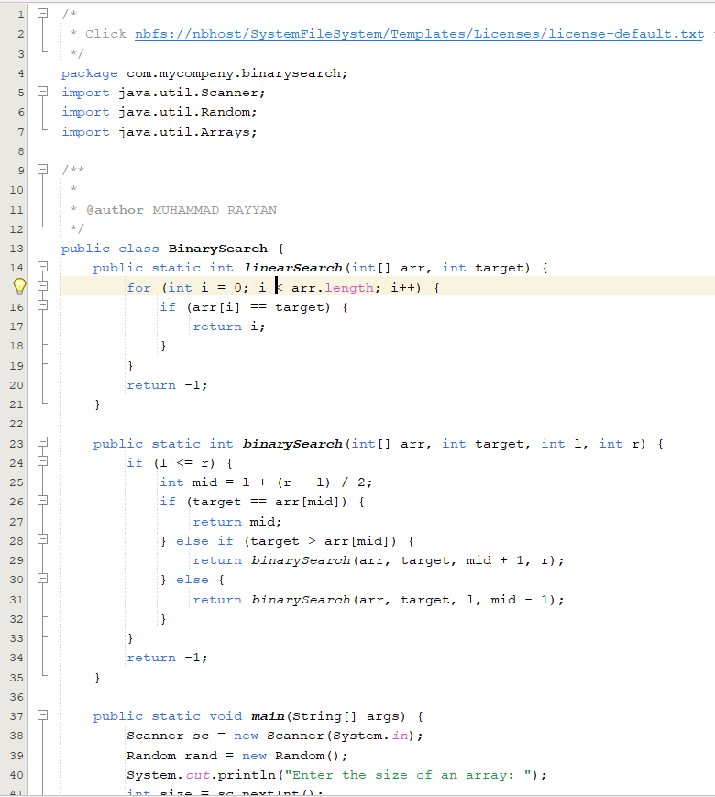
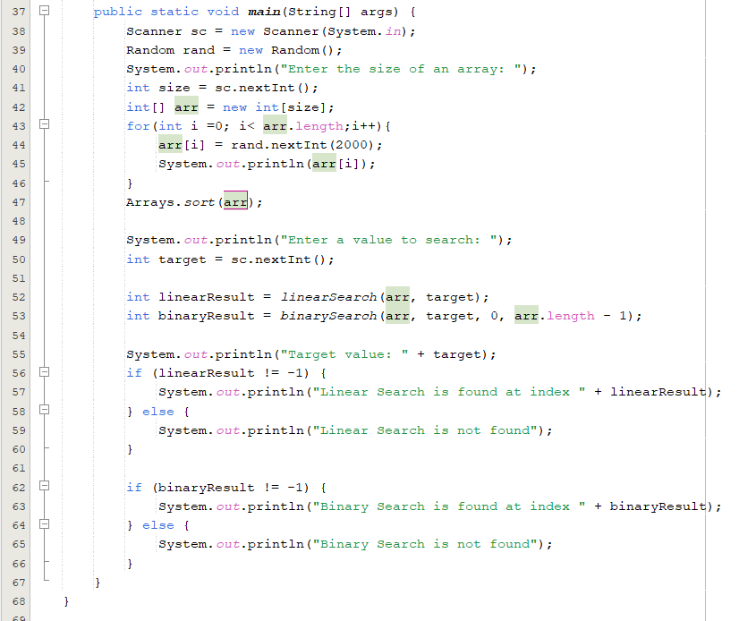
Output:
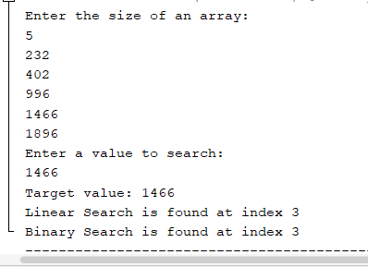
Activity 02(Stack):
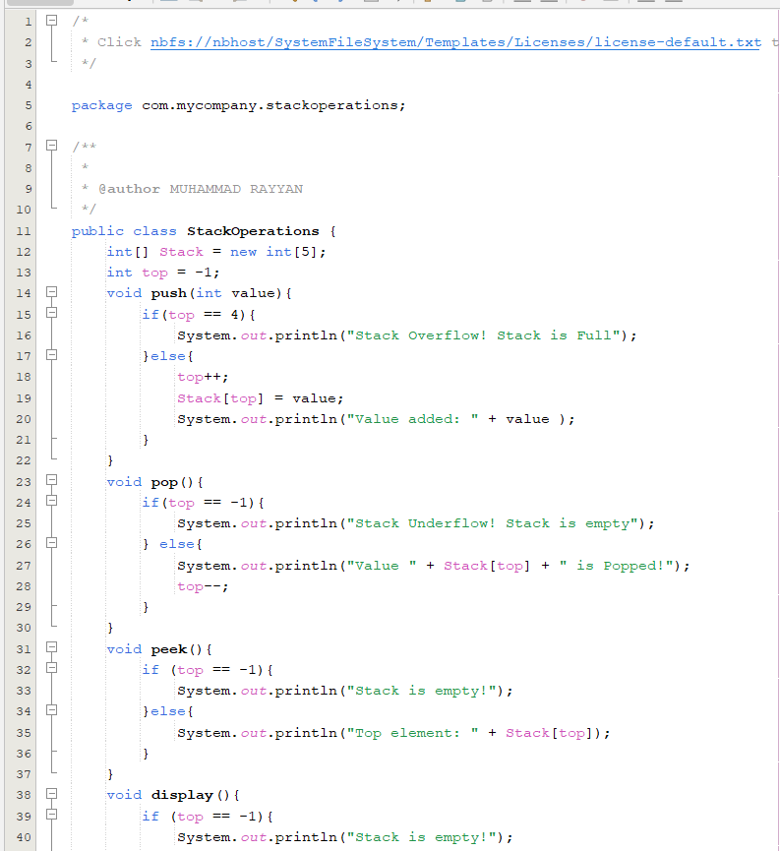
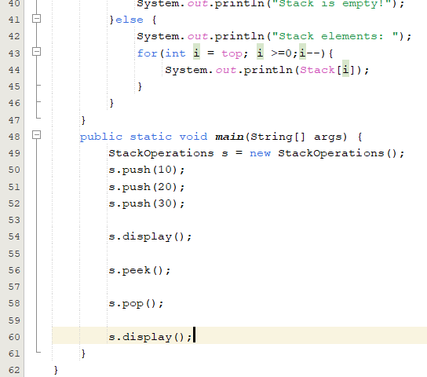
Output:
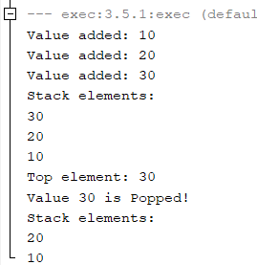

Activity 03(Queue):
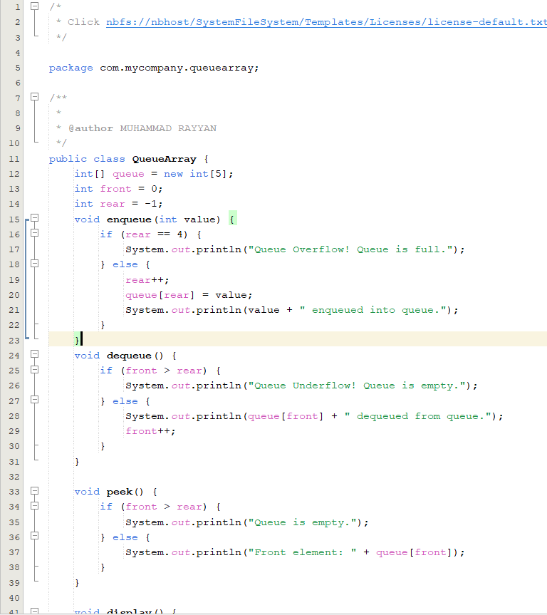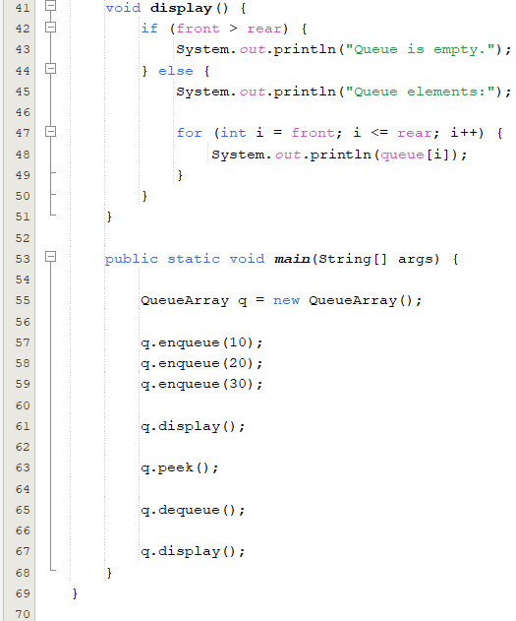

Output:
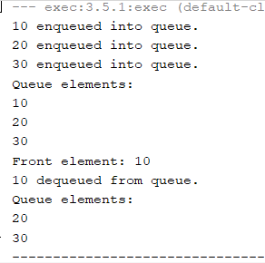

Brief Comparison of Linear Search and Binary Search:
Linear Search checks each element one by one until the required element is found. It does not require the data to be sorted thus making it simple and easy to use. Binary Search, on the other hand, works only on sorted data and repeatedly divides the search area into half to find the required element. Therefore, Binary Search is generally faster for large, sorted datasets, with a time complexity of O (log n), while Linear Search has a time complexity of O(n).

Brief Comparison of LIFO and FIFO:
LIFO and FIFO describe the order in which elements are removed. LIFO (Last In, First Out) means the element added last is removed first, which is followed by a Stack. For example, if 10, 20, and 30 are pushed into a stack, 30 will be removed first. FIFO (First In, First Out) means the element added first is removed first, which is followed by a Queue. For example, if 10, 20, and 30 are added to a queue, 10 will be removed first.

