CST2335 Lab 3: Activity Lifecycle and Intents
Mobile Graphical Interface Programming — Lab Report
Student Name: | Rayyan Haque
Student ID: | 041256359
Course: | CST2335 - Mobile Graphical Interface Programming
Git Branch: | lab_3
Submission Date: | October 2026
-----------------------------------------------------------------
1. Overview
For this lab, we created an Android app with two activities (MainActivity and NameActivity) to practice using explicit intents, passing data back and forth between activities, and saving data persistently using SharedPreferences so user input isn't lost when the app closes.
2. Code Explanation
MainActivity
• onCreate(): When the activity loads, it accesses SharedPreferences (named 'MyPrefs'). If a name was previously saved under the key 'USER_NAME', it loads it into the EditText. If nothing was saved yet, the EditText remains empty.
• Next Button: When clicked, it takes the text entered in the EditText, puts it into an Intent extra, and launches NameActivity using startActivityForResult().
• onPause(): Whenever the activity goes into the background or pauses, we override onPause() to save whatever text is currently inside the EditText into SharedPreferences using editor.putString() and editor.apply().
• onActivityResult(): When NameActivity returns, this callback checks the resultCode. If the code is 1 (from the 'Thank You' button), it calls finish() to close the app. If the code is 0 (from 'Don't call me that'), it stays on MainActivity so the user can edit their name.
NameActivity
• onCreate(): Reads the name passed in the intent extra and updates the TextView to say 'Welcome ' + the name (for example, 'Welcome Rayyan!').
• 'Don't call me that' button: Calls setResult(0) and finish() to return back to MainActivity with result code 0.
• 'Thank You' button: Calls setResult(1) and finish() to return back to MainActivity with result code 1.
Localization (English & French)
All button and text labels are stored in res/values/strings.xml for English and res/values-fr/strings.xml for French. When the device language is changed to French, the labels automatically update to:
- 'Enter your name' -> 'Entrez votre nom'
- 'Next' -> 'Suivant'
- 'Welcome !' -> 'Bienvenue !'
- 'Don't call me that' -> 'Ne m\'appelez pas comme ça'
- 'Thank You' -> 'Merci'
3. Screenshots
Below are the screenshots from running the application on the test device:
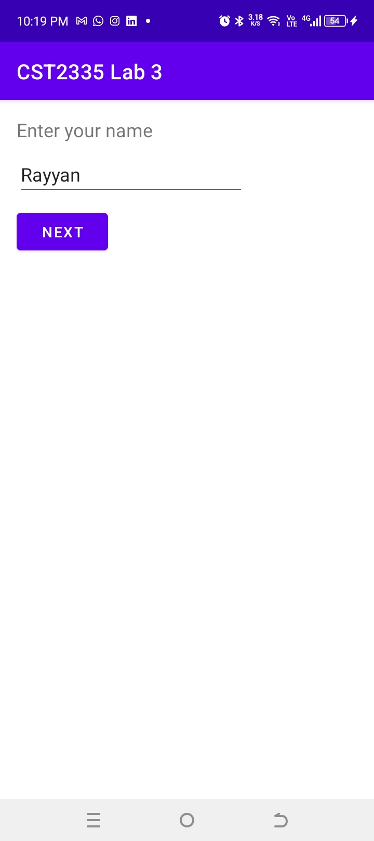 | 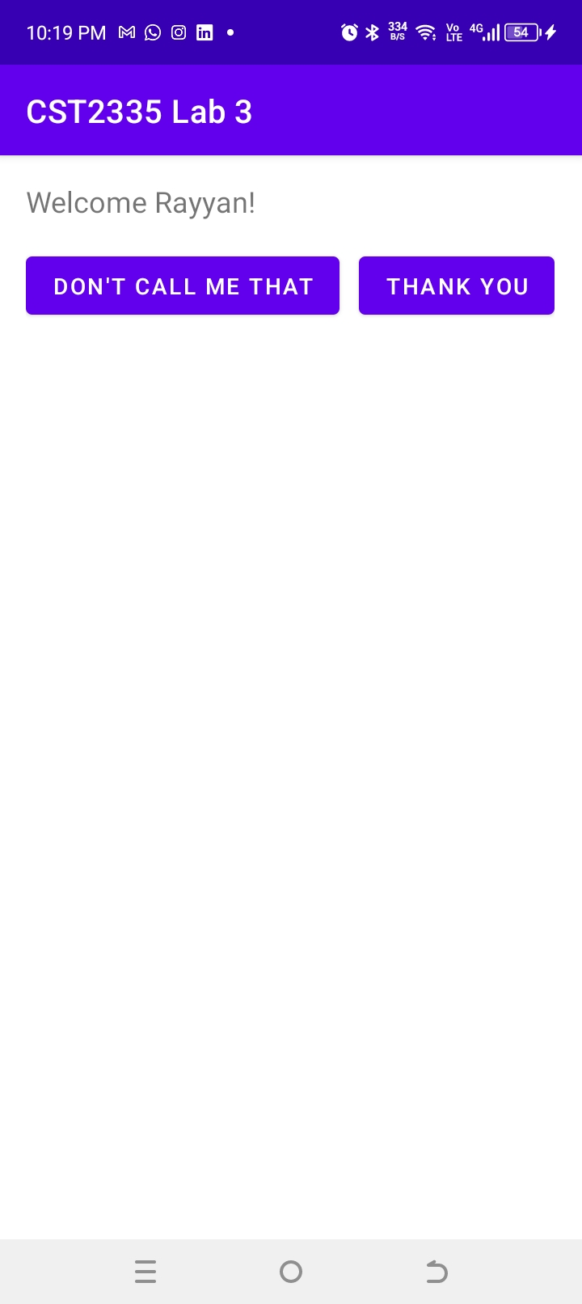
Figure 1: MainActivity with name entered ('Rayyan') | Figure 2: NameActivity showing 'Welcome Rayyan!' and buttons
4. ADB Shell SharedPreferences Verification
To check that the name was properly stored in SharedPreferences on the device storage, I opened the Command Prompt and used ADB shell with the following commands:
1. adb shell
2. run-as com.cst2335.lab3
3. cd shared_prefs
4. ls -l
5. cat MyPrefs.xml
The XML file shows the key 'USER_NAME' with the value 'Rayyan' saved inside:
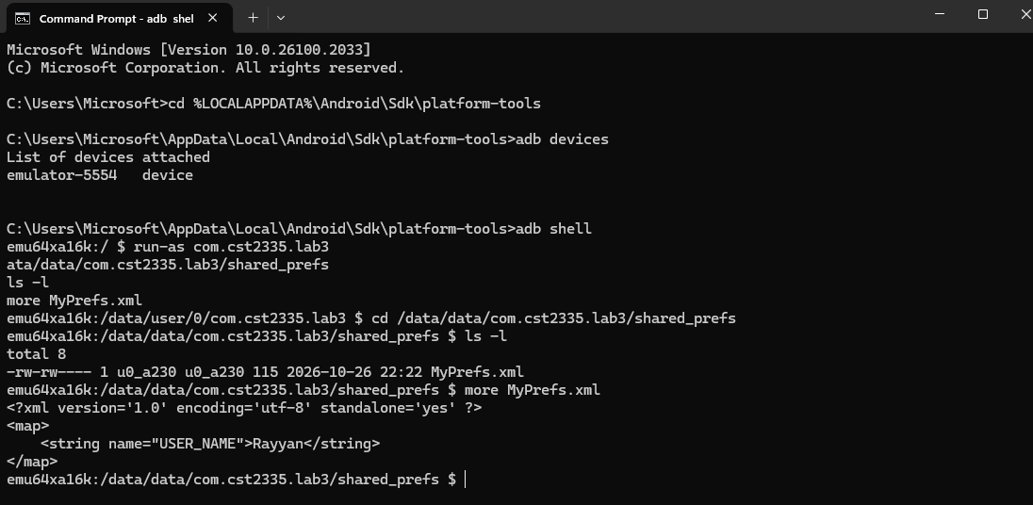
Figure 3: ADB shell terminal session showing MyPrefs.xml contents
Note on Video Recording: A full screen recording of the app in action ('app_demo_recording.webm') is also saved in the project's 'media/' folder, demonstrating the complete flow including name entry, button responses, closing, and reopening.

