CST2335 - Lab 4
To Do Application using ListView and BaseAdapter
Student Name: | Rayyan Haque
Student ID: | 041256359
Course: | CST2335 - Mobile Graphical Interface Programming
Lab Assignment: | Lab 4 (ListView, Custom BaseAdapter & AlertDialog)
Date: | October 2026
-----------------------------------------------------------------
1. Overview
In this lab, we built a To Do list Android application to practice using the ListView widget and implementing a custom BaseAdapter. The app allows users to add tasks to a list, flag certain items as urgent using a switch, and delete items from the list by long-clicking them to trigger an AlertDialog confirmation.
2. Code Explanation
TodoItem Model Class
A simple Java class (TodoItem.java) was created to hold the data for each task. It contains two fields: a String for the task text and a boolean for whether the task is urgent (isUrgent), along with standard getters and setters.
Layout Structure
- activity_main.xml: Contains a ListView that takes up the main height of the screen. At the bottom, there is a horizontal row with an EditText (hint: 'Type Here'), a SwitchCompat ('Urgent'), and an 'Add' Button.
- row_todo.xml: A separate layout file representing each row in the ListView. It contains a TextView with the text size set to 20sp for clear readability.
Custom BaseAdapter Implementation
A custom TodoAdapter extending BaseAdapter was created to bind the ArrayList of TodoItem objects to the ListView:
- getCount(): Returns the total number of items in the list (todoList.size()).
- getItem(int position): Returns the TodoItem at the given position.
- getItemId(int position): Returns the position as a long identifier.
- getView(int position, View convertView, ViewGroup parent): Inflates row_todo.xml and sets the TextView's text. If the item is marked urgent, the row's background color is set to RED (Color.RED) and the text color to WHITE (Color.WHITE). For normal items, the background is set to WHITE and the text color to BLACK.
Adding & Deleting Items
- Adding: Clicking 'Add' reads the text from the EditText and checks the switch state. A new TodoItem is created and added to the list, the EditText is cleared, and adapter.notifyDataSetChanged() is called to refresh the view.
- Deleting (Long-Click): An setOnItemLongClickListener is attached to the ListView. Long-clicking any row opens an AlertDialog displaying 'Do you want to delete this?' with the message 'The selected row is: ' and the clicked row index. Pressing 'Yes' removes the item from the list (todoList.remove(position)) and refreshes the list; pressing 'No' dismisses the dialog.
Localization (French)
All user interface strings are defined in res/values/strings.xml for English and translated in res/values-fr/strings.xml for French ('Tapez ici', 'Ajouter', 'Oui', 'Non', etc.).
3. Screenshots
Below are the screenshots captured from running the application:
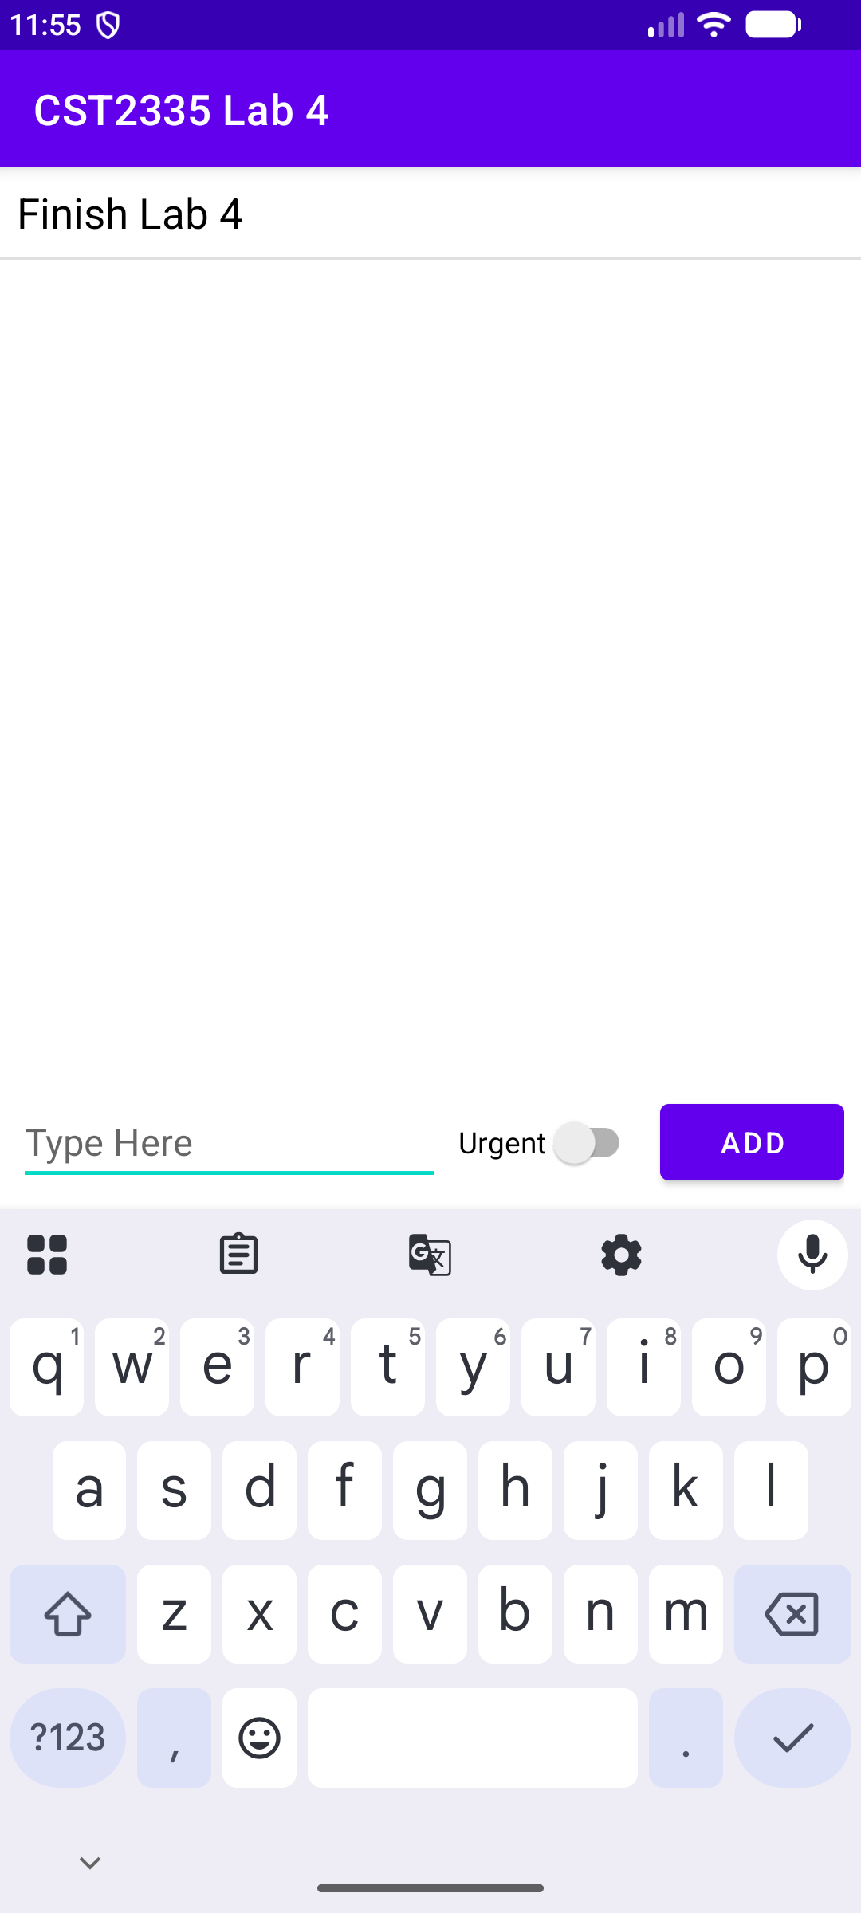 | 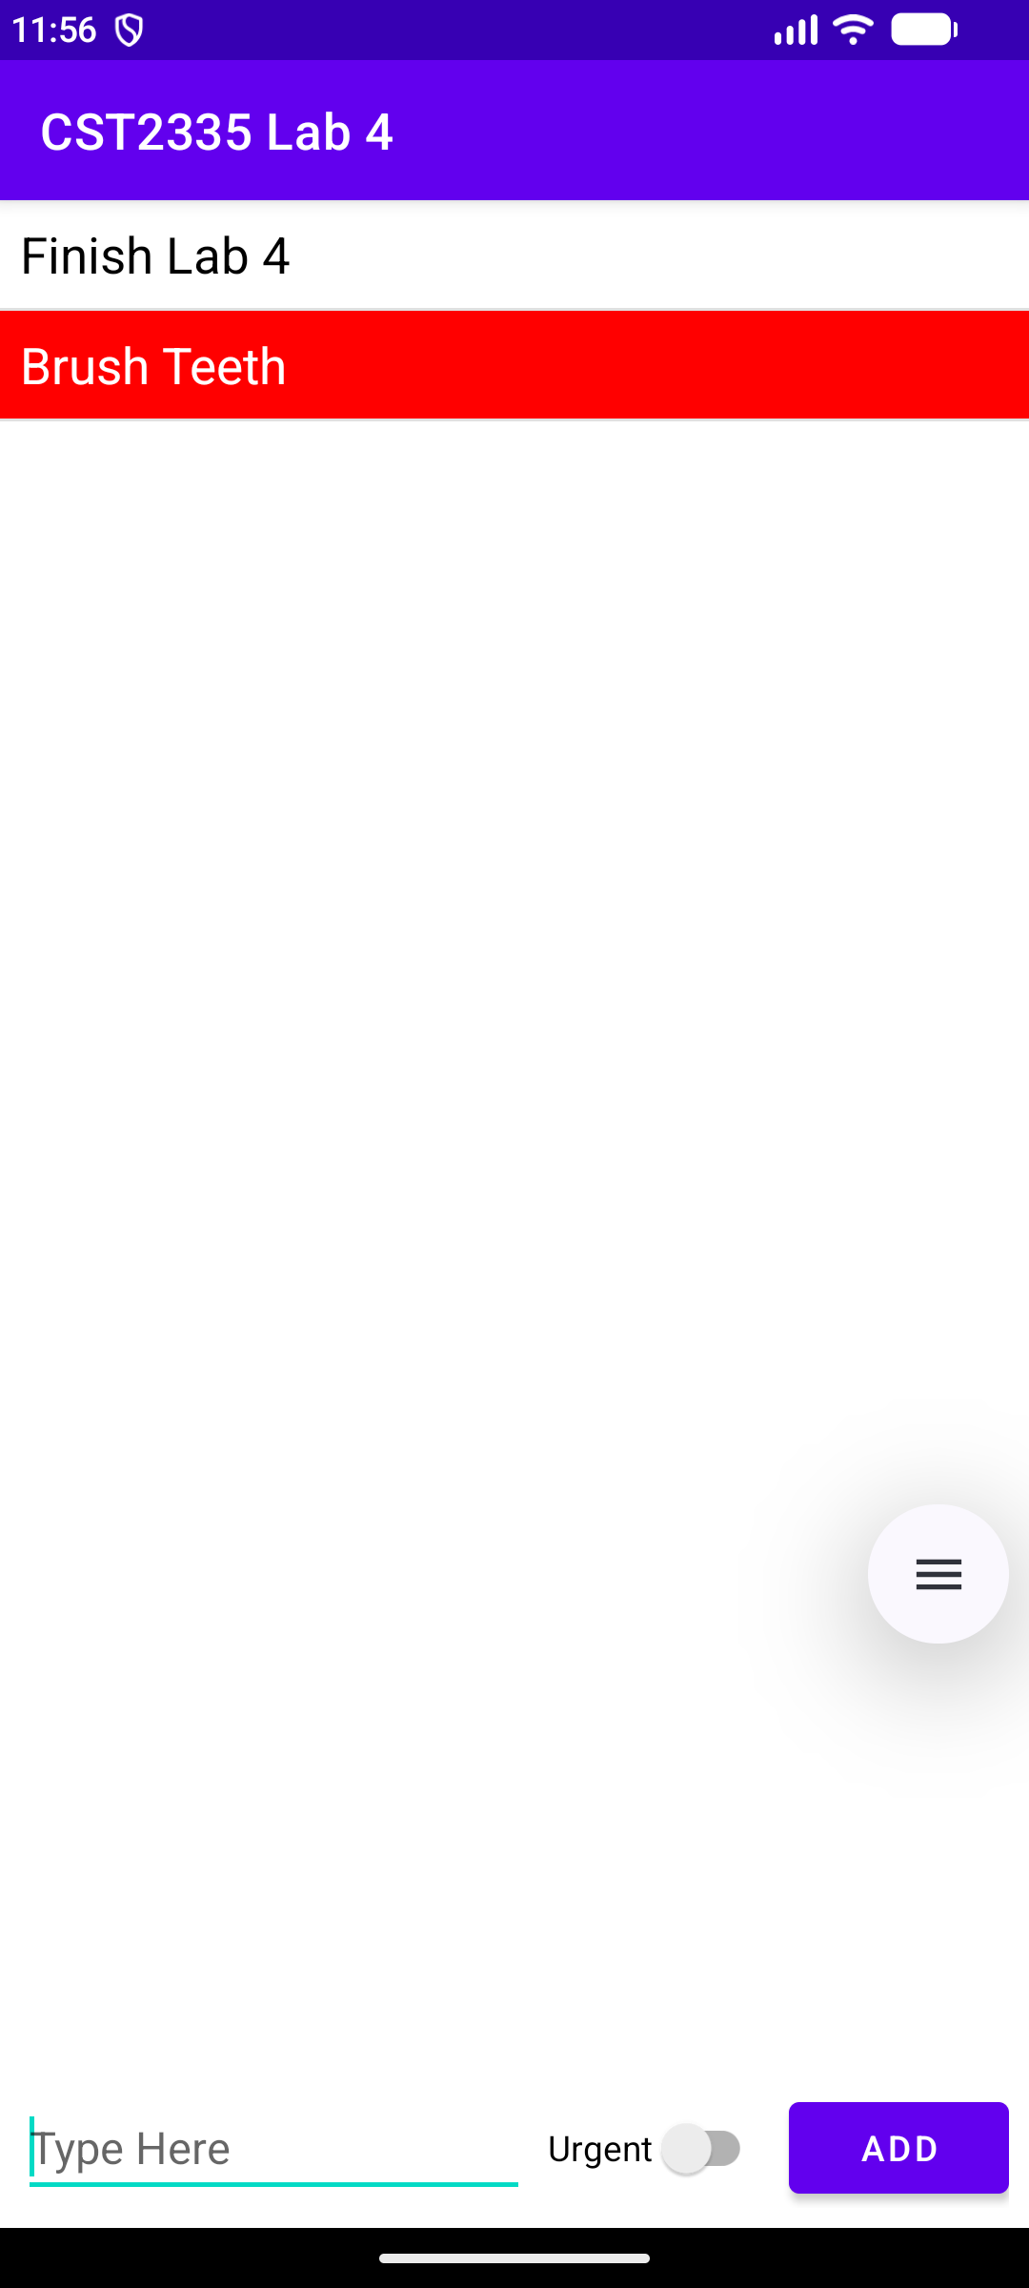
Figure 1: Normal item ('Finish Lab 4') added with EditText cleared | Figure 2: Urgent item ('Brush Teeth') added with red row and white text

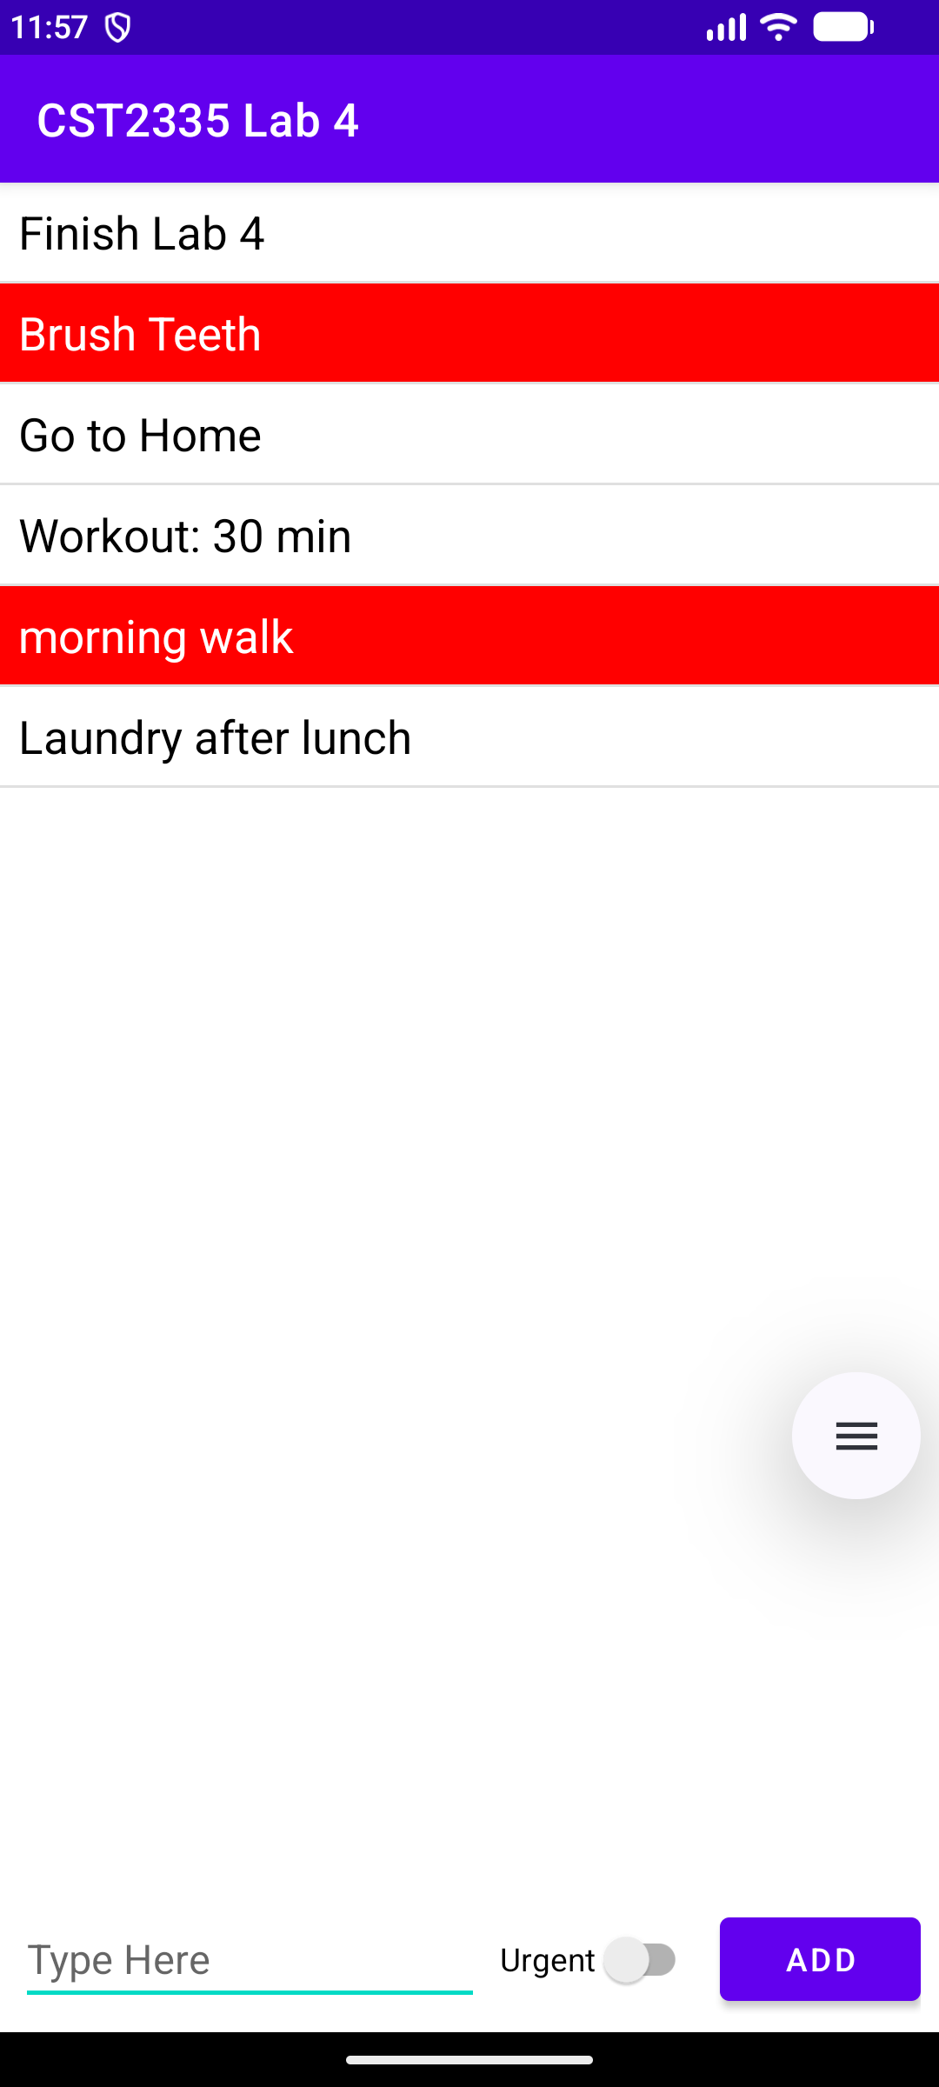 | 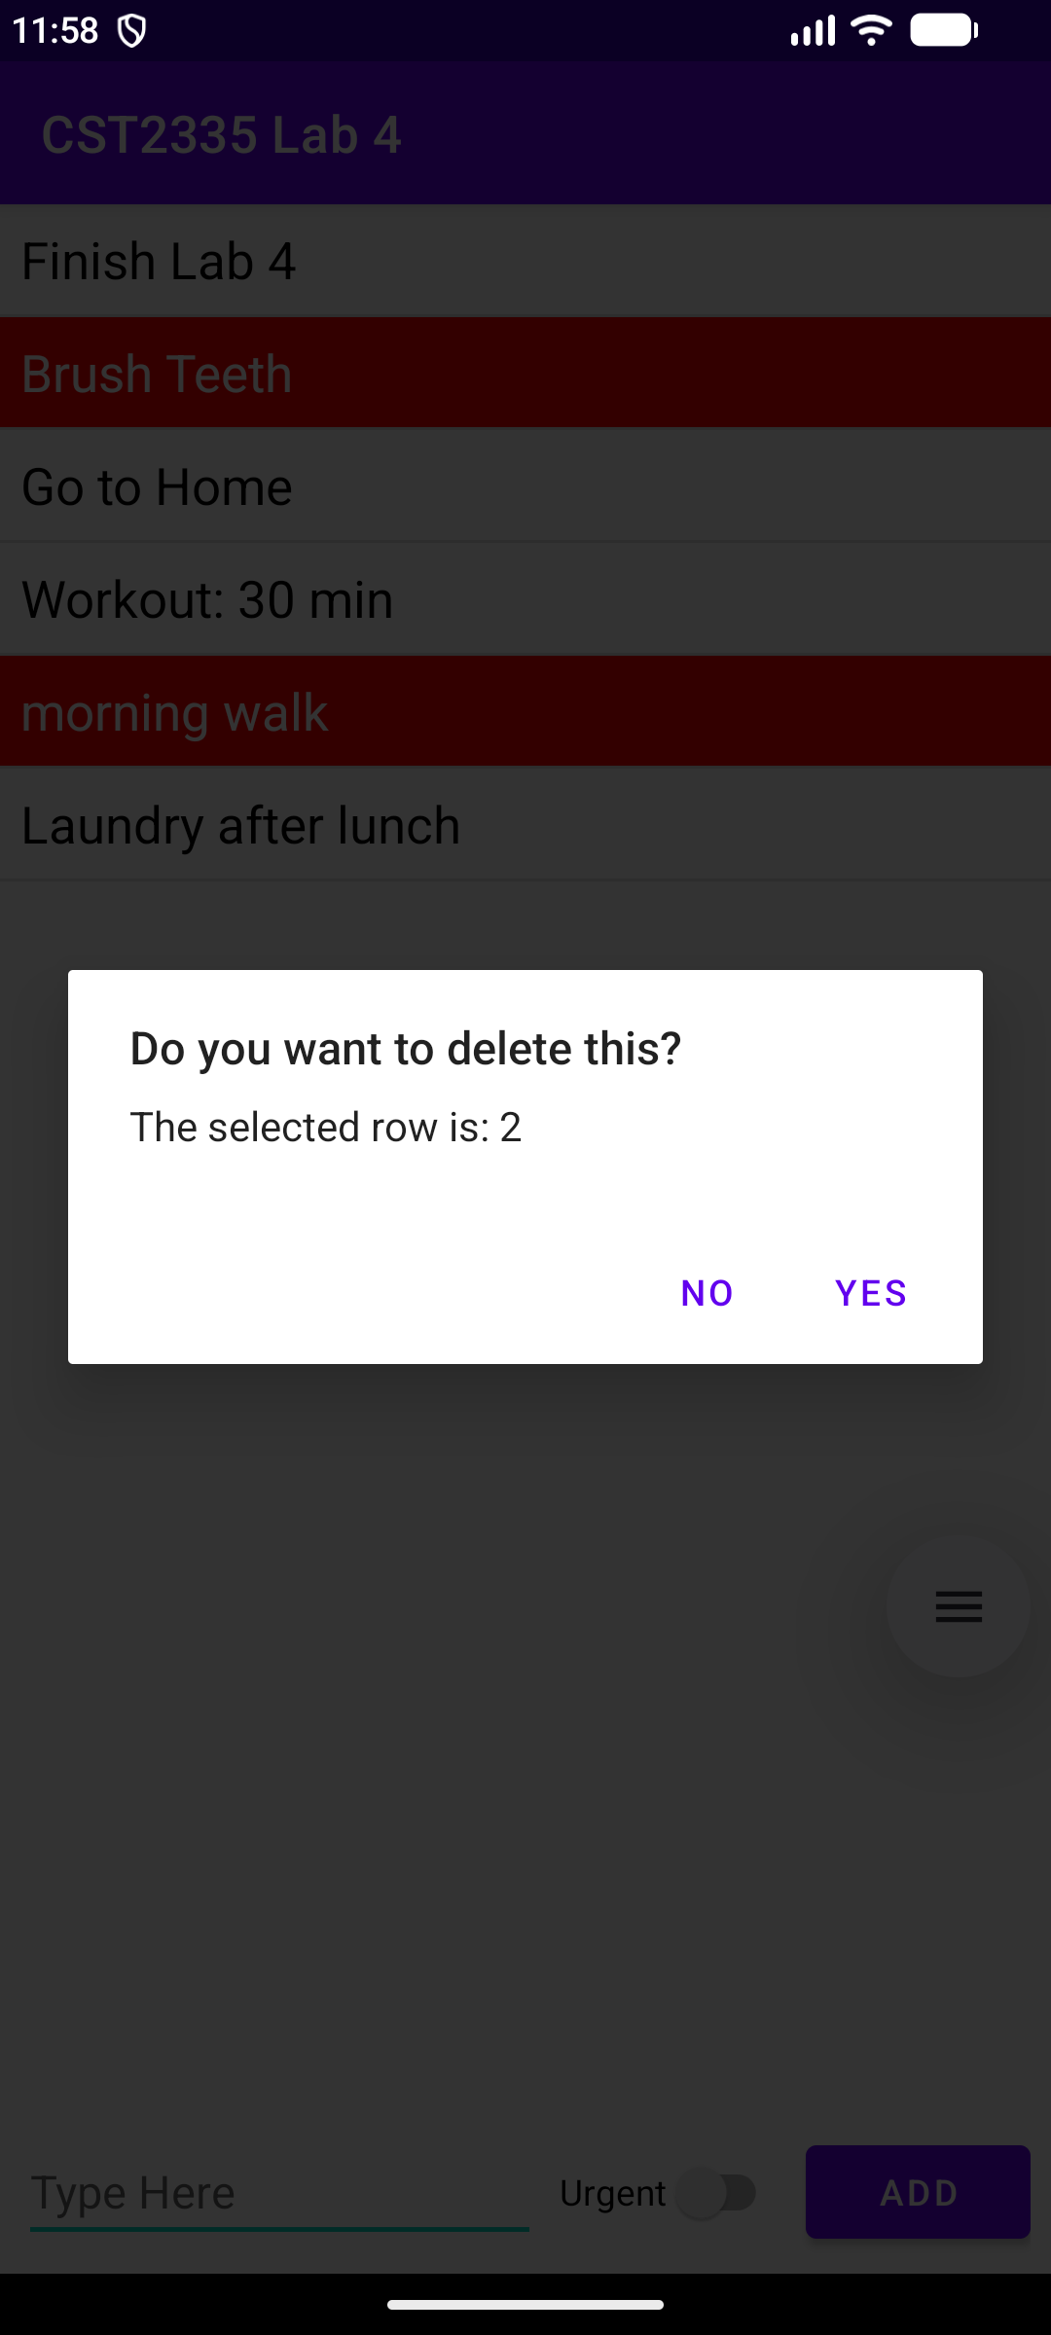
Figure 3: ListView showing multiple normal and urgent items | Figure 4: AlertDialog showing selected row index upon long-click

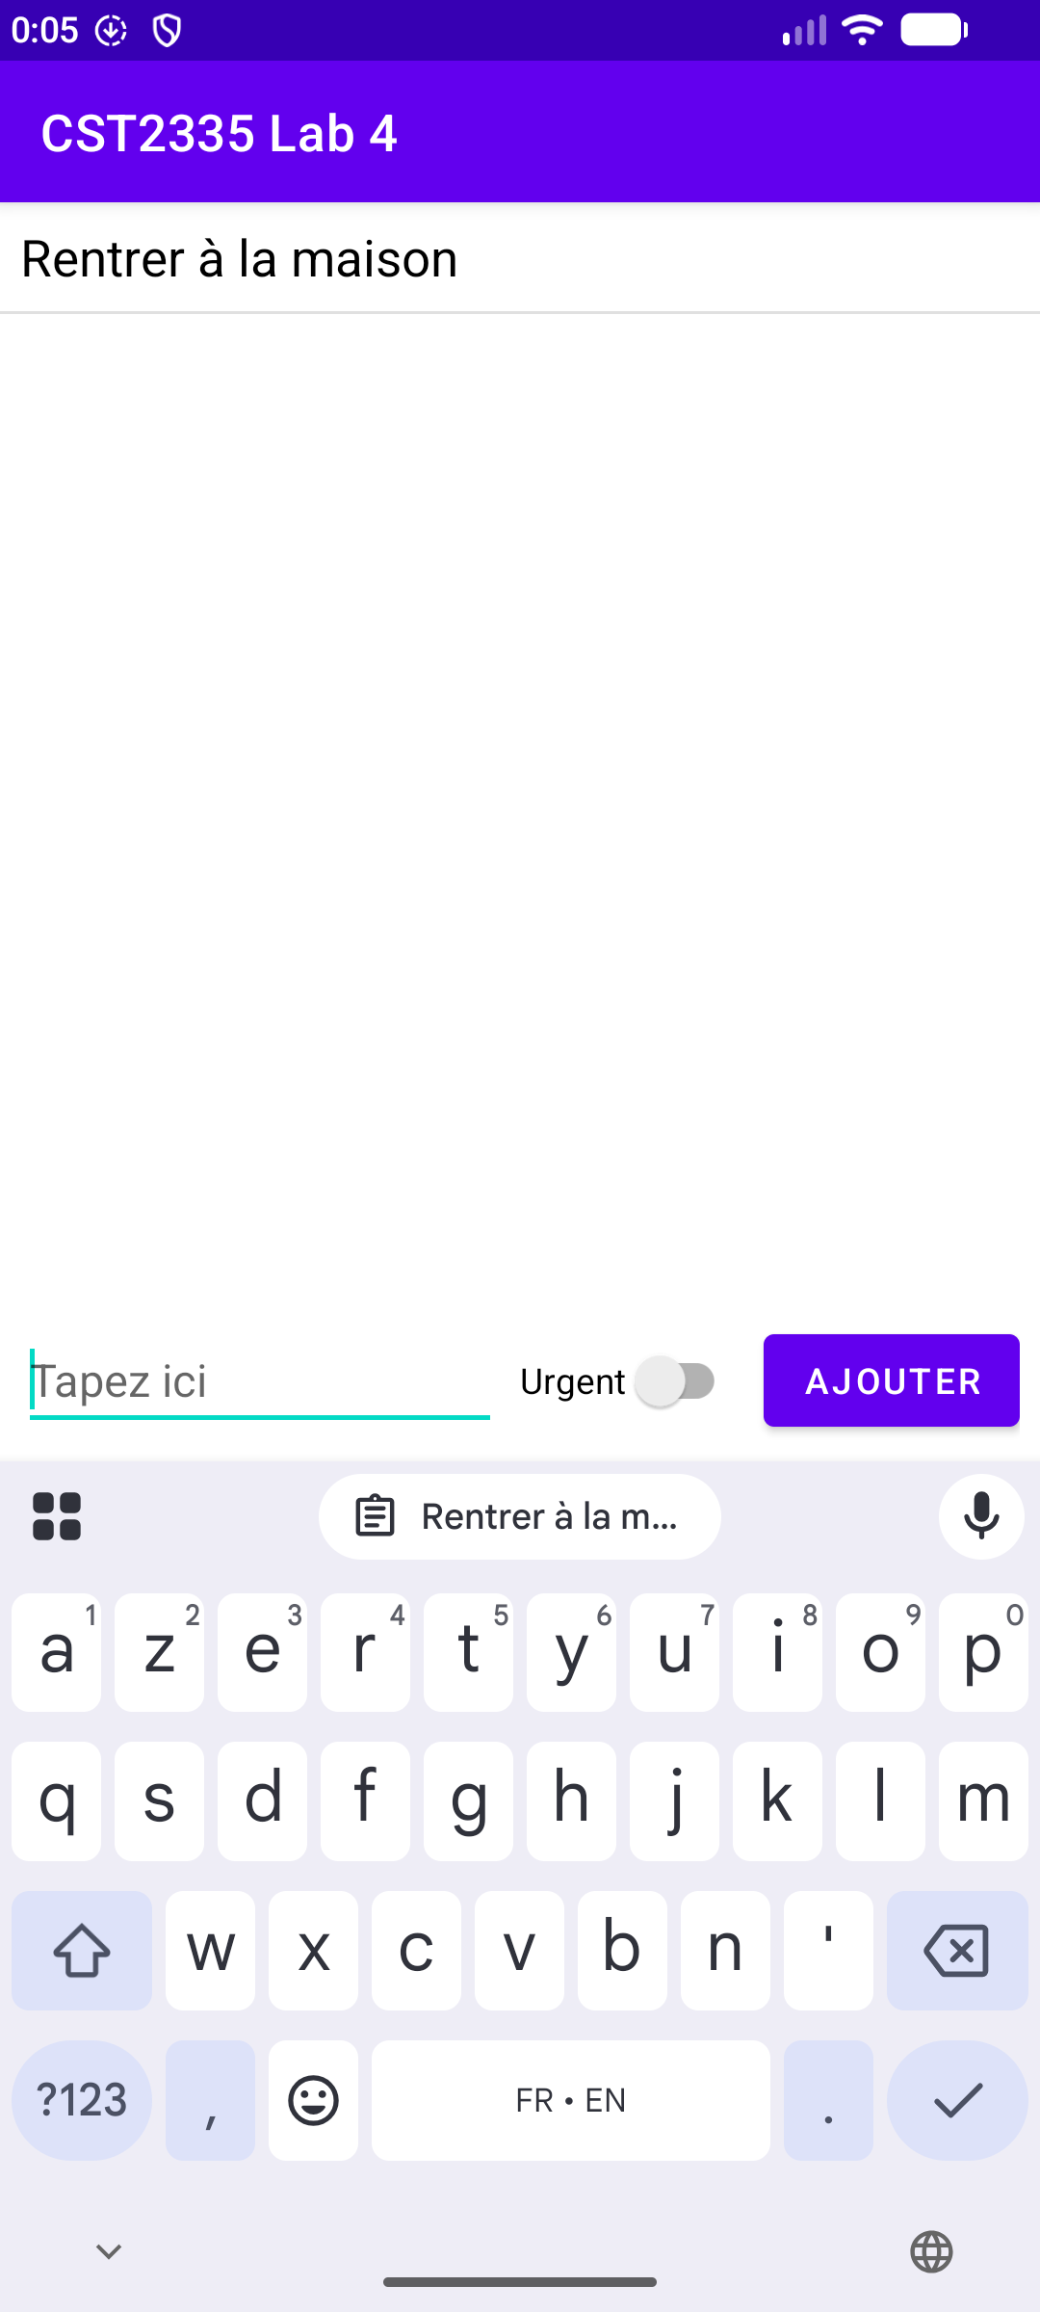
Figure 5: French localization ('Tapez ici', 'AJOUTER', 'Rentrer à la maison')
4. Demo Video Recording
A full screen recording of the app in operation ('app_demo_recording.webm') is stored in the project's 'media/' folder. It demonstrates adding normal items, adding urgent items with the red row styling, and long-clicking an item to delete it using the confirmation dialog.

