CST2335 Graphical Interface Programming
Lab 7: Fragments & Star Wars Encyclopedia Report
Course: | CST2335 - Graphical Interface Programming
Student Name: | Rayyan Haque
Student ID: | 041256359
Git Branch: | lab_7

1. Objective & Lab Overview
For Lab 7, the goal was to build a Star Wars encyclopedia app that demonstrates the use of Android Fragments and responsive layouts. The app queries live data from the Star Wars API (SWAPI), shows a list of characters on the main screen, and lets users tap a character to see their height and mass. A key requirement of this lab was handling different device screen sizes: on a standard phone, selecting an item opens the details in a new activity using a fragment; on a 720dp tablet, the layout automatically switches to a dual-pane view showing the list on the left and the fragment details right beside it.
2. Code Implementation Details
A. Fetching SWAPI Data with AsyncTask
Android doesn't allow network operations on the main UI thread—doing so causes a NetworkOnMainThreadException. To fetch the character data in the background without freezing the UI, I created an inner class called StarWarsQueryTask which extends AsyncTask<String, Integer, String>:
• onPreExecute(): Makes a ProgressBar visible in the center of the screen so the user knows data is loading.
• doInBackground(): Connects to https://swapi.dev/api/people/?format=json via HttpURLConnection, reads the returned JSON stream with a BufferedReader, and returns the response string.
• onPostExecute(): Hides the ProgressBar, extracts the "results" array from the JSON string, and loops through each character to read their name, height, and mass into a Character model object. Then adapter.notifyDataSetChanged() updates the list.
B. ListView & Custom BaseAdapter
I created a custom adapter called CharacterAdapter extending BaseAdapter to display character names in the ListView. In getView(), it inflates row_character.xml and sets the TextView with the character's name. This provides clean view recycling as the user scrolls.
C. DetailsFragment & Layout
To show the details, I created DetailsFragment.java and its layout fragment_details.xml. The layout has three horizontal rows for Name, Height, and Mass. Following the instructions, all label titles are set to 20sp bold, and the value fields are also 20sp. In DetailsFragment's onCreateView(), I retrieve the character data using getArguments() and populate the respective TextViews.
D. Phone vs. Tablet Adaptive Handling
The project includes two separate versions of activity_main.xml:
• Phone Layout (res/layout/activity_main.xml): Has only the ListView filling the screen width.
• Tablet Layout (res/layout-sw720dp/activity_main.xml): Has a horizontal layout where the ListView width is set to 300dp on the left, a 1dp divider line, and a FrameLayout (id: fragment_container) on the right taking up the remaining space.
In MainActivity's setOnItemClickListener, I check which device is running by doing:
View fragmentContainer = findViewById(R.id.fragment_container);
• If fragmentContainer is null, the app is running on a phone. The app creates an Intent for EmptyActivity, passes a Bundle with the character's Name, Height, and Mass, and starts the activity. EmptyActivity then loads DetailsFragment full-screen.
• If fragmentContainer is not null, the app is on a tablet. MainActivity directly creates DetailsFragment with the Bundle and uses getSupportFragmentManager().beginTransaction().replace(R.id.fragment_container, detailsFragment).commit() to show details side-by-side.
3. Emulator Snapshots & Verified Use Cases
Here are the emulator snapshots showing the app working on both phone and tablet screen sizes, testing character selection and fragment updates:
Figure 1: Main Screen (Phone) - Character List Loaded from Star Wars API
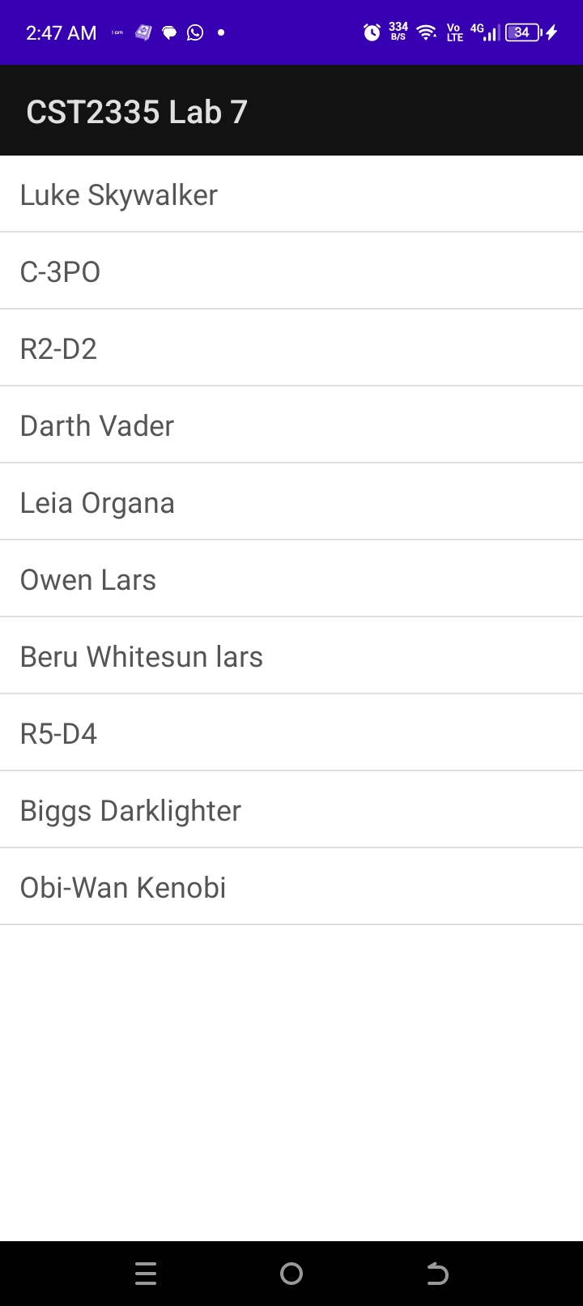
When the app starts on a phone, the ProgressBar runs while AsyncTask queries the SWAPI endpoint in the background. Once the data returns, the ProgressBar disappears and the ListView is populated with character names (Luke Skywalker, C-3PO, R2-D2, Darth Vader, Leia Organa, etc.) using our custom BaseAdapter.
Figure 2: Phone Mode - Full-Screen Character Details (Luke Skywalker)
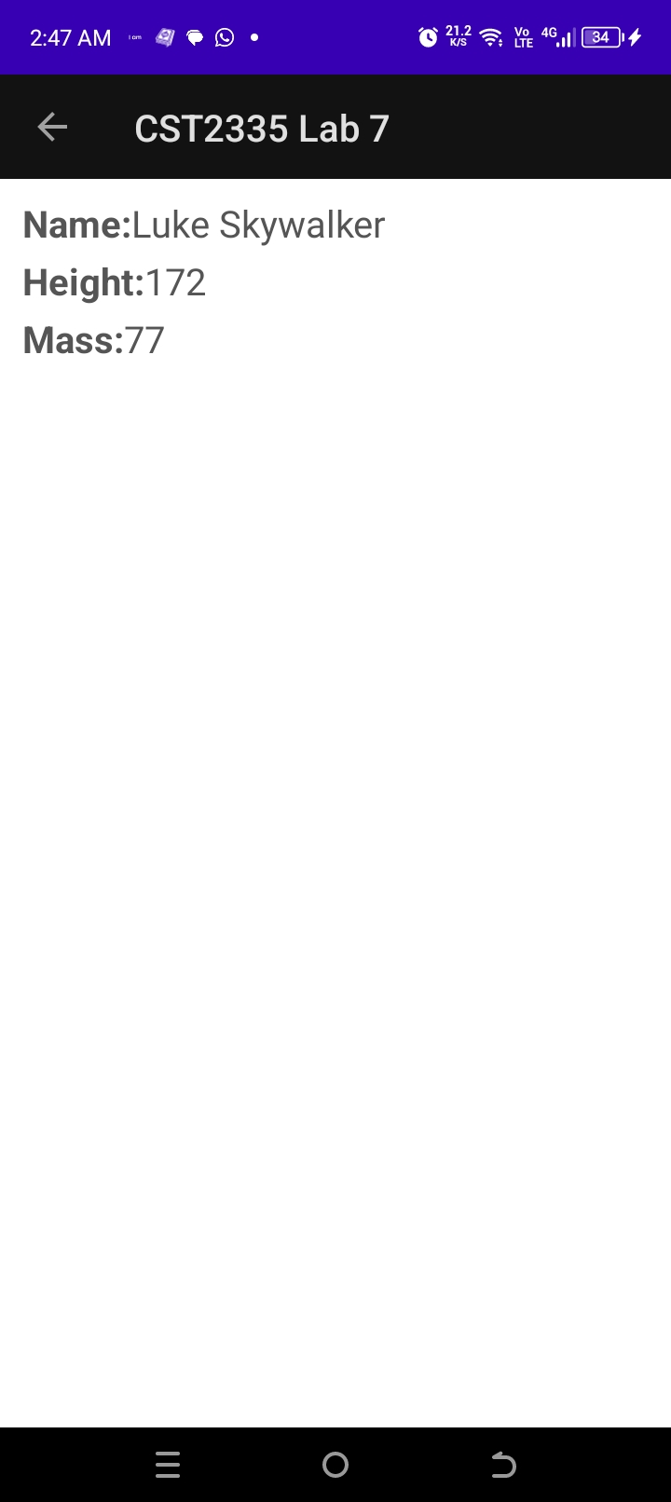
Tapping Luke Skywalker on the phone emulator detects that findViewById(R.id.fragment_container) is null. MainActivity creates an Intent and passes a Bundle to EmptyActivity. EmptyActivity embeds DetailsFragment, correctly displaying Name: Luke Skywalker, Height: 172, and Mass: 77 in 20sp text with bold headers.
Figure 3: Phone Mode - Character Details Updated (Leia Organa)
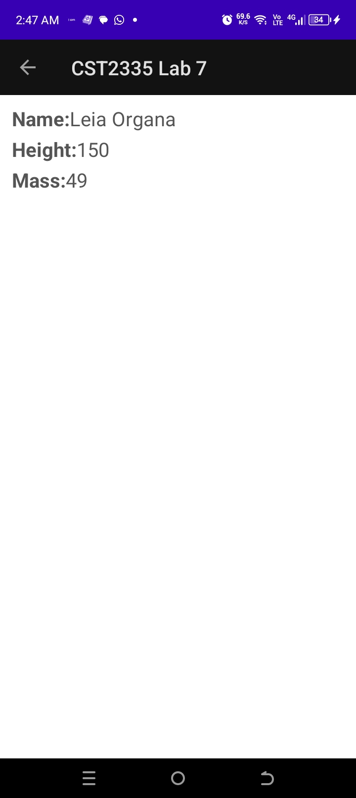
Selecting another character (Leia Organa) from the list demonstrates dynamic data passing. MainActivity bundles her specific attributes and passes them to EmptyActivity, where DetailsFragment updates cleanly to show Name: Leia Organa, Height: 150, and Mass: 49. The top Action Bar remains consistent.
Figure 4: Tablet Mode (sw720dp) - Dual-Pane Side-by-Side Layout
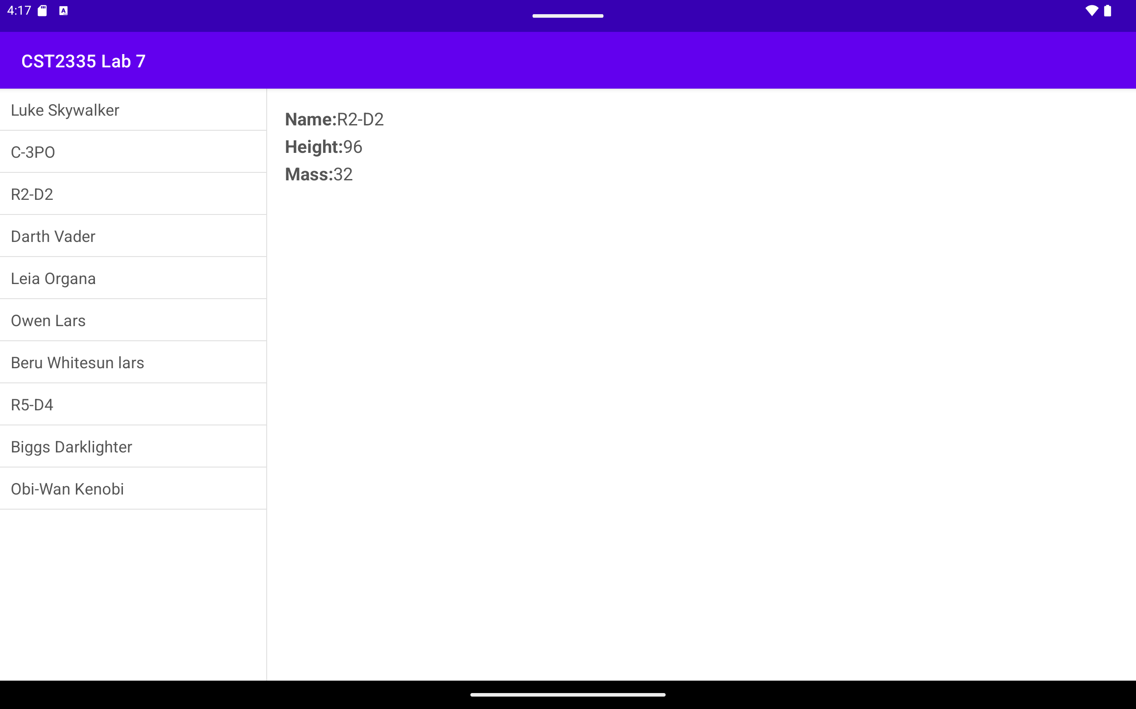
Running the app on a tablet emulator (screen width 720dp+) automatically applies res/layout-sw720dp/activity_main.xml. The list of characters remains pinned on the left side at 300dp width. The FrameLayout on the right displays the DetailsFragment simultaneously without leaving MainActivity. Here, selecting R2-D2 directly populates the right pane with Name: R2-D2, Height: 96, and Mass: 32 using FragmentManager.
4. Git Submission Details
A dedicated Git branch named lab_7 was created in Android Studio for this lab assignment. All project commits have been committed on this branch.
GitHub Repository Link: https://github.com/RayyanHaque05/CST2335_Lab7a

