CST2335 - Graphical Interface Programming
Lab 8: Toolbars, Menus & Navigation Drawer
Lab Report & Implementation Documentation
Student Name: | Rayyan Haque
Student ID: | 041256359
Course: | CST2335
Lab Assignment: | Lab 8: - Mobile GUI Programming
GitHub Repository: | https://github.com/RayyanHaque05/CST2335_Lab8

1. Objective & Lab Requirements
The primary objective of this assignment is to implement Android Toolbars, custom Menus, and the Navigation Drawer pattern while adhering strictly to clean object-oriented software architecture and code reusability principles.
- Git Branching: Created a dedicated Git branch called 'lab_8' and committed all finalized code with the message 'Finished lab 8'.
- Theme Configuration: Updated themes.xml with windowActionBar=false and windowNoTitle=true to disable the standard framework action bar and enable our custom standalone Toolbar.
- Custom Toolbar: Configured a Toolbar containing two clickable action icons (Choice 1 Star and Choice 2 Heart) that trigger custom Toast notifications.
- Navigation Drawer: Implemented a slide-out NavigationView containing Home, Dad Joke, and Exit options.
- Code Reusability: Encapsulated all Toolbar and Navigation Drawer logic inside a shared BaseActivity to eliminate duplicated code between MainActivity and DadJoke activity.

2. System Architecture & Code Design
To achieve optimal maintainability and satisfy the requirement of sharing the Toolbar and Navigation Drawer across both activities without duplicating code, a BaseActivity design pattern was implemented.

BaseActivity (Inheritance & Code Reusability):
BaseActivity extends AppCompatActivity and implements NavigationView.OnNavigationItemSelectedListener. In its custom setContentView() override, it inflates the root DrawerLayout (activity_base.xml), attaches the child layout into a content FrameLayout (R.id.activity_content), sets up the Toolbar via setSupportActionBar(), and initializes the ActionBarDrawerToggle.

Action Item Click Handling (onOptionsItemSelected):
When the user taps Choice 1 or Choice 2 on the Toolbar, the onOptionsItemSelected() method intercepts the menu IDs (R.id.action_item1 and R.id.action_item2) and displays the exact required Toast notifications: 'You clicked on item 1' and 'You clicked on item 2'.

Navigation Drawer Routing (onNavigationItemSelected):
The drawer listener checks the selected item ID:
• Home: Navigates back to MainActivity if not already on it, clearing redundant stack frames.
• Dad Joke: Launches the DadJoke activity if not currently active.
• Exit: Invokes finishAffinity() to cleanly close all running activities and terminate the application.

3. Emulator Snapshots & Test Cases
The application was thoroughly tested across five distinct use cases. Below are the actual execution snapshots verifying all assignment requirements:
Use Case 1: Main Activity & Custom Toolbar
Displays the Home screen with our custom Toolbar featuring the hamburger menu icon, the application title, and the two action icons (Choice 1 Star and Choice 2 Heart).
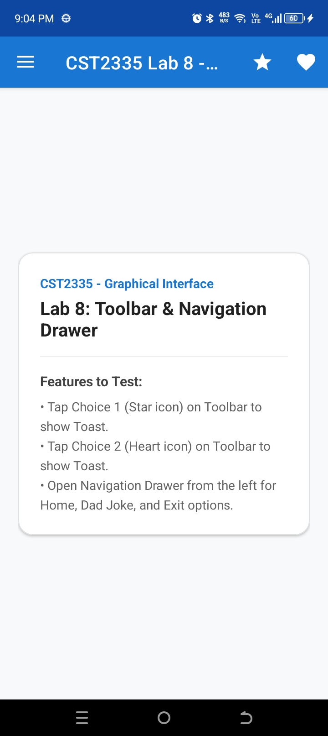
Figure 1: MainActivity running with custom Toolbar and two action icons.

Use Case 2: Toolbar Choice 1 Toast Notification
Triggered upon clicking the Star icon (Choice 1) in the Toolbar. Verifies that the exact Toast message 'You clicked on item 1' appears at the bottom of the screen.
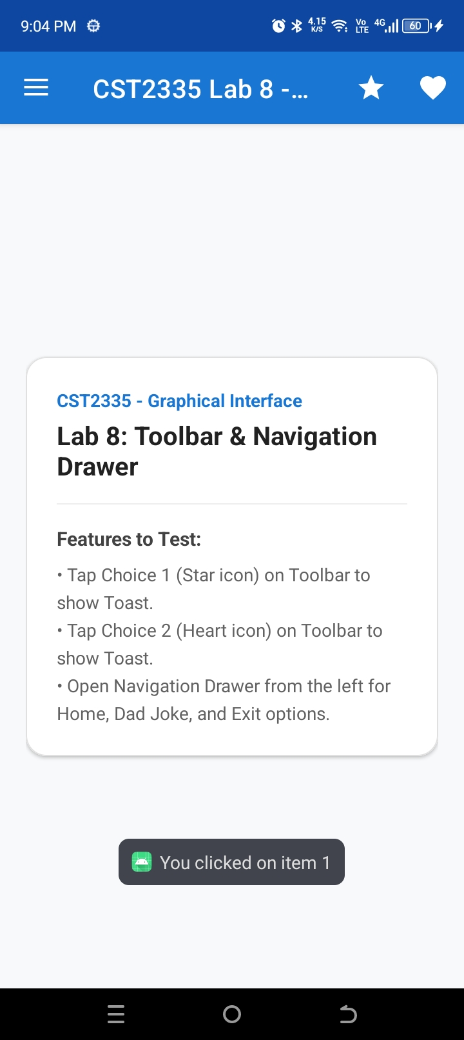
Figure 2: Toast notification displayed on clicking Choice 1 ('You clicked on item 1').

Use Case 3: Toolbar Choice 2 Toast Notification
Triggered upon clicking the Heart icon (Choice 2) in the Toolbar. Verifies that the exact Toast message 'You clicked on item 2' appears.
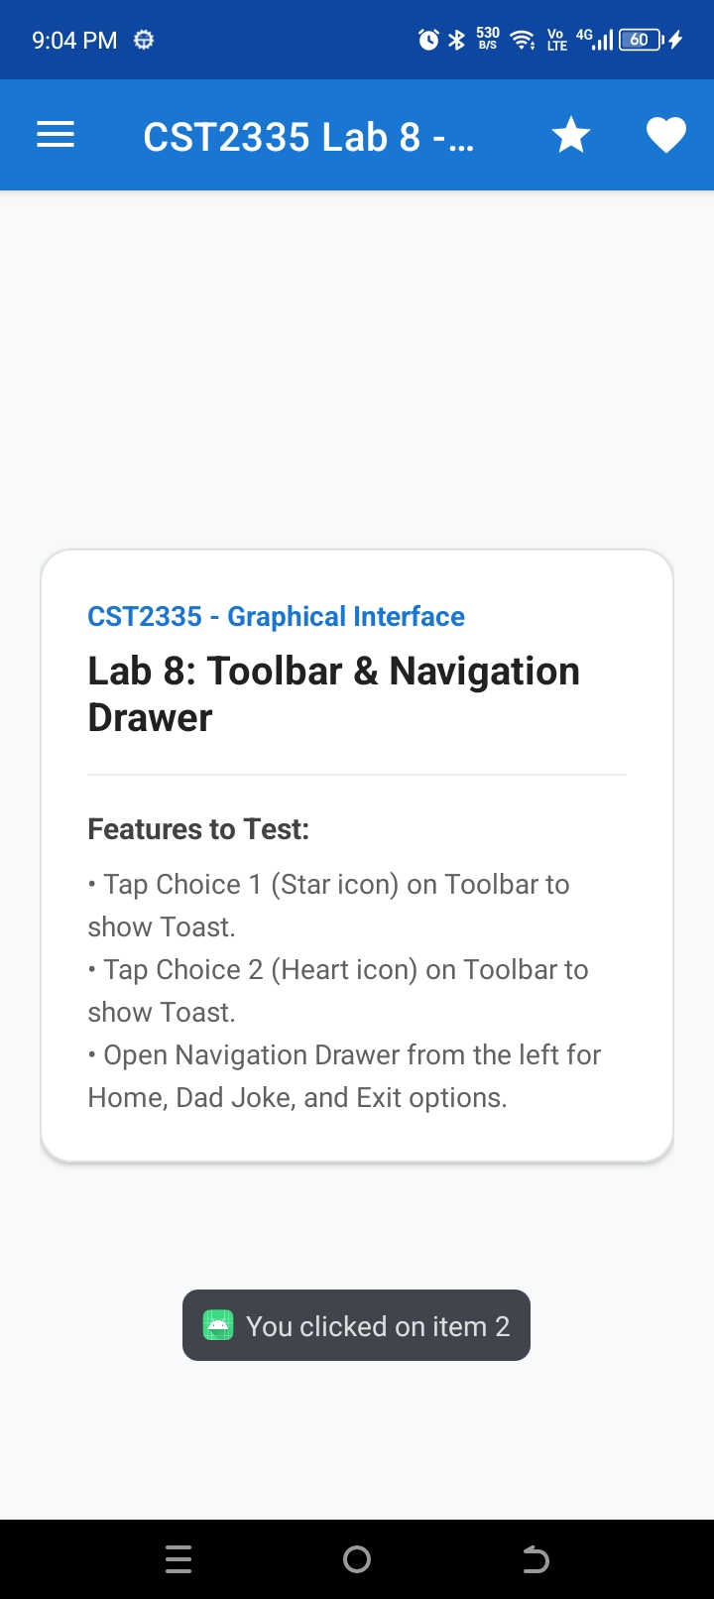
Figure 3: Toast notification displayed on clicking Choice 2 ('You clicked on item 2').

Use Case 4: Slide-out Navigation Drawer
Displays the open Navigation Drawer showing the branded header with icon, along with the menu options: Home, Dad Joke, and Exit.
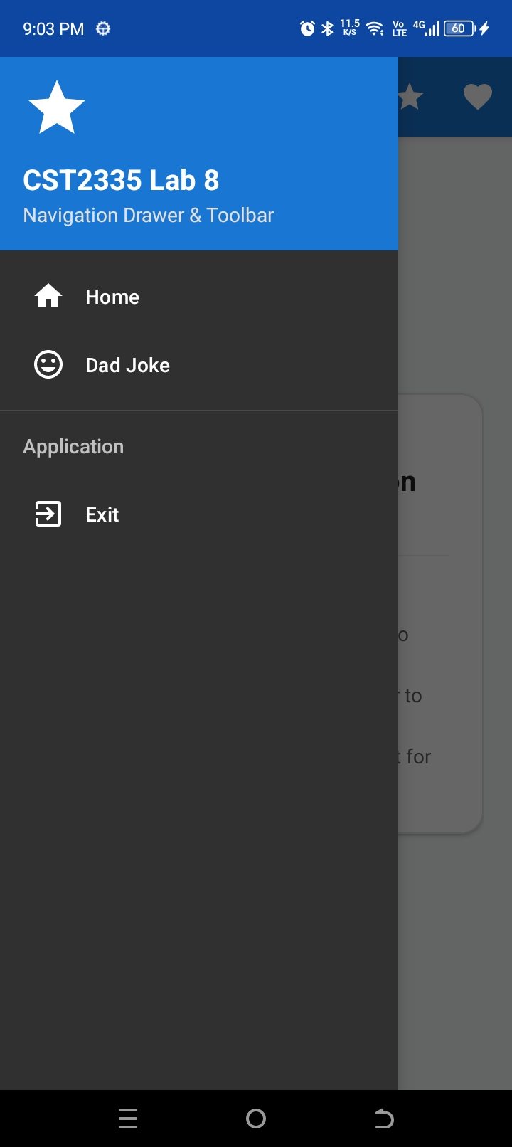
Figure 4: Open Navigation Drawer displaying header and navigation options.

Use Case 5: Dad Joke Activity
Displays the DadJoke screen navigated from the drawer, showing the shared Toolbar, drawer toggle, and the Dad Joke rendered cleanly inside the TextView.
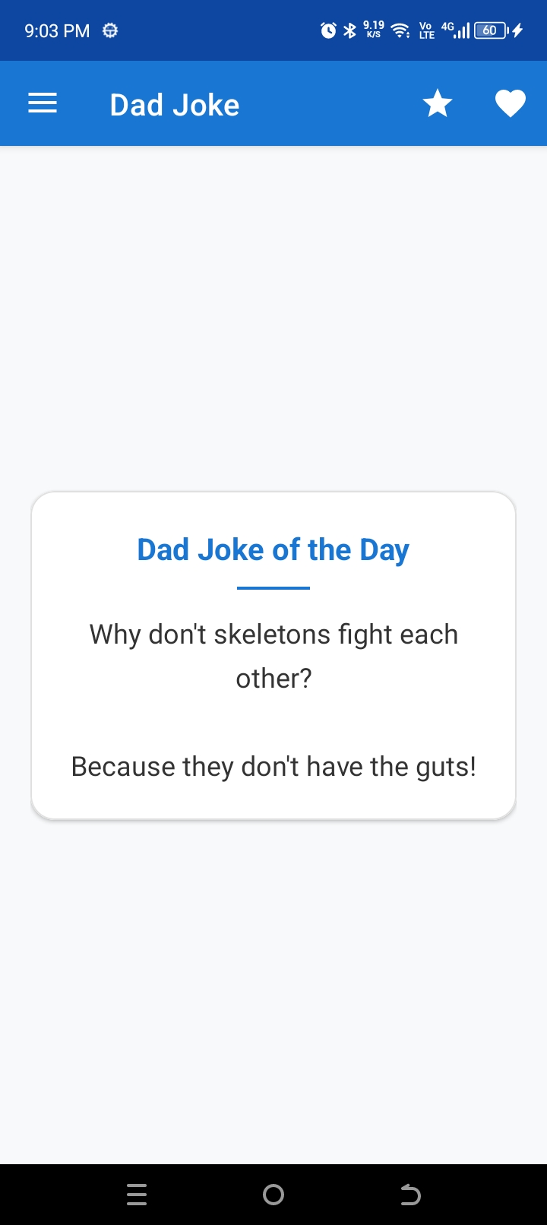
Figure 5: DadJoke Activity displaying joke in TextView with shared Toolbar.

5. GitHub Submission Information
Repository URL: https://github.com/RayyanHaque05/CST2335_Lab8

