Ray Marken

# Windows Administration and Hardening

## Task 1

Take a screenshot of all the GPOs created for this homework assignment. To find these, launch the Group Policy Management tool, select Group Policy Objects, and take a screenshot of the GPOs you've created.

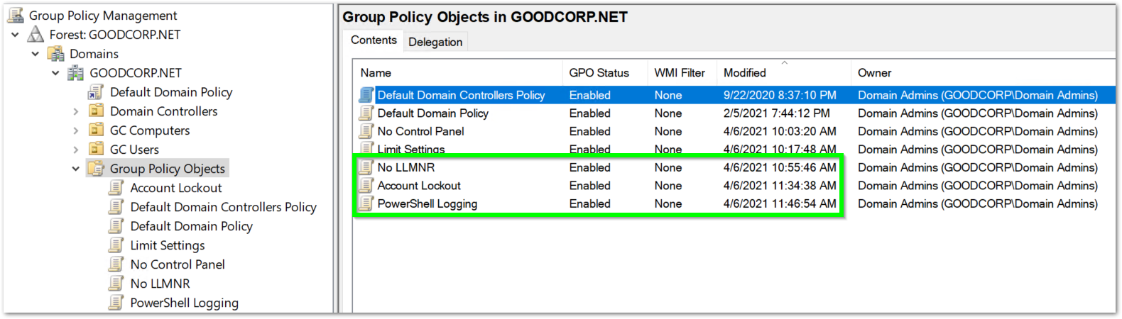

## Task 2

Submit a screenshot of the different Account Lockout policies in Group Policy Management Editor. It should show the three values you set under the Policy and Policy Setting columns.

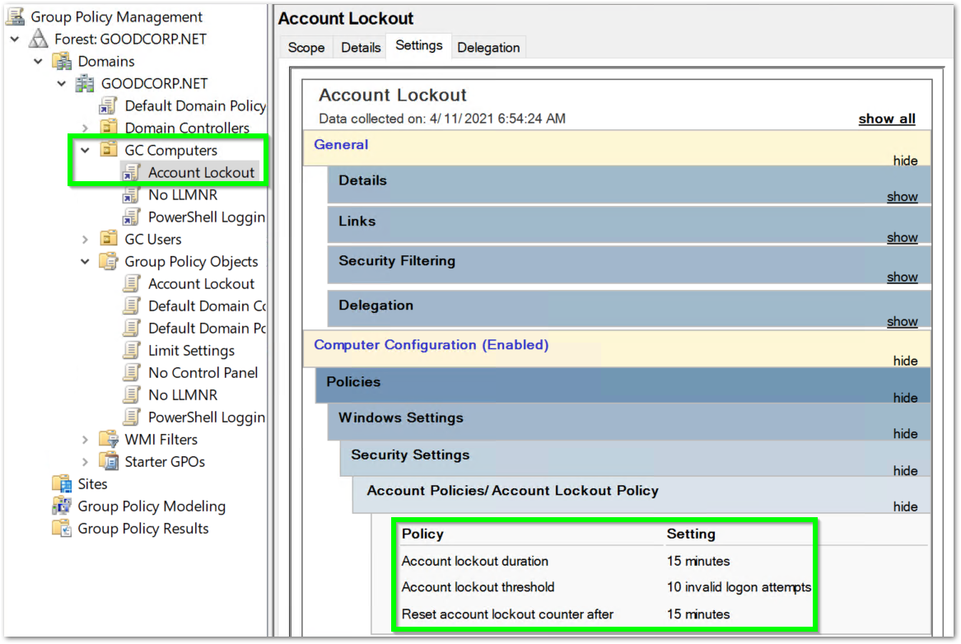

## Task 3

Submit a screenshot of the different Windows PowerShell policies within the Group Policy Management Editor. Four of these should be enabled.

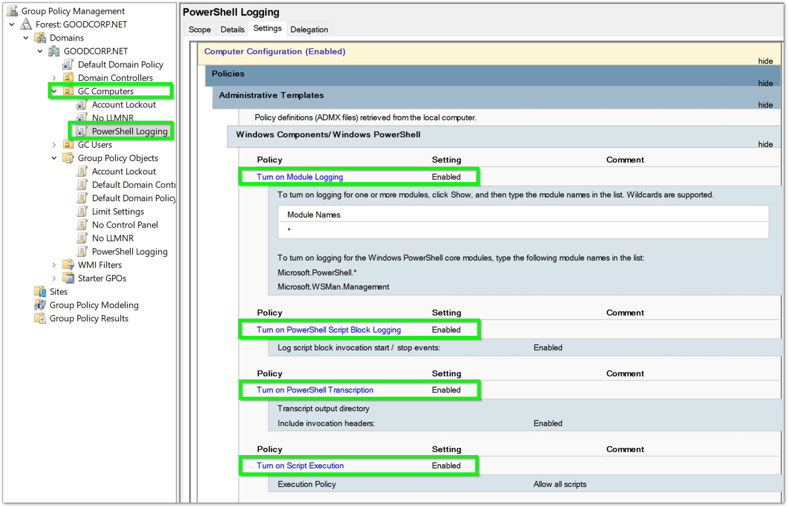

## Task 4

Submit a copy of your enum_acls.ps1 script.

Although the enum_acls.ps1 script is included as a separate file, the screenshots below show the script contents and example output for convenience.

**Script contents….**

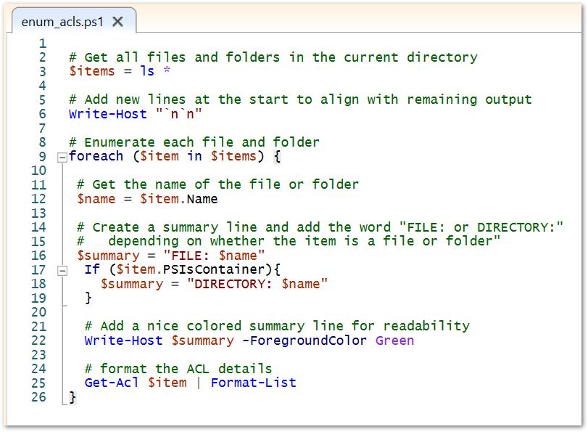

**Example output….**

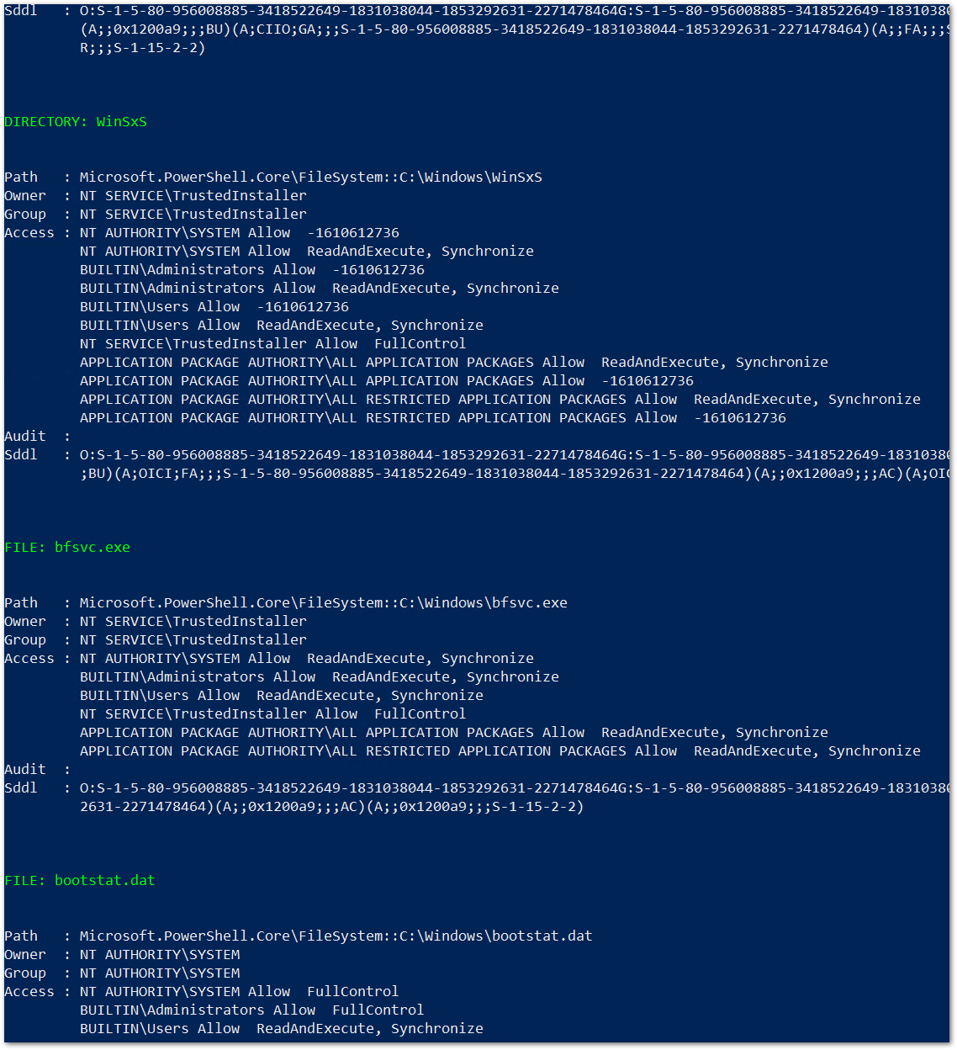

## Bonus Task 5

Submit a screenshot of the contents of one of your transcribed PowerShell logs or a copy of one of the logs.

